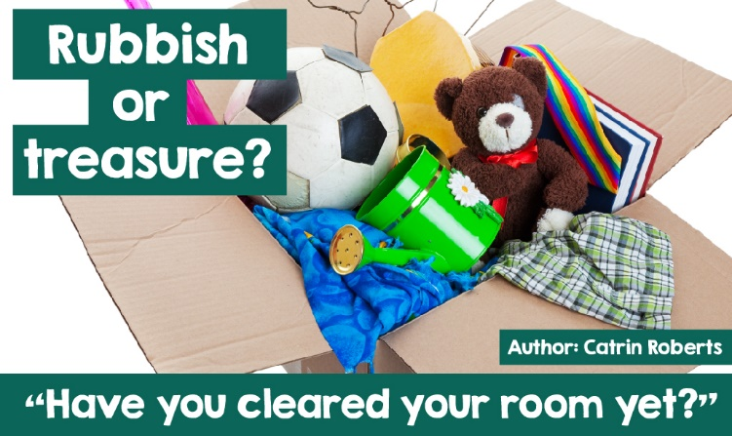

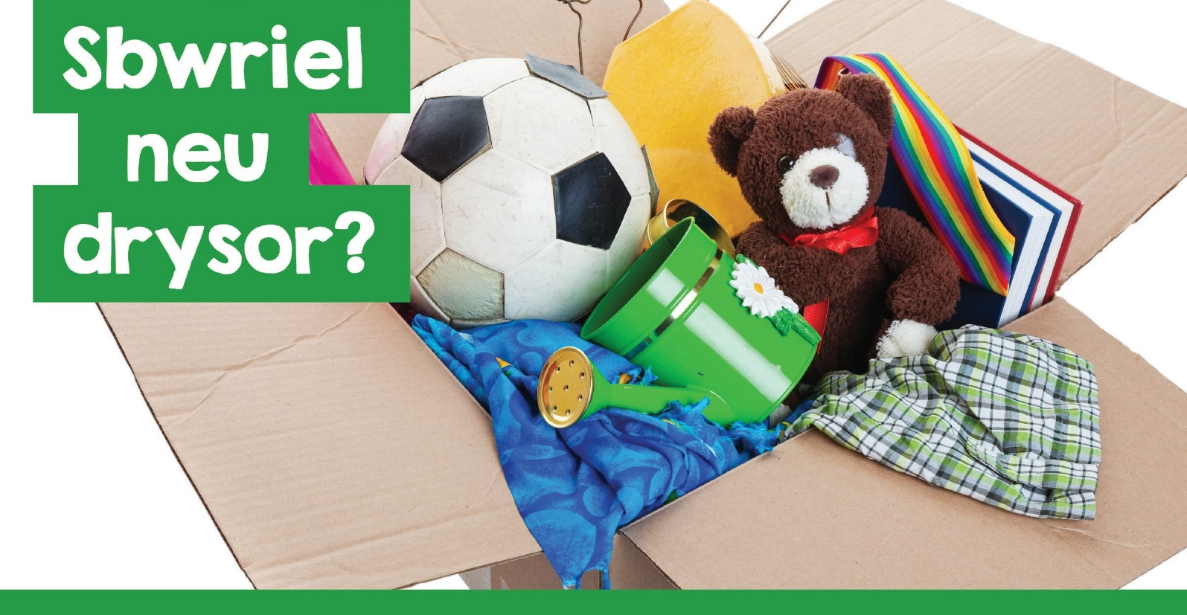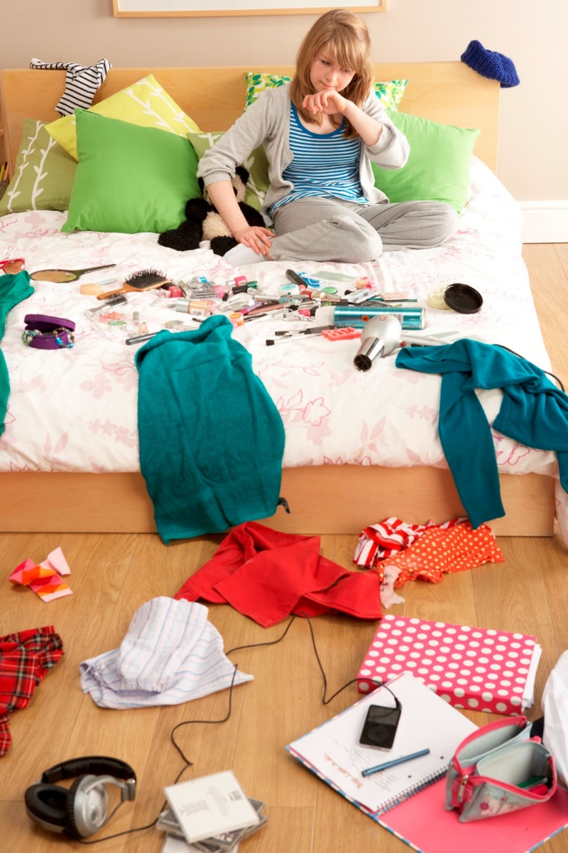

How many times have you heard those words in your life!

And the command is impossible to ignore - you must obey and tidy up, empty rubbish bins, put everything in its place.

But sometimes clearing isn't enough. Things must be disposed of - shoes or 'trainers' that have become too small; toys that are by now too childish for you; old-fashioned electronic equipment of which you have recently had a newer version.

I remember having to do this clearing up, feeling sad to see things that I thought the world of, having to go in the bin, and mum saying explicitly, "They're of no use to you now, so they might as well go!”

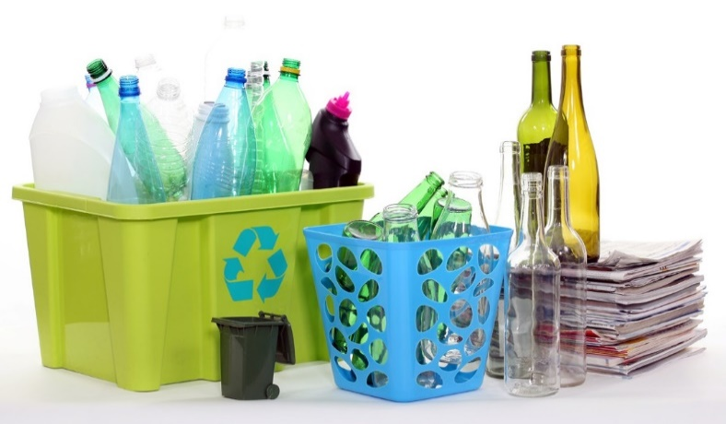

But there is great emphasis nowadays on recycling resources. Councils organise bins or bags and recycling centres so that our glass, cardboard, paper, tins are reused in a bid to protect our planet's future, by avoiding wasting resources and energy, and reducing pollution. To learn more, click on https://your.caerphilly.gov.uk/kidsgogreen/ cy/parth-gwybodaeth/pam-ailgylchu. Do you play your part in the important work of caring for the future of our world?

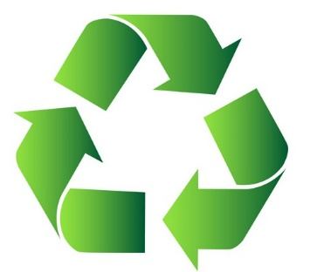

**Treasure → rubbish → treasure offering new hope**

Another possible alternative when disposing of property is to donate them to a charity shop. Many of these shops are found in our towns and villages. What is the main message of these types of shops? 'Your rubbish becomes treasure in our hands'. That is, if you give us the items you don't need, we can sell them in our shops and raise money to support our work as a charity, for example Oxfam, Barnardo’s, British Heart Foundation, Tŷ Hafan, Hope House. Mind, Cancer Research

.... the list is endless.

A great deal of money is raised through charity shops as they sell clothes,

furniture, baby utensils, books, jewellery, pictures, crockery and much more, things the public give away. Some charities sometimes share door-to-door bags for you to fill.

Click on <http://www.charityretail.org.uk/>

how-charity-shops-work/ to learn more.

This is a great example of actual recycling. That is, the item that was once

'Treasure', but which has now become 'rubbish' is turned into 'treasure' again by funding the work of a charity that offers hope to people in need. The item does not have to be financially valuable; anything can be treasured because it is important or dear to us.

What is your treasure? What are the things you would be sad to miss? Family? Friends? iPad? Your collection of music?Many people say that our greatest treasure is our health. Being healthy to do whatever you want, with nothing stopping you.

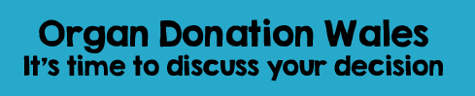

It is, therefore, sensible to do all we can to protect that treasure while looking after our body through exercise, healthy eating (not too much sugar, lots of fruits and vegetables), and getting enough sleep.

[https://www.bhf.org.uk/-/media/files/](http://www.bhf.org.uk/-/media/files/) publications/healthy-eating-and-drinking/ g186weatingwellwelshtranslationbwytanor

<http://sport.wales/newyddion-a->

digwyddiadau/newyddion-a-digwyddiadau/

ein-hymgyrchoedd/cadw’n-heini-am.

Organ Donation Wales – It’s time to discuss your decision

**Presumed consent**

Every part of our body is important, a 'treasure', playing its part in enabling us to live life to the full - even those parts that are out of sight, for example our heart, eyes, kidneys, liver.



But sometimes life can be cruel. Sometimes we lose our health. Sometimes our body is seriously injured in an accident, and it is not possible for us to live.Years ago when a person died, then the 'treasures' (the organs) in the body would be lost as they were buried in a grave or cremated in a crematorium.

But good news! Nowadays, doctors can transplant organs, and dead people’s organs do not have to become rubbish.

For many years now there has been a scheme where people can officially note or carry a card to say they want their organs to be used to help others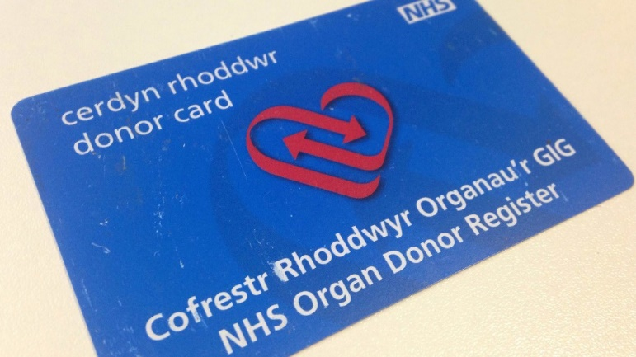 via transplant if the worst came to the worst.

Since the end of 2015, the Welsh Government has assumed that we are ready to donate our organs upon our death to help another person, unless we have officially opted out.

<http://organdonationwales.org/FAQs/Organ->donation-from-december-2015/?force=en

**Burying a Bentley!**

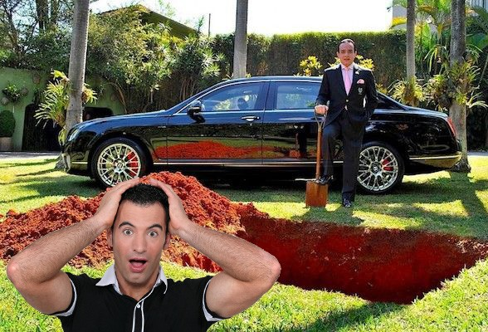Have you thought about this? Would you want to see your organs

'recycled' and used to help another person?

There are some who argue for and against this.

Have you ever heard of a man named Thane Chiquinho Scarpa? He's one of Brazil's richest and most powerful men. One day he announced that he was going to bury his expensive Bentley car - to drive around heaven in style after he died!

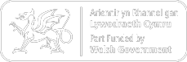

He gained a lot of attention on television and in the other media. People were critical of him - why not donate the car to charity to raise money? Burying the car was a waste - and for what? But he went ahead with his plan and held a burial ceremony.

And then, a few seconds before lowering the car into the earth, he explained the real reason for doing such a thing - highlighting the need for organ donation.

[https://www.everplans.com/articles/rich-guy-](http://www.everplans.com/articles/rich-guy-) buries-million-dollar-bentley-to-prove-point

He said:

"People criticise me for burying a multi-million-dollar Bentley. But the truth is, most people bury much more valuable things than my car. They bury hearts, livers, lungs, eyes, and kidneys.

That's so silly! There are so many people waiting for a transplant, yet we are burying organs that could save so many lives.”

Hmm!

Organs – rubbish to be buried or treasures to donate to others? What do you think?