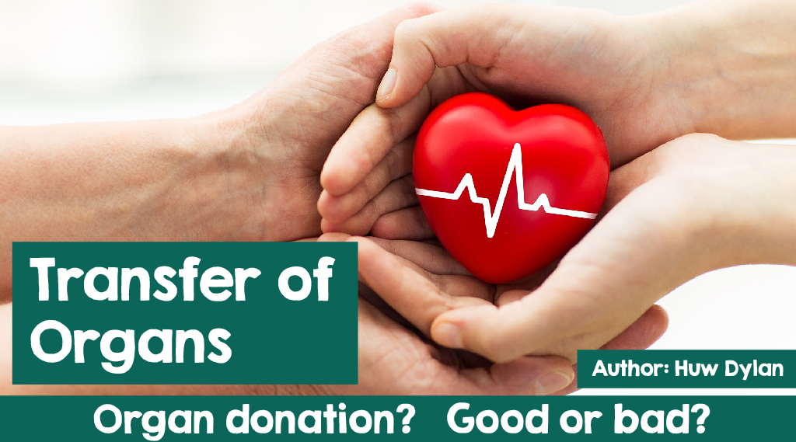

Well, what a stupid question! Of course, organ donation to help others is a good thing - how could it not be? Unfortunately, religious teaching is never quite that simple, especially on moral issues, and organ donation is one of those topics.

The world’s religions have been considering this topic for some time but, of course, the Welsh Assembly Government's decision to change the procedure regarding giving consent to the use of organs for transplantation, has brought some attention to the issue.

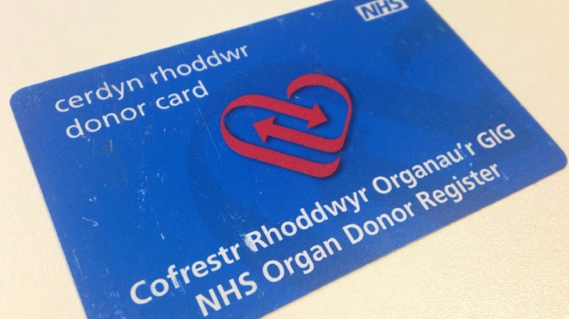Organ donation is the gifting of one of the organs of the body such as a heart, liver, kidney to help another person who needs a transplant. This happens most often after the donor dies.

Yet some transplants do occur where the donor is

alive and continues to live after the transplant. There

are many examples of a sister giving one of her

kidneys to another sister or a mother to a daughter.

Organ donation certainly saves or improves the lives

of hundreds of people every year.

So, what do some of the world's leading religions think

of this issue?

Although organ donation is a personal decision, it can be said that Christianity in general, Protestants and Catholics, are very much in favour of it.

Helping others is a key part of every form of Christianity and organ donation is seen as an act of love that follows the example of Jesus Christ. Many Christian leaders, past and present, have shown their support for organ donation.

According to the Pope, John Paul II, 'With the advent of organ transplants, which began with a blood transfusion, man has found a way to give of himself, in terms of blood and body, so that others can continue to live.'Sentamu Ebor, Archbishop of York, said,

'There are thousands of people in the United Kingdom waiting for a transplant that could save or significantly improve their lives ………… I hope everyone is thinking about whether they could give life to others after their own death. '

And according to the Archbishop of Wales, Barry Morgan, ‘organ donation is the most generous way possible to give of oneself.

Ioan Paul II Ebor Morgan

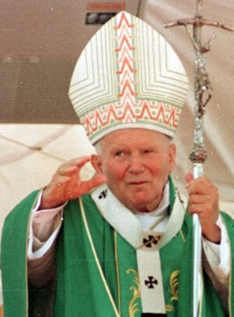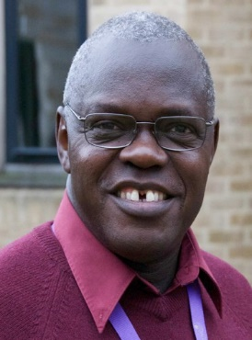



There is more disagreement about organ donation to be seen within Islam. For some Muslims, abuse of the human body, before or after death, is forbidden in Islam.

Others are more supportive of living donor transplants rather than after death donation. Another thing that worries some Muslims is burial rituals in Islam, where it is traditional to bury the body within 24 hours. Organ donation may run counter to this.

Islam also teaches that everyone will be resurrected on the Day of Judgment to face the judgment of Allah and many Muslims are concerned about what will happen to them at that time if the body is not whole.

On the other hand, many Muslims argue in favour of organ donation. The Qur'an teaches 'Whoever saves the life of one person, seems to have saved all of humanity's life. '(Chapter 5:32).

According to many Muslims, Islam is a message of love, mercy and compassion for all and that organ donation is acceptable to both Muslims and non-Muslims respectively.

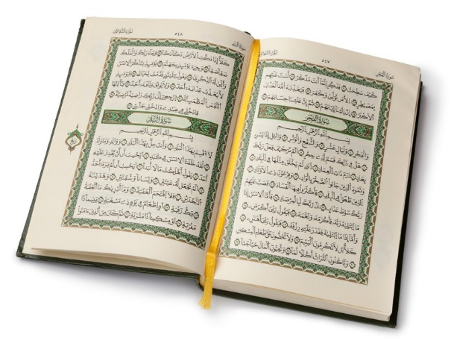

Although Islam prohibits abuse of the body, some Muslims state that what is necessary according to the teachings of Islam is

more important than any prohibition. This is called *al-darurat tubih al-mahzurat*.

In 1996 the Muslim Legal Council of the United Kingdom issued a religious resolution stating that organ transplantation is in keeping with the teachings of Islam.

Other Muslims are of the view that organ donation is acceptable if it is within the conditions set out in Shari´ah law.

Yet many Muslims would seek the advice of the local Imam before making any decision.



There is no religious law that prohibits Hindus from donating organs. Life after death is very important to Hindus. They believe in reincarnation and that the soul moves on to another body after the death of the body. This can happen thousands of times until they purify their karma and break the cycle of rebirth and reach Moksha.

Many Hindus, therefore, believe that the body, once the soul has left, is no more than a machine and that there is no reason not to share parts of it with others. Yet, some are opposed to this because if someone gets e.g., a new heart in this life, then by the law of karma, a heart has to be put into the next life. This means that it will not be possible to break the cycle and this is a disadvantage to many. But for most Hindus this is a selfish debate.

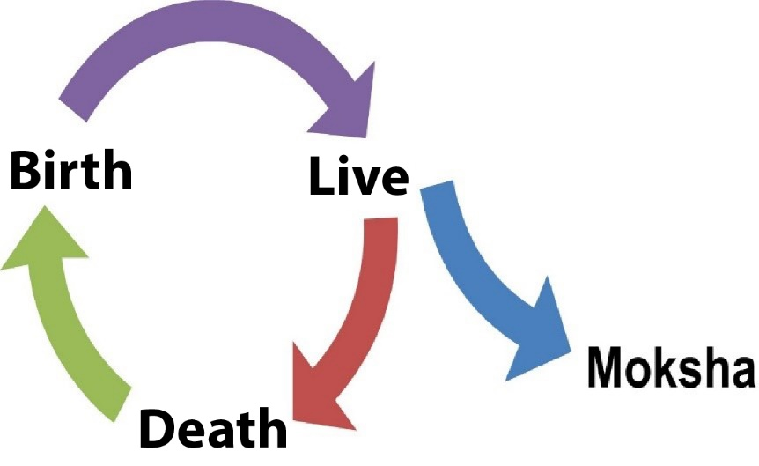

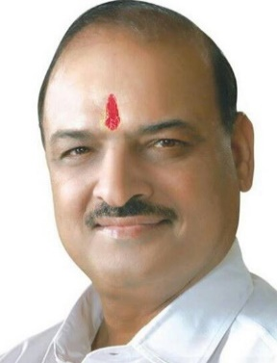

Hindu scriptures support the idea of organ

donation and transplantation. In the list of the ten

Niyamas or good deeds, Daan, namely selfless

Giving, is the third in importance.

According to the Vedas what sustains life is

Dharma - virtuous or good living.

The Manusmruti says - 'Of all you can give, to give your own body is much better' and the Bhagavad Gita, one of the most important Hindu scriptures says '… .the soul is said to be invisible …… ..knowing this, do not mourn for the body.' (Chapter 2:25)

According to Om Parkash Sharma, President of the National Council of Hindu Temples “Organ donation is in keeping with Hindu beliefs because it can help save other lives.

Sharma

So, organ donation - good or bad?

Although some religious believers have some reservations in all the major religions of the world, the majority, undoubtedly, support the idea, mainly for one reason - that it is an expression of love, of selfless giving and a means of saving and improving the lives of others.