

**Sport + Christianity =?**



What happens when you mix water and oil?

Yes, you're right - NOTHING!

Nothing happens because water and oil don't mix! There are some things in this world that can't be mixed!

What about mixing sport and the Christian faith? Is that possible?

And is there any point in mixing Sport and Christianity?

Yes - that is Christians in Sport’s (CIS) answer to the first question, and

Yes is the answer to the second question

Many Christians who like, or shine, in sport, and who are even part of the professional elite, think that their ability is something God has given them and they want to use that ability to worship and glorify God (read Romans 12 verse 1). They believe that true worship is the giving of themselves completely to God, and this includes their sporting ability. By being in the world of sport, God places people around them (fellow players, people coaching or running a club) in order that they show and share Jesus with them when the opportunity arises.

Christians in Sport says -We’re all in for Christ. All in on sport. And all in it together.

For us, sport is more than a game. It’s about who God made us to be.



More than 40 years ago, a small group of Christians from sport, at a professional level (players, commentators, and organisers), got together. They had a dream - a network built on faith, which would spread throughout the world of sport, and unite and support Christians in Sport. They were excited by the idea of mixing sport and faith, and the rising profile of Christianity in sport.

Christians in Sport today supports thousands of Christians in sport. There is a great deal of work being done at sports camps and at universities and thousands of people have heard the Gospel at various meetings where churches, Christians in Sport and sports teams hold joint events.

**Lloyd Thomas**



**Lloyd Thomas** is a young Welsh speaker working for Christians in Sport, mainly in south-west Wales. He is Head Coach of Bettws Ammanford RFC and plays for the team as well.

**What is Lloyd's job with CIS?**

*I connect with supporting Christians in Sport across Wales. This is done by opening the Bible with Christians and encouraging and equipping them to live for Jesus, wherever they play.*



*As a worker in Wales, I work with local chapels across the country by running exercise sessions for Christians in the sport and again opening the Bible to encourage and equip people to extend the local sporting world to Christ. This can be one chapel or a group of chapels in a town or city. If Christians or chapels want to reach out to the local sporting scene around them, I come and help run events to give people in sports the opportunity to hear the gospel. This is driven by the local Christians or chapels and CIS's job is to give help and support. Jesus also said that he would come back to life on the third day after the crucifixion - which is amazing - and impossible, according to some! But the Gospels present witnesses who say that this is exactly what happened. Therefore, if Jesus was telling the truth about coming back to life, the Christian thinks he is telling the truth about other things too.*

[*Link: Penngrove’s Apostolic Church*](https://www.facebook.com/penygroesapostolicchurch/posts/1970925796483342)

*I also train on Sports Plus courses (for 11–17-year-olds), a week of specialist training for young people who are serious about sport and regularly play in a club or team. Everyone who comes to the course will know that they will also hear about the Christian faith and have the opportunity to think, for the first time, who Jesus is.*

*I know that talking about faith can make a difference. It made a difference in my life. In 2014, I went to Australia on contract to play rugby. Some of the boys in the team were Christians and I talked to them and listened to what they had to say about God and Jesus. When I came back, I had changed, and I started an Internet with CIS*

***Joseff Edwards***

*Someone who has worked as an intern for Christians in Sport is* ***Joseff Edwards****, formerly of Bala.*



*Working for CIS combined my faith in Jesus, my love of sport and the joy that comes from sharing the most incredible message to the world of sport ... ... As an intern, I was travelling the country, training university students to see their sport as not separate from their faith in Christ, but something to be used as a worship of God ... ... Much of my role was to encourage Christians to see that they had a purpose in their sports team, it wasn’t just a way to keep fit, but an opportunity to share the life that Jesus offers. Jesus said (Matthew 28.19) "Therefore go and make disciples of all people" - the world of sport is a very big 'country' today, and Jesus needs to be taken to the players, to the coaches, to everyone who is part of that 'country'.*

***What kind of help / resources does CIS offer?***



***Quiz Night Resources***

*A multimedia quiz with a slot for presenting a Christian message. During 2019, rounds were added due to the various World Cup competitions - ICC Cricket World Cup, FIFA Women's Soccer World Cup, Rugby World Cup, Netball World Cup.*

**Big Screen Event**

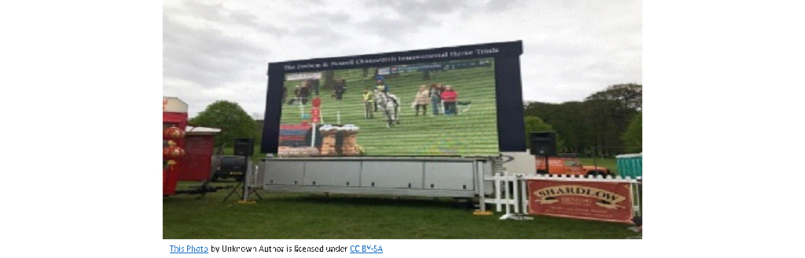

*An opportunity for a Club or Chapel / Church to invite people to come and watch an important game on a big screen or television in a home. During the evening, there is an opportunity to share a Christian message or to show a CIS movie*

***Schools***

**

*CIS also offers resources to help people who work in schools talk to youths involved in sport. There are materials for assemblies and lessons - all based on the theme of Faith and Sport.*

*What about you?*

*Do you take part in sport?*

*Do you think it is possible to mix religion and sport?*

