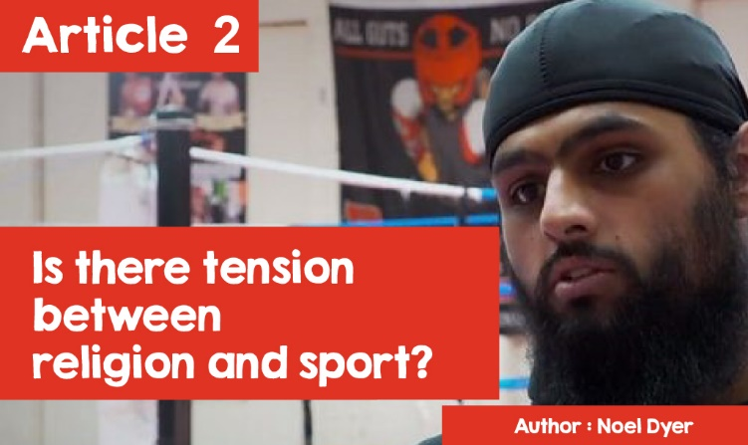

**Is there tension between religion and sport?**

"Remember that Sunday school is tomorrow morning at ten."

"No mum, you should remember that rugby practice has moved to Sunday morning, that's the only time everyone can come!".

The relationship between religion and sport is generally poorly addressed. It is occasionally noticed when religion affects a person's willingness to participate in a sporting event of great importance. Many athletes actually thank God for their success. This sometimes means sacrificing opportunities for their faith.

Chariots of Fire was the most successful 1981 film - winning an Oscar and Bafta as the best film of that year and the opening music by Vangelis is still well known today. It tells the story of two young runners in the 1920s as they prepared for the 1924 Olympics. Eric Liddell from Scotland was a devout Christian who saw running as a service to God and Harold Abrahams was a Jew. Eric Liddell refused to practice and compete on Sundays and Harold Abrahams had to face anti-Semitic prejudice.

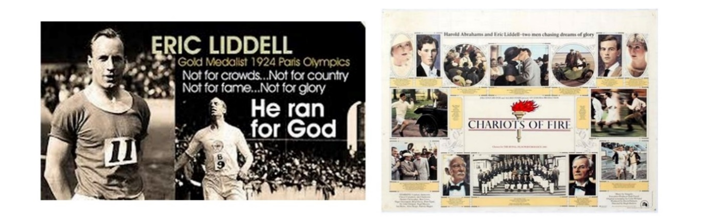

Eric Liddell decided not to run the 100-meter race at the Paris Olympics in 1924 because it took place on a Sunday - a day of worship and rest for Christians. He decided to run the 400 meters instead as that took place during the week. He won the race and received the Gold Medal. For the rest of his life, he carried out Christian missionary work in China.

"Muhammad Ali is still remembered by many as being such a successful boxer and such a great character. Fewer, now, remember that he changed his name from Cassius Clay to Muhammad Ali in 1964, when he converted to the religion of Islam. He used his faith to inspire him in the boxing ring. His faith led him to refuse to fight for the United States of America in the Vietnam War. This cost him dearly in his career for a while.

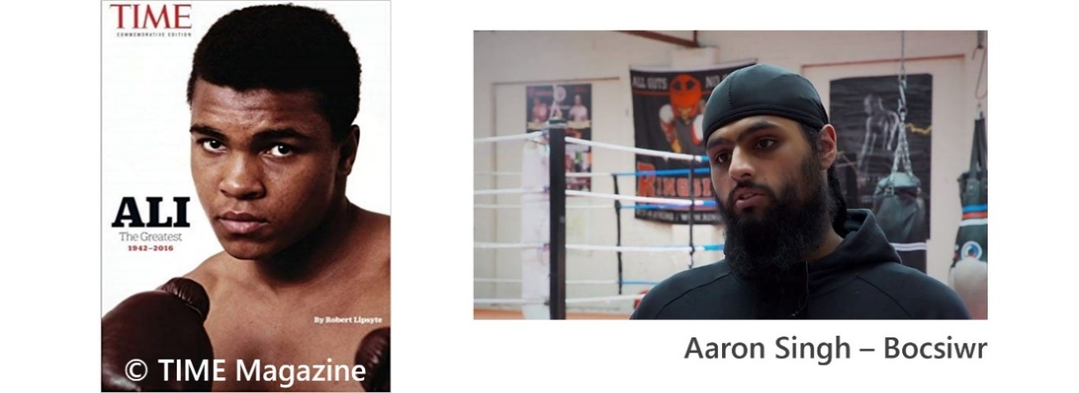

Aaron Singh - Boxer

Boxing and religion have been in the news again very recently in England and Wales. Sikh and Muslim boxers claimed that a rule that said that one couldn’t box sporting a beard unfairly discriminated against those who wore a beard as part of their religious traditions. This is true of Sikhs and Muslims.

Aaron Singh said that the Welsh Boxing Amateur Board's rule about shaving the face prevented him from competing because of his faith. (The English boxing board recently changed the rule). Aaron Singh said; 'So that I can compete; they ask me to shave off my beard and that is contrary to my religion. Personally, I find this a discriminatory rule.' The Kesh principle of Sikhs is one of the 5K's and prohibits cutting and shaving hair as it is considered a gift from God.

These are the famous words of Bill Shankly (former Liverpool manager); 'Some believe that football is a matter of life and death ... I can assure you it is far more important than that!'

For some, the love of football is so strong that some have described it as a religion! Perhaps an exaggeration but there is a connection between the two. In some towns in Scotland, England and certainly Northern Ireland, religion can influence which team is supported. Glasgow city in Scotland and Manchester in England are examples. Celtic and Manchester United were traditionally Catholic teams while Rangers and Manchester City were Protestant teams. Historically, this was due to links with Ireland, with the Irish Catholic, who fled Ireland from difficult conditions there, identifying themselves with one team in particular. This divide has now been greatly reduced but elements remain. The practice of singing 'Abide with me' and 'You’ll never walk alone' has certainly continued in the culture of fans as has singing 'Cwm Rhondda' and 'Calon Lân' in Wales.

The religious dedication of many players is evident, even on the pitch. Football players are often seen crossing themselves before coming on the field. Others are seen raising their eyes and hands upwards (to the heavens) after scoring. Others deliver a prayer before taking a penalty kick. Ederson Moraes (Manchester City) is not afraid to show his faith and has a tattoo that includes a dove and the words 'I belong to Jesus'.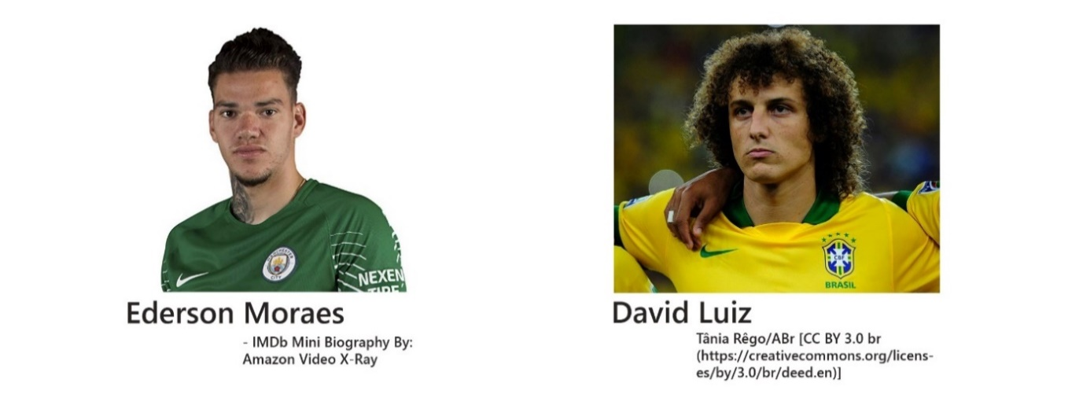David Luiz has written a children's book about faith and football and he thinks; 'Everything in life belongs to God'.  
  
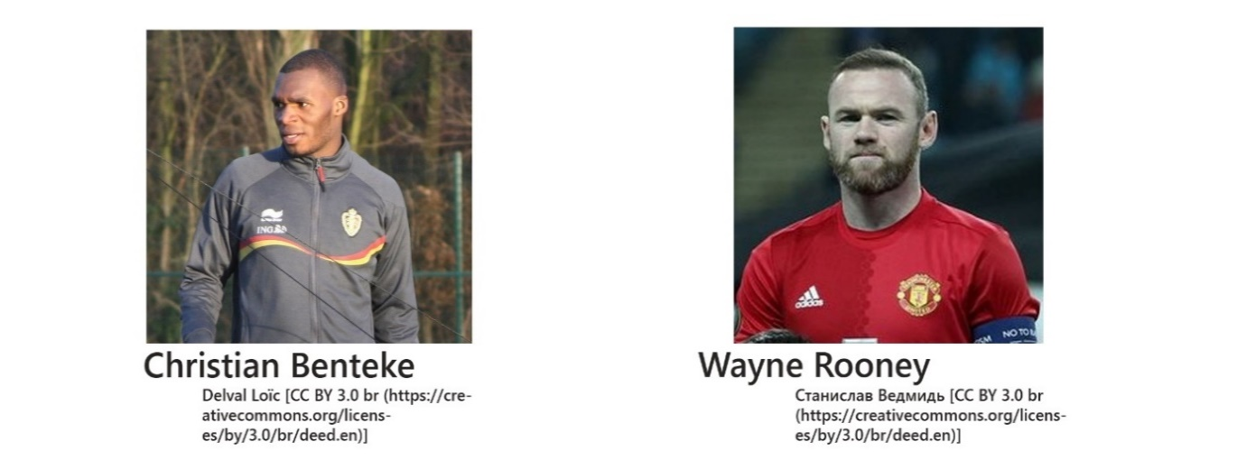It is customary for Christian Benteke (Crystal Palace) to point up after scoring. His explanation was 'I do this as a celebration because I believe in God. I am a very religious person. After scoring, the first thing I have to do is thank him. Wayne Rooney had a reputation for being wild off the field but, after becoming a father, he has calmed down, returning to his faith, and talking openly about it.

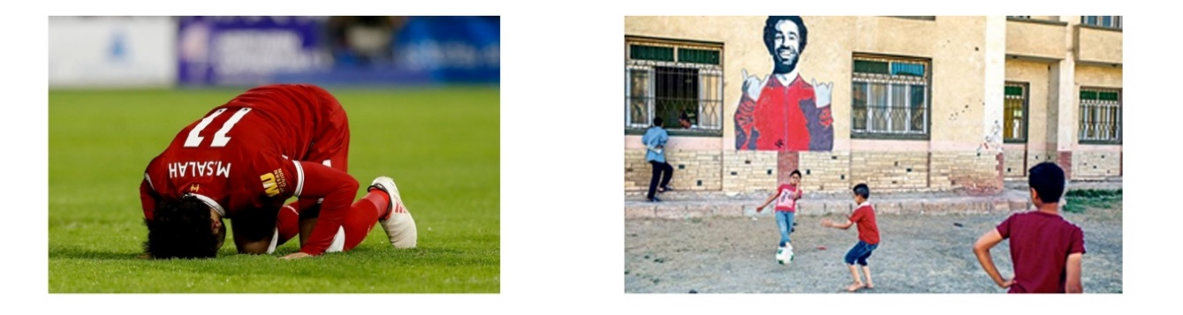

Football players can influence other aspects. Mo Salah's success after signing for Liverpool has helped fight anti-Muslim sentiment across Merseyside and North Wales, where there are many Liverpool supporters. Research showed that there was a 20% reduction in hate crime and fewer anti-Muslim comments online. Mo Salah's prominence as a Muslim player is thought to have reduced prejudice creating a more positive picture. Mo Salah prepared to show his faith on the pitch - especially when performing sujood - kneeling on the floor and praising Allah after scoring a goal. According to one commentator, 'Mo Salah's involvement with Liverpool has shown the public and Liverpool fans that a footballer, who happens to be Muslim, is a person they can relate to and admire'. Another factor that has added to the respect he is given is all the work he has done for charity. He has donated thousands of pounds to all kinds of charitable work back in his home country of Egypt.  
  
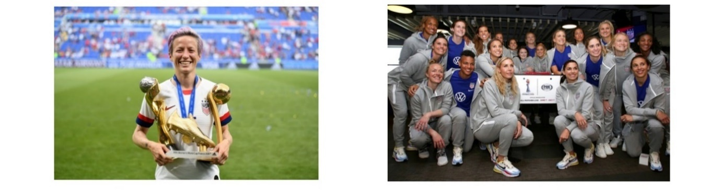

The Women's World Cup has highlighted women's place in sport recently. The BBC has been praised by many for giving these games more attention than ever before. The winning United States of America team in particular has made several stances regarding rights - notably the right to equal pay for women and men and lesbian, gay, bisexual and transgender (LGB & T) rights. Some have criticised the women of the team for turning football into a topic of debate and politics. Others have argued that Jesus contributed to the debates and rights of his day and that it is right for Christians and others to do the same. Indeed, the stance of some members like Megan Rapinoe, who was described as the 'heart and soul' of the USA squad is part of a long tradition of American athletes like Muhammad Ali and Billie Jean King who took a stand for rights. Megan Rapinoe challenged the crowd who came to congratulate the team in July, 2019, "We have to be better. We must love more. Hate less ... It's our responsibility to make this world a better place. "