

**Rugby, The Webb-Ellis Cup and Religion -**

**welcome to Japan, 2019**

One of the biggest sporting events in all four years, especially if you are a rugby fan, is this year's Rugby World Cup in Japan. Since its inception in 1987, the competition has visited many countries, including Wales, and has grown from strength to strength and twenty countries will compete in Japan for the privilege of winning the Webb-Ellis Cup. All teams have, for some time, been preparing to achieve this and Japan has been preparing to welcome the world when the competition kicks off on Friday, September 20th. Of course, rugby will be the main focus but when twenty different countries come together to a particular country, it is very interesting to notice the different culture and customs of those countries, and especially their religious affiliations.

Religion in Japan is a wonderful mix of ideas from the Shinto religion and Buddhism. Unlike religion in the West, religion in Japan is rarely preached and cannot be called teachings either. Instead, it is a moral guide, a way of life and it is very difficult to see the difference between Japanese religion and social and cultural values. Japanese religion is also a private, family affair. Religion has nothing to do with state and government. There are no religious prayers and symbols in schools and there is very little discussion of religion in everyday life. Most Japanese do not worship regularly or claim to be religious. Yet most people follow religious rituals concerning birth, marriage and death and participate in spiritual festivals (matsuri) all year long.

The Shinto religion is Japan's original religion. All living things are believed to be in nature e.g., trees, rocks, flowers, animals, including kami or gods. Shinto principles are found throughout the Japanese culture, where the nature and the passing of the seasons are considered so important. This is reflected in art such as ikebana (flower arranging) and bonsai which is the design of a Japanese garden. Yet, Buddhism is also important in Japan and the two religions co-exist happily together. To celebrate a birth or marriage or to pray for a good harvest, the Japanese turn to Shinto but funerals are Buddhist rituals`

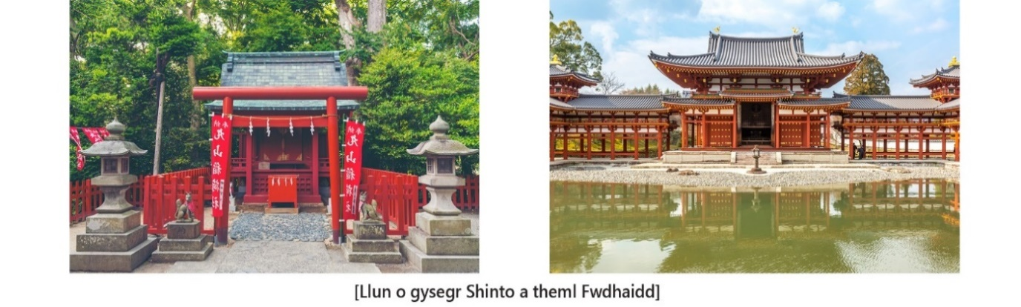

[A picture of a Shinto sanctuary and Buddhist temple]

If you were to visit Japan you would see shrines and temples, but what's the difference between them? The shrines generally belong to Shinto and the temples to Buddhism, although it is sometimes difficult to tell the difference between the two. A sanctuary usually has a huge red gate as an entrance - a Torii - and beside it is a fountain or water trough. Here you must use a spoon made from bamboo to wash your hands and mouth to purify the spirit before entering. Then, in front of the altar, you must ring the bell, throw a coin as a gift, clap three times to call on the kami and then put your hands together to pray. In a temple, your shoes must be removed before entering the building and you must kneel in front of an image before praying.  
  


[A picture of a Shimogamo sanctuary]

There is one very special Shinto sanctuary in Kyoto, Japan. It's a World Heritage site but that's not why it's so unique. The site houses a memorial stone and a small shrine, the Sawatasha, and it is the only sanctuary in the world dedicated exclusively to rugby. Why rugby? Well, in 1910 the first rugby match was played in this area of Japan between Kyoto University students and the local residents. The shrine features a Shinto bell in the shape of a rugby ball and visitors can write their wishes on pieces of wood in the form of rugby balls. The sanctuary is, therefore, very popular with young rugby players and fans who want to wish their teams good luck. The sanctuary will, therefore, be very busy during the world cup and it may be advisable for some Welsh fans to visit!!

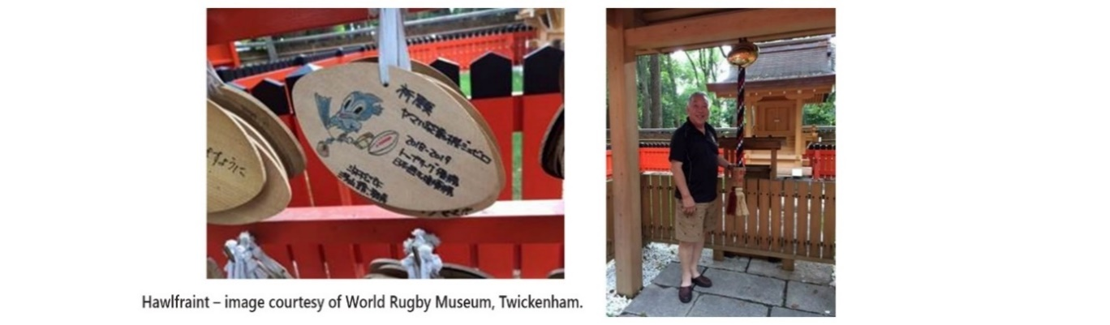

Other religions are also found in Japan and people have complete freedom to follow their own religion. And, of course, those religions will feature prominently in the rugby world cup. It is interesting to notice teams from Pacific countries - Samoa, Tonga, and Fiji. Before and after each game they gather together in a circle to pray, irrespective of whether they win or lose. Former Fiji captain, Akapusi Qera, says their faith keeps them together and makes them strong as a team. Another religious aspect featured in the world cup is the words of the national anthems. Many of them ask for God's blessing on the country - the New Zealand anthem asks God to defend the country and the South African anthem - Nkosi Sikelel to Afrika - asks God to bless Africa.

So, when the hustle and bustle of the Rugby World Cup kicks off in Japan, look out for the religious elements that will be the backdrop and part of it all. And come on Wales!!