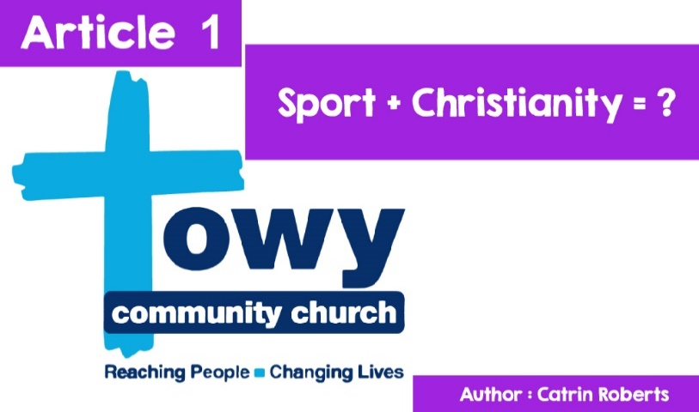

**TOWY COMMUNITY CHURCH  
New ideas?**

Helter Skelter in a Cathedral? That's a new venture!

And what about a Crazy Golf course?

That's what was seen at Norwich Cathedral and Rochester Cathedral in the summer of 2019. And these two attractions attracted a large number of people who would not have, otherwise, ventured through the door of a Cathedral.

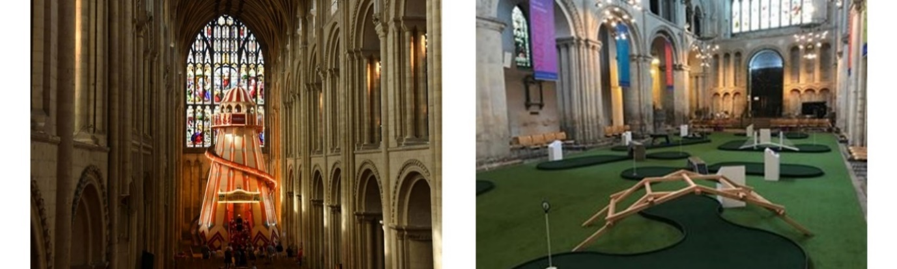

*©Reproduced courtesy of Rochester Cathedral*

So, what about a Ten Pin Bowling Centre?

**Towy Community Church, Carmarthen**, has been at the forefront of these Cathedrals in offering a Ten Pin Bowling Centre service to the area since 2013. Why would a church bother to do this? - read on and you'll find out.

**But first, a word about Towy Community Church.**

You can get a glimpse of church life on its website

([LINK: https://cy.towychurch.co.uk/](LINK:%20https://cy.towychurch.co.uk/)).

Church attendees come from all over Carmarthenshire to worship Jesus. It is interesting to note that they meet on Sundays at the Queen Elizabeth School and not at a **traditional** place of worship.



*©Queen Elizabeth School*

The meetings have a warm, welcoming, and friendly **atmosphere** and try to offer **contemporary** worship and an opportunity for people and children of all ages to come to and grow in faith. Sunday worship and praise is lively and modern, with activity for children and youth who split into groups to read the Bible and learn more.

Also, during the week, there are groups (called 'life groups') for adults. People meet in small groups in homes to read the Bible, pray and enjoy one another's company; Some will take an **Alpha** course to learn about the Christian faith. Towy Tribe is for young people from school years 7-10 (offering relaxation, playing games, creating challenges, and enjoying the company of friends from a Christian perspective). Children's activities include **Little Fishes**: ages 0-4, **Splash**: Reception - Year 2, **Xstream**: Year 3 - Year 6, **Rock Solid**: Year 7 - Year 10.

**PEOPLE**



*©This Photo by Unknown Author is licenced under CC BY-NC-ND*

Paul Griffiths is chief leader. He and his wife Caroline have been leading Towy since 2018. But they get help from many others - for example

• Nick is responsible for work for children and youths, and his wife Hazel looks after the worship leading team.

• Chris and Nicky are responsible for the church's prayer life - not just Sunday prayers.

• John and Ruth are responsible for the life groups (smaller groups of people who meet during the week to socialise and learn more about the Christian faith and to pray). They love investing in people and seeing the church in action as a community.

• Angelo and Heather visit and help the church support and meet the needs of the community.

• Wyn and Helen are missionaries, making connections with people at a local and international level.

You can see a picture and more about the leaders on the website.

How is Towy Community Church different?

The church wants to make a difference. Like other churches and chapels, the members of Towy Community Church want to present God, Jesus Christ, and the Bible to people with the help of the Holy Spirit, but also want to respond to the needs of the local community in practical, emotional, and spiritual ways through DEEDS.

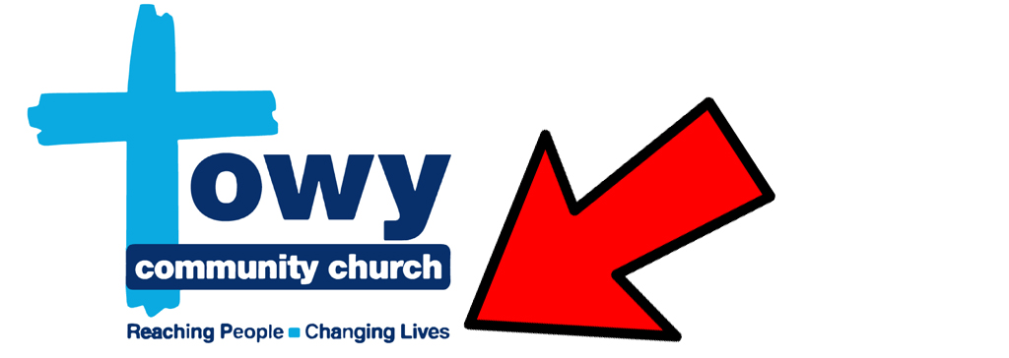

*©Towy*

Look at the 'strap line' in the logo - Towy Community Church wants to change lives, and to try to do that, in addition to their Sunday activities and in faith and prayer groups, the Church set up a project in 2013 called the Xcel Project, in collaboration with secular groups such as the Welsh Government, Carmarthenshire County Council, the European Union and others.

**What is the Xcel Project?**

The project includes



*©Towy*

The project includes a 12 lane Bowling Centre, which offers fun and a lively community setting for people to congregate. Carmarthen youngsters don't need to stand on the street and complain, "It's boring! There's nothing to do!” They can go for a game of ten-pin bowling and also have something to eat at the Xcel Cafe.

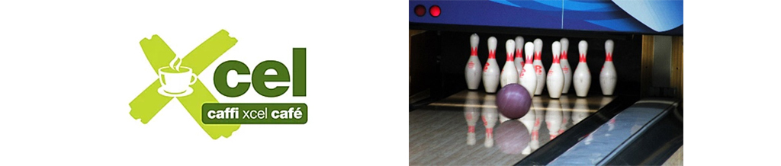

*©Towy*



All Xcel Bowling proceeds go to help locals in need.

*©Towy*

It is also the location of Carmarthen Food Bank. The Food Bank collects packs of food donated by shops and the general public to give to people / families who find themselves in difficulties, without money to buy food. People turn to the Food Bank because their wages are low, or they have lost their jobs. Sometimes their **benefits** are suspended or late. To find out more click on (LINK : https://carmarthen.foodbank.org.uk/).



*©Towy*

Xcel Furniture Recycling Centre collects, recycles, and sells second-hand furniture and white goods equipment. People in the area can get in touch to say they have unwanted furniture/ fridges/ cookers / freezers and want to donate it free of charge to the Centre.

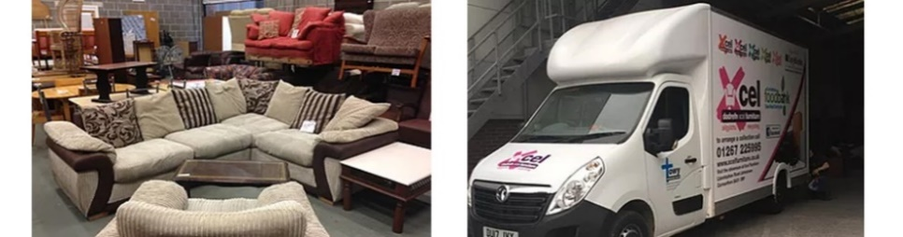

*©Towy*

All proceeds go towards the work of the Xcel Project. And furniture is given free of charge to local people in crisis.

*©Towy*

Xcel Community Store collects Clothing, Toys, Bric-a-Brac, DVDs, and CDs. This is another example of collecting, recycling, and selling using the profits to help others. As the website says, "***The community shop is a vibrant, diverse place, which always offers surprises. If you need a toy for 10p, several cups of tea for a wedding, or a new outfit, this is the place for you.”***

**Impact of this Activity**

What impact is the Towy Community Church and the project having in the area?

• Many new people have come into contact with the Christian faith. Many have come to believe in God and are worshipping and reading their Bible regularly.

• It has a positive impact on hundreds of lives on a daily and weekly basis by providing support to those facing difficult circumstances. In conjunction with various agencies and services, food parcels, furniture, clothing, and other essentials are offered to people in need.

• It has led to job creation, but also enabled the local community to volunteer with projects that provide practical and social support to other people.

• Recycling clothes, furniture and other items also helps to look after our environment and avoids unnecessary waste.

**Helping people and helping the world!**

*©Ingimage*

**A vision that has grown and grown**

Realising the vision has taken time and hard work for this community of Christians in and around Carmarthen. Click on

[LINK: https://www.xcelprojectcymru.co.uk/cartref](LINK:%20https://www.xcelprojectcymru.co.uk/cartref)).

to see video clips showing the development of the work from the beginning.

Hard work - yes, but work that, in the opinion of the worshippers of Towy Community Church, serves God and the local community.