

**SIKHISM IN WALES**

Sikhism is the youngest of the major world religions and it is only recently, during the last century, that Sikhs began to settle in the British Isles, from the Punjab in Northern India. Although some came at the beginning of the century, many came in the interwar period. They usually arrived at ports such as Bristol, Manchester, Portsmouth, or Cardiff and rented rooms. They, then, bought items such as floor brushes, wipes (cleaning), shoe laces and knives and forks and sold them door-to-door. Other Sikhs worked in open air markets. They did not intend to stay permanently, and their families were still living in the Punjab. When they had made enough money to secure a better life, they returned home to their families.

The big move to Britain in the late 50s of the last century came mainly to industrial areas, like West Yorkshire, the East and West Midlands and parts of London for economic reasons - there were plenty of jobs available. This time the majority decided to stay permanently and send for their families to join them.

The arrival of Sikhism in Wales is, therefore, quite recent, and according to the 2011 census there were 2,962 Sikhs in Wales, representing 0.1% of the population.

In September 2019, there was a great celebration among the Sikh community in Cardiff. The celebration was called Nagar Kirtan and lasted three days. There were two reasons for the celebration - remembering that it was 550 years since Guru Nanak, the founder of Sikhism, was born and that it was 65 years since Sikhs first met in Cardiff and that Gurdwara Sri Dasmais Singh Sabha was 30 this year. Hundreds of people attended the celebrations and took part in the procession through the city, ending in Cardiff castle followed by a huge community meal to which everyone contributed.

[A picture of the celebrations]

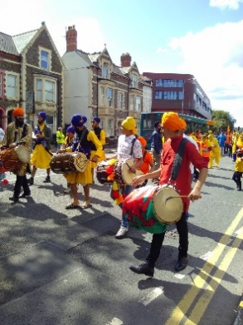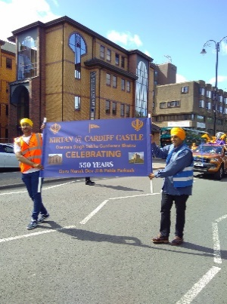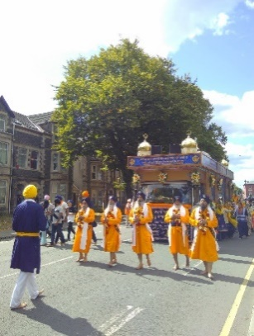

©Becca Falvey from Keep Riverside Tidy

The community used to meet in a temporary temple before moving to a purpose-built one on Ninian Road, Cardiff. This is the first gurdwara in Wales and the third in Britain. Then, 30 years ago, it moved to its current position on Tudor Street. One of the first Sikhs to move to Wales from Kenya in 1949 was Balwant Singh Bhogal who came to study Engineering at Cardiff University. He remembers the warm welcome he received and, although after graduating, he moved to places like Canada, London, and Kenya, in 1974 he returned to live in Cardiff. 'This is my home' he said.

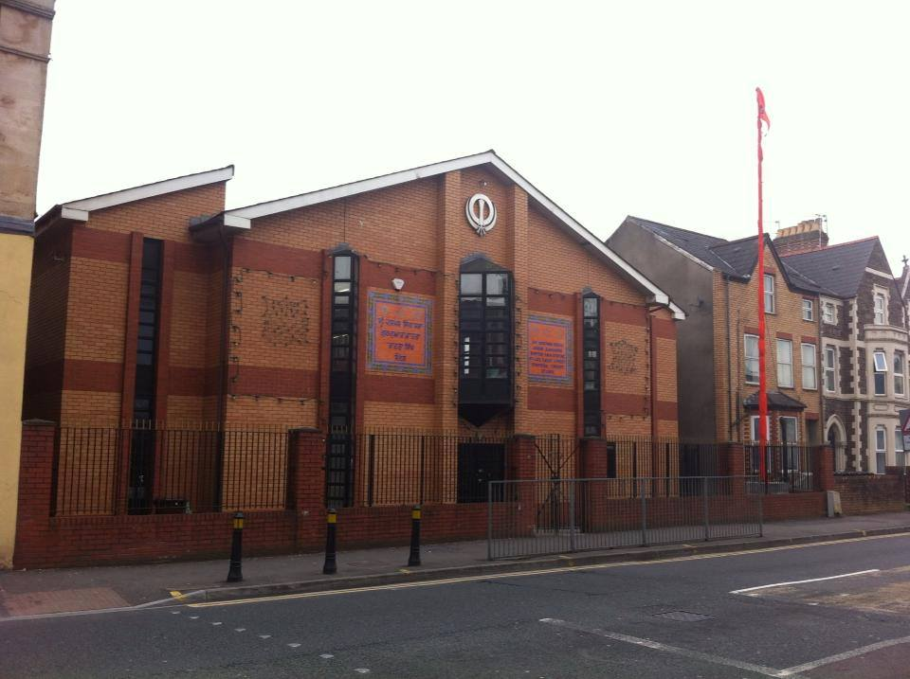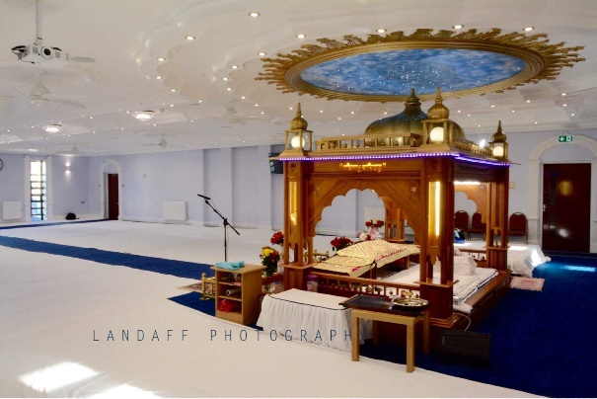

©David Singh Swali

[A picture of the Gurdwara, Ninian Park Cardiff]

Hardev Kaur is another from the Cardiff Sikh community who works as a teaching assistant and is one of the first Sikh women to work in the city. She said, 'My very first day was scary, thinking what everyone would think of me but, after that, many Sikh women have followed in my footsteps and found jobs in many places that have given them the confidence to go out and do what I did as a young Sikh. But she also says it wasn't all easy as she grew up. 'There was some racism' she said, but then adds, 'you won't see that today, they are more aware of other people's culture. We all have different religions, but we are all the same. And that's one thing I've seen that has changed over the years. The children have been educated.'

Joga Singh president of the gurdwara echoes what Hardev Kaur says - 'We have been part of the fabric of this area, since the' 50s. What has helped is that many members of the community have grown up with the wider community and gone to local schools. We've all grown up together. Growing up in such a multicultural society no one sees anyone else as different. I think Cardiff is great and I was born and raised here. Everyone is aware of the differences; there is a very vibrant Sikh community that, in my opinion, is open and mixing with the wider communities. There have been many interactions that have helped us to be one with one another, and to move on, understand and respect each other's religions and cultures. We have been able to be ourselves, by that, I mean our physical identity. I feel comfortable walking around the city as a Welsh Sikh, with my turban and beard and knowing that no one is looking at me and thinking 'oh, that's unusual.' I think, as Sikhs in Wales, we are very stable and feel part of the fabric of the community. Our Welsh culture and religious stance really intertwine, we are one. I think it's great. When the Six Nations competition comes, we all know who we're supporting. "

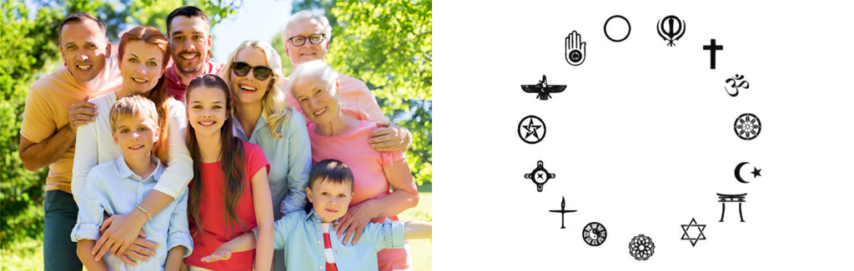

[Picture of a multi-faith community / symbol]

Suki who is originally from Singapore and now lives in Cardiff is the same - "The best thing about Cardiff, especially compared to London, is that it's a small and familiar city. I've worked in the city centre for 35 years now and I've seen the city grow. All the restaurants and shoppers, we've all worked together, so this is like my neighbourhood. I have regular customers who come by every day to say hello. When I go to London now, they call me Taffy. I feel like a Welshman now. Welsh Sikh, that's what I would call myself."

Another prominent member of the Sikh community in Wales is Neeta Baicher who represents them on a number of local and national bodies. Neeta works independently as a social worker and serves as a Justice of the Peace, Community Councillor, Vice Chair of Newport SACRE Council, and former chair of Monmouth SACRE. As a Sikh, she believes in living in harmony with non-Sikhs and all members of the community. She believes in being a responsible and active member of the community by following the teachings of the Ten Guru. The Sikh's contribution to the community is based on three principles - Kirat Karo - work hard on whatever tasks you conduct and make an honest living. Vand Chhako - sharing wealth and talents with others and Nam Japo - reflecting on God both internally and externally through recitation, chanting and singing. The community, through the Gurdwara and the increasing use of social media. are also helping Sikhs to maintain and practice their faith here in Wales. Neeta believes that following the message of the second Guru, Guru Angad Dev is very important - getting rid of self-deception and achieving service to humanity. That's the way to achieve an honour. Neeta's message to the young people of Wales would be a message from Guru Granth Sahib - Before becoming a Muslim, Sikh, Hindu or Christian, let's first become human.