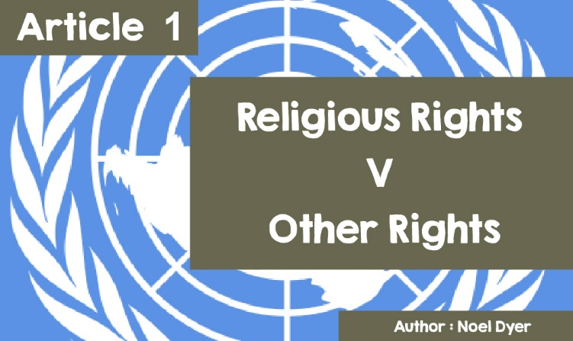

**Human Rights - Religious Rights v Other Rights**

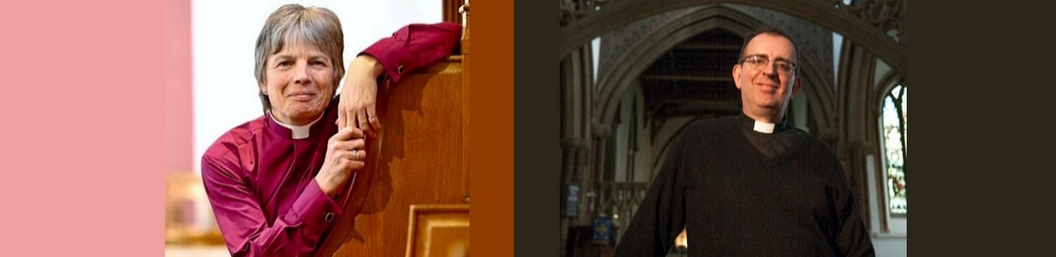

*©Church in Wales      &       NMP Live* [*https://www.nmplive.co.uk/*](https://www.nmplive.co.uk/)

What do these two have in common? Their costume shows that they are church leaders! They are also open about being gay and in (or have been in) a relationship with a same-sex partner. On the left is Cherry Vann, the new **bishop** of Monmouth and on the right is Richard Cole, **vicar** of England and a bit of a celeb. Richard Cole is a member of the group, *The Communards*, a radio presenter and took part in the Strictly Come Dancing competition in 2017!

The **United Nations** Convention on Human Rights covers all kinds of rights that people all over the world should enjoy in every country. Article 18 pays particular attention to freedom of thought, conscience, and religion.



*'Everyone has the right to freedom of thought, conscience and religion; this includes freedom for them to change their religion or belief, and also freedom, either alone or with others, publicly or privately, to manifest their religion or belief through teaching, practice, worship and ritual observance'.*

At first glance, this may seem simple and acceptable in this day and age - but what happens when a religious right contravenes other fundamental rights? This has led Deborah Orr of the Guardian newspaper to say, *'For human rights to flourish, religious rights must come second'*. She argues that, over recent years, people's attitudes towards racism, women and gay people have changed dramatically, asking whether religion can be a barrier to this. She refers to Russia introducing laws against gays, some Arab countries denying women the right to drive cars etc, ethnic cleansing in many countries - with these happening partly on religious grounds!

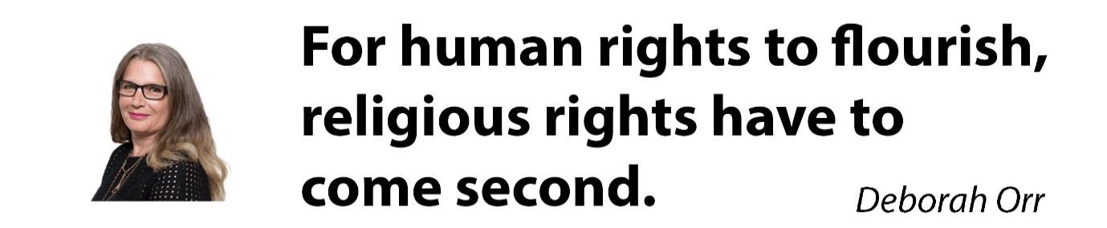

**Here are a few stories that have arisen over the last few years:**

There have been several instances when the occupant of a Bed and Breakfast at their home refused a gay couple a double room. The owners of the Bed and Breakfast in Cookham, Berkshire said they made the decision based on their Christian faith and the words of the Bible. In March 2010, the owners refused to let Michael Black and John Morgan stay in a double-bedded room. The couple, who was refused a place, were assisted by the Liberty movement. They argued that it was against the law to refuse service to someone on the grounds of sexual orientation. The court accepted Liberty's argument and the owners of the accommodation had to pay a £3,500 fine. According to the owner 'I am not homophobic… but I felt it would be wrong here. I wanted to support marriage, saying 'No, not here'. The result [in the court case] reflects the human rights of both men, but they are against our human rights! '



In **2008**, a registrar named Lillian Ladele in Islington, London was in danger of being disciplined and even dismissed for not conducting a civil partnership ceremony between two men as part of her job. She refused on the basis of her Christian faith. She argued that she had been treated unfairly by the employing council and won her case. She said, 'This is a victory for religious freedom… gay rights should not be an excuse for bullying people because of their religious beliefs'.



By 2013 things had changed. Lillian Ladele had now resigned due to the pressure. She lost her argument in court as Stonewall's organisation claimed, 'Public bodies have a duty to treat everyone equally and there is no right to refuse service to anyone'. This may reflect a change in the attitude of society as the influence of religion diminishes.

**The Israel Folau Affair.**

One story that came to the world’s attention was the comments of the Australian international rugby player, Israel Folau. He is an **Evangelical Christian** with strong beliefs. In April 2018, one of his followers on Instagram asked him what he thought would happen to gay people according to God's plans.

His answer was 'Hell, unless they repent of their sins and turn to God'. When questioned further, he refused to withdraw his words and added 'I stand firm on what I believe, it is something personal to me. It comes from the bottom of my heart. It does not interfere with my rugby or the players around me'.



He lost the support of the sponsor of the Wallabies team and after a period of contention, lost his place as a professional rugby player. As a result, Israel Folau brought court action against them on the grounds that terminating their agreement was a case of religious discrimination. The two sides reached an agreement and paid a large sum of money to Israel Folau.

He said he did not want to see any people being treated unfairly and had nothing personal against gays. On the other hand, he argued that he was entitled to his personal opinion. He is now playing for a new team and has resumed his successful career.

That has not stopped him from creating further commotion. He recently mentioned the severe fires in Australia. He referred to the legalisation of abortion in Australia and the right granted to same-sex marriages there. He suggested that the severe fires in Australia were God's punishment on the country for these changes and quoted from the Bible to strengthen his remarks.

Pictured below is a poster that Israel Folau shared on the social media site Instagram, with the words from the Bible.



**Nigel Owens’ Response.**

One Welshman who responded to Israel Folau's comments is international rugby player and referee, Nigel Owens. Nigel Owens announced that he was gay in 2009 - very few rugby players had done so before. He said he agreed with Australian Rugby sacking Israel Folau. In his view, this sent a clear message that there are consequences of expressing beliefs that really hurt and are not acceptable in today's society.

Rugby is inclusive for everyone, which means it's open to me. He explained that he respected other religions and asked everyone to respect other lifestyles. He added that comments similar to those of Israel Folau could lead some young people to despair and could seriously damage their self-confidence and mental health. People can choose their religion and the way they live, but people can't choose their sexuality.

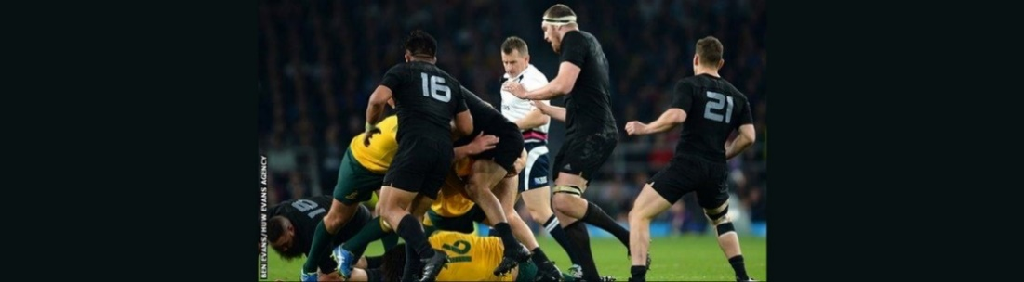

*Nigel Owens refereeing the Australian team, including Israel Folau, and the New Zealand team in 2015.*