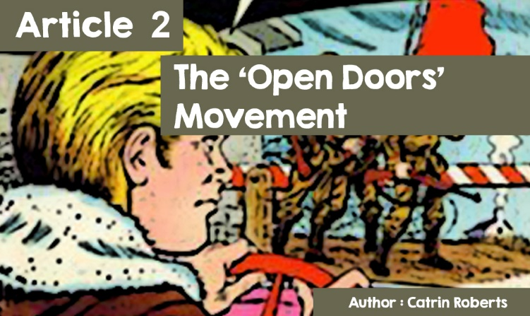

**HUMAN RIGHTS - THE RIGHT TO BELIEVE**

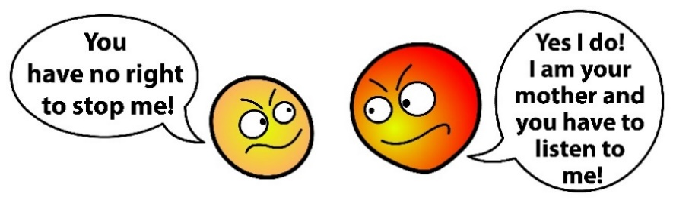

Familiar words?

Sometimes there are arguments in a family about a teenager's right to do something.

**Who's to say what rights people have?**



*©https://wiki.tfes.org/images/d/d1/United_Nations_emblem_blue_white.svg*

In 1948, the United Nations made a statement describing the fundamental rights that every person in the world should have. (<https://www.amnesty.org.uk/files/universal_declaration_of_human_rights_welsh_0.pdf>)



The statement contains 30 articles e.g. the right to food and education, but also the rights of faith and religion. Article 18 specifically addresses freedom of thought, conscience and religion.

*'Everyone has the right to freedom of thought, conscience and religion; this includes freedom for them to change their religion or belief, and also freedom, either alone or with others, publicly or privately, to manifest their religion or belief through teaching, practice, worship and ritual observance'.*

In many countries of the world, the right to exercise your choice of religion does not exist, and individuals suffer cruel persecution. This has been the case for Jews for centuries, and we recently heard of the persecution of Muslims in China and **Rohingya** Muslims in Myanmar.

Another religion that is suffering great **persecution** is Christianity, and the **Open Doors** Christian movement works to secure the rights of people of faith and support those who are persecuted. Open Doors has previously delivered food to Rohingya people living in a temporary refugee camp in Bangladesh. They focus particularly on Christians. One of the possible motivations of Open Doors members is Bible teaching and this is clearly reflected in the movement's slogans; *'If one part suffers with it'* and *‘we dream of a world in which every Christian who is persecuted is remembered and supported by other Christians.'*

All over the world, Christians suffer in violation of article 18 of the UN Declaration, and also of articles 5, 9 and 20.

**Article 5 addresses punishment and cruelty, *No one shall be subjected to torture or to cruel, inhuman or degrading treatment or punishment.*' Article 9 deals with the *cruelty of theft and slavery, ‘No one shall be subjected to arbitrary arrest, detention, or exile...*' Article 20 is directed at the freedom of peaceful assembly, '*Everyone has the right to freedom of peaceful assembly and association. No one may be compelled to belong to an association.'***

**THE BEGINNING OF OPEN DOORS**

In 1955, a young Dutch man, Brother Andrew, realised that Christians in some countries could not read the Bible because it was illegal and Christian churches were subject to persecution. He began smuggling Bibles into Eastern European countries. Read the story in his book, God’s Smuggler. Exciting!!



*This Photo by Unknown Author is licensed under CC BY-NC-ND*

The work grew in the 1970s and spread to the **USSR**, Africa, Asia, South America, and China. Bible smugglers faced punishment or imprisonment if caught! The work then spread to predominantly Muslim countries. The task was not just to provide Bibles, but to help Christians who had been imprisoned because of their faith. Supporters were arranged to write to prisoners in order to raise their spirits;

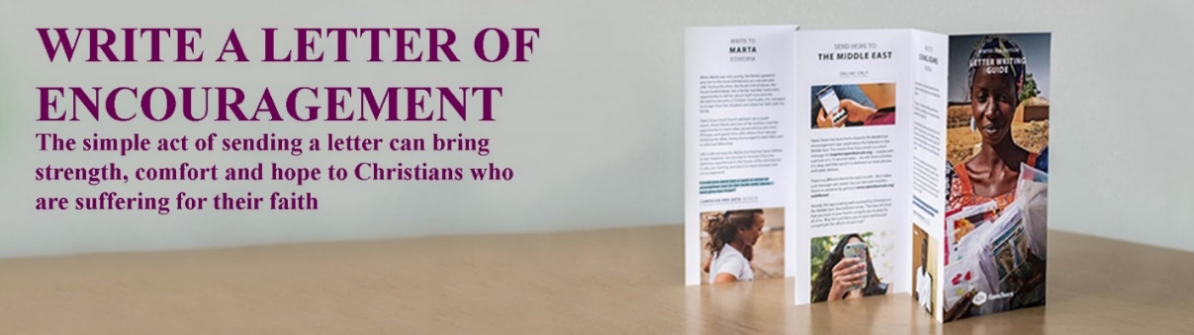

campaign for their release; providing reading teaching classes so that people can read the Bible; and training leaders for churches.



*This Photo by Unknown Author is licensed under CC BY-NC-ND*

In the late 90's, Open Doors began intensive **advocacy** work - speaking on behalf of the people whose countries denied them the UN Human Rights 18, 2 and 9 rights. And most of all, praying for people who suffer persecution because of their faith. A Prayer Diary is being sent out to encourage people to pray. 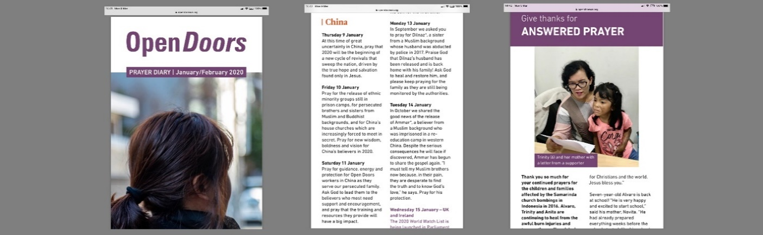

**Open Doors** has been working diligently over the years to speak up, draw attention, campaign, put pressure on governments, provide resources to educate people. A very important part of the recent work was the **Hope for the Middle East** campaign where a petition of 800,000 signatures was presented to the United Nations and world governments, on behalf of Iraqi and Syrian Christians and other faith minorities there.

If you want to read the history of presenting the petition, go to <https://www.opendoorsuk.org/news/stories/middle-east-171213/>

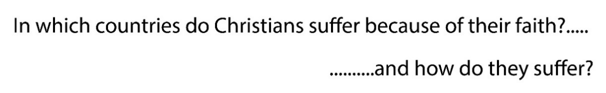



Each year Open Doors produces a List – ***The*** ***World Watch List***.



It lists the 50 worst countries for persecuting Christians and the 2020 report ranks North Korea, Afghanistan, Somalia, Lybia and Pakistan as the top 5 worst countries for persecuting Christians. Visit the website and learn more about what's happening in the countries.

<https://worldwatch.opendoorsuk.org/persecution/world-watch-list/?_ga=2.192946669.1748801372.1581942659-1033732111.1581330968>

Why not watch a video about the top 5 countries on the list?

North Korea

Afghanistan

Somalia

Libya

Pakistan

<https://www.opendoorsuk.org/news/stories/world-watch-list-2020/>

How are Christians persecuted?

* Being imprisoned without trial or based on lies
* Being sent to a labour camp
* Being physically hurt
* Disappear and nobody knows what has happened to you
* Being thrown out of the home / family
* Being separated from your children / parents
* Loss of work
* Even being killed

You can learn about the experience of a young person like you by clicking on

<https://opendoorsyouth.org/news/laos-threats-just-weeks-after-becoming-a-christian/>

The Open Doors movement proposes that Christians pray for the Christians of Vietnam and those who persecute them, but also to convert to Christianity.

What is Open Doors' attitude to believers of other religions?

*‘I pray for those that are persecuting Loe and his friends and family. I ask that that they will encounter You in an incredible way and they will have a change of heart, coming to know You and Your truth. Amen.’*

**UK and Welsh Government’s response**

Well-known journalist Deborah Orr said, *"For human rights to flourish, religious rights have to come second".* But not everyone agrees. In 2019 a new post, *Special Envoy for the Freedom of Religion or Belief* was created by then Prime Minister, Theresa May. This is what Rehman Chishli said, who took office, after he and other members of parliament heard evidence from Open Doors.

*‘It is also disheartening to learn from Open Doors' report that the number of Christians living in countries where they are at risk of high to extreme levels of persecution has increased to 260 million people. [...] This is an alarming trend [...] Tackling religious intolerance and persecution is a key foreign policy and development policy challenge, because where freedom of religion or belief is under attack, other human rights are threatened too. Societies that aim to protect and promote freedom of religion or belief are more stable, are more prosperous and likely to be more resilient against violent extremism.’*



And at the Welsh Senedd, at a meeting to introduce the *Hope to the Middle East* campaign, Assembly Members and representatives from the **Yazidi**, Muslim and Jewish faith communities, church leaders and people from the Welsh Iraqi community got together - because they believe what is being said in the UN Declaration of Human Rights.

**Open Doors worker in Wales**

Many in Wales support the work of Open Doors by campaigning and negotiating with politicians. Others write letters to persecuted Christians. Capel y Nant, Swansea, runs Amnesty International sessions as part of the Contemporary Meetings and writes letters to support victims of injustice and cruelty around the world. Chapels and churches are asking their members to pray for those who are persecuted because of their religion. Jim Stewart has recently started working for Open Doors as the Church Relations Manager for Wales. Prior to that, he worked for many years in public affairs for a Christian umbrella organization - the Evangelical Alliance of Wales, as well as for the BBC and other charities. "*I'm very proud to work for Open Doors" said Jim "Their emphasis on supporting the persecuted church is one that I hold dear, and it is a great privilege to promote their work in Wales."*

***Thanks to Open Doors for permission to use their website content in this article. If you want to learn more, visit*** [**www.opendoorsyouth.org**](http://www.opendoorsyouth.org/) **or you can follow @opendoorsyouthuk on Instagram****.**