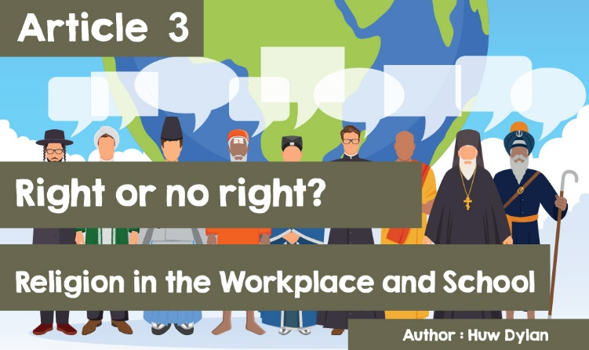

**A right or no right? - Religion in the Workplace and School**

Sometimes, being a member of a religious tradition, and what that means, can be in conflict with what someone is doing where they work or at school. So, what exactly are the rights of people of different religions? Unfortunately, as with many legal issues, the answer is not always clear.

The Equality Act 2010 makes it unlawful to discriminate against or treat someone unfairly because of their religion. This can include name calling and religious abuse, dismissing job applications because of the applicant’s religion, refusing to let employees follow their religion, unfair dismissal, prevent somebody from getting a better job because of their beliefs or refusing to allow people to wear a sacred item.



In the workplace there are three main areas where discrimination can occur: in employment, having time off work to celebrate religious festivals or having a time and place to pray, and food and dress practices.

When it comes to employment, discrimination could mean giving someone a job or not on the basis of their religion e.g. not consider a person for a job at a faith school because the person's religion is different from the faith of the school. At an interview, an employer should explain exactly what the duties of the job are to make sure there are no misunderstandings.

There are some jobs where an employee may ask not to do certain things because of their religion or belief e.g. handling meat or alcohol. However, the employer does not have to grant their request if there are good business reasons, such that it would seriously disrupt the business or put too much extra work on other staff for refusing the request. Celestina Mba - a Christian care worker claimed she was forced to leave her job after refusing to work on Sundays because of her faith. Her legal appeal was lost, and more about the case can be read here: <https://www.bbc.co.uk/news/uk-england-london-25229807>.

When it comes to having time off for religious holidays, time for prayer and where to pray, there is no automatic right to these things. Yet, the employer must listen and consider all requests carefully and reasonably as refusing the request without good business reason could be seen as discrimination e.g. a group of Christian workers are asking their employer for permission to use an empty room in their own time to pray.

The employer rejects the request without giving any explanation. This could be seen as discrimination especially as the company provides other facilities for staff including a games room and exercise room.

In another case at a small data processing company in South Wales, David is asking to be allowed to finish work early on Friday afternoons in the autumn and winter so that he can be home before sunset - a requirement of his religion - Judaism.

He is willing to work extra hours during the week instead of the time lost. If the company insists that he has to wait until the usual 5 o'clock finish time, they would have to give a clear business reason.

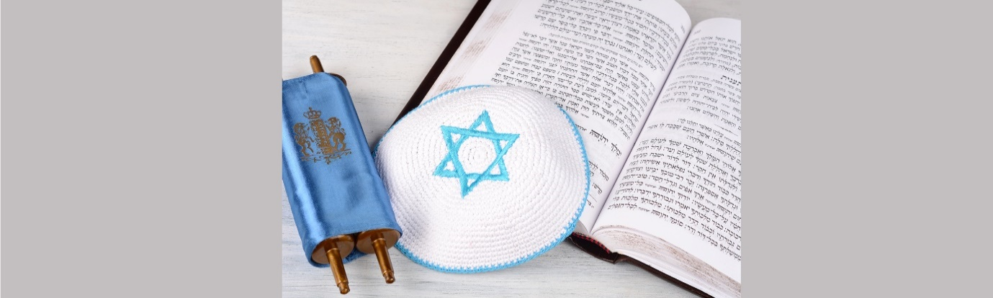







In terms of dress practices, if an employer has rules about appearance and what to wear, these should be based on business reasons and should be explained to staff. There are a number of reasons why an employer may have dress rules - conveying the image of the company, ensuring customers can identify staff and health and safety reasons.

If an employer has dress rules, they should have discussed them with their staff and the Trade Unions, so that they have an opportunity to submit ideas. The employer should also consider that some people are not prepared to wear certain items of clothing or want to wear special clothing because of their religion. In a job interview candidate Tawfiqa was asked if she had any questions.

She asked for dress rules and was told the staff uniform was a skirt, jacket and blouse. She asked, if she got the job, if she could wear trousers instead of the skirt because she had to cover her legs as part of her Muslim beliefs. The employer agreed because it was a reasonable request. Refusing her request could be considered discriminatory.



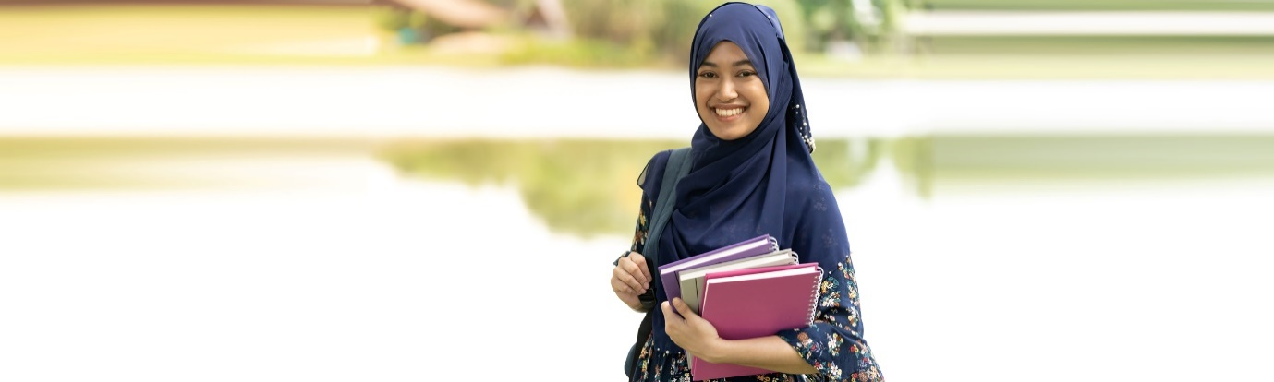

Religions may have requirements as to what food is allowed but an employer does not have to provide for them or provide facilities other than a clean seating area. Some religious people fast as part of their religion e.g. Muslims during Ramadan but, again, no employer is obliged to make any provision for them.

However, any responsible employer would liaise with their employees to avoid any situation that might be perceived as discrimination. Mo Salah and Sadio Mané were fasting in the Ramadan period of 2019 ahead of the Champions League final. The manager was very supportive of both and said, "There is no problem with my players, I respect their religion, they were always wonderful and they offered the best whether they were fasting or not".

The situation in a school is different of course but school pupils have many rights in terms of their religion. The Welsh Government was the first country to incorporate the 2011 Children's Rights Convention. Education Wales defends Declaration 14 of the 2011 Children's Rights Convention i.e. your right to follow your own religion. They have the right to talk about their religious beliefs, to pray, to read their Holy Books and to invite their classmates to join them in these activities, as long as they do so voluntarily.

Another right for pupils is to express their religious point of view in a classroom discussion or as part of a task, as long as what they say is relevant to the topic in question. They can also take part in religious clubs and have access to school facilities and resources. However, these clubs need to be started and led by pupils and also have the support of the school. They also have the right to invite outside speakers to the religious club activities, but the permission of the school must be obtained. Pupils can also pray alone or in groups in their own time, as long as it does not interfere in any way with school life. Some schools provide a 'prayer room' for their pupils.

Perhaps the most controversial right and the one that has received the most media attention is the one about religious dress. Again, there is no specific answer and it depends on each individual school’s uniform policy and how crucial these uniforms are to the religion in question e.g. members of the Sikh religion banned for wearing the kara and kirpan. In the past there have been conflicts between religious rights and the rules of school uniform / PE uniform, but the Welsh Government is now committed to defending the 2011 Children's Rights Convention by ensuring that schools consider the statements.

Government is also encouraging schools in planning for the new curriculum to learn about human rights, through human rights and for human rights. By making religion of values ​​and ethics an obligatory element of the new curriculum, the Welsh government is demonstrating that it respects the rights of individuals.