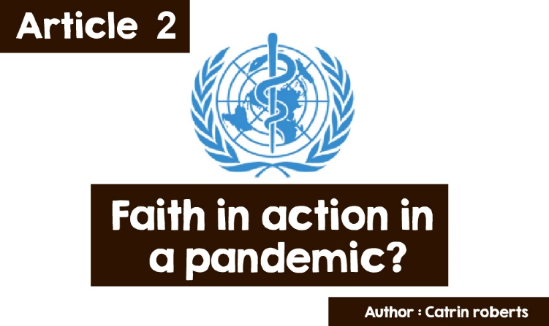

**Faith in action in a pandemic?**



If you have been following news bulletins over the course of the coronavirus pandemic, you will have seen the logo, above, as representatives of the UN medical department deliver reports and advice to countries around the world. The logo displays the United Nations logo, with a pole and a snake circling it in the middle. The British Medical Association also uses a similar logo.

This is an image that comes from ancient Greek mythology. The god Asclepius was considered the god of medicine, with the ability to restore health and bring people to life. Snakes played a part in his treatments.

And there is a reference to a stick and a snake in the Old Testament of the Christian Bible as well - in the book of Numeri chapter 21, in which the Jewish nation, led by Moses, travels to a new country. 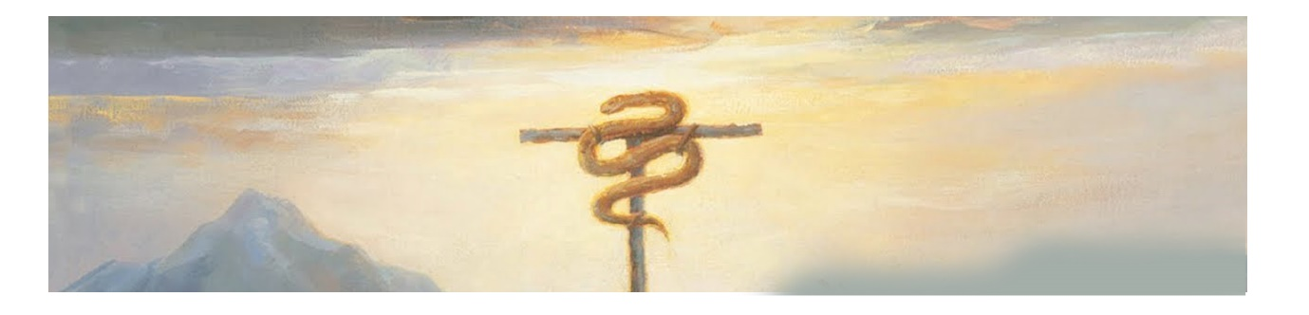

A flock of snakes comes to bite and kill them. Moses commands God, "Make a snake and put it up on a pole; anyone who is bitten can look at it and live.”

So, the connection between religion, God / gods, faith and disease, restoration, and medicine goes back a long way in history.

But what about today?

Has religion / faith played its part during the coronavirus?

Two people who have been on the 'frontline' during the coronavirus are Rev Dr Sangkhuma and Dr Owain Edwards.

Reverend Dr Sanghkuma Hmar



Raised in Mizoram, Northeast India, Sanghkuma had a simple upbringing, the son of farmers who cut down bamboo trees to plant rice, vegetables, and maize - without the aid of machinery.

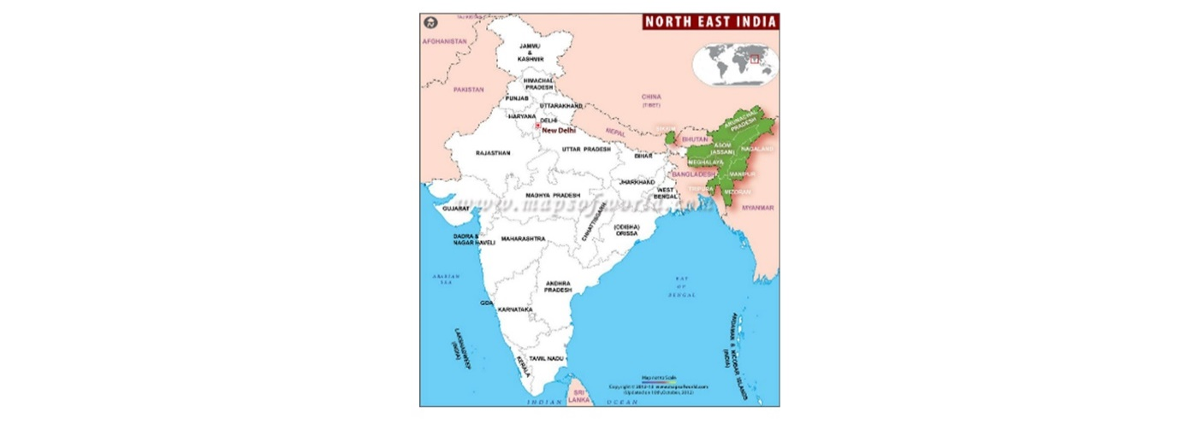

The Mizos were an animated tribe but when the missionaries of the Presbyterian Church of Wales came there about 200 years ago, the population converted to Christianity. 96% of the people are now Christians. The missionaries wrote down the Mizo language for the first time, creating a science, establishing schools, colleges, and hospitals.

Sangkhuma felt the call to serve as a minister, first in rural churches in Mizoram and then, as a missionary in Nepal and Bhutan.

He came to Wales as a Mission Enabler to help Welsh churches with their work. He was also a pastor of 5 churches in the Bridgend area and worked with other missionaries in South Wales. He served as a chaplain in 4 care homes in the Maesteg area - an excellent preparation for his current work as a part-time chaplain during the coronavirus pandemic.

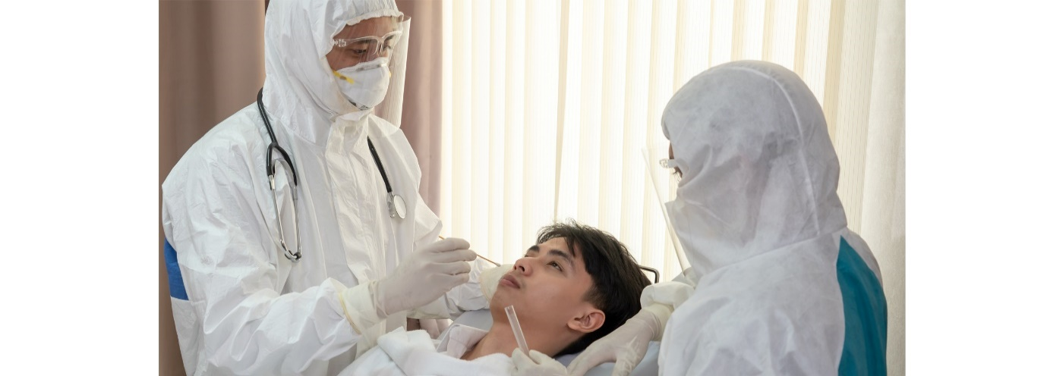

Sangkhuma said, "*As a chaplain, I provide pastoral and spiritual care to end-of-life patients, and I counsel the families of the dying."* He has continued to work with patients and the bereaved throughout the period of Covid-19, on the wards caring for those suffering from the infection. Challenging work - before starting on these wards, special training was required to learn the correct way to wear PPE (personal protection equipment) over the collar he wears as a minister.

He was at personal risk, but he says he doesn’t think about it - this is what Christians are supposed to do - help, support, listen and be with people on the journey of life. *"Seeing patients go through this suffering is heartbreaking and painful. They haven't seen their families for weeks and feel lonely and isolated. Families at home are waiting for news from the hospital and feel powerless. Staff deal with very difficult and challenging situations.*

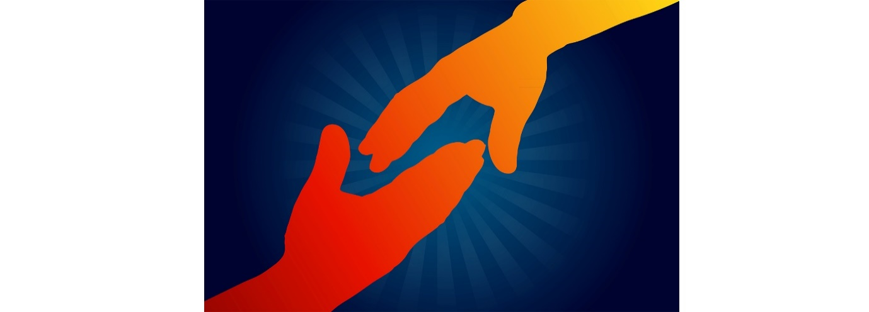

*As a chaplain, I support patients and staff and give them the opportunity to share their fears and concerns. I also help staff deal with the emotional challenge of caring for dying people, ready to listen to them describe their work day or talk about the personal side of their life. Sometimes medical professionals think that they have to appear strong, but it is difficult for them to wait to see what the fate of the most serious patients will be.”*

It is not only Christians who receive Sangkhuma's help. He also goes to people of different faiths and religions; BAME people (black and Asian and ethnic minorities) and to people of no faith, but who need somebody to listen to them.

Sangkhuma appreciates the fact that people are praying for him and the other chaplains and their work in Chirk, Llandough, Neath Port Talbot and Morriston hospitals.

**Dr Owain Edwards**



A General Practitioner (GP) since 1998, Dr Owain has served in Whitechapel, London, Penrhyndeudraeth and now in the Bala area, but combines being a doctor with the joint management of Coleg y Bala (Children’s Work Centre and Youth Presbyterian Church of Wales) with his wife, Siân.

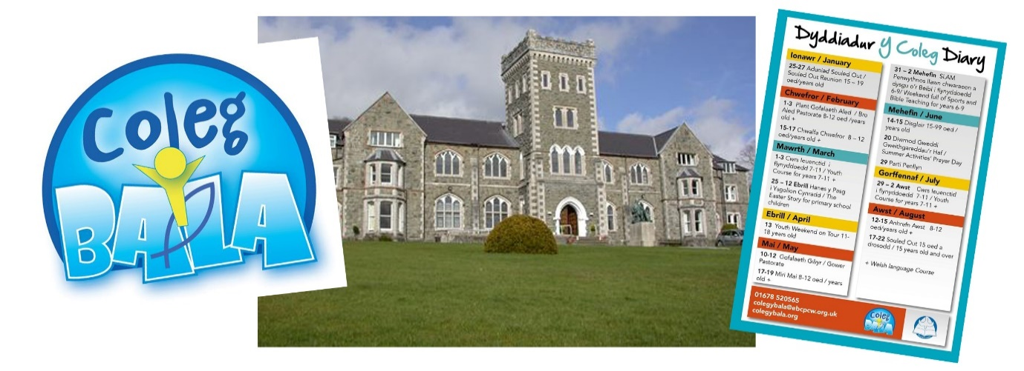

The work of the centre had to be *stopped* because of the pandemic, but Dr Owain has been very busy looking after the College and carrying out his work as a doctor.

Dr Owain says,

*"We prevented the few outbreaks in care homes from spreading to the community, but the virus has had an impact on the community and the practice. Interviews had to be conducted over the phone, which means there is no opportunity to see a patient walk into the consulting room, something which teaches the doctor a lot. The surgery had to be modified to protect staff and patients. Unfortunately, due to fear, some people stopped coming to the doctor with their problems, causing the problems to get worse, such as burst appendix, foot infection leading to toe amputation.*

*The need for isolation has been a problem, with an increase in mental health disorders.*

**

*The pressure of work on us as doctors increased. The solution to each case is not always clear to a doctor and a lot of thinking is required to make the most of these difficult circumstances. In addition, there is the need to look out for Covid-19 symptoms and protect ourselves and others from infection.”*

**And the link between faith and his work as a doctor?**

Owain was brought up in a Christian household, but at the age of 9 in 1979, at a Christian meeting in Liverpool, Dr Owain realised that Jesus loved him personally to such an extent that he died on a cross for him. Knowing Jesus was not just for his parents and others, but for him, Owain. Since then, he has come to know Jesus better and his faith is the centre of his life.



As a doctor, knowing that God is *'in charge'* gives him strength and helps him deal with work pressure, because diagnosis is not always clear. A doctor is also aware of his responsibility to do everything possible for his patients, which can lead to anxiety. But giving a short, silent prayer asking God to help him care for and show God's love for a patient will reassure him. He also prays when fatigue strikes, and pressure to complete his work when time is short. He prays for wisdom and the ability to cope. " *It is so much easier to sleep at night, having submitted it all to God and putting the work into His hands,"* says Dr Owain.

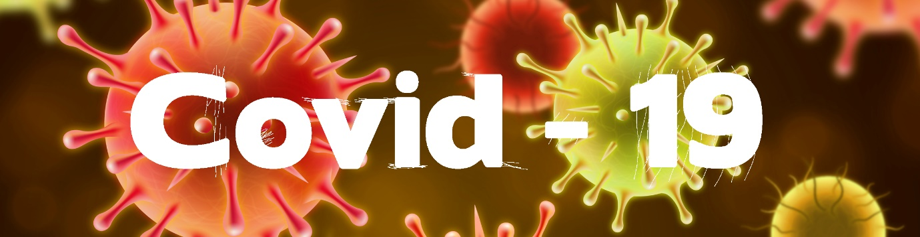

Reading the story of Sangkhuma and Dr Owain, we see that faith still leads individuals to help people in ill health and is resilient when faced with the challenge of being a frontline worker in a pandemic.