

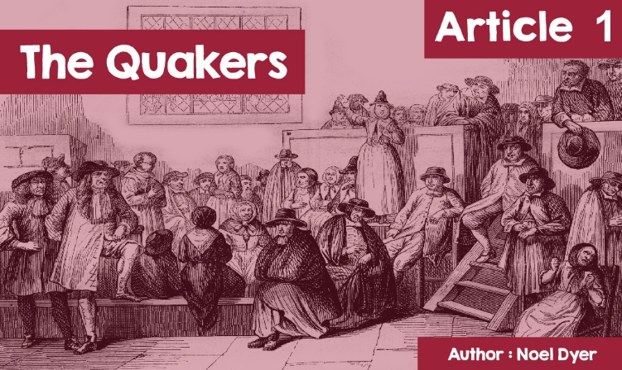

**The Multi-Belief Society of Wales – The Quakers**

Everyone likes chocolate, I suppose. But what do John **Cadbury**, Joseph **Rowntree** and Joseph **Fry** have in common? Herbert Hoover and Richard Nixon were two American presidents but what did they have in common? Likewise, what connects James Dean, Joan Baez and Judi Dench? The answer is a connection with the Quakers / The Society of Friends.

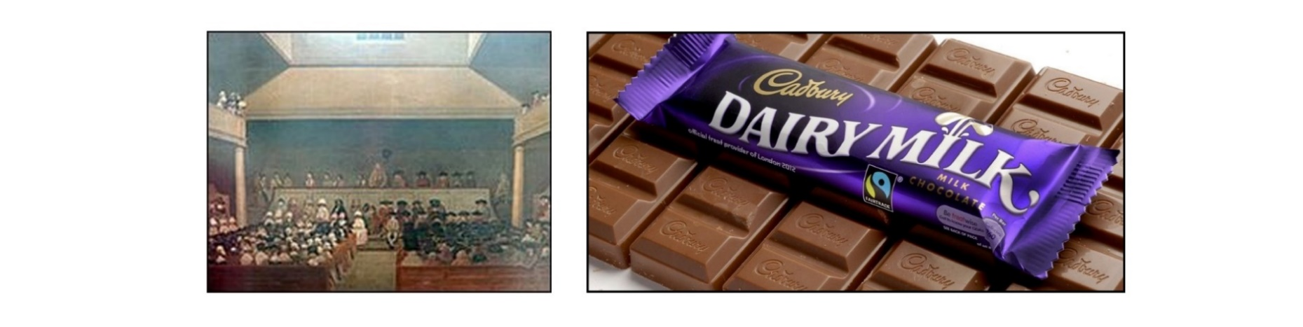

The term **Quakers** was used for a religious group or sect that emerged in the 17th century. **Quakers** was a rather derogatory term because people thought they were trembling when they got together and faced the wrath of the authorities who were persecuting them. In fact, the more official name, namely the 'Society of Friends', says much more about the nature of this denomination.



The **Quakers** were originally a small group of people who broke free from the only established and accepted church - the Church of England, a church to which everyone was expected to belong! A man by the name of George Fox, the son of a Leicestershire weaver, was the first leader of the group in the 17th century. He believed that Christ could be proved without the intervention of a vicar. The message spread from England to Wales and Scotland and beyond and, for a time, some areas of Wales became key in their history.



The **Quakers** were soon in collision with the authorities. Everyone was expected to bow to the Church of England and there were laws against the **Quakers** in 1662 and 1664. Despite abuse, imprisonment and embargoes, there were about 60,000 followers in Britain by 1680.

**Quaker** ideas were new and revolutionary:  
  
• Oppose all wars and fights,

• Want to abolish slavery,

• Refuse to pay **tithes** (money) to the Church of England,

• Refuse to remove a hat and recognise leaders, such as the squire or priest,

• Refuse to take an oath, e.g., to the king,

• Argue that everyone is equal.

One area of ​​Wales with a special connection with the **Quakers** is Dolgellau. George Fox travelled through Dolgellau in the company of the Welshman, John ap John. Many Dolgellau residents were happy to receive the message. There was no need for a priest between a worshipper and God and, therefore, there was no need to rely on the church for religious support. He said that the light of God is in every person and that this goodness is in everyone.

Following this, the new **Quakers** would meet outdoors or at each other's houses, e.g., farms such as Tyddyn y Garreg and Dolgun Uchaf. Not everyone was happy with this, and a cruel persecution commenced. Some were taken to court and there were threats of the death penalty. Some were jailed and others were heavily fined. The result was that many of them left for America. William Penn (founder of the state of Pennsylvania) offered religious freedom and good land to farm there. From 1686 onwards many Quakers left the Dolgellau area for America and began a new life there. To this day their descendants come to Dolgellau every three years to see places associated with their ancestors.

One that brought to life the history of the **Quakers** in Dolgellau was the novelist, Marion Eames. She published two novels about their persecution and emigration to the United States – *Y Stafell Ddirgel* and *Y Rhandir Mwyn*. These have also been made into a television series.



What happened to the **Quakers** following all this?

The situation was so bad that, by the 18th century, supporters described themselves as 'the rest'. There was a bit of a revival after the First World War. Their stance for peace and against war won new supporters. South Wales **Quakers** were keen to help those in need during a very difficult economic time. According to historian Barrie Naylor, *"Unemployment was a serious problem, especially in the Rhondda and the rest of South Wales. The* ***Quakers*** *made efforts to improve the situation. Their organisation in Maes yr Haf provided all kinds of services and clubs ... It was an outstanding example of service to others.”* In 1929 the 'Brynmawr Experiment' was set up, a co-operative that trained and employed unemployed young men to make furniture.

So, what is the situation today? There are around 15,000 in the UK, 1,200 in Wales, with those meeting in about 30 groups. Catherine James is one of Dolgellau's Quakers today and she and others illustrate them on the video **Y Ffordd Dawel**:

Click on <https://quakersinwales.org.uk/resources/y-ffordd-dawel/> to learn more.

According to Catherine James, “*Being a Quaker is not a dogma, it's a way of life. George Fox's vision was that there is goodness in all of us, some God in every person we meet.”* On the video we see her leading a walk around the Dolgellau area sites, leading simple worship.

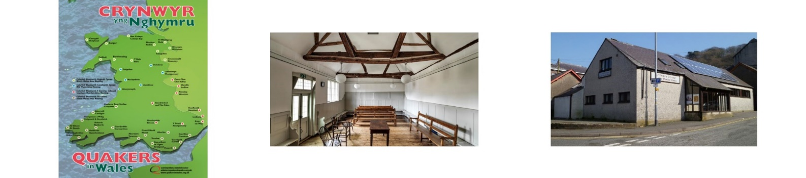

Everyone is welcome at our meetings where we gather to worship in friendly silence. We try to reach the Meeting ready to reassure our minds and hearts. Inside each of us is the Inner Light that responds to God. During worship, some of us may feel a call to get up and speak from our inner experience of God, or to read a passage that has led us to a better understanding of the Spirit. We listen to each other openly, in friendship and humility, leaving space for each speaker to reflect quietly. Our hour of worship ends with a handshake.

In the words of a member of the Pwllheli circle, *"The main function of* ***Quakers*** *is silent worship and, consequently, spiritual research. One of the things that first drew me to the* ***Quakers*** *was a group of people who were asking questions and not offering answers.* ***Quakers*** *do not define themselves according to their belief and the emphasis is on spiritual research, sharing the journey with anyone who is seriously considering their spiritual life.’* According to the web site <https://crynwyrcymru.org.uk>, *“We do not recite beliefs, we do not sing hymns or repeat formal prayers. We want to worship simply. There is neither ritual nor priest, nor a prearranged service.”*



It would be difficult to mention the Quakers in Wales without reference to Waldo Williams (1904–1971), one of our most famous poets. He believed strongly in peace and opposed all wars. He refused to join the army during World War II. He subsequently refused to pay income tax as some of that money went to the cost of militarism. As a result, he began to show more interest in the **Quakers** who had always opposed war. He started attending the **Quaker** Meeting House in Milford Haven, Pembrokeshire. Their approach to worshipping in silence appealed to him. On one occasion he broadcast a talk on the radio entitled 'Why I am a Quaker' stating 'The **Quaker** approach makes it easy for man to look at God in his own way ... and yet feel united with his society'. The pacifism that was so central to his life is reflected in one of his most famous poems - *Y Tangnefeddwyr* (‘Peacemakers’), which conclude with the words:

*Gwyn ei byd yr oes a’u clyw, Dangnefeddwyr, plant i Dduw*

(Blessed is the age who hear them, Peacemakers, children of God).

Catherine James from Dolgellau was asked the following questions, and her response is given below:

**How do the Dolgellau Quakers usually come together?**  
  
*A worship meeting is usually held every other Sunday morning at Llanelltyd Village Hall. The chairs are arranged in a circle, and all are free to sit wherever they wish. The meeting lasts about an hour, with the elders shaking hands at the end to indicate that the meeting is over. During the meeting, if one of those present, be they members or attendees, feel that the Spirit wants them to say a word or prayer, or read from the Bible, they get up and do so. After the meeting, there is often some discussion on current issues, such as food banks, the needs of the area, what the government is doing, climate change and what we can do to help with problems. There's also tea/coffee for everyone who wants some.*  
  
**How have things changed since the Lockdown?**  
  
*In order to worship together, a number of Quaker meetings have gone 'online'. Others adhere to the usual dates and times but worship at home: usually, an image, Bible passage, poem etc. for worship are sent to the people worshipping at home. For those who go online, the largest local meetings arrange their own meetings, and the smaller meetings join together as a regional meeting. Wherever we worship, it is different from our usual meetings, but the intention, the self-discipline to turn to the Spirit, to listen to the Inner Light and to all who minister, is just as when we really meet each other.*

*Lockdown has offered new opportunities. The Pwllheli meeting which, like Bala, meets and acts in Welsh, has held weekly worship meetings and informal chats, online in Welsh for the whole of Wales. Contact via the Pwllheli* ***Quakers*** *website.*

**Is it possible to have quiet periods and reflect on Zoom etc?**

*Yes - you need to calm the mind before and when you join the meeting to let go of everyday issues.*

**How does your faith as a Quaker influence your day-to-day life?**

*Because we see everyone as equal before God, and all with the Inner Light, we must strive to travel through the world and respond to what God has in us all. The Bible requires us to be truthful, and we try as best we can. That is why we refuse to take an oath - to do so would strongly suggest that we only have the Bible in our hand. We also try to tread lightly on the ground - climate change is a big issue for us - so living by simple means is important.*

**What is the Quakers’ vision for a future Wales?**

*We seek to work with churches and other organisations, or on our own, on sustainability, peace, a fair and inclusive economy, affordable housing, equality of language, gender, belief and race, and getting quality work for our young people. All these are needed for Wales to prosper as we wish.*