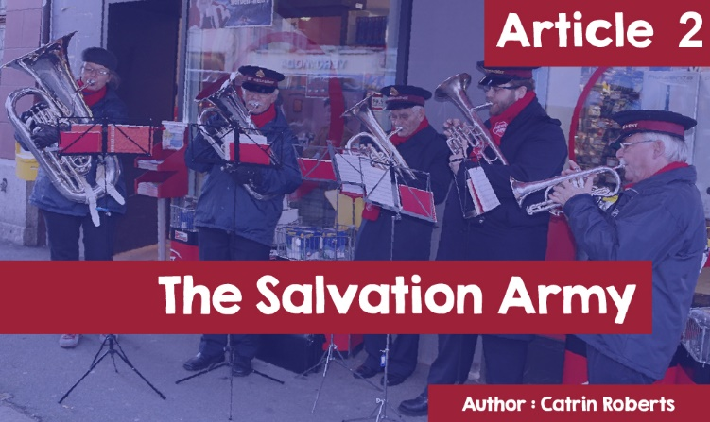

**Salvation Army**  
  
  
***Actions speak louder than words!***  
  
William and Catherine Booth, the founders of the Salvation Army, would 100% agree with those words. Enthusiastic Christians in London in the 1800s, both felt that the Christian faith needed to be taken to the people, instead of waiting for people to come to chapel.



They also wanted to put their faith into action and give practical help to the poor of the time through a campaign called - *‘soup, soap and salvation’*.



What help? - food, a chance to be clean, a chance to hear the Bible’s message, a place to sleep, help for women to break free from prostitution, support for victims of domestic violence and a campaign for better working conditions, for the Match-girls for example.



‘Down and outs', alcohol and morphine addicts, and prostitutes, would be looked after by the Booths and their colleagues under the name, ‘The Christian Mission.’ The name changed to the Salvation Army in 1878.

Members of the Salvation Army wore a semi-military uniform as William Booth saw their work as a battle against evil. He was the 'General', the local church was a corps, the ministers were officials, the members were soldiers and the church's motto was ‘*Blood and Fire’* (the Blood of Jesus / the fire of the Holy Spirit).

.

*Mike Kirby / Salvation Army Motto and Badge  
This Photo by Unknown Author is licensed under CC BY-SA 2.0*

Contrary to the custom of the time, William Booth believed that women were given equal standing in the work of Jesus Christ.



**Today**

The Salvation Army works in approximately 131 countries. It adheres to the beliefs of the Christian mainstream, but the sacraments (Communion / Baptism) are not part of the Army’s life.

Music is important on Sunday and street worship - Salvation Army brass bands often play carols at Christmas, ……



or distribute the newspaper WarCry!



An unusual thing in the Army buildings is the mercy seat (a special bench in the worship hall) where people go for prayer or go to pro*fess*.

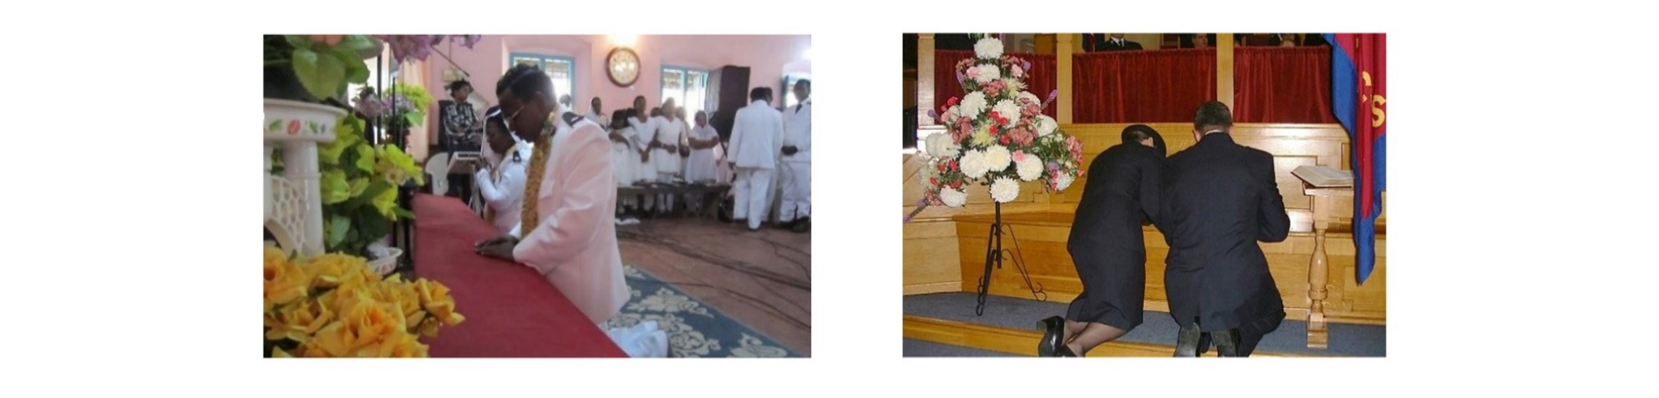

William Booth's work continues today - work based on faith in Jesus, and the whole point is to put that faith into practice in giving practical help to people, no matter who they are:  
  
    • Stand up for vulnerable people

• Fight injustice

• Fight modern slavery

• Helping the homeless (through Life house units), drug and alcohol addicts

• People caught up in the sex industry

• People facing poverty and debt and in need of guidance and support

•..and many more.

If you want to see the Salvation Army in action, watch the movie *Faith Into Action* by clicking the link below

[www.bing.com/videos/SalvationArmy_Faith_into_Action_video](https://www.bing.com/videos/search?q=Salvation+Army+Faith+into+Action+video&view=detail&mid=C59B7AAF9827F93B3438C59B7AAF9827F93B3438&FORM=VIRE)

The Salvation Army, Carmarthen.

<https://www.salvationarmy.org.uk/carmarthen>

The Salvation Army has been operating in the Carmarthen area since about 1885. The work ended between 1946 and 1993. Since 2010, Captain Neil Duquemin and his wife Liz are leading the work with the help of two Commanders, and a young Cadet called Jamie, who is training to be an Officer (minister).



*Captain Neil Duquemin*

At the Carmarthen Centre there is a charity shop (providing clothes and other necessities to those in need / selling goods to the public in order to raise funds), and a coffee shop (open to the public and providing food for the homeless and others).

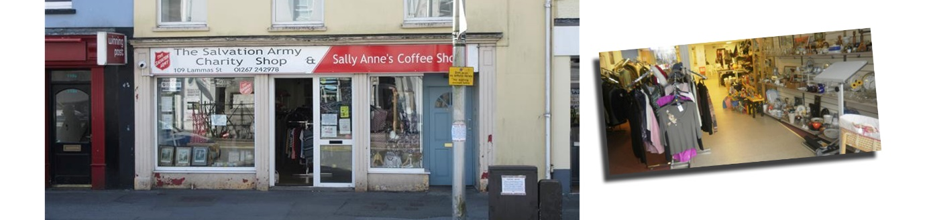

Next to the shop and café is the community centre which houses the large worship hall and modern kitchen.

.

Much of the preparation of meals has temporarily ceased due to Covid-19, but the kitchen still offers free lunch and takeaway packages, and an opportunity to invite people for a cuppa and a one-to-one chat. People are more willing to come in for a chat over tea/coffee and ask for help, or discuss problems - debt, alcoholism, drugs, homelessness or personal problems.

This is what Captain Neil said when I questioned him.

Are the problems in Carmarthen different from those in other parts of the UK?

*"No, these problems are common to other cities and towns. People travel to Carmarthen from places like London, to escape their problems, intending to live in a tent. But that is difficult at any time of the year. Often, they arrive without a supply of strictly necessary personal medicine. Their problems bring them to Carmarthen. There is no hostel here to help with homelessness. The visibility of the Centre (and next to a betting shop) means that people know where to find help.”*

How did you become a captain here?

*"I grew up in Guernsey in a Salvation Army family, and as a young person I was a member of brass bands. I worked for 12 years as a marine engineer and my wife worked in finance and nursing before we felt the call to serve full time with the Army. We worked in Merthyr Tydfil before coming here. I lead worship and oversee the work, but I have a heart for our clients, especially those who suffer from addiction. About 30 come to worship. We have tried to run Sunday School,* ***Llan Llanast*** *and Youth work, but children's work is difficult.”*

Is there a Welsh element to the work?

“Not much - I haven't been able to learn Welsh. We had a special Welsh edition of *WarCry* last year. Some of our volunteers speak Welsh, and that helps because it is easier for some clients to open up about their problems in Welsh.”

Do you have a message for the young people who will read this article?

"*The work of the Salvation Army involves standing up for the vulnerable and voiceless. I would encourage any young person to be brave and use their voice to speak up for people in need.*

*The Salvation Army is also a church, and our uniforms show who we are - people who believe in Jesus Christ. It is difficult for young people today to show that they believe in anything religious, but if they have faith, I would encourage them to be brave, and to show that.*

*And finally, I would encourage any young person to look into the history and work of the Salvation Army and think about whether there is a place for them in the work. Again, courage will be needed, but there are global opportunities to get involved with the work."*

On to the future?

From the days of William and Catherine Booth to the present, the need remains, with Salvation Army workers still there to put their Christian faith into practice.



To learn more about the Salvation Army, click on:

<https://www.salvationarmy.org.uk/>