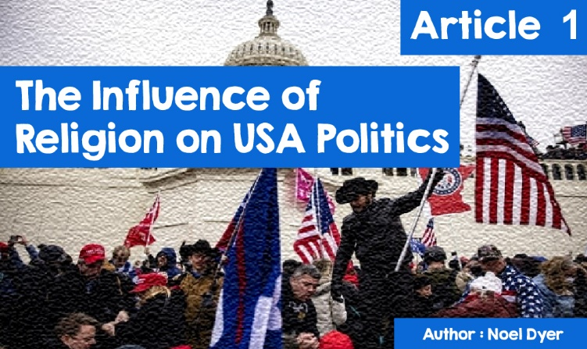

**The Influence of Religion on USA Politics**

**Trump V. God**

The United States of America! What springs to mind?  
   • Hollywood;  
   • California;  
   • Miley Cyrus;  
   • Trump, Biden, Obama;  
   • The ‘Stars and Stripes’;  
   • Manhattan and New York;  
   • Disneyworld and Universal Studios;  
   • Las Vegas;  
   • Religion!!!!!!!!

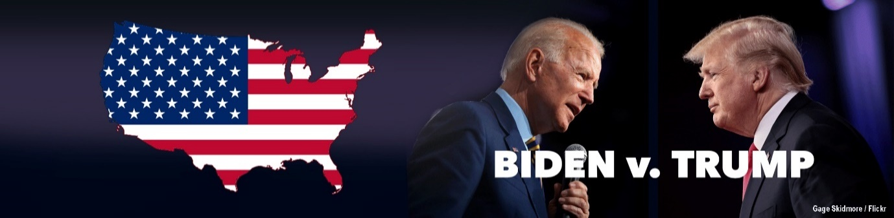

Hundreds of things come to mind when thinking about the USA but why religion? The fact of the matter is that the USA is one of the most religious countries in the world - certainly one of the most religious in the Western World. The US **constitution** protects the right of every American to follow a religion of their choice - the **constitution** stated that 'some self-evident truths were that all men were created equal and that their creator had endowed them certain rights'. The separation of religion and the state dates back to the days of the Declaration of Independence in 1776. In the United States, religious freedom is very important. Having said that, many have said that it would be impossible for an **atheist** to be elected president.

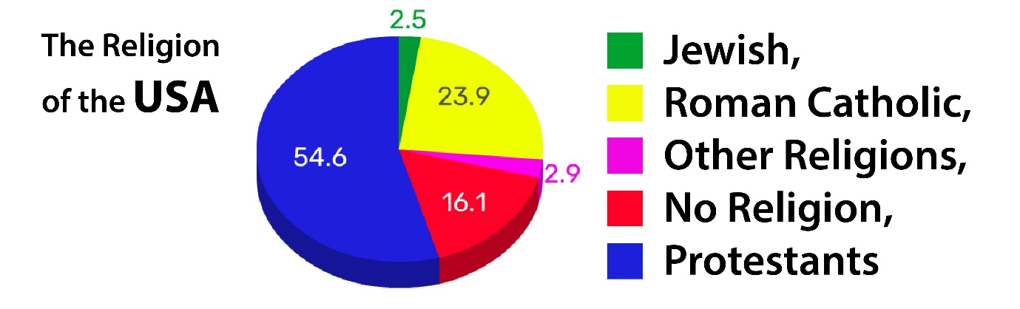

Quite simply, three-quarters of the people of the USA classify themselves as Christian. Less than a quarter of people say they don't follow any religion. Only small percentages follow other religions; e.g., Jews (2.5%), Muslims, Hindus etc around 1% each! When it comes to believing in God, over 80% answer *yes* but more significantly is that over 50% of Americans say that religion is important or very important to them. It is possible to gather all kinds of detailed statistics on US religion at the following site:

<https://www.pewforum.org/religious-landscape-study/>

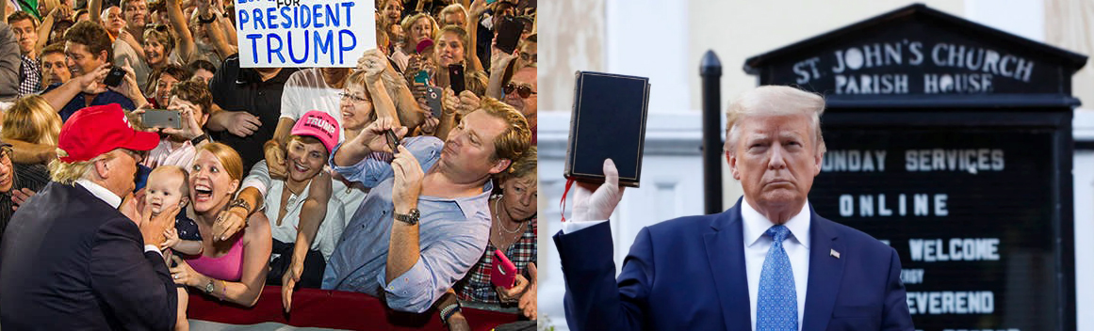

**How have these statistics influenced the elections of the United States of America?**  
  
Protestants, and certainly Evangelical Christians, have traditionally tended to vote for the Republican Party. This became more and more apparent in 2020 as we saw slogans like 'Jesus is my Saviour, Trump is my President' on T-shirts and the like! There was a real split between two visions of America's future, to a much greater extent than in the past. On the one hand Donald Trump with his *Make America Great Again* and Joe Biden and his more inclusive message. What created added tension was the close proximity of the vote - in the words of Welshman / American Jerry Hunter (Opinion Magazine - December / January 2020/21), “Joe Biden got more votes than any other candidate in US history ... Donald Trump got more votes than anyone else in the country's history except Joe Biden”. Donald Trump, like Joe Biden, received overwhelming support. To add to the tension, Donald Trump was reluctant to accept the result and a group of his followers stormed the Capitol building in Washington in early 2021.

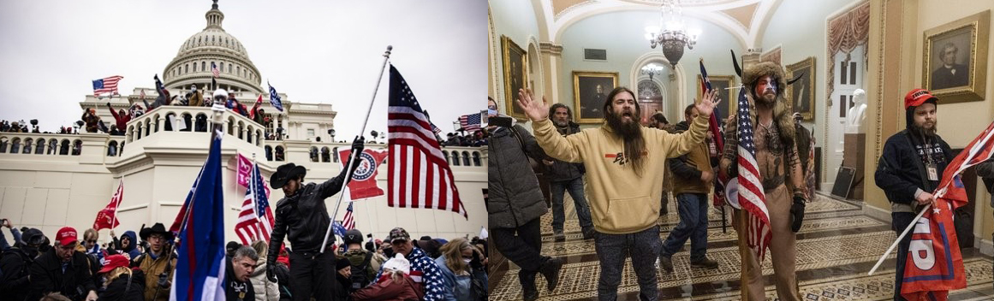

Jeremy Hunter and others believe that Americans' voting method is heavily influenced by two things: religion and race. In the view of commentators, white **evangelical** Christians are the core of the Trump and Republican support. About a quarter of all U.S. voters are white **evangelists**. The vast majority of these would have traditionally voted Republican. According to one expert, this type of Christianity is associated with racism. Millions of them want to keep the United States a Christian country and also keep it a place where the white people rule. Trump managed to give the impression that he was pursuing the same vision as them. He refused to condemn those who held **white supremacy** beliefs**,** responded very strongly to Black Lives Matter protesters, and condemned them as criminals.

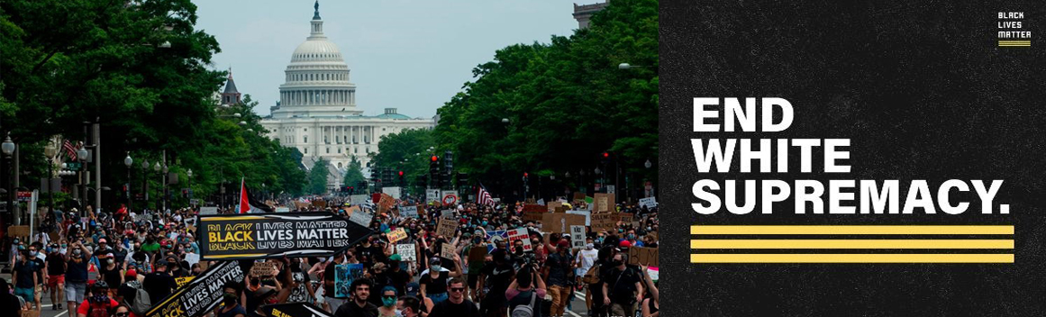

Donald Trump's personal and political life story is not always consistent with the views of this faction. His life may be far from the Christian ideal but one evangelical minister says "*Donald Trump may not look like a Christian, but I believe God is acting through Donald Trump!"*

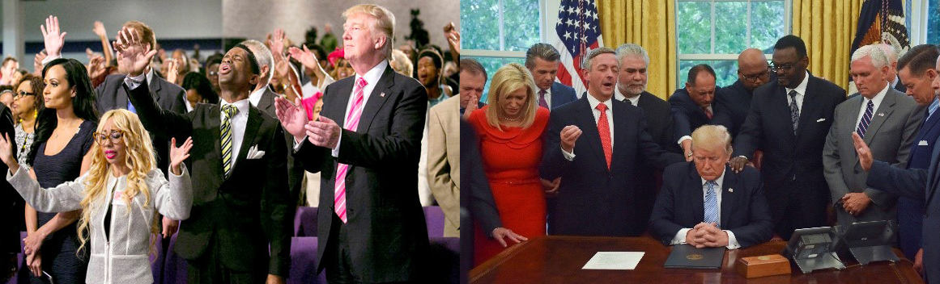

When the **Puritans** went to America in the 17th century, they believed that God had given America a special role in the history of humanity. That belief among the **evangelists** of the country continues - a belief that God has chosen the United States of America as a Christian country and elevated it above the nations of the world - here is a large contingent of Trump's natural voters and Republicans. On the other hand, some believe that the overwhelming support for Trump reflects the decline of religion in America because Trump does not really reflect Christian and religious standard and morality; e.g. Gary Silverman's article in the Financial Times: <https://www.ft.com/content/b41d0ee6-1e96-11e7-b7d3-163f5a7f229c>  
  
In the 2020 US election, there was a lot of talk about the 'Bible Belt'. This is a term that is used for many states in the southeast of the country - states like Georgia, Tennessee, Alabama, Mississippi, Virginia, Carolina and Texas. Here evangelical and conservative Protestantism plays an important role in people's lives. These provinces have consistently voted for the Republicans in most elections over the past half century. Donald Trump tried to appeal to Christians through Twitter, 'Democrats want to close your churches' and his son, Eric Trump, claimed his father had 'saved Christianity'. Donald Trump further used the term 'chosen one' for himself, claiming that God was on his side and that Biden would 'damage the Bible and do harm to God'. Republicans have surely used Christianity as a weapon in favour of Trump's efforts.

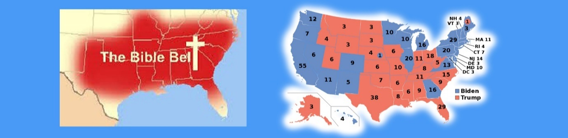

Trump's campaign gained the support of prominent **Evangelists** for his campaign. Reverend Franklin Graham, son of the famous Billy Graham, organised what he called a massive prayer meeting in Washington. It was stated that it was not a political occasion but the emphasis was on the fact that America was a Christian country and one Republican speaker after another addressed an audience wearing slogans such as *'Make America Great Again'* and *'Make America Godly Again'*.

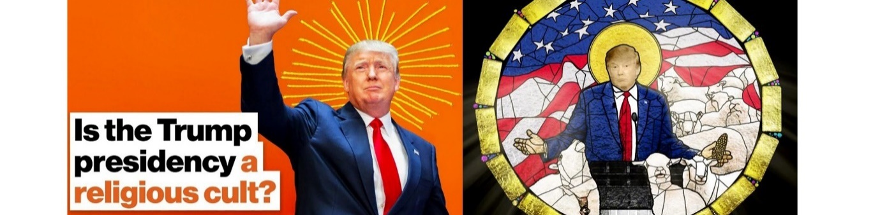

It must be remembered that the evangelists of the USA are only one Christian tradition. About a quarter of the population are Catholics. Over the years, their vote has been split evenly between Republicans and Democrats. Of the 45 US presidents, only two were Catholics - the first was John F. Kennedy and the second was Joe Biden, the current President. As a Democrat candidate and a member of the Catholic Church, his election campaign was very different to that of Donald Trump. His Catholic background probably appealed to the country's Catholics. Similarly, much was mentioned about his strong Irish roots which would obviously appeal to Americans with connections to Ireland. There is no set pattern for the Welsh American vote in America but many American Welsh speakers have certainly voiced their concerns about Trump. Biden tried to appeal to a wide range of people and attracted support from all sections of society.

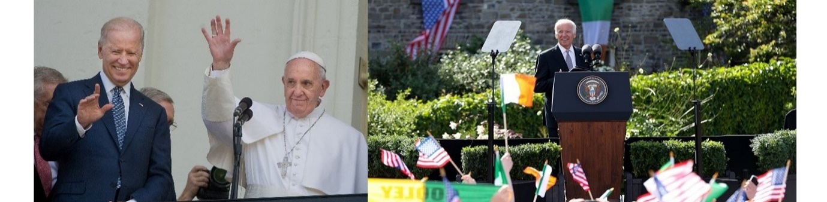

Contrary to the picture often given in the election campaign, there are many **Liberal** aspects of American life. What we see in American films and television programmes is very different to what we saw on the news over the last year or two. What showed in the end-of-2020 result may be the huge divisions and gaps among US residents. This was clearly seen in the result itself. Joe Biden won 51.3% of the vote while Donald Trump won 46.9%. The task over the next few years will be to unite all factions - Republicans and Democrats, white and black, **Protestants** and Catholics, ensuring fairness for religious and ethnic minorities including those of Latin background such as the Mexicans, not forgetting the Native Americans.