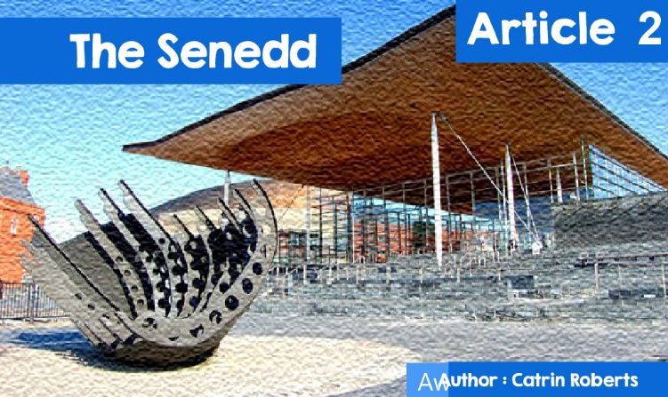

**The Senedd**

**2Ps in the Senedd?**

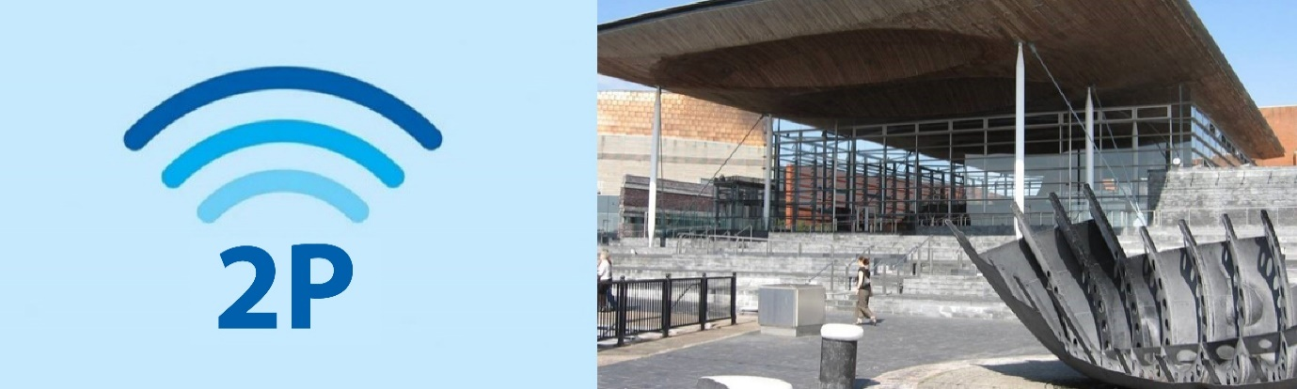

2P actually stands for Politics and Prayer!

And the answer depends on which parliament you're talking about.  
  
   •   The UK Parliamentary sessions in Westminster open with daily prayers.

• The Northern Ireland Parliament provides an opportunity for its members to pray or meditate quietly at the start of a business session.

• In the Scottish Parliament there is a Time for Reflexion once a week.

• But there is no equivalent in the Welsh Parliament - the Welsh Parliament is regarded as a secular institution.

• When Members of the Welsh Parliament take their seats, they have a choice of two statements, with the second omitting any reference to God;  
  
*"I, ... ... ... ..., do swear that I will be faithful and bear true allegiance to Her Majesty Queen Elizabeth the Second, her heirs and successors, in accordance with the law. So help me God.”*

*I, ... ... ... ... do hereby declare and affirm solemnly, sincerely and in good faith, that I will serve Her Majesty Queen Elizabeth the Second, her heirs and successors, in accordance with the law.”*  
  
**Is there a place for prayer or religion in Welsh national politics?**

Yes, say Welsh churches. The Bible says:  
  
I urge, then, first of all, that petitions, prayers, intercession and thanksgiving be made for all people for kings and all those in authority, that we may live peaceful and quiet lives in all godliness and **holiness.**  
  
- 1 Timothy 2:1-2  
  
That is why **Cytûn** (Churches Together in Wales - cytun.co.uk) appointed a Policy Officer to work in the Senedd, You can view a list of Cytûn churches by clicking on [Pwy Ydym Ni – Eglwysi Ynghyd yng Nghymru | Churches Together in Wales (cytun.co.uk)](https://www.cytun.co.uk/)(Welsh), but it also works closely with other religions.

Gethin Rhys is the current Policy Officer.

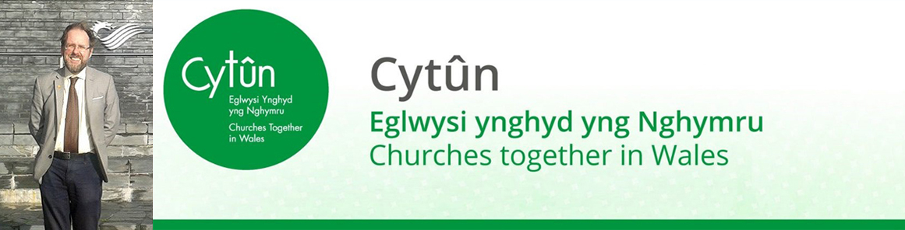

**And his work?**  
  
   •   Monitoring the developments in Parliament and the Welsh Government that affect or are of interest to the churches. The churches often campaign for the eradication of poverty, climate change, agriculture, the Welsh language, refugees, education ...

• Helping churches build relationships with Government and members of the Welsh Parliament.

• Promoting co-operation with other organisations and religions.

• Serving on Welsh Government working groups where a Christian perspective is needed e.g., the Covid-19 pandemic and opening / closing places of worship.

• Publishing a Policy Bulletin and briefing papers on topics such as Climate Change and responding to the Curriculum and Assessment Bill for Wales.

**Why do Cytûn members think there is a need to pray for Parliament?**



Arfon Jones (who was responsible for preparing beibl.net, a modern, Welsh translation of the Bible for young people living in Cardiff) has been involved in a monthly prayer meeting for the work of Welsh national politicians since devolution. Christians of different backgrounds and parties meet in a Committee Room in the **Senedd** in order to pray  
  
   •   For decisions that will promote the justice and wellbeing of the people of Wales.

• For individual MPs, especially if they are under pressure, ill, or facing difficult circumstances.

• For **Senedd** staff, and all levels of government, from local / county councils to Welsh MPs in Westminster.

• For co-operation between the political parties for the benefit of the people of Wales, for any debate to be constructive putting Wales first, not party.  
  
**2P in Politicians’ lives?**  
  
Not everyone has faith, but here are three members of the Welsh **Senedd** discussing their faith.



**Conservative Darren Millar. Chair of the Cross-Party Faith Group**  
  
*“As a teenager I experienced realising that God is real, he loves me and that Jesus died for me. It changed my life. I knew that God had a plan for me - serving my community and sharing my faith in the political world. Politics to me is a* ***calling****, not a job that pays the bills!*

*I chair the Cross-Party Faith Group, a group that highlights the important contribution of faith communities to Welsh life and within the* ***Senedd****. It meets 4/5 times each year, with members of different parties meeting with representatives of Welsh faith groups to discuss various topics e.g., the future of Religious Education in Wales, the work of faith-based communities with the homeless, faith tourism, the place of prayer in public services, marriage between same-sex couples. There is usually a speaker, and a discussion before action points are agreed for submission to Welsh Government Ministers. Here are some results: Wales is the first nation in the world to develop a Faith Tourism Action Plan; establish Spiritual Care Guidelines for the Welsh Health Service and provide public funds for* ***chaplaincies****.”*

**Conflict between faith and politics?**

*“It is my faith that forms my understanding of the world and what is right / wrong. I believe in the holiness of life so I wouldn't vote for* ***abortion*** *or euthanasia. But no one has asked me to vote against my convictions. It's my hard work for my constituency that matters.”*



**Dai Lloyd, Plaid Cymru**  
  
*“I've been a member of Parliament for over 16 years, and everyone in Welsh political life knows I'm a Christian - the information is on my political CV! As a lay preacher, my faith is an ongoing part of my life. Many Christian people have opposed me because of my Christian beliefs, especially online. Acting as a Christian in Wales today is challenging - many think something is wrong with you if you are a Christian. But the care of the weak, the poor, the patients, the homeless, the victims of injustice, people in prison etc. is of core importance. I put my concern in these areas down to my faith.”*



**Baroness Eluned Morgan, Labour MP and Minister for Mental Health, Well-being and the Welsh Language**  
  
In practicing her Christian faith through politics, Eluned Morgan follows the example and values of her father, a vicar who was a strong believer in social justice and a campaigner.

*“It is my faith and upbringing that has developed and shaped my ideas and morality. I believe I have a calling to serve the public and that it has been influenced by Christianity. Faith groups have a contribution to make to the work of the* ***Senedd****. But, for me, what matters is that they do not limit themselves to discussing issues that just touch the church / chapel / faith. Religion has a responsibility to consider the community and the country as a whole.”*  
  
**What about other religions, or people without faith?**  
  
Since the death of Mohammad Ashgar (the first Muslim Member of an ethnic minority background) no member has publicly professed any of the other religions - although there are some candidates in the 2021 election (e.g., Altaf Hussein, Conservative, who is a Muslim). But some members are humanist e.g., Julie Morgan, ASC of Cardiff North, and part of the **Humanist Parliamentary Group** (a **cross-party** group which is not formally part of the **Senedd**).

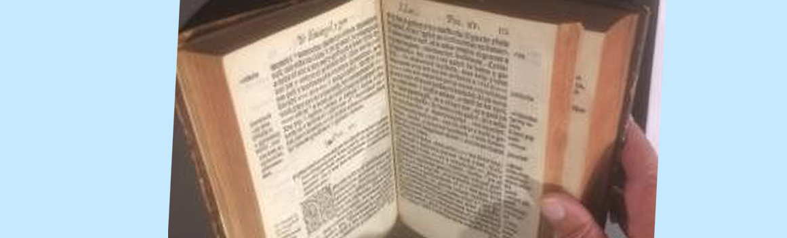

Other Members of **Parliament** expressed their view that there is no place for Religious Education in schools when discussing curriculum changes, and in the past there has been a negative reaction to the attempt to present a copy of the first Welsh Bible to the **Senedd** - but that was mainly opposition from outside -  
[Sixteenth-century Bible presented to the Welsh Assembly (eauk.org)](https://www.eauk.org/current-affairs/politics/sixteenth-century-bible-presented-to-the-welsh-assembly.cfm)

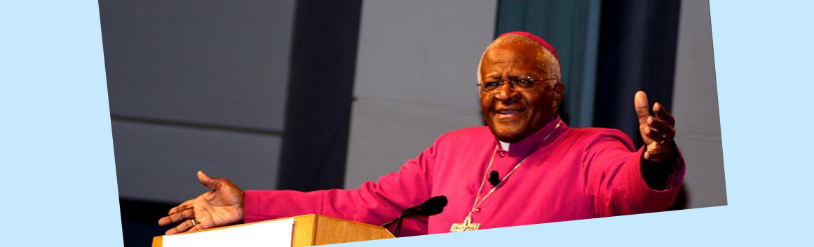

During the campaign against Apartheid in South Africa, **Archbishop** Desmond Tutu said he was confused about which Bible people were reading when they said religion and politics do not mix.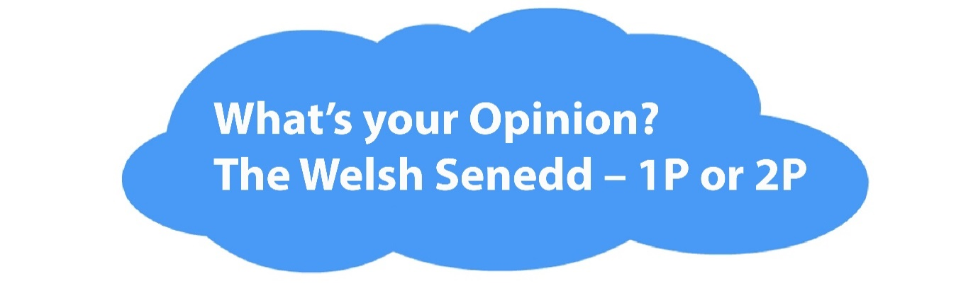

*This article was written before the May 6, 2021 Elections*