

**Friends or Enemies?**

I'm sure you all know people who sometimes look and act like they were the best friends ever and, yet, on other occasions you would argue they were worst enemies. Well, the relationship between religion and politics is similar, but one thing that one cannot deny is that they are very closely related. According to **Albert Einstein,** those who did not realise that, did not understand religion or politics.

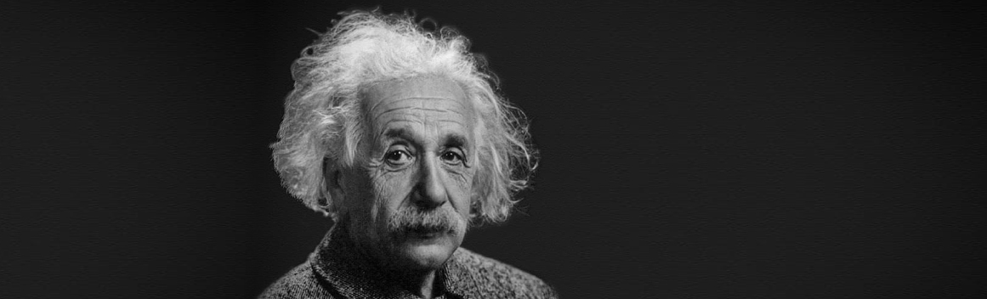

*Albert Einstein*

It is impossible for them not to be friends because they are both involved in people's daily lives and relationships. In many countries, religion has a voice in government and, therefore, can influence political policies. This is true of the British **Parliament,** where **Archbishops** and some bishops are allowed to sit in the House of Lords. One country where that has happened is Iran, where the religious leaders are also political leaders, and all the country's laws are based on religious laws. Iran's main religious and political leader is **Ayatollah** Ali Khamenei. A country governed in this way is called 'Theocracy'. The religion of Islam is of course the basis of the Iranian government, but **Theocracy** can be found in other religions. I wonder how many of you realise that the **Vatican** in Rome is a country as well as a city? It is also another example of **Theocracy** but this time based on Christianity and Pope Francis is the political and religious leader.

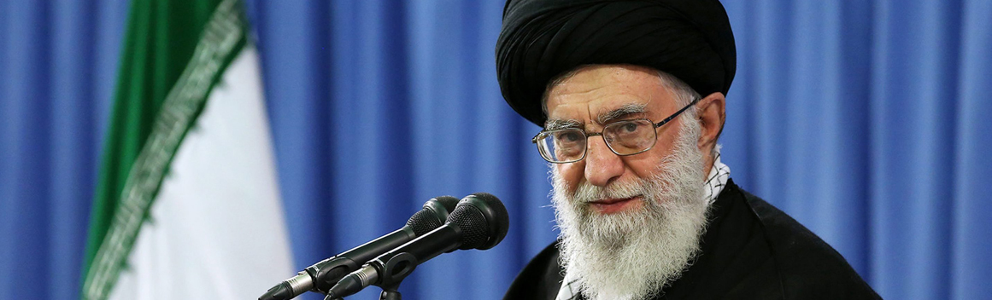

*Ali Khamenei*

Yet, even though they are very closely related, there is a very important difference between religion and politics regarding the question - are we the people who make the kind of society we live in or is it society that creates us to be the kind of people we are? What do you think? Put simply, the fact that we live in a clean and tidy house makes us clean and tidy people or is the house clean and tidy because we are clean and tidy people? If I built a house and everything in it is good, does that mean that anyone who lives in the house would be good or is the house good because I'm good? Politics believes that the house comes first and that the kind of society we live in affects the kind of people we are. Religion, on the other hand, believes that people come first and that the kind of people we are, affects the kind of society we live in. That is why the aim of religion is to change people for the better. So here are the different formulae:

Good society = good people (politics)

Good people = good society (religion)

When politics and religion agree, there is no problem for religious believers but when political policies challenge religious beliefs then very difficult questions arise. Who is a religious believer to listen to - his religious conscience or the government of a country, his God or the law? If religious believers believe that the government / politicians are acting in violation of religious principles, do they have a moral obligation to stand and oppose in order to effect change for the better? Certainly, if we look back over history, that is what many believers have believed and done. People who were prepared to follow their religious conscience, whatever the cost to themselves and the stance of many of them led to a better world. People like Dietrich Bonhoeffer, a minister of the German Lutheran Church who was executed at Camp **Flossenburg** on April 9th, 1945 for his opposition to **Nazi** policies led by Adolf Hitler.

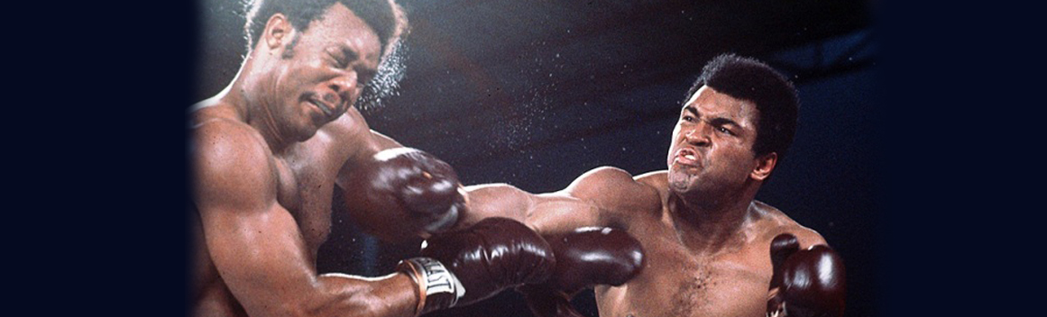

*George Foreman /****Muhammad Ali***

Boxer **Muhammad Ali**, on the basis of his Muslim beliefs, refused the order to go and fight in the Vietnam war. He was arrested and suspended from boxing and stripped of all the championships he had won. He didn't box at all for over three years but, in 1975, he regained the world heavyweight championship when he defeated George Foreman in Kinshasa, Zaire.

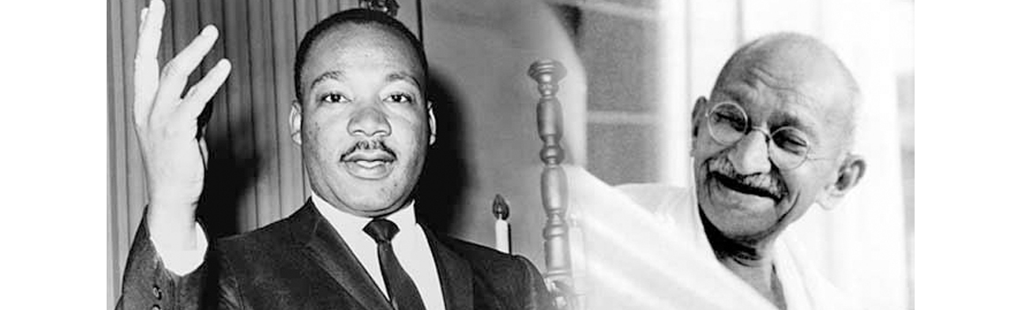

*Martin Luther king / Gandhi*

Two other famous people who took a firm stand on the basis of their faith were Martin Luther king and **Mohandas Gandhi**, one a Christian and the other a Hindu. Both, because of their stance, paid the ultimate price yet, through their sacrifice, made the world and the life of humanity better. And it's important to remember that there are people of all religions who are taking a similar stance today against politics that they believe goes against their faith. The Dalai Lama, the spiritual leader of Tibetan Buddhism, has had to flee his country because China occupied Tibet. But he still leads a non-violent opposition to the occupation and makes a stand for the right of the Tibetan people to have their religion freely followed.

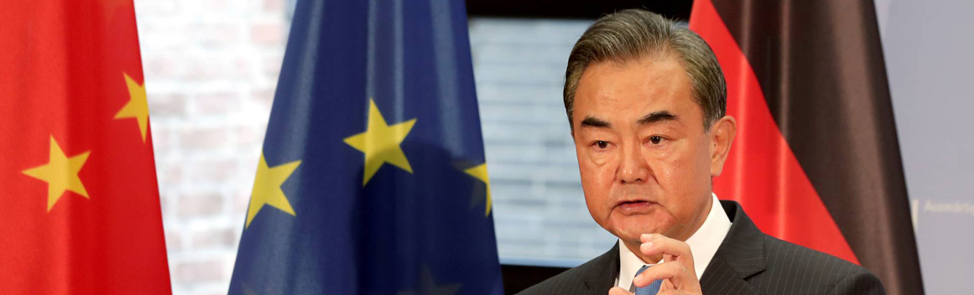

*Wang Yi*

However famous people or people we know their names are not the only ones making a stand in the name of their religion. There are hundreds of ordinary people doing that on a daily basis. I wonder how many of you know that Christianity is the most persecuted religion in the world and, so, Christians in many countries often have to stand up for their faith and challenge the government. In North Korea, it is illegal to follow Christianity and Christians who are caught praying, meeting each other or owning a Bible are sent to prison camps or even face the death penalty. In China, too, recently, the authorities have been persecuting Christians more and more, although the government insists that they respect religious belief. Wang Yi, pastor of the Early Rain Covenant Church in Chengdu, and his wife were arrested and charged with acting in a way as to undermine state power, a charge that could lead to fifteen years in prison. This is what Wang Yi himself said,

*"As a minister of a Christian church, I must openly and severely condemn this wickedness. The call I received requires me to use non-violent methods to disobey those human laws that obey the Bible and God."*

Friends or enemies, you be the judge.