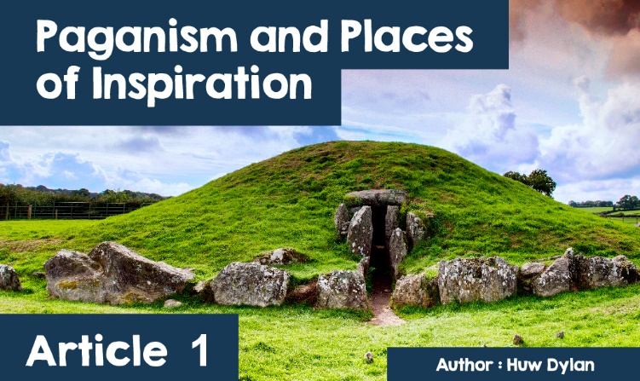

**Paganism and places of inspiration**

What does the word 'pagan' mean to you? In the past it was used to refer to idol worshipers who acted immorally or to people who did not follow Judaism, Christianity or Islam. Today Paganism is recognized as a religion but what exactly is it?  
  
Paganism is an umbrella term for many different traditions that are closely linked to their environment in terms of history, geography, culture and myths. These traditions are often but not always polytheistic or pantheistic and are associated with seeing the sacred in nature and interacting with gods, animals, plants, mountains or rivers. Therefore Paganism, like any other religion, has many places regarded as sacred or special.  
  
In Paganism it is personal and social experience that is important rather than being obedient to a particular deity or holy book. This is why the word 'inspiration' is often used and in Wales Druidic poets refer to the search for the muse the creative force that flows through nature.

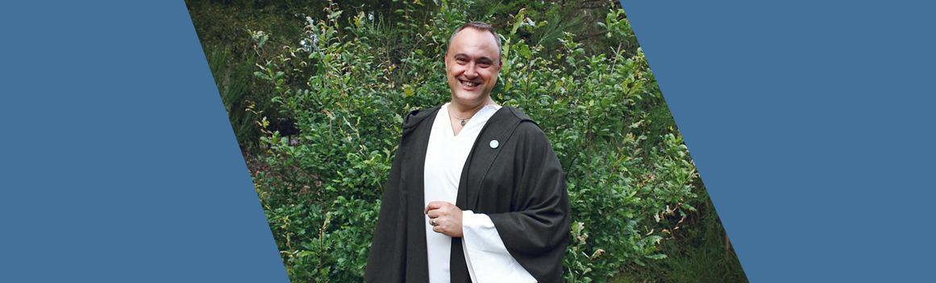***Kristoffer Hughes*** *(*[*https://www.bbc.co.uk/programmes/p04cjbq5/p04chysd*](https://www.bbc.co.uk/programmes/p04cjbq5/p04chysd)*)*

It can be said that Wales has a close association with Paganism dating back hundreds of years to the Druid era and beyond and continues to do so today. Many Pagan groups meet regularly throughout Wales. One of them is the Anglesey Druid Order. Their chief or leader is a man by the name of Kristoffer Hughes. He believes that Paganism is closely linked to the land in Wales and is rooted in Welsh and Celtic mythology.  
  
He says that Anglesey is *"a natural headquarters for Paganism in Wales, as the Druid tradition is so prominent in the area and prehistoric relics, such as the Neolithic burial chamber Barclodiad y Gawres, are so numerous there."* Cae Braint is the Anglesey Druid Order’s headquarters, donated by the owner to be a place dedicated to the ancient Celtic goddess Brigantew and a nature reserve. Kris explains the importance of special places:- *" We believe that the spiritual essence of everything in the world is around us and that Welsh gods and goddesses reflect the power of the earth. Goddesses like Rhiannon, Branwen and Ceridwen are especially important to me to honour. ”*

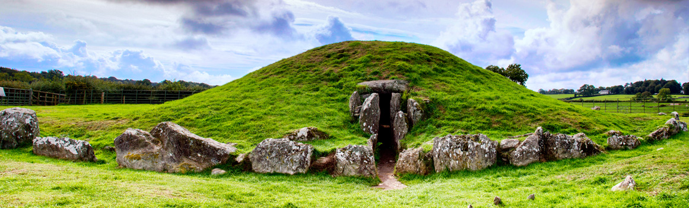***Bryn Celli Ddu*** *(Sterim64 WIKIMEDIA)*

One special place for Pagans on Anglesey is Bryn Celli Ddu Burial Chamber. The name literally means 'the Mound in the Dark Grove' - and is a striking Neolithic tomb. Its original purpose was probably to protect the remains of ancestors, and to pay tribute to them. It was constructed about 5000 years ago, as a 'stone circle'. It consisted of a bank around an inner ditch that enclosed a ring of upright stones. The stone circle was later removed and replaced with a passage tomb.  
  
Graves of this type have been found on the coast of Ireland and as far as Brittany. Bryn Celli Ddu’s passage tomb contains a long hallway leading to a polygonal stone chamber. But what makes Bryn Celli Ddu unique and special to Paganism is that it is the only tomb on Anglesey perfectly placed to coincide with the rising sun on the longest day of the year. At dawn on midsummer solstice, blades of light from the rising sun are thrown down the hall to illuminate the inner burial chamber.  
  
Some believe that this has spiritual significance and that the intention may have been for sunshine to give heat and life to the ancestors buried there. Pagans meet at Bryn Celli Ddu to celebrate the sun's rotation on the longest and shortest days of the year and to identify with the history and legend of this special place. Kris Hughes says: *"We have the privilege of witnessing the dawn breaking in the same way as our ancestors did, over 5 thousand years ago. Bryn Celli Ddu is not seen as a relic; it is a living monument and it likes to have all the attention. We consider ourselves a community with Bryn Celli Ddu. It connects us with Anglesey's ancestors and we have a deep sense of connection with this past where we honour our ancestors and what they built. "*  
  
During the Summer Day ritual several Druids meet at Bryn Celli Ddu to greet the dawning sun on the longest day of the year. Kris Hughes says: *"We are a tradition that emphasizes the value of life. What happens to us after a death is not so important, what is important is what is happening now. The pagan traditions are more about what you can do now to honour the world around you. We begin our ritual by asking people 'do you come to this place in peace and honour?' We tell everyone present that the site is particularly sacred. It is a place where they not only celebrated the passing of life in the ancient world but also where they placed their dead. Our ritual is one that honours the power of the sun and its life-giving power. We thank the sun for the fruit it brings. We ask people to reflect on the things they have been grateful for over the past year and then consider the coming of darkness. Bryn Celli Ddu coincides exactly with the sun and is very impressive. The sun comes straight down the middle and illuminates the corridor in a golden pattern deep inside. It's amazing. ”*

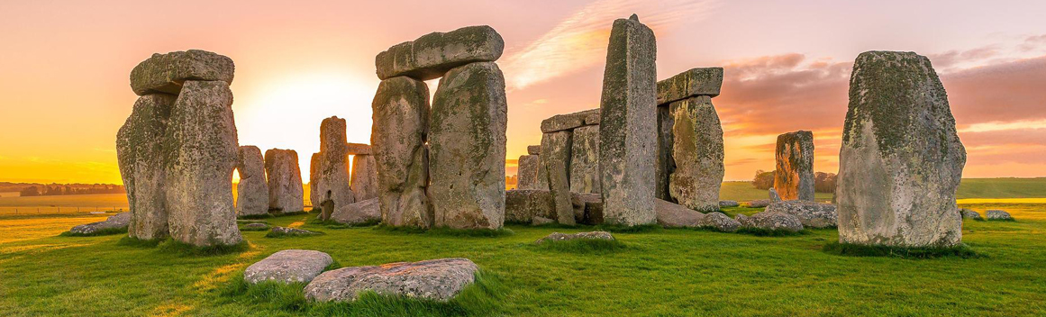

***Stonehenge*** *(Freesally – Pixabay License)*

Another place in Britain which is regarded as being very special in Paganism is Stonehenge. It is thought to be around 4,500 years old and apart from its architectural significance the place is of sacred importance to many. Much of its history is still a mystery, but one thing is sure, it was built on land that was long used for religious purposes. The stones that make up the vast circle are thought to have been collected from various places, some as far as 150 miles away, and then moved and erected using sophisticated techniques to attach them together - but it is unclear exactly how the builders achieved these masterpieces. It is also uncertain what the original purpose of the site was.

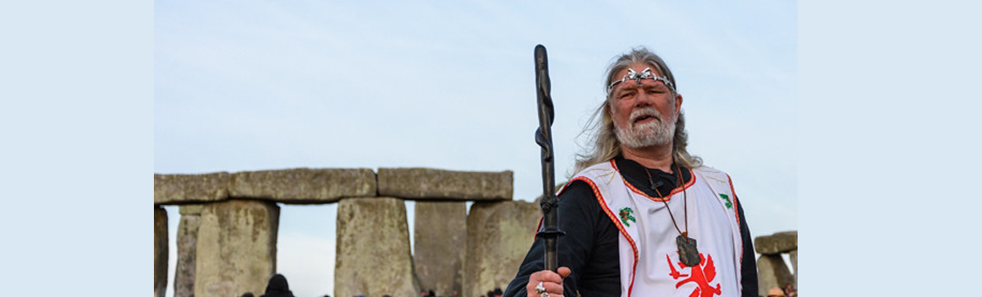

***King Arthur Pendragon*** *(*[*https://www.flickr.com/photos/starsphinx/42247793224*](https://www.flickr.com/photos/starsphinx/42247793224)*)*

One of the most important and best known features of Stonehenge is that the sun during the winter and summer solstices rises and sets in perfect alignment with the massive stones of the site. During these times a local Druid will perform a special ritual and as one of their leaders, King Arthur Pendragon, explains about winter solstice *"We are really here to celebrate the rotation of the world, and from now on the days get longer and the sun returns. It's a time of change and hope is renewed - it's the same message from a pagan and Christian perspective. That's the essence of this season - a message of hope."*  
  
Pagans believe that the summer solstice also has a special power, as a time when the veil between this and the next world is at its thinnest. Singing, dancing and music are central to today's celebrations across Europe.