**Article 3: Charities' response to poverty**

Think about your local high street in Llanelli, Swansea, Aberystwyth, Wrexham, Caernarfon or wherever. Bangor was a popular shopping location - Debenhams, H&M, Burtons, Topshop, Dorothy Perkins. Unfortunately, all these shops closed down. Why? Covid-19? On-line shopping? What replaced them? Empty shops usually. Some blamed charity shops but the reality is that these save the high street to some extent. Here are examples of some that can be seen in Bangor:

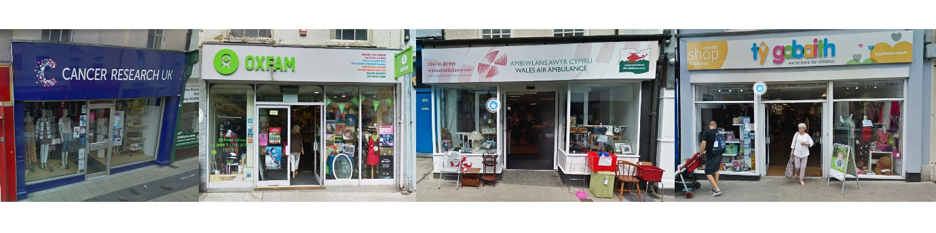

**Christian Aid**

The Christian Aid charity had an office on Bangor high street but it may not have been as prominent as some of the other charities. Officers are now (after Covid-19) working from home. On the other hand, work undertaken by this Christian charity since it was established at the end of the Second World War is monumental. The aim of the charity is to **abolish poverty** and ensure **fairness** following Christ's message - especially where it emphasises the need to help others in the Judgement of the Nations parable. Here are his words:

**'For I was hungry and you gave me something to eat, I was thirsty and you gave me something to drink, I was a stranger and you invited me in, I needed clothes and you clothed me, I was sick and you looked after me, I was in prison and you came to visit me... (Mathew 25:35-36)**

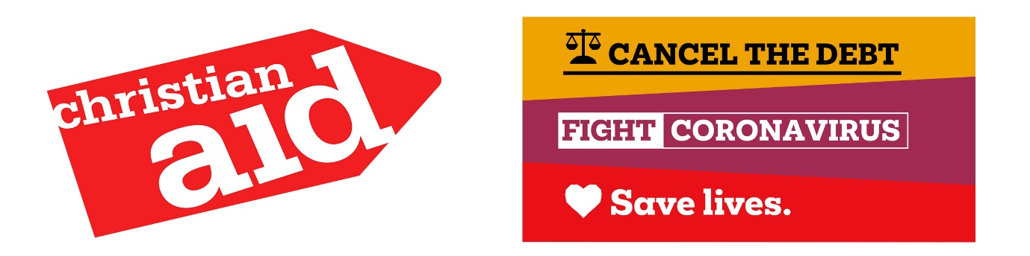

**Christian Aid**

Christian Aid receives support from 40 Christian denominations in Britain. It works with local partners on over 650 projects in 60 developing countries - countries where poverty problems are at their worst. Here is the nature of the work:

**Short Term Aid**

Due to climate change, the sea level is increasing and flooding and storms occur more frequently. When disaster strikes, Christian Aid immediately sends out money and goods. They draw attention to climate change, which is outside the control of poor nations.

**Long Term Aid**

Christian Aid improves the lives of a billion people living in poverty. Aid is provided to grow food, obtain clean water and sewerage, develop education, medical care and to deal with disease.

**Writing-off Debts**

Many developing countries were in debt to western countries. Christian Aid managed to get wealthy countries to write-off these debts,

**‘Drop the Debt’** was the familiar slogan.

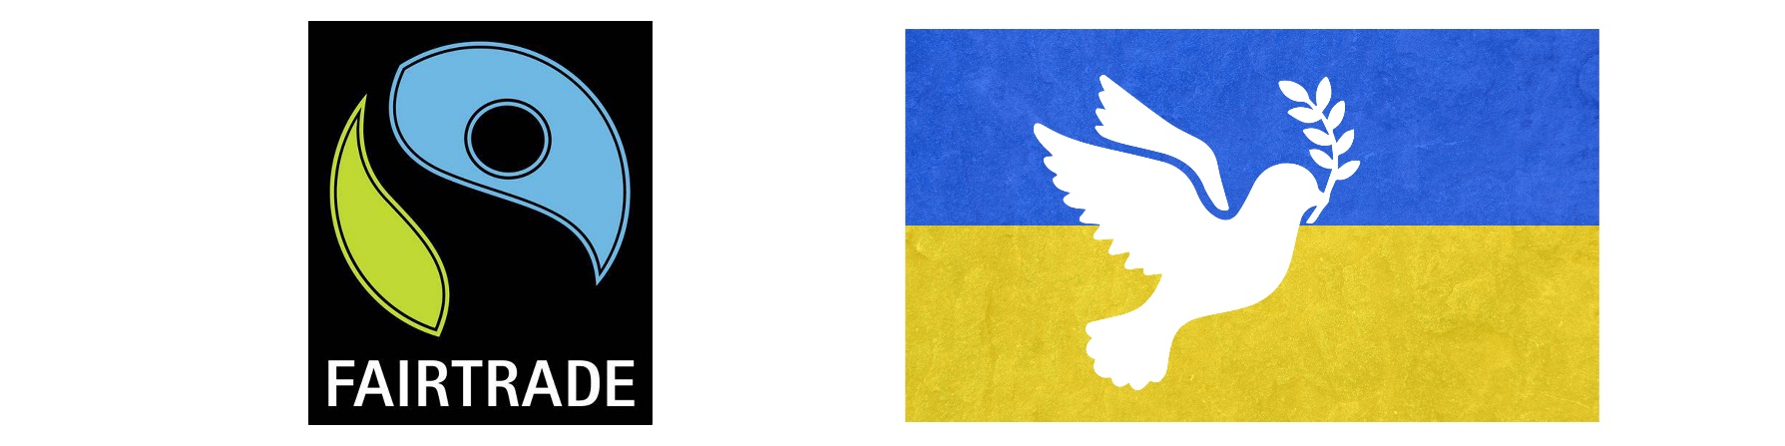

**Fair Trade**

Farmers and food producers do not always receive sufficient payment for produce such as fruit, vegetables, coffee and cocoa beans. The Fair Trade logo became more common in shops by means of Christian Aid campaigns, thus improving the lives of thousands of farmers.

**War and Conflict**

We regularly hear about conflict in many parts of the world. This causes suffering for many, especially refugees. Christian Aid provides food, shelter and medical care.

**Educating and Fund-raising**

**'We believe in life before death'** is one of the charity's familiar slogans. **Christian Aid Week** is an annual event every May. People must be educated about poor people's situation in order to gain support and fund-raise for the work.

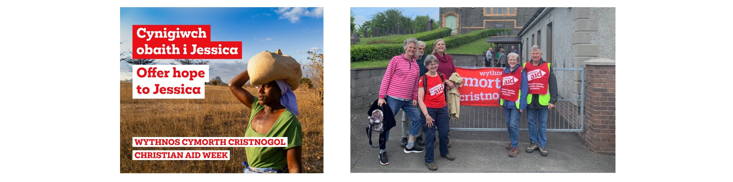

This year, Christian Aid Week emphasised the difficulties of Zimbabwe when dealing with problems of insufficient food production. <https://www.christianaid.org.uk/get-involved/get-involved-locally/prosiect-cymru-zimbabwe> Drought makes it increasingly difficult to ensure that families do not suffer from starvation. Climate change has made drought, flooding and storms more common. Women often undertake the work of growing crops and the campaign draws attention to the tireless work of these women as they seek to ensure sufficient food for their children. There are several videos on the Christian Aid website and YouTube e.g.

https://www.youtube.com/watch?v=VEQub_uxGvM

**Muslim Aid**

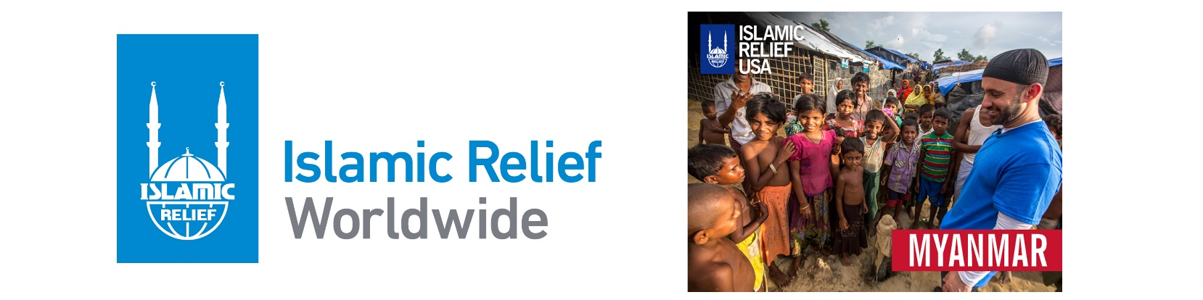

Muslim Aid was established in response to famine in Africa - **'The aim of Muslim Aid is to alleviate suffering; famine, illiteracy and diseases across the work without considering colour, race or belief'.** These are the methods of working:

* Providing aid in a crisis by providing food, water, shelter and medical care immediately after a disaster.
* Providing medical care and educating about health matters - mobile hospitals, vaccination clinics, dealing with diseases etc.
* Many suffer from a lack of clean and safe water. Therefore, water sources, systems and better cleanliness are needed to save lives.
* Establish schemes to provide employment, skills for people to make a living.
* Improve children's quality of life - provide education and care for orphaned children to ensure life opportunities.
* It collaborated with other charities to educate people in wealthier countries about the problems of the poor. This is part of the charity's plans to raise money.

It does not follow that each charity derives from a religious motive; e.g. Oxfam, Comic Relief and the numerous charities seen on the high street that are involved with different conditions and diseases; e.g. Tenovus, Air Ambulance etc.

**Teams4U**

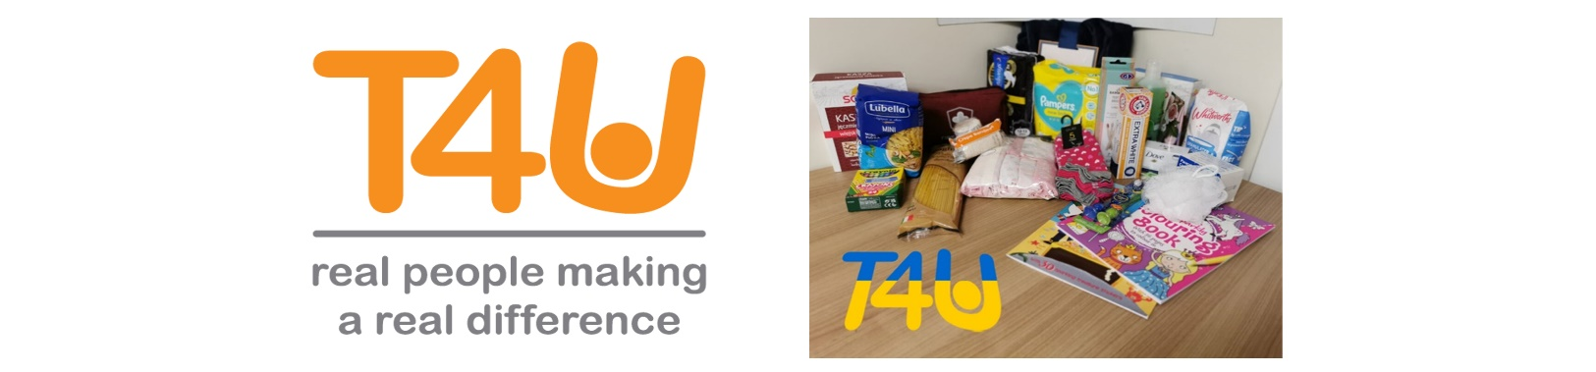

One charity that received attention in Wales recently is Teams4U which is located near Wrexham. It was established in 2006 with the aim of helping children across the world. According to the founder **‘I established Teams4U as I wanted to give people, who wanted to help, the opportunity to do more than just give money'.**

Certainly, the need to help children has become apparent in Ukraine following the Russian invasion. Teams4U have been busy in a children's home in Chernivtsi. Although the town is a considerable distance from the major conflict, the war has affected the children's home there. Ten children were being looked after in the Magala children's home but in March, 42 children were sent there from the Donbass region after a home was destroyed there by bombs.

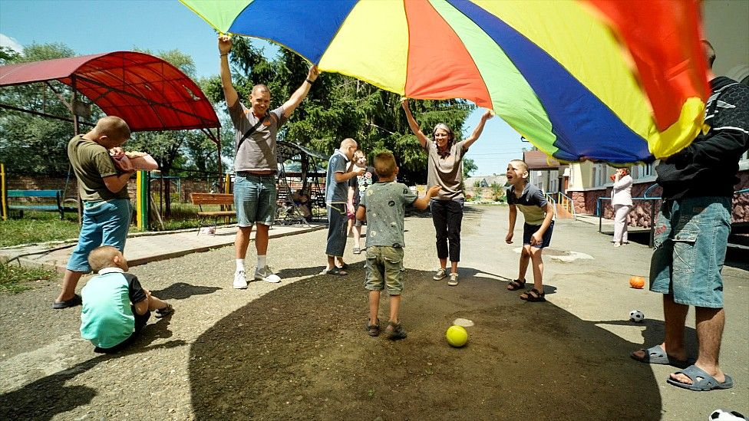

The charity has shared toys, food and other essential items in the home. They have funded new toilets that were much needed. According to Simon Cooke, **‘For those who have given us money and donations, thank you. They are going to the right places. The children are being fed as a result of donations from people back home. But please do not stop. The war has not ended'.** Dr Ruth Wyn Williams, lecturer and specialist learning disability nurse originally from Abersoch, accompanied Simon on the visit. She says that more assistance is needed as staff and resources; **‘Staff are trying their best with the available resources. But there are no resources here. Looking around, there are no toys, no clothes that fit properly and the children want something to do'.**

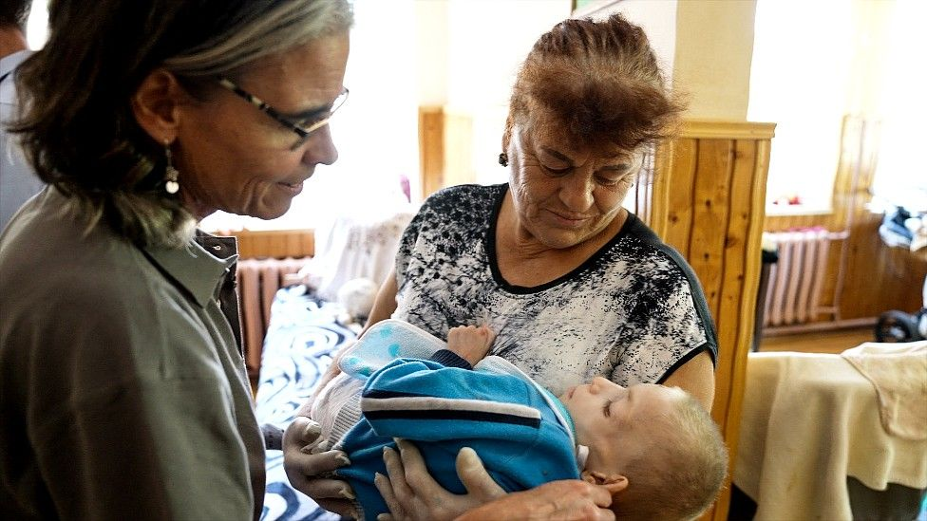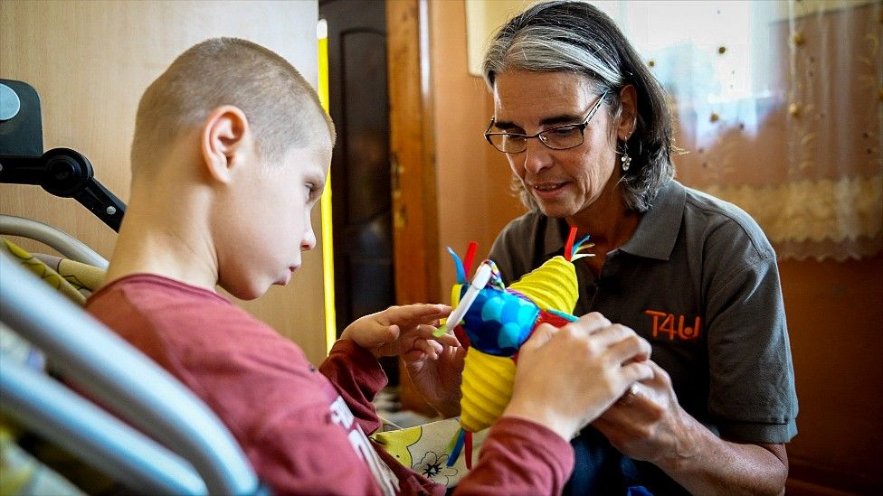

A report about the work appeared on S4C News. It was seen that the children were very thin. 20 boys were in a yard for hours with only one staff member to keep an eye on them. There were no balls or games for them to play. Some laid down on the floor and others wandered aimlessly. These were children with all kinds of mental and physical difficulties and without staff the situation is impossible - there was no choice but to tie one boy to a chair. This is only one example of suffering among children in Ukraine. It is difficult to fathom the suffering across the country thanks to the merciless and cruel invasion of Russia. Here is a report from S4C News: <https://newyddion.s4c.cymru/article/9053>

Here is an article on the BBC website:  
**BBC : Ukraine orphanage struggles as children flee war** - by Gwyn Loader (Newyddion S4C)  
[https://www.bbc.co.uk/news/uk-wales-62220152/](https://www.bbc.co.uk/news/uk-wales-62220152)