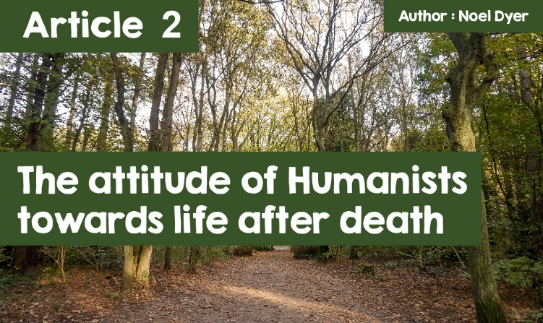

**The attitude of Humanists towards life after death.**

The first obvious question is **'What is Humanism?'** The majority of people would answer the question in a similar way to this - **'Humanism is an attitude towards life that is based on reason and what we share as people. It recognises that values are found in human nature and in the human experience (and not in any supernatural being or God).'**Therefore, it is not possible to describe Humanism as a religion!  
  
By looking at this definition, it is unsurprising that a number of the great thinkers and scientists of the past considered themselves as humanists. There is a long list of patrons on the official Humanists UK website. These include a number of figures from the field of entertainment: **Ricky Gervais, Sandi Toksvig, Stephen Fry, Tim Minchin** and **Simon le Bon**; famous authors such as **Ken Follett, Ian McEwan** and **Salman Rushdie**; as well as numerous members of parliament. In Wales, **Dr Iolo ap Gwynn** and **Leanne Wood** are prominent patrons.

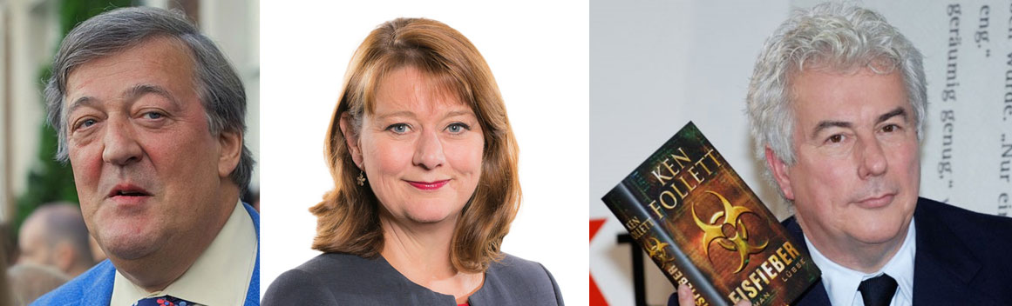

***STEPHEN FRY****- (US Embassy London, Public domain, via Wikimedia Commons),****Leanne Wood****- (National Assembly for Wales - CC BY 2.0),****Ken Follet****- (Blaues Sofa - CC BY 2.0)*

For a full list of patrons, visit: <https://humanists.uk/about/our-people/patrons/>

**What do Humanists believe about life after death?**

Humanists reject the belief that there is a supernatural being, such as a God. They consider themselves as agnostic or atheists. Therefore, it is unsurprising that they reject the idea of life after death. They focus on the present by being involved with people's well-being and happiness in the here and now as they believe this will be the only life. They believe that everyone needs to get the most out of their life while on earth. They also believe that everyone has a duty to do their best for others so everyone can have the best possible life. As they are concerned about the future generation, they view solving environmental problems as an important role for humanity.





***Wales Humanists Logo & Humanists UK*** *(© Humanists UK)*

**Do humanists have burial practices?**

Like everyone else, humanists need the opportunity to grieve and to say farewell to loved ones, by paying tribute to them. It is possible to hold the funeral in a public cemetery, crematorium or green burial site. Humanists have specific members who can undertake the work of organising with the family and lead. It is possible for a person to make their own choices in advance. Otherwise, close family will be consulted regarding the arrangements. There will be practices such as lighting a candle in memory of the person who passed away but there are no prominent religious elements. Emphasis is on the celebration of life and mention of the person living on in another life is avoided. Memories, family and the impact of their good work are the things that remain.

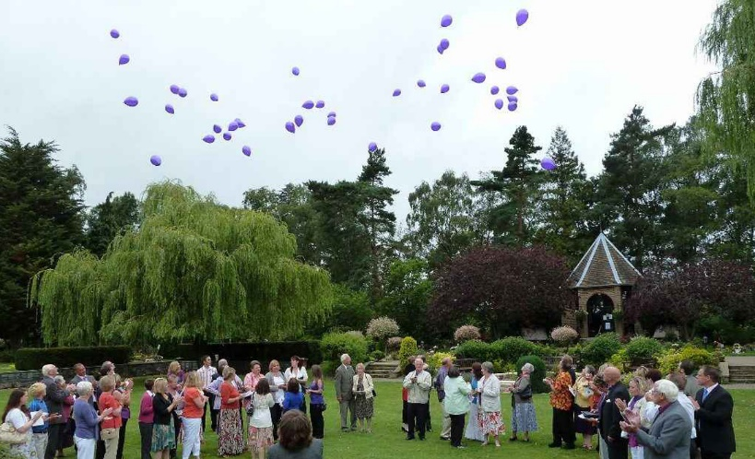

***Humanist funeral ceremony:***

*family members and friends meet to celebrate the life of a loved one who has passed away.  
(© HUMANISTLIFE.org.uk)*

There is no specific plan and every ceremony is different. Here are some of the usual elements:

* The leader welcomes the mourners to the accompaniment of opening music;
* Reflect on the life of the person who passed away giving thanks;
* Family member or close friend pays tribute remembering the life and contribution of the person who passed away;
* Readings from a favourite poem or prose;
* A further opportunity for mourners to reflect on their loss and memories;
* The burial itself when the body is interred in the ground ( cremation is also possible);
* Music to conclude;
* There may be an opportunity for everyone to get together to chat and reminisce in a more social environment.  
    
  Humanists have now got representatives across Wales and it is possible to organise a funeral through them in any part of Wales.

**The Eternal Forest.**

One unique burial site is the one in Boduan near Pwllheli - Boduan's Eternity Forest. It was established twenty years ago on a seven acre site and it offers an alternative for people in the north-west. Indeed, those who have taken advantage of the alternative is full of praise:  
  
***“We are so pleased we chose the Eternal Forest as our final resting place - it is such a beautiful site... Thank you for everything."  
  
"Thank you so much for your kindness and sympathy... You have created something special and I'm sure it will bring peace to many people for generations."***

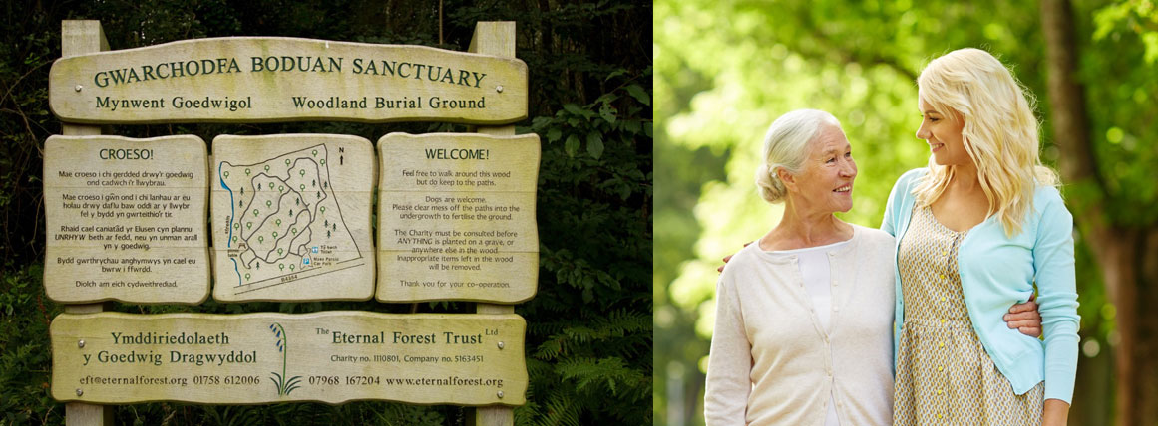

***Boduan Sanctuary Reserve Sign***

*Forest Cemetery. (© Memorialise.co.uk)*

Those who are buried there will literally become a part of the forest and will be part of the forest's life cycle. This is deemed as something sustainable that does not harm the environment in any way - which is different to cremation that produces carbon emissions. Therefore, the ethos of the charity is respect towards life, emphasising that all forms of life are inter-linked. They seek to help mourners to face death by accepting the peace and harmony of the forest as a soothing balm. The content of the ceremony etc. is the family's choice, and whether to follow a secular or religious path.

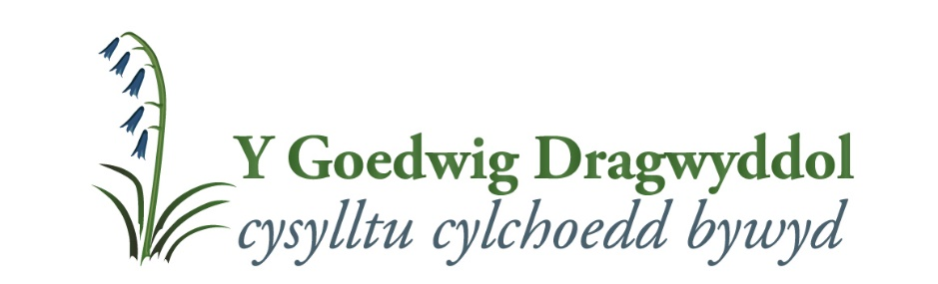

***The Eternal Forest***

The charity summarises its message in four objectives:  
  
**1. Offer the forest as a resource to the public;  
  
2. Educate about our indigenous forests;  
  
3. Offer and maintain a green burial site;  
  
4. A sanctuary for mourners.**  
  
One visitor to the site was **Kate Humble** for her programme ‘Off the Beaten Track’ – <https://www.bbc.co.uk/programmes/p07l2117>

**How do humanists remember?**

People's methods to remember a family member or friend are very personal and are up to the individual. On the other hand, humanists offer memorial ceremonies. This is an opportunity for family and friends to gather later to remember in some way. This is an opportunity for everyone to gather in time. An opportunity to celebrate life with family and friends and in any location - the garden, park, forest, beach or wherever. This is an informal occasion in order to remember and celebrate. It can be used as an opportunity to scatter the ashes of the person who passed away if a cremation previously took place.  
  
To summarise, Humanists focus on the present to live a happy life as this will be the only life and that everyone needs to get the most out of their lives.