**Religion, Values and Ethics E-magazine: June 2023**

**Title: Forgiveness**

| **Titles** | **Forgiveness - Christianity** | **Forgiveness - Buddhism** | **Forgiveness - Islam** |
| --- | --- | --- | --- |
| **Logic** | **DISCLAIMER:** The Teachers' Notes have been updated so that the resource can be used through Curriculum for Wales. However, the content of the articles has been archived and the information has not been updated. The articles are kept on the website as the content is still relevant to Curriculum for Wales: Religion, Values and Ethics.  **The four purposes of 'Curriculum for Wales - A curriculum for life'**  **By learning about Special Places in their Religion, Values and Ethics education lessons, there will be opportunities for learners to develop [as/into]:**  • Ambitious, capable learners who can explain the ideas and concepts they are learning about;  • Healthy, confident individuals who have secure values and are establishing their spiritual and ethical beliefs;  • Enterprising, creative contributors who give of their energy and skills so that other people will benefit;  • Ethical, informed citizens who engage with contemporary issues based upon their knowledge and values.  **RVE in The Curriculum for Wales**  By reading and using the articles in their Religion, Values and Ethics lessons, learners will have opportunities to:   * Engage with and explore ultimate and philosophical questions * Undertake enquiries and engage with sources of wisdom and philosophies * Develop and express their own informed viewpoints * Use their knowledge and understanding of religious and non-religious worldviews to think critically about their own values * Explore the ways in which religion and non-religious philosophical convictions have influenced human experience throughout history * Evaluate and use evidence from a range of religious and non-religious sources to engage with ethical and moral issues * Explore the beliefs and practices of the people in their community, Wales and the wider world and respond sensitively to them * Develop secure values and establish their own ethical beliefs and spirituality * Discuss and reflect on their own perspectives and those of others   **The RVE lens**  By reading and using the articles in their Religion, Values and Ethics lessons, learners willhave opportnities to explore a range of RVE concepts through **the sub lenses below:**  • Search for meaning and purpose;  • The natural world and living things;  • Identity and belonging;  • Authority and influence;  • Relationships and responsibility;  • Values and ethics;  • The journey of life;  *Please note that RVE is locally determined through an agreed syllabus. Each local authority has its own agreed syllabus for RVE that schools must have regard to. All agreed syllabi have had regard to the Curriculum for Wales framework and RVE guidance referenced above and below.  **Useful Links:**  **The RVE Guidance -** [**https://hwb.gov.wales/curriculum-for-wales/humanities/designing-your-curriculum/#religion,-values-and-ethics-guidance**](https://hwb.gov.wales/curriculum-for-wales/humanities/designing-your-curriculum/#religion,-values-and-ethics-guidance) **Hwb Humanities Guidance -** [**https://hwb.gov.wales/curriculum-for-wales/humanities**](https://hwb.gov.wales/curriculum-for-wales/humanities)  **Statements of What Matters -** [**https://hwb.gov.wales/curriculum-for-wales/humanities/statements-of-what-matters/**](https://hwb.gov.wales/curriculum-for-wales/humanities/statements-of-what-matters/) **Cross-cutting Themes -** [**https://hwb.gov.wales/curriculum-for-wales/humanities/designing-your-curriculum/#cross-cutting-themes**](https://hwb.gov.wales/curriculum-for-wales/humanities/designing-your-curriculum/#cross-cutting-themes) | | |
| **Key words** | Revenge/vengeance – The feeling of wanting to pay someone back for what they have done to you, e.g. If someone hits me then I try to hit them back in a worse way.  Holocaust - Hitler's attempt to murder all the Jews in Europe during the Second World War.  Peter – Simon Peter, one of Jesus' first disciples.  Parable – a story with a lesson.  Gospel of Matthew – one of the four books in the New Testament that gives the story of Jesus' life and teachings. The other three are Mark, Luke and John.  Sinning – to transgress against God or another person.  Accounts – the financial record of the money that has been received and spent in a business.  Repentant/repent – feeling bad that you have said or done something to harm another person and which leads to asking for forgiveness.  Apartheid – the political system of keeping black people and white people apart and of treating black people unfairly. This was a system that existed in South Africa and in some states of the USA. | Inner Peace – a mental and spiritual feeling of being at peace.  Buddha – one who is enlightened with special knowledge and understanding; it can refer to a particular individual such as the founder of Buddhism.  Dalai Lama – one of the 14 foremost spiritual leaders of Tibetan Buddhists.  Non-violent means – acting in a way that does not harm another person.  Nobel Peace Prize – an annual award given to a person who has made a special contribution to peace. | Allah- God  Compassionate- Feeling or showing sympathy and concern for others.  Diverse- People from a range of different social and ethnic backgrounds.  Extremism- The activity of conducting acts by any means to express views which justify or glorify terrorist violence.  Forgiveness-The action or process of forgiving or being forgiven.  Fundamentalism- A movement or attitude stressing strict and literal adherence to a set of basic principles.  Hadith- A record of the words and actions of the Islamic Prophet Muhammad.  Islam- One of the major world religions.  Muslim- A follower of Islam.  Peace- A state of no conflict.  Peace be upon Him- Said by Muslims after saying Prophet Muhammad’s name as a sign of respect.  Qur’an- The Islamic holy book.  Reconciliation- The restoration of friendly relations.  Shahada- One of The Five Pillars of Islam, The belief in one God (Allah).  The 5 pillars of Islam- The five core beliefs of Islam. |
| Search words | Revenge/vengeance  Holocaust  The Christian Religion  Peter  Parable  Gospel of Matthew  Debt  Crucifixion  Anthony Walker  Gee Walker  To murder  Nelson Mandela  South Africa  Apartheid  President  Prison  Rainbow Nation | Peace of mind  Buddha  Dalai Lama  Monk  Spiritual leader  Non-violent means  Nobel Peace Prize | Allah  Compassionate  Diverse  Extremism  Forgiveness  Fundamentalism  Hadith  Islam  Muslim  Peace  Peace be upon Him  Qur’an  Reconciliation  Shahada  The 5 pillars of Islam  Sheol |
| Extended tasks |  | | |
| Classrom tasks | 1. Discuss in groups and as a class whether it is possible to forgive without forgetting. 2. Create a blog on the Christian teaching about forgiveness. Does this expect too much from Christians? 3. Research the history of other individuals who have forgiven those who committed terrible crimes against them. Prepare a short biography of the person. 4. Are there some crimes that cannot or should never be forgiven? Write an article expressing your opinion. 5. Ask your fellow pupils for their opinion on forgiveness. Film a video of their response. 6. Prepare a questionnaire for people in your community on forgiveness and analyse the data collected. | 1. It seems that there are some things within Buddhism which are impossible to forgive. Make two columns – Things to forgive / Things that are difficult to forgive. Give reasons for your choice of column. 2. Research further into the title of Dalai Lama. Gather information about the way this leader is chosen. 3. From a very young age, the Dalai Lama was raised to live the life of a monk. What is the nature of a monk's life in Buddhism, especially in Tibet? Is this kind of life appealing? 4. The people of Tibet follow a special form of Buddhism. Gather information about the country and what is special about the people of Tibet. 5. The Dalai Lama received the Nobel Peace Prize in 1989. Why do you think he deserved to receive this special award? 6. Try to come up with six or more quotes of your own that explain how essential forgiveness is in life. 7. Search for video clips where the Dalai Lama talks about forgiveness. Try to analyse his message in these clips, e.g.   <https://www.youtube.com/watch?v=deJeN36EnY8>  <https://www.youtube.com/watch?v=TaxZLcREoh4>  <https://www.youtube.com/watch?v=etRLJttD9Rc> | 1. How much do you agree with these statements? Write your answer out of 10, with 1 being “completely disagree” and 10 being “completely agree”.   -Justice means ‘an eye for an eye’ (revenge) -If people are truly sorry, they should be forgiven. - There are some acts that should never be forgiven. -People who do wrong to others get what they deserve. - You should forgive, but never forget. - Forgiveness is something we do for ourselves, not for others.  Find more tasks on the bottom of the document. |
| **Further resources** |  |  |  |

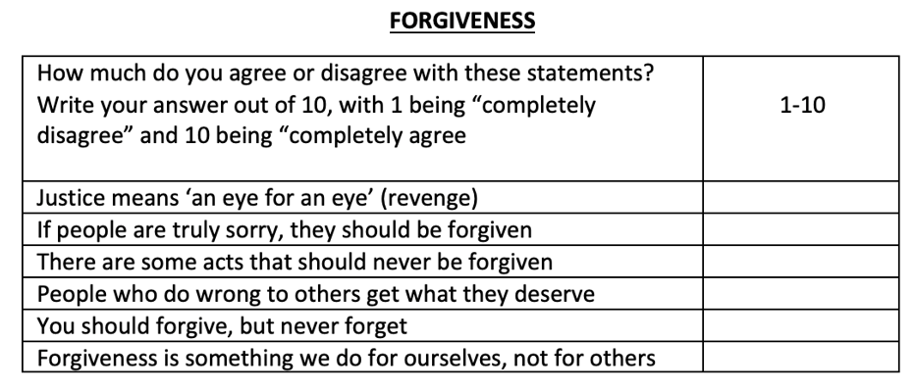**2**

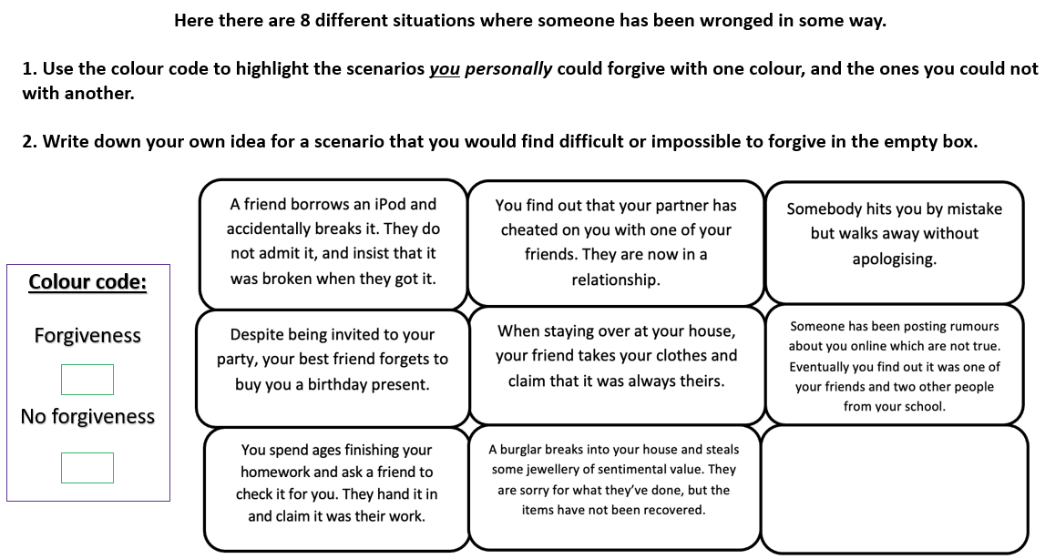**3.**

**4.**

**Here are 5 quotes about forgiveness from Islam.**

**Underneath each, explain what you believe is the true meaning of each.**

(Move the purple boxes to check your answers)

1.“We have not created the heavens and the earth and everything in between except for a purpose. And the Hour is certain to come, so forgive graciously.” (Quran 15:85)

In this verse, we are reminded that our time on this earth is limited – thus we must try to understand the importance of forgiveness. If we ourselves hope to be forgiven for our own wrongdoings, we need to forgive and pray for the forgiveness of others.

2.“And the retribution for an evil act is an evil one like it, but whoever pardons and makes reconciliation – his reward is [due] from Allah. Indeed, He does not like wrongdoers.” (Quran 42:40)

Allah will reward those who are able to forgive. While it may be difficult, we must understand the importance in reconciling with those we may have never thought possible of being forgiven.

3.“And whoever is patient and forgives – indeed, that is of the matters [worthy] of resolve.” (Quran 42:43)

The Quran reminds us that being patient and being able to forgive are two sides of the same coin. We must strive towards reconciliation and forgiveness for the betterment of our society.

4.*“It is by Allah’s mercy that you are gentle to them; and had you been harsh and hardhearted, surely they would have scattered from around you. So excuse them, and plead for forgiveness for them, and consult them in the affairs, and once you are resolved, put your trust in Allah. Indeed Allah loves those who trust in Him.” (Quran 3:159)*

In the eyes of Allah, to forgive is to trust Allah as well. We must trust that Allah Sees everything, and remember that the only One worthy enough to judge our actions is Allah Himself – we must forgive and trust that Allah will always reward us for what we deserve.

*5.“Do not let the people of virtue and affluence among you swear to suspend donations to their relatives, the needy, and the emigrants in the cause of Allah. Let them pardon and forgive. Do you not love to be forgiven by Allah? And Allah is All-Forgiving, Most Merciful.” (Quran 24:22)*

Just as we love to be forgiven and shown mercy by Allah, we must strive towards showing mercy and forgiveness in our own lives – as Muslims, this is the least we can do in showing how much we love Allah.