

Imagine for a moment that you live in a country where the group you and your family belong to is treated differently from the rest of the country's population. You don't get the same rights as most and you aren’t allowed to speak your own language, or follow your own culture or religion. The authorities blame you for many of the problems in the country and this, in turn, leads to great hatred of you by the majority of society.

You are subjected to verbal and physical attacks and members of your family are arrested and detained without charge and, while there, they are tortured in horrific ways. You have some kind of choice - stay and suffer or flee to another country where you can live free from fear and violence. Now, stop imagining and look at the real situation that exists in countries around the world. Situations that force people to flee for fear for a number of reasons, for example, race, religion, sexuality, social group or political views. Many also flee due to war or natural disasters.

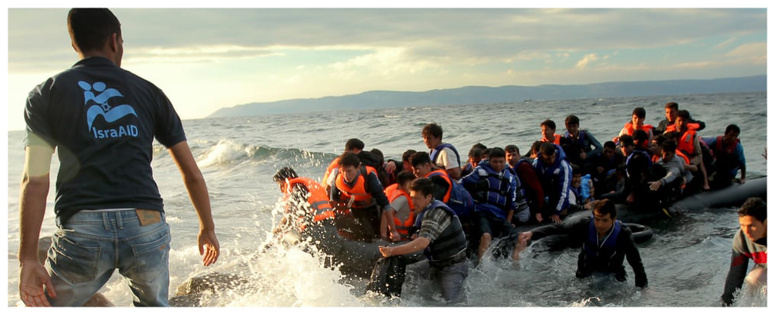

**What are our rights? What are our responsibilities?**

The United Nations Universal Declaration of Human Rights sets out the basic rights that all human beings should have – irrespective of who they are or where they come from. The countries of the world agreed that these rights are necessary to ensure that every person has a level playing field in life. Many are relevant to the situation of refugees. Article 3 states:

**Everyone has the right to life, liberty and the security of person.**

And Article 14.1 clearly states:

**Everyone has the right to seek and to enjoy in other countries asylum from persecution.**

One of the main reasons why people flee and seek refuge in another country is the lack of religious freedom - they are not allowed to follow their own beliefs, customs and festivals. Article 18 states:

**Everyone has the right to freedom of thought, conscience and religion; this includes freedom for them to change their religion or belief, and also freedom, either alone or with others, publicly or privately, to manifest their religion or belief through teaching, professing, worshiping and observing rituals.**

**Have the Welsh had to flee for religious reasons?**

Unfortunately, in today's world these rights are only a dream for thousands and thousands of people. Yet having to flee for religious reasons is not a feature of the modern world alone. It has happened consistently throughout history in many countries and in many religions. The pursuit of religious freedom was the main reason why Quakers, including many from all parts of Wales, left Britain in the 17th century and set sail for America and settled in Pennsylvania. William Penn, founder of the Quakers, believed that there was some God in every person and that there was no need for a church, officers or services to enable a person to connect with God. At that time, the Anglican Church had great political power and believed that the Quaker message was an attack on the Church and its teachings. The Quakers refused to swear an oath of allegiance to the King or go to church. They were considered a threat to society and, therefore, many Quakers were persecuted and imprisoned for their beliefs. In fact, between 1662 and 1670 some 6,000 Quakers were imprisoned. There was no choice but to flee to another country in order to have the freedom to pursue their own beliefs.

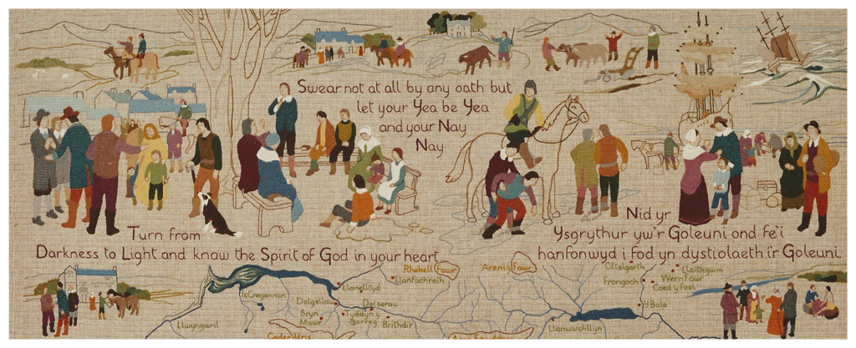

**Who are the current religious refugees?**

In today's world, the most prominent refugee situation is the Syrian situation and within that situation many are fleeing because they are seeking religious freedom. The conflict started in 2011, mainly for political and economic reasons but, today, the situation is much more complicated.

As IS controls parts of the country and many Islamic Jihadists play a leading role in the fighting, the position of the country's Christians is very fragile. They face threats to their faith in all aspects of life - family, community and religious. This is especially true for Christians of a Muslim background. Many churches have been deliberately destroyed. That's why 700,000 Christians, 40% of the population, have had to flee the country.

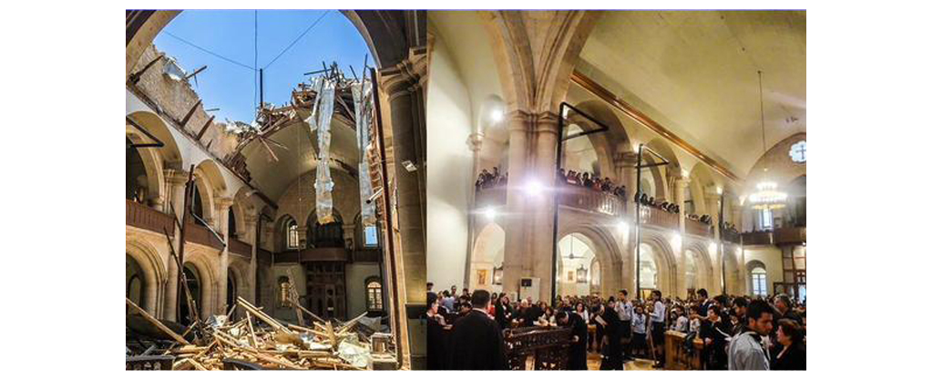

Of course it's not just Christians who are religiously persecuted in Syria and have to flee because of it. IS persecutes anyone, including Muslims, who do not share the same ideas as them. The choice often given is to change to accept IS beliefs or death.

This was especially true in what IS did to the Yazidis in Northern Iraq. The Yazids are a Kurdish society that follows an ancient religion. They believe that God has given seven angels control of the world. They do not believe in Hell. So IS considers them the worshipers of the devil. Many of the men of the Yazids have been murdered and many of the women have been sold as slaves.

Here is a young Yazid girl named Shanar and her description of what happened to her and a hundred other girls captured by IS, some as young as ten - "They forced the girls to change their religion to Islam and then marry an IS member. They beat us on our legs, arms and heads and demanded that we serve them or be sold as slaves. Their intention was to harm us and they enjoyed every minute. The abuse was so terrible we wanted to die. ” In fact many of the women attempted suicide. The only option they had was to flee in one way or another.

