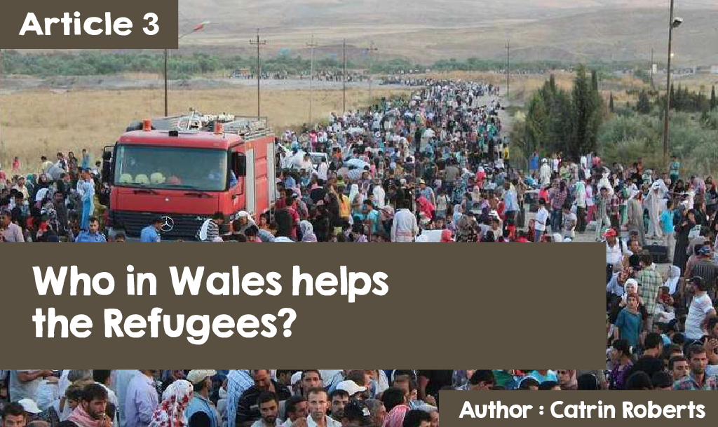

**Imagine it .......**

......... one day you are living in your own home, sleeping in your own bed, going to the local school, playing with your friends, sharing jokes in your own language - and the next day you leave all that is familiar, and move to a place that seems like another world!

That is what is happening to so many, including children the same age as you are today. They must leave because of war, climate change, famine, poverty, and persecution. And the label on these people? - refugees. The charity, Save the Children, has produced two short videos to help children imagine life as a refugee.

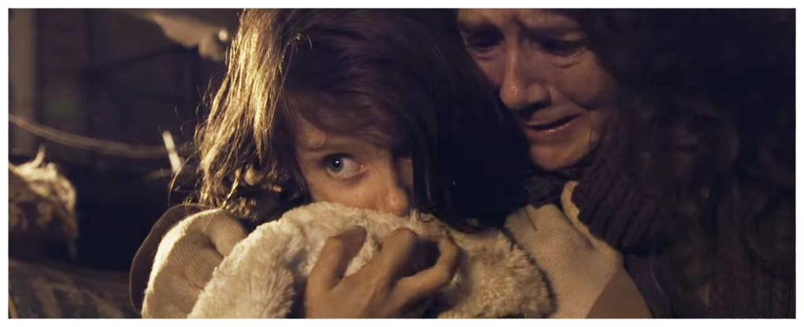

Leaving everything and an uncertain future, after seeing bombs, killings, hunger and more - traumatic! Different countries and organisations try to help refugees by setting up camps for them, but life is extremely hard even then. Year 11 pupil at Ysgol y Gader, Dolgellau, Owain Meirion, volunteered for a while in 'The Jungle' (a now-closed refugee camp in Calais) and was truly shocked; it was a real eye-opener for him. "I realised how privileged our life is, in comparison to these poor, wretched people, who risked everything for a better life," he said.

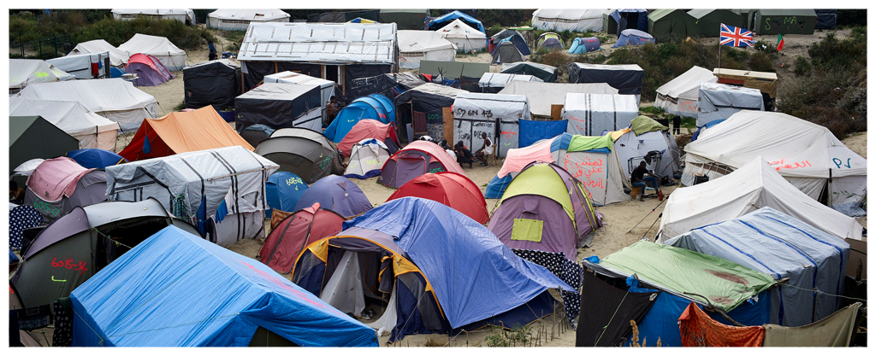

To reach safety, you must face great danger - travelling in fragile boats across seas, with many drowning on the way. You then must go through a complicated process to get permission to move to a country that will provide shelter and security. Only then is there an opportunity to build a new life. However, many refugees dream of returning home.

**What is the Welsh Government doing?**

Here in Wales, the Welsh Government has been at the forefront of assisting and welcoming refugees. They want Wales to be a Nation of Sanctuary and offer refuge to those who have had to leave their homes and their country. Ceredigion was the first area in Wales to house Syrian people and, as a token of their gratitude, one refugee family went out onto the Aberystwyth promenade and shared [flowers](http://www.walesonline.co.uk/news/wales-news/beautiful-moment-syrian-refugees-welsh-11607478). All Local Authorities in Wales have by now welcomed refugees.

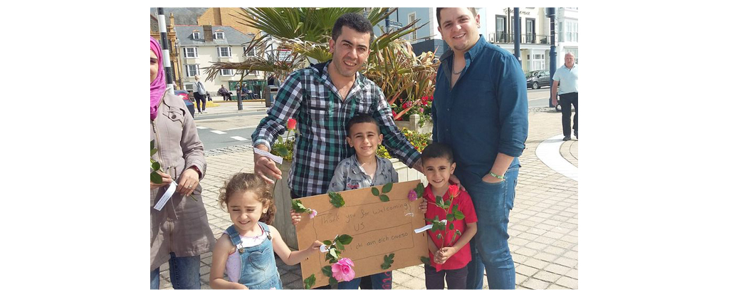

**The response of religious communities to the refugees**

Many Christian denominations in Wales have been at the forefront of helping refugees. The Bench of Bishops of the Church in Wales decided to issue this statement:

God calls on Christians to welcome the stranger and to help those who are frail, homeless, and suffering from injustice. So, we call on our congregations to join us in prayer for all the minorities who have had to leave their homes, for the persecuted, and for refugees. Also, to act, in their favour. This includes:

* Donating to charities directly involved in philanthropic work such as Christian Aid
* Organising refugee groups that become part of our communities in Wales
* Collecting and distributing essential items to the arriving refugees who have nothing
* signing petitions asking the UK to accept a fair number of refugees and provide the financial resources needed to assist them
* Investigating whether there is any church property that could be offered to the agencies as a refuge or suitable refuge home.

When the Presbyterian Church of Wales heard of the great need of Syrian refugees because of the war there, they offered a chapel house that happened to be vacant as a family home. Why do this? Because the Bible requires them to show love to fellow man in word and deed.***"*** **Dear children, let us not love with words or speech but with actions and in truth**.***"***1 John 3.18

Blaenau Ffestiniog Orthodox Church decided to collect necessary supplies for refugees, and some of Ysgol y Moelwyn's pupils went to help with the packing.



Just before Christmas 2016 a group of supporters of the Christian Aid charity from Bethlehem, Carmarthenshire, walked to Egypt in Denbighshire to highlight the great need of refugees and to raise money to support them. The walkers were made very welcome, people offered accommodation and food - and that is what refugees who must leave everything need. The story of the journey can be found here:<http://www.christianaid.org.uk/cymru/news/escape-completed.aspx?Page=2>

Assembly Member, Eluned Morgan, was one who walked the 'Flee to Egypt' tour. She said, ***"At Christmas, people celebrate the birth of the Christ, but they forget that he was also a refugee, having to escape his home and homeland. This is a very timely reminder of the need to think of the true meaning of Christmas and the need to reach out to vulnerable refugees all over the world. "***

Islam's faith communities also help refugees through the charity Muslim Aid. ([muslims.org](https://www.muslimaid.org/)). They raise money to support Syrian refugees in Jordan, Iraq, Lebanon, the UK and within Syria itself.

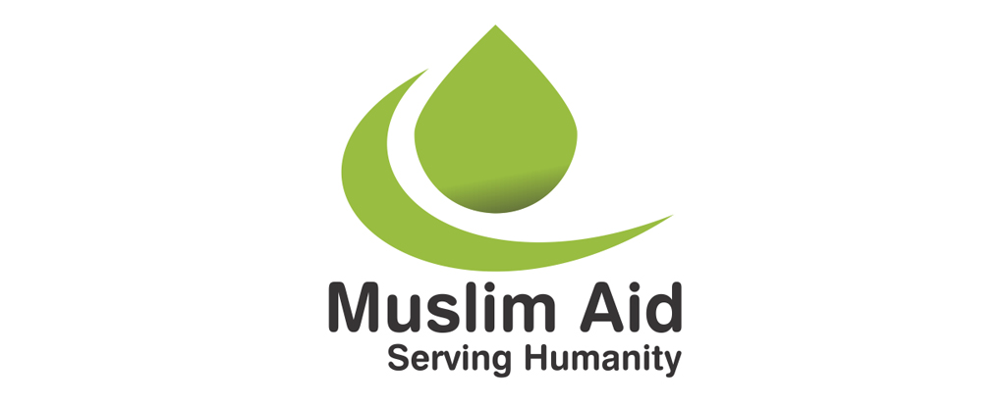

So, too, the charity Islamic Aid UK in response to the Qur'an, which says, “***Whoever saves the life of one person, seems to have saved all of humanity’s life*** *"* Qur'an 5:32

A place to meet, to learn about their new country and learn the language, get practical help and company - that is what is available in centres all over Wales, from people of all faith backgrounds. That is the work of centres, such as Oasis and Trinity House, Cardiff and Community House, Newport.

Cytûn (Churches Together in Wales) works with organisations such as the Welsh Refugee Council and different faith communities to reach out. This is what the Reverend Aled Edwards, Chief Executive of Cytûn has to say, **"For fifteen years, devolved Wales has been particularly welcoming to asylum seekers and Syrian refugees in recent months.**

**There have been distinctly Welsh policies regarding health provision and training schemes such as that for doctors and dentists. In communities across Wales, friends came together to offer hospitality in a most practical way including food, clothing, resources and visits to the worst crisis-hit places, such as Idomeni in Greece and Calais."**

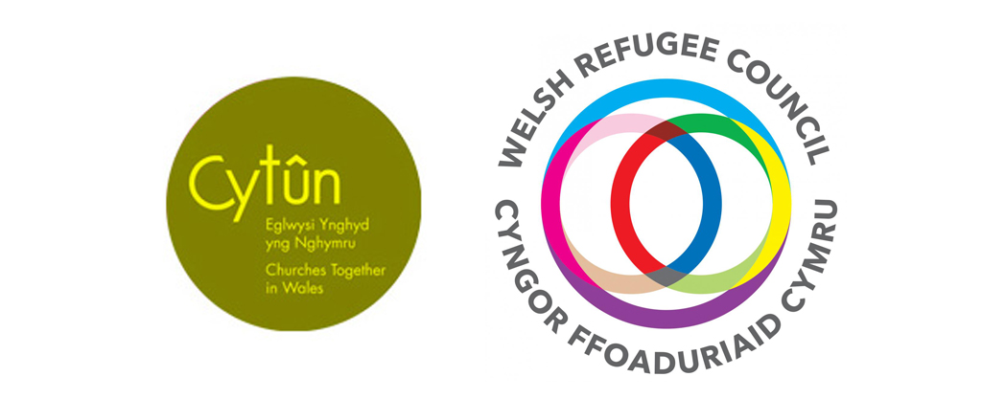

Many Muslims across Wales have been helping the refugees. They believe it is important to do this as Muhammad himself was a refugee at one time (see article 2). The Qur'an teaches that aid must be given to people who must flee and, also, that people in need should be helped. Members of the West Wales Islamic and Cultural Society have been busy collecting money and clothes for refugees.

According to the Chairman, Dr Baba Ghana, the Association also offers practical assistance to the small number of Syrian refugees who have recently moved to the area, for example, help with Arabic to English translation, and religious and spiritual support. A refugee welcome day to the area was recently held at the mosque in Carmarthen. It was an opportunity for everyone to get to know each other, pray and enjoy a delicious meal.

**Different views of refugees**

It must be acknowledged that some are scared when strangers move in among them. Others argue that it is not strangers that need to be looked after, but locals. Some groups have been formed to oppose the refugees coming to Wales. They have organised protests in places like Blaenau Gwent and Llangefni. After a family moved into a Presbyterian Church of Wales house in South Wales, members of the chapel organised a welcome meeting, but did not advertise the meeting - fearing opposition.

But there is another side, too. People all over Wales have formed a 'Wales for All' movement that wants to see love not hate and which says, ***"All human beings, regardless of race, language, culture, religion, gender, sexuality or ability must be respected indiscriminately. We are proud of the rich diversity of the people of Wales and insist that discriminating against any because of their background or attribution is totally unacceptable."***

Pupils at Ysgol Gymraeg Aberystwyth have conveyed this message in a mural indicating that they want to welcome refugees to the area. What do you think?

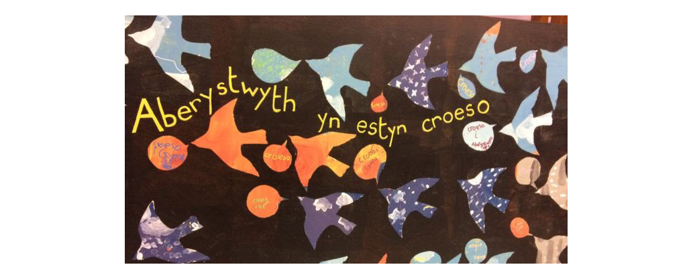

**Aberystwyth extends a welcome**





