# 

# **Vegetarian ism and veganism**

The Oxford Dictionary defines a **vegetarian** as:  
  
**“A person who abstains from eating animal food and lives principally or wholly on a plant-based diet; esp. a person who avoids meat and often fish but who will consume vegetables, dairy products, and eggs.”**

Basically, it's a way of eating that's becoming more popular, especially with all the talk about it in movies and TV shows, and with groups saying it's the right thing to do.

Why do people become vegetarians? Well, there are lots of reasons. Some care a lot about animals and don't want to eat them. Others worry about the environment and how raising animals for food can harm it. And some do it for their health or because of their religion.

|  |  |
| --- | --- |
| Ceri Lois Williams | Beca Wyn Owen |

I talked to three people in Wales who are vegetarians. One of them, Ceri Lois Williams of Dwyran, Anglesey, started when she was 17, as a kind of a personal challenge. She learned a lot about how the meat industry works and decided she was happier without meat. Then there's Beca Owen of Brynsiencyn, Anglesey, who made the switch at 13 because she loves animals and didn't feel right eating them anymore. They both say it's cool if other people still eat meat; they're just doing what feels right for them.

Now, let's talk about something called Ital. It's a way of eating that's part of a religion called **Rastafari**. Basically, it's all about eating natural, organic food straight from the earth. It's not just about being healthy; it's also about being connected to nature and respecting all living things.

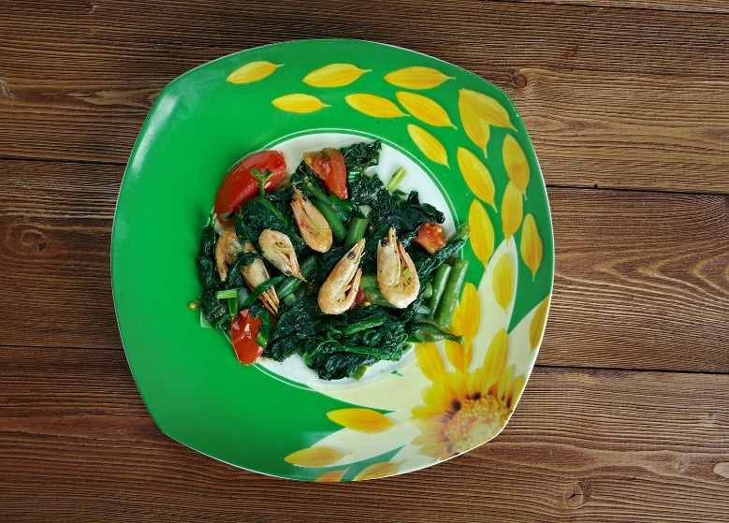

*Callaloo*

India is another place where lots of people don't eat meat. It's actually got the most vegetarians in the world! That's because of three big religions there—Hinduism, Jainism, and Buddhism—that teach about being kind to animals. Not everyone in India is **vegetarian**, and the religions there don’t insist on having a meat free diet, but Indian cuisine stands out as the most plant-based friendly globally, and it isn’t difficult to find an Indian restaurant anywhere with many **vegetarian** dishes on their menu!

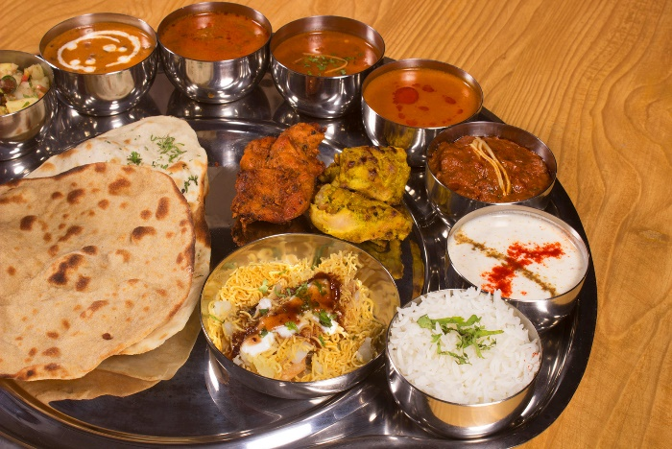

*Indian Thali*

Now, some people take things a step further and become vegans. What's a **vegan**? Well, they don't just skip meat; they also don't eat any animal products like milk, cheese, or eggs. And it's not just about food; they try to avoid using anything made from animals, like leather or certain cosmetics.



Cara Medi Jones

A third person, Cara Medi Jones of Llandegfan, Anglesey, went from being **vegetarian** to **vegan**. She felt weird calling herself an animal lover while still eating meat, so she switched. After doing some research, she learned about how dairy farms can harm animals too, so she decided to cut out all animal products. She says it's not as hard as people think and that you can get all the nutrients you need from a **vegan** diet, except for one vitamin that she takes a supplement for. “I thought veganism would be a much harder lifestyle change and so put it off for a while, however I decided to do **Veganuary** one year and found it so easy I just carried on,” explained Cara.

There's also this idea called **spiritual** ecology, which is all about how our **spiritual** beliefs connect with taking care of the environment. For some people, being **vegan** is part of their **spiritual** journey. They see it as a way to show kindness to animals and take care of the Earth.

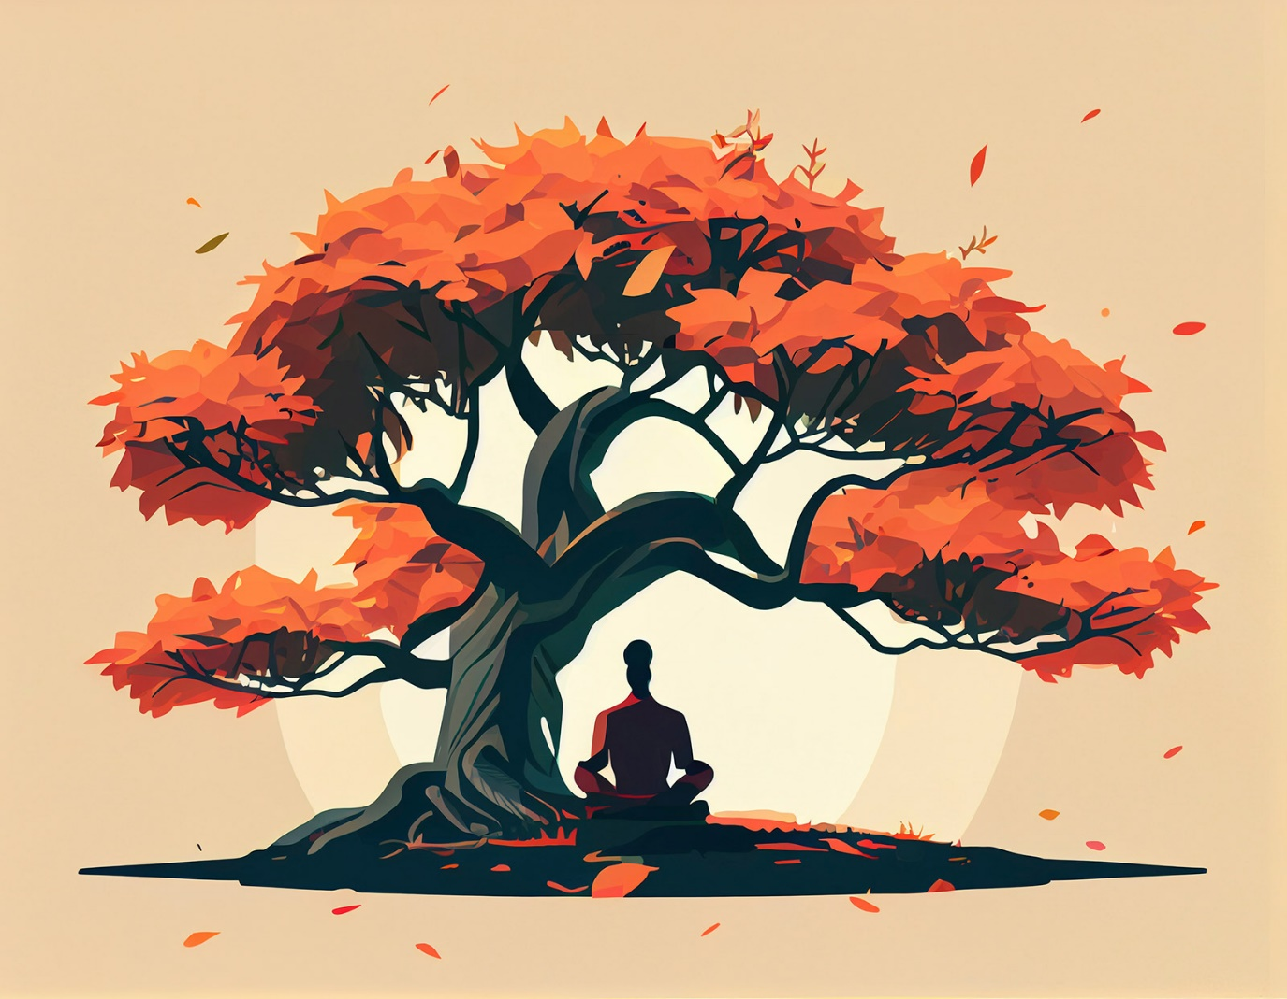

In the end, whether someone's **vegetarian**, **vegan**, or eats meat, it's all about what feels right to them. It might be because of their beliefs, their health, or just what they like to eat. And that's cool! What matters is that we respect each other's choices and try to make the world a better place in our own way.