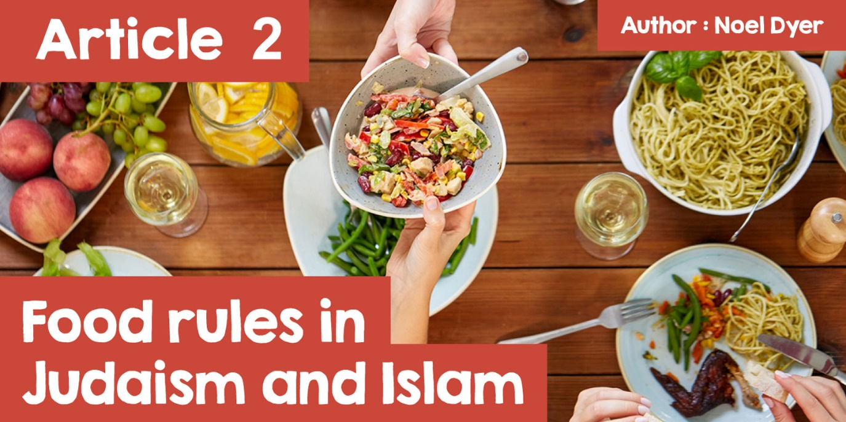

# **Food rules in Judaism and Islam**

**'I have two slices of brown toast with marmalade for breakfast every morning'**  
**'I never drink coffee after seven at night'**  
**'If I have lamb, it has to come from Wales'**  
**'I make an effort to eat fresh fruit and vegetables every day'**

|  |  |
| --- | --- |
|  | *Bwyd Epic Chris (Cwmni Da, S4C)* |

We all have some food rules like these. Those we have created for ourselves somehow. Calling them food habits might be more accurate. On the other hand, many religions have strict rules that a lot of the followers of those religions follow carefully.  
  
**'Where do these food rules come from?'**  
  
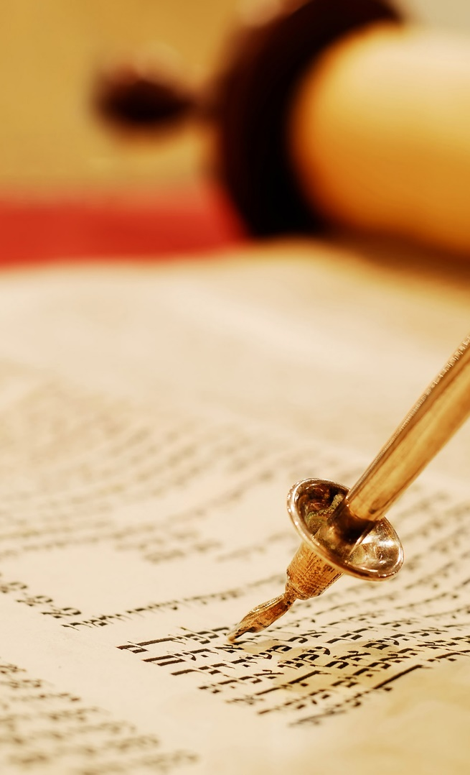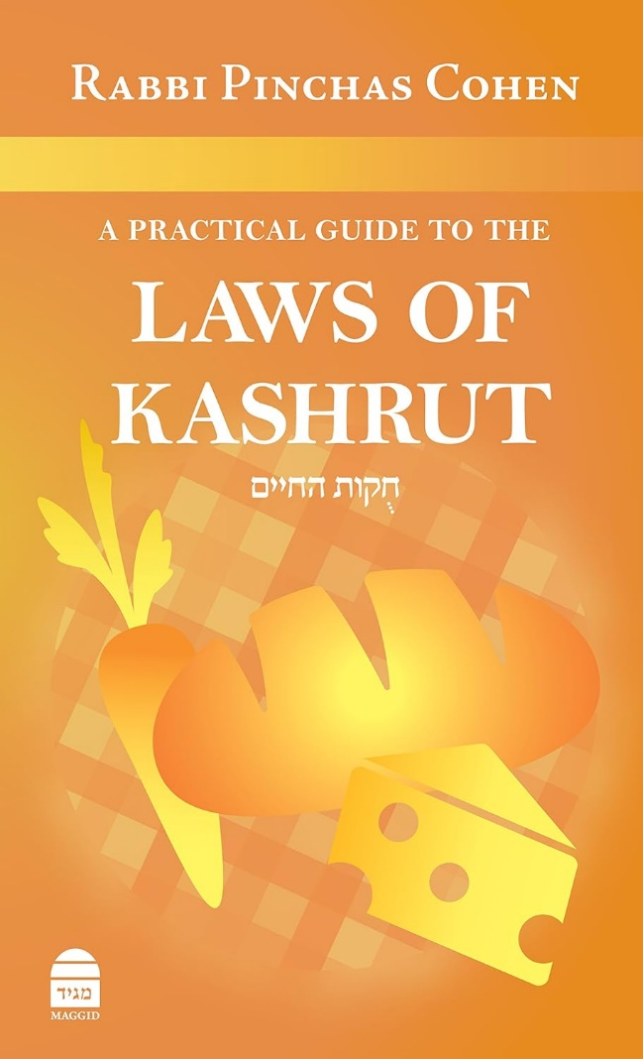

|  |  |
| --- | --- |
|  |  |

The term for the food rules of the Jews is **kashrut**. These rules can be found in the **mitzvot** which are commandments to follow. In terms of food, most of the rules are contained within the Books of Deuteronomy and Leviticus which are a part of the **Torah**, so the rules come from the holy book of the Jews. Many Jews feel that they are following God's commandment by following the rules. Food that is allowed is called **kosher**, which means 'acceptable to eat'. As a result there is food which is not acceptable to eat and the term for that food is **trefah**.

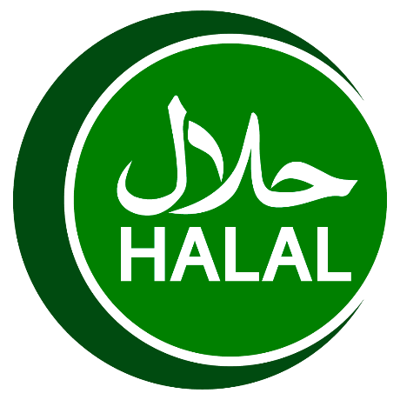

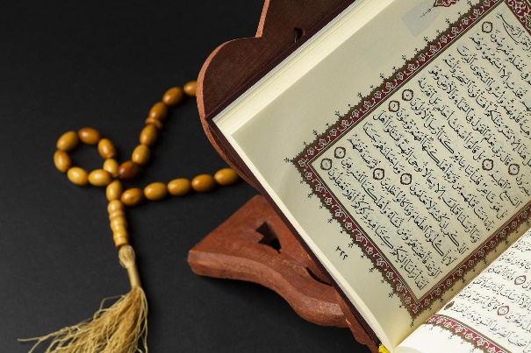

The food rules of Islam come from Islamic law which is based on the **Quran**, the Holy Book, as well as from a collection of traditions attributed to the prophet Muhammad. This collection is known as **Sunnah**. These rules explain which foods are **halal**, (lawful/allowed) and which foods are **haram**, (unlawful/forbidden). By following the rules, Muslims believe that they are obeying Allah.

**'What exactly are these food rules?'**  
  
**Jews:**  
  
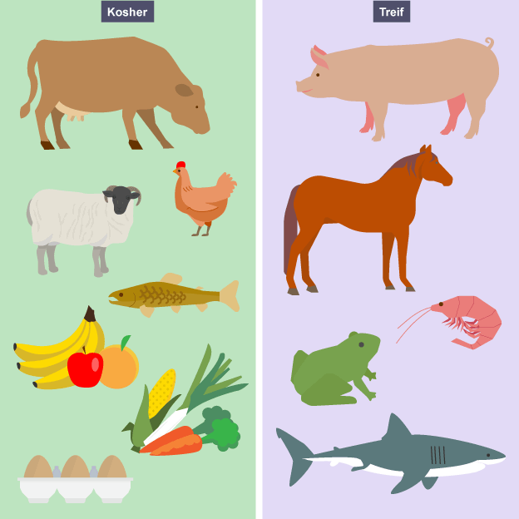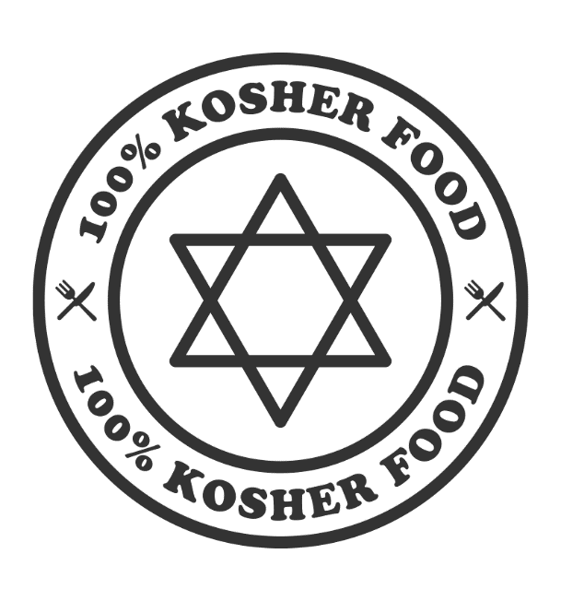

|  |  |
| --- | --- |
| *©* [*https://www.bbc.co.uk/bitesize/guides/zqk8v9q/revision/4*](https://www.bbc.co.uk/bitesize/guides/zqk8v9q/revision/4) |  |

* Land animals must have cloven hooves and must chew the cud (chew grass over and over in their mouth after swallowing it as cows and sheep do);
* Sea and river fish, etc. must have fins and scales, e.g. cod, salmon, etc. Shellfish are not allowed;
* In terms of birds, what is described as poultry is allowed, e.g. chicken, duck, turkey. It is forbidden to eat birds of prey, i.e. birds that hunt and kill other animals;
* It is forbidden to eat meat and dairy together. This is due to the following sentence from the book of Exodus 23:19 in the **Torah**:**'Do not boil a kid [young goat] in its mother’s milk'**. No cheeseburger or lasagne then. This means leaving a long time between eating something containing meat and then eating something containing milk. This also makes things complicated in the kitchen as separation resources are needed;

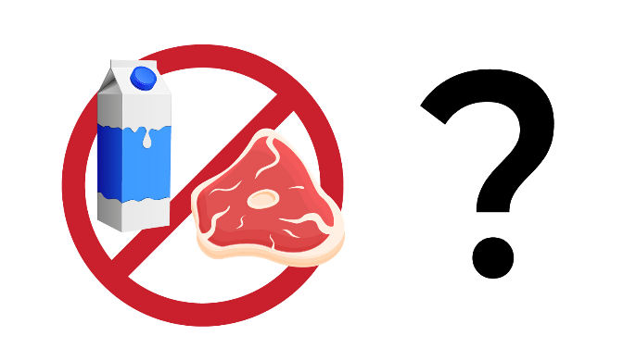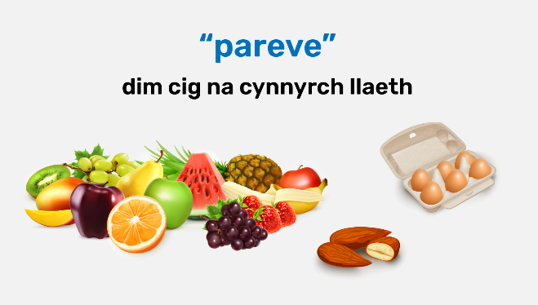

* There is also a class of food called pareve (neutral), vegetables, fruit, pasta and rice, and these can all be eaten with meat or dairy products;
* There is another rule in the Book of Deuteronomy 12:23 which reads as follows: **'Only be sure that you do not eat the blood, for the blood is the life, and you shall not eat the life with the flesh'**. This means that the animal's life is contained in the blood and therefore meat with blood in it should not be eaten. As a result, an animal must be slaughtered in the correct way with a very sharp knife which ensures that all the blood drains from the animal's body, a method called **shechitah**. This must be done by a person trained in the correct way, called a **shochet**.

**Muslims:**  
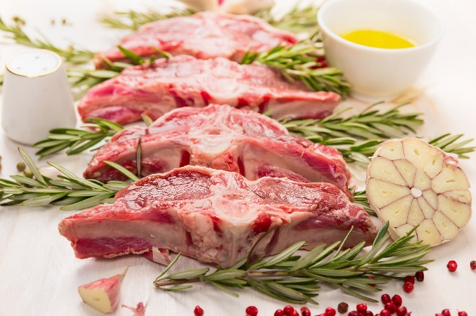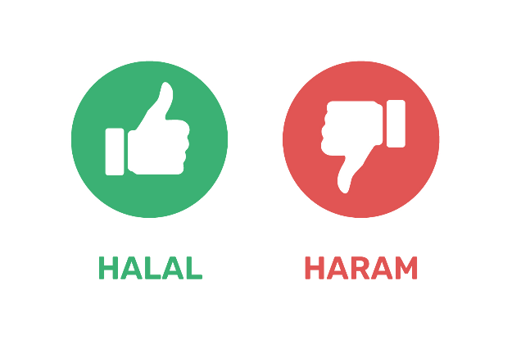

* In general Muslims are allowed to eat everything that is considered good - pure, clean, nutritious and wholesome things. This includes most meats and fish of all kinds, fruits, vegetables, rice, grain, etc. To a certain extent everything is allowed (**halal**) except when it is forbidden;
* In accordance with Allah's rules in the **Quran**, Muslims are forbidden from eating foods that may be bad for health or in terms of hygiene. The following rules are considered to be **haram** (forbidden) - blood, pork of all kinds, drinks containing alcohol, meat that has not been slaughtered according to the rules of Islam;
* All meat must come from animals slaughtered in the appropriate way. Muslims slaughter animals with a sharp knife across the throat, ensuring that the animal does not suffer unnecessarily. Words from the **Quran** are recited and it is made sure that all the blood drains from the animal. Only by following the rules can the meat be called **halal** meat.

**I had the opportunity to ask a Jew and a Muslim who live in Wales about their experiences of adhering to the food rules of their religion.**  
  
*The two who took part have asked us not to share their names.*  
  
**Keeping to the Rules - Jews:**

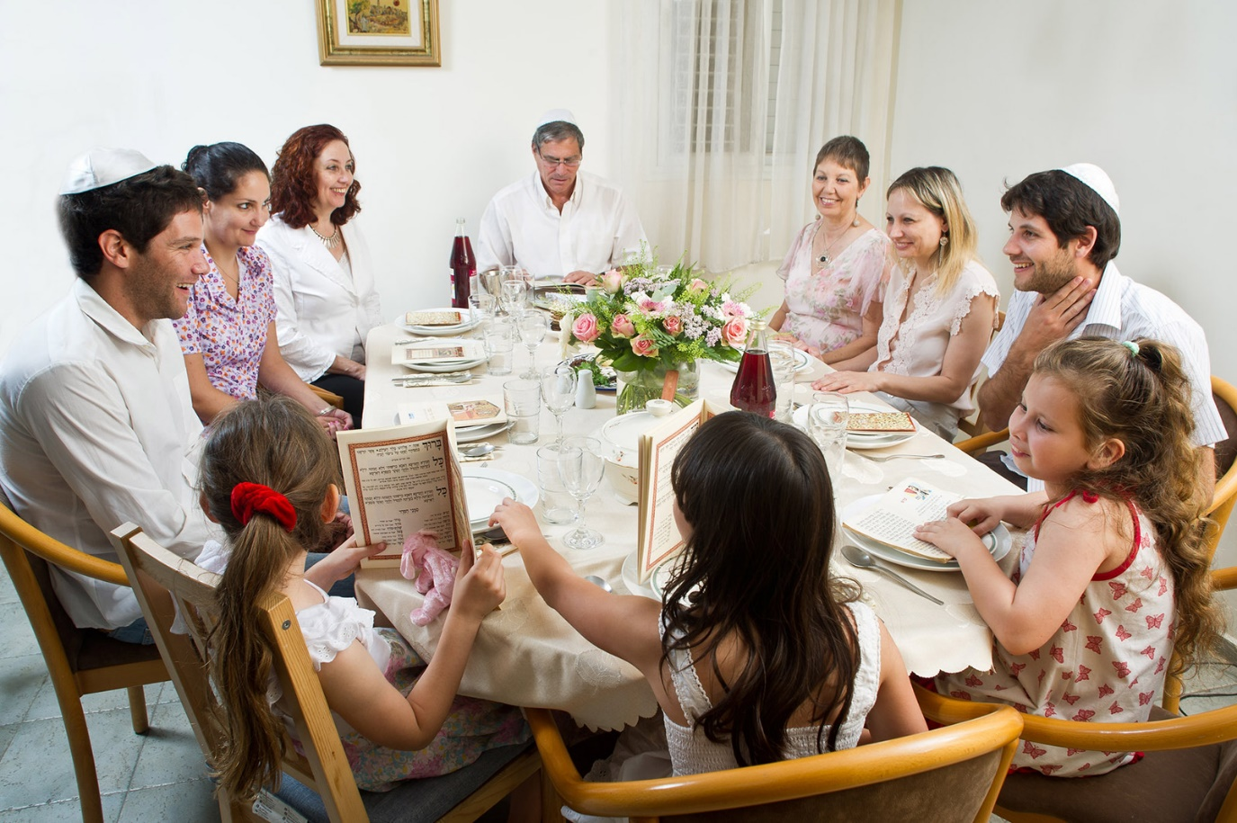

[*Israel_photo_gallery*](https://www.flickr.com/photos/israelphotogallery/15366025786/in/photostream/)

**Participant 1:**

1. **What is the purpose and the value of the food rules to you?**  
   "As a family, we see the rules as something cultural. It is a habit that can unite Jews across the world, giving a sense of **identity**."
2. **To what extent do you (and the family) keep to the food rules?**  
   "As a family we do not keep to the food rules. Adhering to the rules varies a lot. Jews who belong to the Orthodox tradition usually keep to them in full while Reform Jews vary - some keep to the rules only at home while others hardly adhere to them at all."
3. **How difficult is it to find kosher food where you live in Wales?**  
   "It's very difficult to find **kosher** food where we live in north Wales. It would be much easier in places like Manchester which is almost two hours away!"

**Keeping to the Rules - Muslims:**  
  
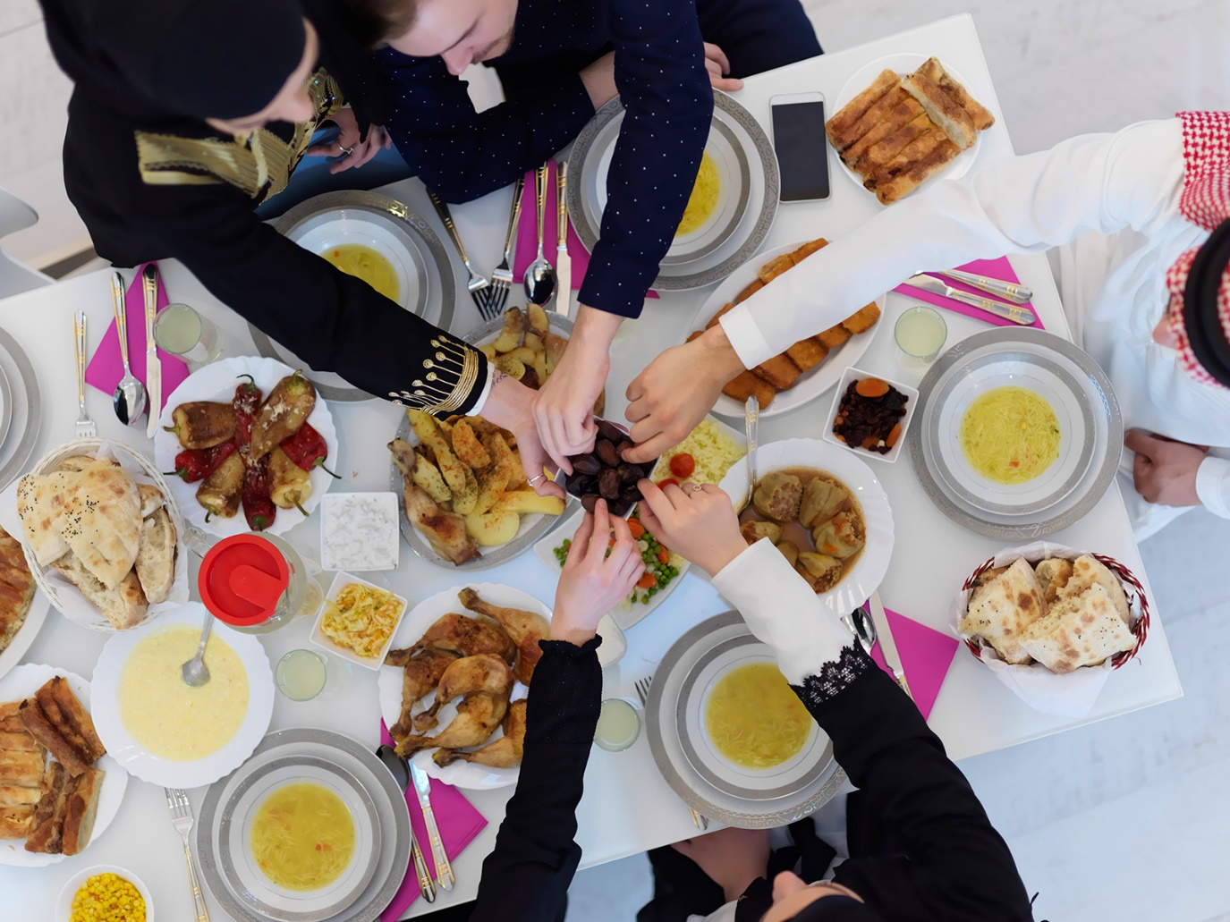

**Participant 2:**

1. **What is the purpose and the value of the food rules to you?**  
   "The food rules show us that our bodies don't belong to us, they come from God. We should take care of our bodies by following God's rules because he knows what is best for us. One of Allah's names is the All-knowing One."
2. **To what extent do you (and the family) keep to the food rules?**  
   “As a family, we make sure that we eat **halal** food at all times. We only eat **halal** meat (which has been slaughtered in the correct way) and we don't eat pork or drink alcohol at all."
3. **How difficult is it to find halal food where you live in Wales?**  
   “We live in Cardiff and it's quite easy to keep to the food rules of Islam here. There are a lot of **halal** butchers in the city and plenty of restaurants that use **halal** meat. City Road is definitely the best place to eat out in Cardiff if you're a Muslim because almost every restaurant on the street is **halal**!"