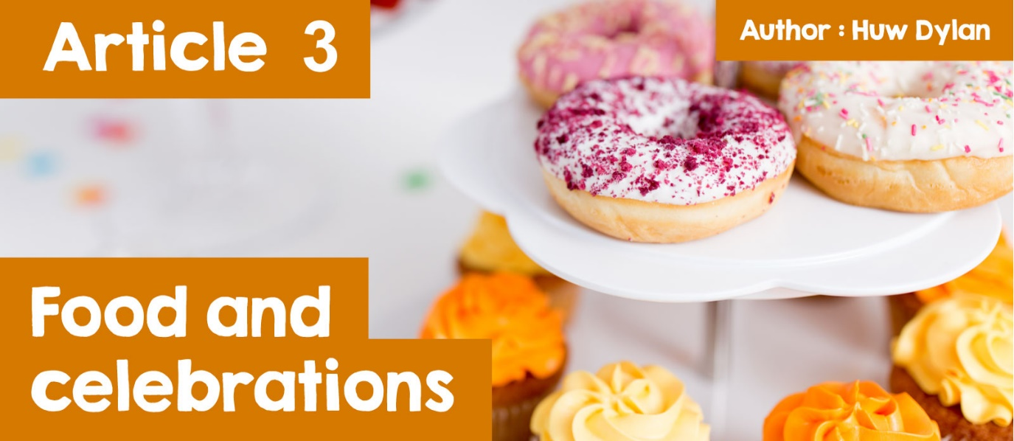

# **Food and Celebrations**

Have you ever thought how much a part food plays in religious and non-religious celebrations?

Can you think of personal and family celebrations where food and eating have played a big part?

There is no need to think very hard because there are so many of them - lunch or tea to celebrate a baptism or naming ceremony, a birthday party with a cake and candles, a wedding reception and even a funeral tea. Not to mention what is eaten at special times of the year such as turkey at Christmas and chocolate eggs at **Easter**.

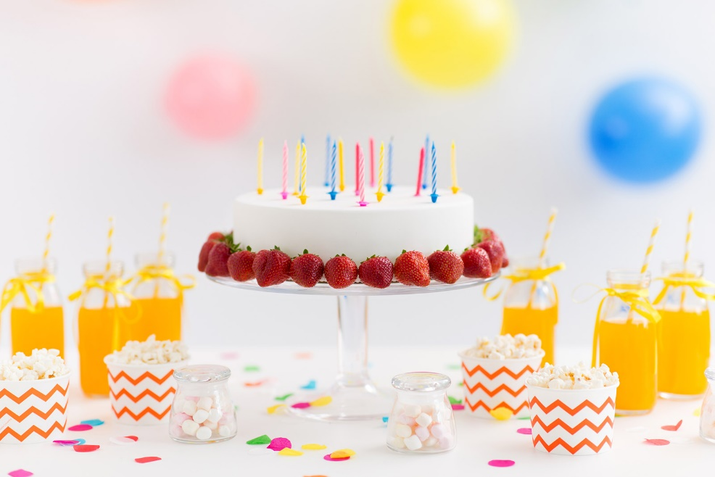

Why do you think food is so central to the celebrations? Food is a language that goes beyond religious, cultural and social boundaries. Food can bring people together. Food isn't just for the body - it can represent values that are important within particular religions, within various cultures and within society in general.

The use of food has always been a part of religious celebrations. Different foods represent different elements in the various religious festivals.

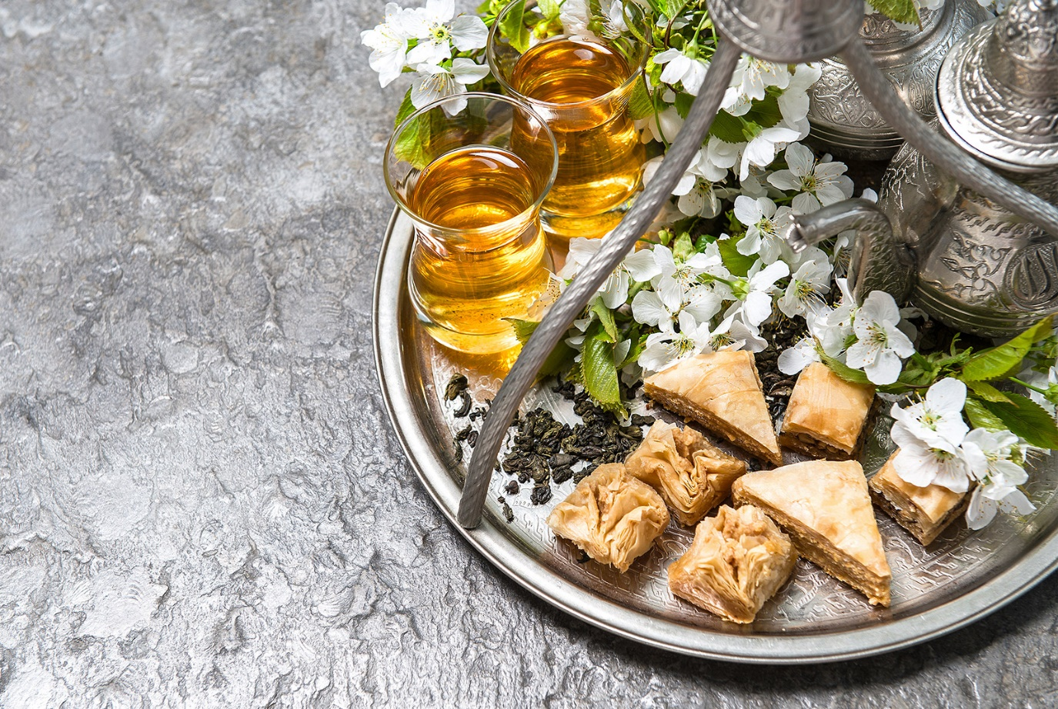

***Eid al-Fitr***

The **Eid al-Fitr** festival marks the end of **Ramadan**, a month of fasting in the Islamic religion. Families and friends meet to enjoy meals and exchange gifts. It is a happy occasion, full of love, happiness and thanksgiving. Eid is called 'Sweet Eid' or 'Sugar Feast' because of the sweet treats that are eaten. The tradition of eating sweets during **Eid al-Fitr** was probably started by early Muslims in **Medina**, Saudi Arabia, who used readily-available cooking ingredients such as dates and honey for their celebrations. The sugar in both foods provides energy after a month of fasting. As Islam spread across the world, those countries used their own ingredients and cooking knowledge for their **Eid al-Fitr** celebrations, resulting in the multitude of **Eid al-Fitr** dishes available today.

Food also features prominently in Jewish celebrations. The Pesach Festival celebrates how the Jews, led by Moses, escaped from slavery in Egypt. One of the main events in the celebrations is when the family comes together to eat the **Seder** meal.

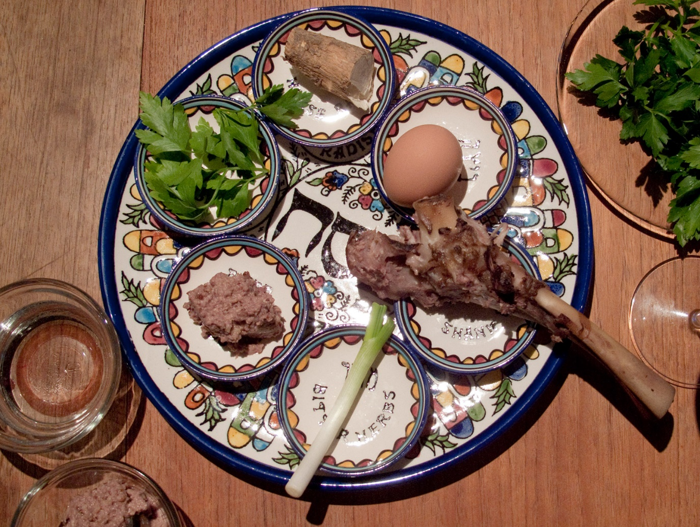

***Seder*** *Plate*

*©* [*https://www.flickr.com/photos/29233640@N07/3425839221/*](https://www.flickr.com/photos/29233640@N07/3425839221/)

In the middle of the table will be the **Seder** plate with each of the foods on it representing some aspect of the history and of the main theme of the Pesach, which is the escape from slavery to freedom. At least five foods go on the **Seder** plate: shank bone (zeroa) - usually lamb as a reminder of the Tenth Plague where the blood of the lambs on the doors saved the Jews from the angel of death; an egg (beitzah) which represents the spring season, bitter herbs (maror) to remind of the bitterness of slavery and the tears of the slaves, green vegetables (karpas) to represent spring growth and a sweet paste called haroset (a mixture of apples, raisins, nuts, herbs and wine) symbolising the mortar that the Jewish slaves used to build for the Egyptians. Generally, only a small amount of symbolic food is included on the **Seder** plate. A more substantial meal follows the symbolic meal.

Another Jewish festival is the **Purim** which commemorates queen Esther and her uncle Mordecai saving the Jews from Haman's plot to kill them. This is the Jews' most joyous festival and eating and drinking is a key part of it. One of the most popular foods during **Purim** are triangular cakes called **Hamantaschen**, which are full of poppy seeds. They eat seeds because Esther only ate seeds while she lived in the king's palace. '**Hamantaschen**' can be translated as 'Haman's pockets' which refers to the bribes he received or as 'Haman's ears' which refers to the type of cap or hat he wore.

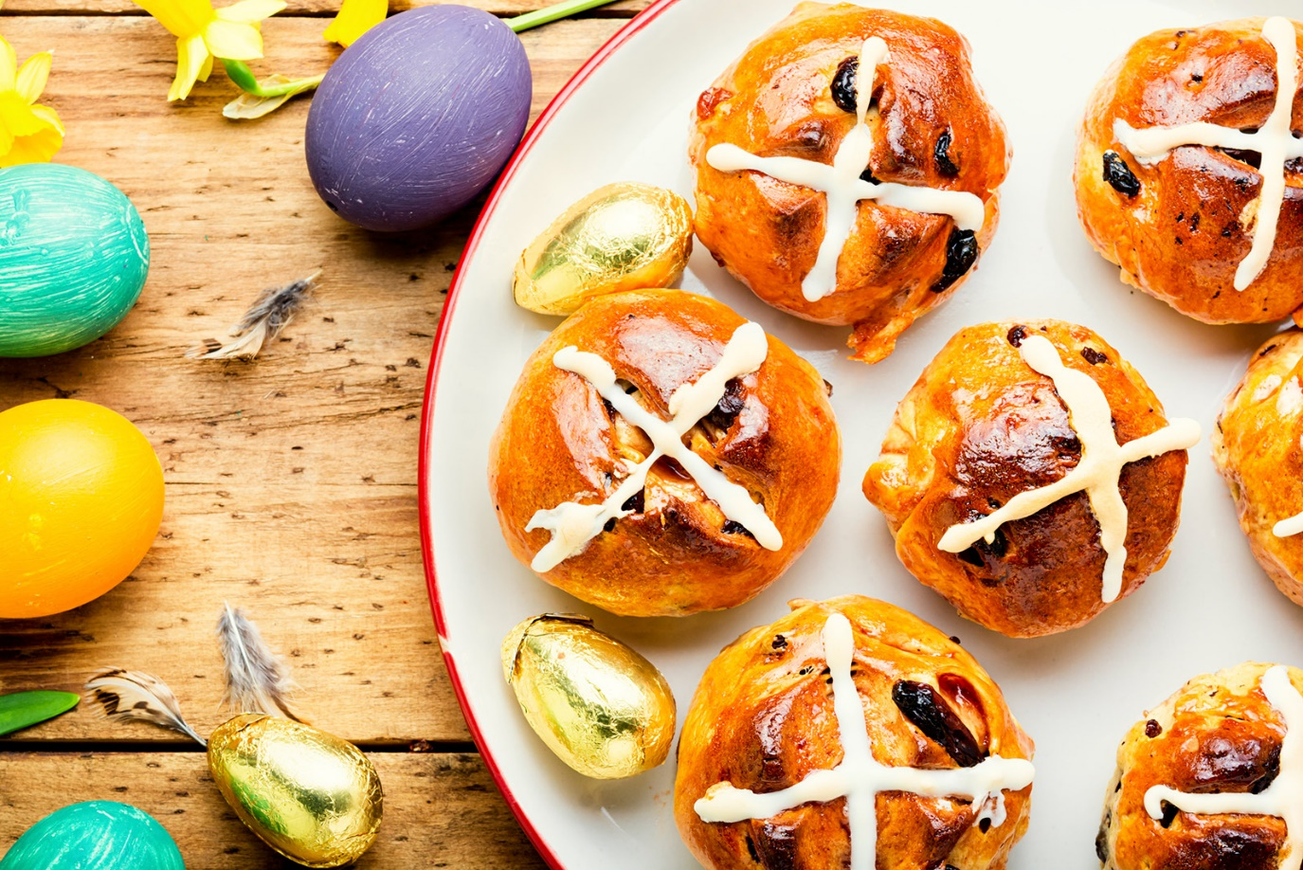

***Easter***

Different foods are also seen as part not only of the Christian **Easter** celebrations but of the festival's celebrations in general. The most popular one is the egg which is a symbol of new life and therefore of spring, but for Christians it's also a symbol of the resurrection of Jesus. The outer shell represents the cave in which Jesus was placed and the chick inside the egg represents Jesus himself. For Christians, eating a hot cross bun marks the end of Lent with the cross at the top representing the crucifixion of Jesus. A Simnel cake is also eaten at **Easter**. Traditionally it is decorated with eleven marzipan balls, one for each of Jesus' disciples. There isn't one for Judas because he betrayed Jesus. For lunch on **Easter** Sunday, lamb is often served which reminds Christians of the sacrifice of Jesus as the lamb of God. Perhaps the foods that Christians most associate with **Easter** are the bread and wine which are used in the **Mass/Communion/ Lord's Supper** service and which remind them of Jesus during the Last Supper taking bread and breaking it as a symbol of his body being broken on the cross and a glass of wine as a symbol of his blood being shed on the cross. During the early years of the Christian Church, symbolically eating the bread and drinking the wine was part of a more substantial meal called the Agape feast which is the feast of love. Christians would bring their own food to eat in each other's company.

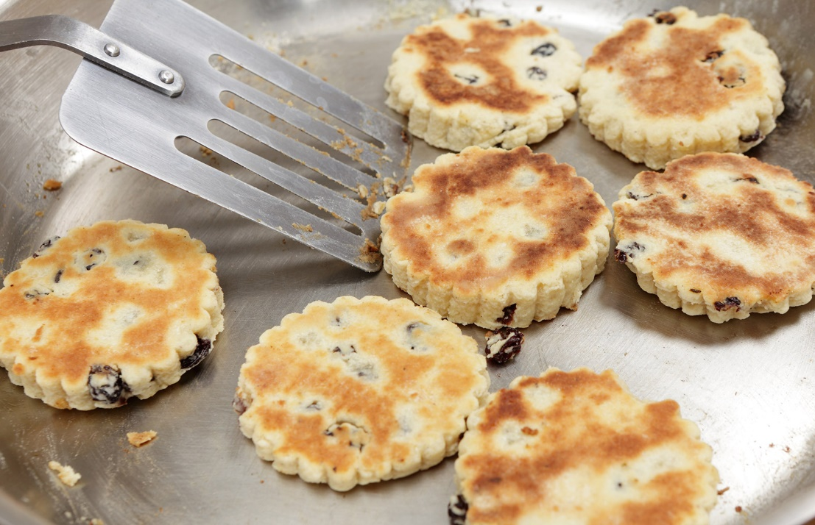

*Welsh Cake*

Food is also a part of the **culture** and **identity** of different countries and people. Are there foods that are part of our **identity** as Welsh people? Historically, Welsh food has been simple, wholesome food - substantial meals made with just a few simple, good-quality ingredients. And today there is a great emphasis on what's called 'Welsh food' - from meat and milk to cheese and wine, to vegetables, eggs and cakes, from jam and pickles to beer and spirits and much more. Produce born and bred and produced here in Wales - food that represents us as Welsh people.

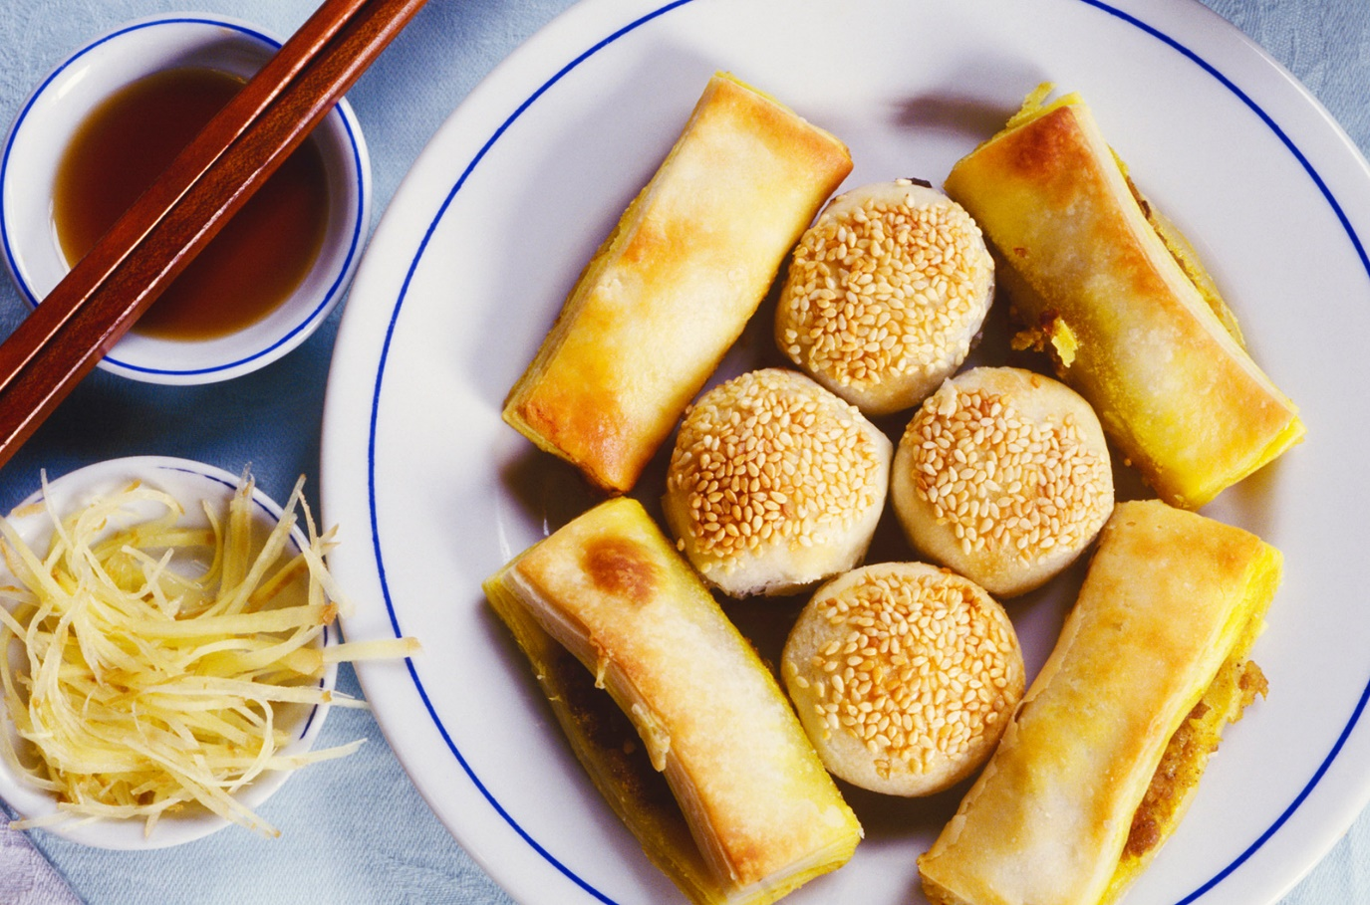

Chinese New Year is another example of a unique **identity** which is celebrated with food. One of the most important events of the festival is the New Year's Eve dinner. The dinner is an opportunity for Chinese families to come together and if a member of the family cannot come to the meal, the family will leave their place empty at the table and place a set of cutlery for them. There are a variety of dishes that are often prepared at Chinese New Year including spring rolls and dumplings.

For many people in our society, going out for a meal is a way of celebrating some of the things that are important to them in life - family ties, friendship and community. Dinner clubs can be found in many areas where people come together to share a meal, to socialise and to listen to a guest speaker.

We see that food is part of all these celebrations and customs and much more of course. Would it be possible to celebrate them without the use of food and eating or is that necessary to give meaning and value to the different celebrations?