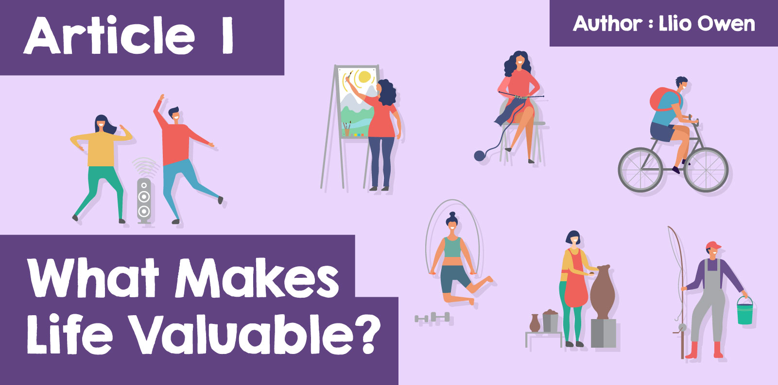

**What Makes Life Valuable?**

The value of life is a complex idea that people all over the world think about. It’s about understanding why being alive is important and what makes life special. Let's explore what makes life valuable, how we can impact others, and why it’s important to respect and care for life.

In general, people say that life is special because every person has worth just by being alive. This means that no matter who you are, where you come from, or what you do, your life is important. Philosophers, or people who think deeply about life, believe that everyone should be treated with respect because each person has their own unique value.

Believing that everyone’s special means that we should treat everyone as such. One of the amazing things about life is that we can make a difference in other people’s lives. When you help a friend, show kindness, or share something you’ve learned, you are having a positive impact. Each of us has the power to make the world a better place through our actions. This means that our lives are not only important for ourselves but also for the people around us. Think of a time that someone else’s company, or their actions, made your life that little bit better, like your friends supporting you from the sidelines of a sports game, or your parents going out of their way to cook you your favourite dinner, just for you.

Another part of understanding the value of life is thinking about what makes us happy and fulfilled. Happiness is more than just having fun; it’s about finding what makes you feel good about yourself and your life. This could be things like learning new skills, spending time with friends and family, or helping others. When we find what makes us happy, we understand more about why life is valuable. We don’t need the most expensive clothes, or the newest phone to truly find happiness. However, sometimes it can be a little difficult to pinpoint those little moments or things that make our life valuable, especially in the chaos of everyday life.

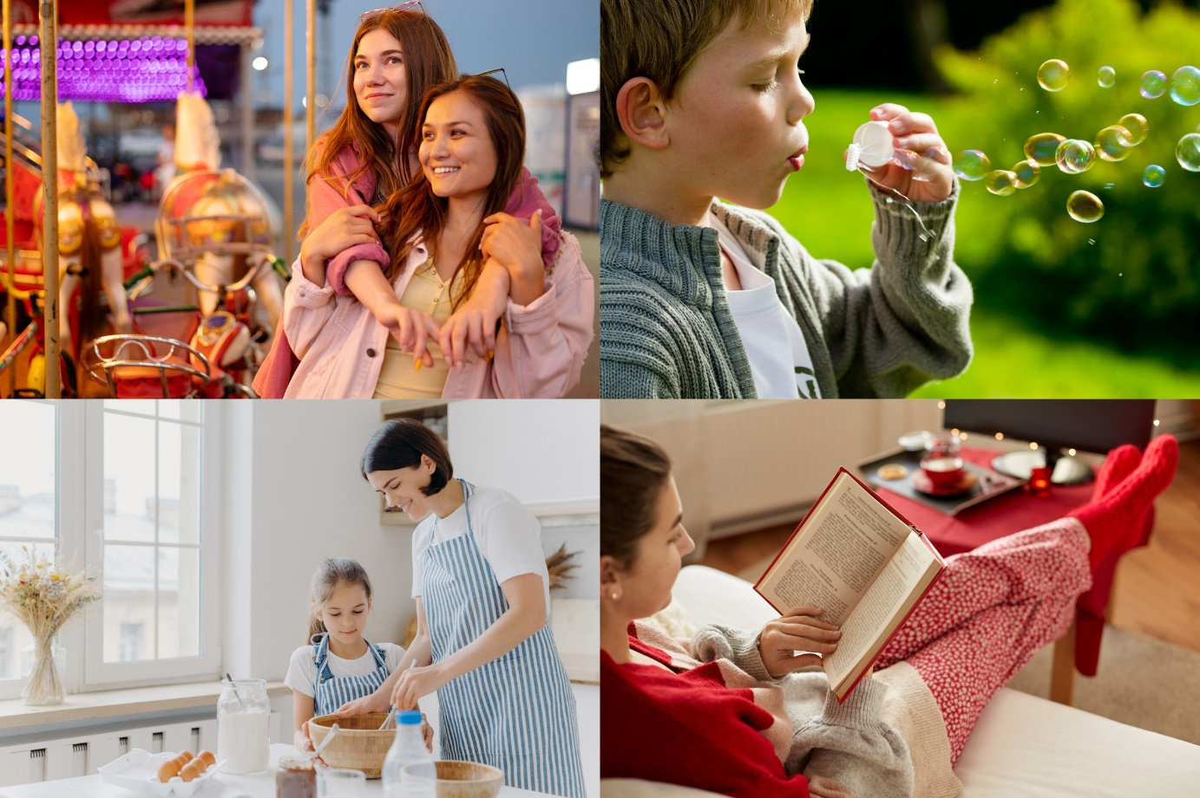

Cenys, a 55-year-old baker, who expressed what gives her a purpose in life; her health, happiness and seeing her children grow and succeed in life. The first two reasons may be obvious, but Cenys said that becoming a mother gave her a new purpose in life. “Before having children, I had a more self-centred approach to life, but today I live my life to be the best mother I can be.”

Another different perspective is from 6-year-old Archie said that the most important thing in his life is to be happy. To him, this is spending time with friends and family, and playing football. As children, we are more focused on what brings us joy, and don’t think much about life’s complex issues.

If we think that life is special, it’s also very important to respect it. Respecting life means treating others and ourselves with kindness and care. This idea is part of many ethical beliefs, which are rules about how to do the right thing. Respecting life also means standing up for people’s rights so that everyone can live happily, and taking care of the environment so that we have a world where we can be healthy and live fulfilling lives. When we respect life, we show that we understand its value and importance.

People around the world have different cultural and religious beliefs that shape how they see the value of life. Many religions teach that life is a special gift and should be treated with care. These beliefs help people understand how important life is and why we should value it. When we see life as a gift, it encourages us to be kind and helpful to others. It also helps us appreciate each moment and feel grateful for the time we have. These ideas can give us comfort when things are tough, showing us how to stay hopeful and strong.

Elizabeth, who is 27 years old is a Christian. She believes that life is a gift from God, and so it is the most important thing. God gives us life, and so He’s responsible for everything that happens to it. That means that Elizabeth doesn’t believe in murder, abortion, or euthanasia. “For me, following religious practice and belief provides a sense of belonging and understanding of life's deeper meanings.” Many people like Elizabeth navigate the world’s complex beliefs through their religion.

|  |
| --- |
|  |
| *God, as depicted on the dome fresco by Johann Michael Rottmayr at Karlskirche (St. Charles’s Church) in Vienna* |

Even though we know life is valuable, sometimes there are hard times. Things like being treated unfairly, violence, and not having enough money to live comfortably can make it difficult to see the value in every life for some. These problems can make people feel sad or unimportant, and so it's very important for all of us to work together to solve these problems. By helping each other and being kind, we can make sure everyone feels valued and loved. This way, we can make the world a better place for everyone, where each person's life is seen as special and important.  
  
Understanding the value of life helps us appreciate our own lives and the lives of others. By treating everyone with respect, making a positive impact, and finding our own happiness, we can help create a better world. Remember, every life is valuable, including yours. So, let’s all do our part to make the most of our lives and help others do the same.