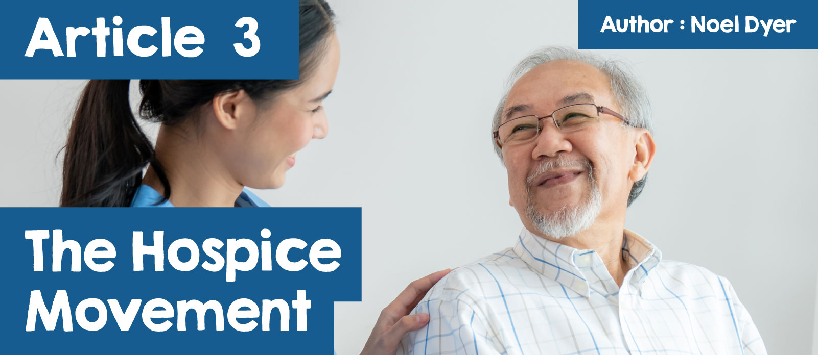

**The Hospice Movement**

The hospice movement refers to a programme that provides care for people as they approach the end of their life. Normally, this is due to a terminal illness that cannot be cured. A hospice offers physical, emotional, social and spiritual care to the patient. Support is also given to the family to support them through a difficult time.

 

Often, the term palliative care is used. This is specialist care that is offered by a team of doctors and carers to relieve the patient's suffering. The aim is to ensure the best quality of life for the patient by making them comfortable and ensuring that they are not in pain. According to some, this makes the idea of euthanasia unnecessary.

**Who provides hospice care?**

Many people provide hospice care - clearly the most obvious is the National Health Service (NHS). Most hospice care is provided at home. It can also happen in a special establishment. Some may visit a hospital or hospice as an outpatient. The care is provided by several different people - doctors, nurses, social workers, therapists, chaplains and others. When the care is in a bespoke building, the establishment is more like a home than a hospital in order to provide a less formal environment than a normal hospital.

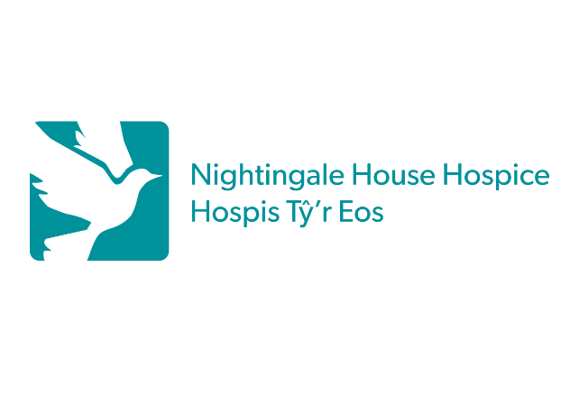

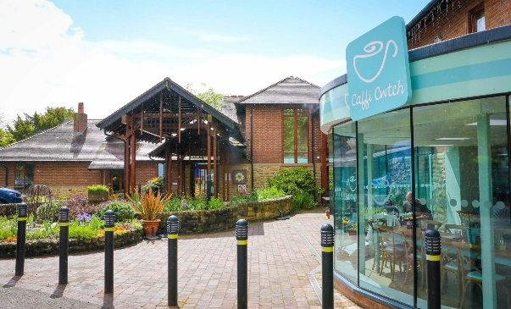

[Nightingale House Hospice](https://uk.linkedin.com/company/nightingale-house-hospice)

These are the types of care provided:

* Medical care to deal with pain and other symptoms;
* Physiotherapy;
* Pain relief, e.g. massage;
* Respite care (for the family to have a break from the care work);
* Financial advice;
* Help for the family to deal with loss.

**Marie Curie.**

Contrary to expectation perhaps, much of the care is carried out by charity. Marie Curie is a charity and they have nine hospices in the United Kingdom, including one in Wales, namely Cardiff and the Vale. The aim is to offer hospice care wherever it is needed - in the hospice or at home. Nurses and carers are able to ensure nursing care, clinical care and emotional care for the patient and the family. The hospice is available to give 24-hour care to ensure that the patient is comfortable and receives the best care until the end.

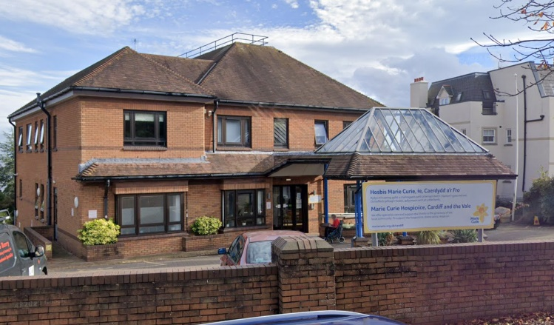

[Google Maps](https://www.google.com/maps/place/Marie+Curie+Hospice,+Cardiff+and+the+Vale/@51.4339138,-3.1702967,3a,75y,121.54h,94.35t/data=!3m7!1e1!3m5!1sz4zogwNxwbKoqZxr-zK5Qg!2e0!6shttps:%2F%2Fstreetviewpixels-pa.googleapis.com%2Fv1%2Fthumbnail%3Fpanoid%3Dz4zogwNxwbKoqZxr-zK5Qg%26cb_client%3Dmaps_sv.share%26w%3D900%26h%3D600%26yaw%3D121.5360776013053%26pitch%3D-4.351731749539695%26thumbfov%3D90!7i16384!8i8192!4m11!1m2!2m1!1smarie+curie+cardiff!3m7!1s0x486e037422ea4277:0x18913785c51fffae!8m2!3d51.4337589!4d-3.1696933!10e5!15sChNtYXJpZSBjdXJpZSBjYXJkaWZmIgOIAQGSAQdob3NwaWNl4AEA!16s%2Fg%2F1tnbkkk2?hl=en&coh=205410&entry=ttu)

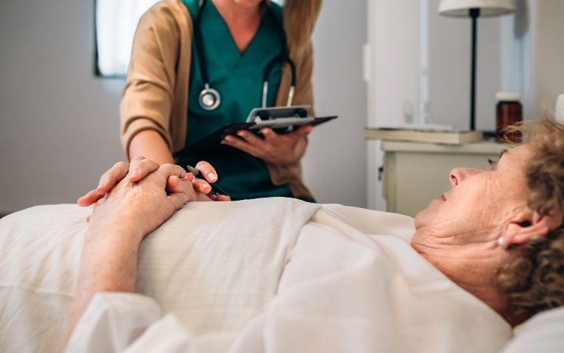

[Nightingale House Hospice](https://uk.linkedin.com/company/nightingale-house-hospice)

This is a comment from a woman about the care that her mother received while in the hospice near Cardiff:



*'We could go and visit mum any time and it did not matter when. That meant a lot. Staff members would sit and speak with us and offer support. It was good to have the reassurance that I was not on my own.'*

The comment from this nurse also says a lot about the nature of the care provided in the Marie Curie Hospice:



*'We laugh with our patients and their loved ones. We hug them when it is needed and make numerous cups of tea for them. We listen to their problems and sometimes sit with them when they cry.’*

Of course, many of us are familiar with Marie Curie’s fundraising work as the charity sells miniature daffodils as one way of raising money for their work.



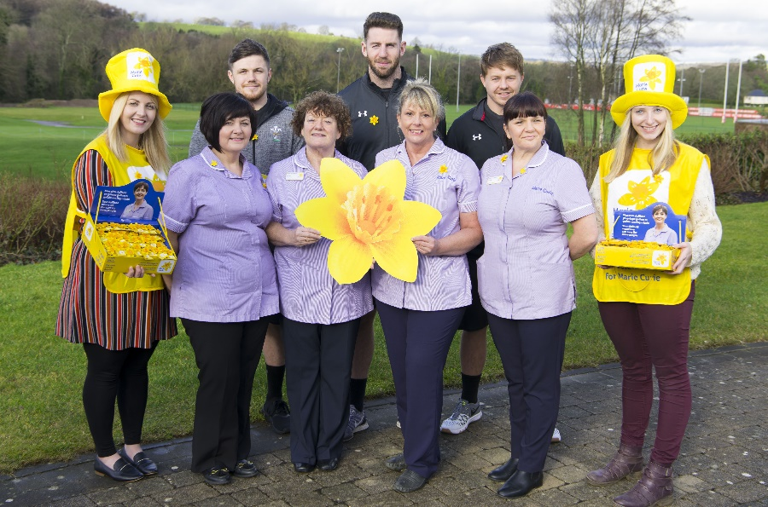

[Marie Curie](https://www.mariecurie.org.uk/media/press-releases/wales-rugby-stars-back-great-daffodil-appeal/179348)

Watch these two videos that give a good insight into the work and objectives of the Marie Curie Charity:

<https://www.mariecurie.org.uk/help/hospice-care/caerdyddarfro>

**Children's hospice.**

One sad aspect of the hospice movement's work is the need for this type of care for children. This is a result of the fact that people and children of all ages can suffer from a terminal illness. One such establishment is Tŷ Gobaith near Conwy. This is an establishment that provides care for babies, children and young adults up to 25 years of age who suffer from life-threatening conditions. It also provides counselling to support families who are facing loss. Tŷ Gobaith serves north Wales, mid-Wales and beyond. It is a charity and depends on people’s fund-raising efforts to support the work, e.g. there are many charity shops under the Tŷ Gobaith name.



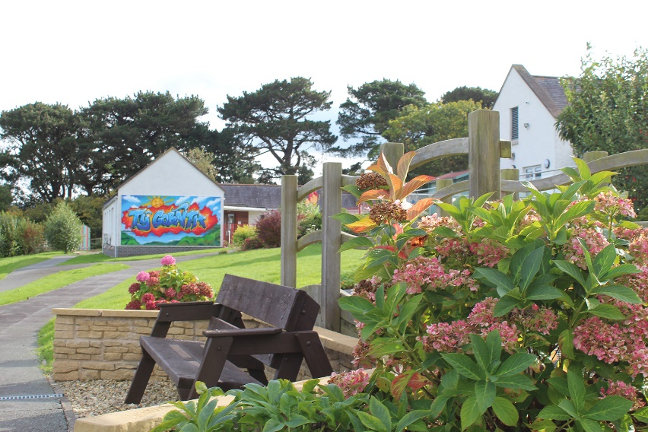

This is how the charity's site describes the work and the location:

***'Our North Wales hospice Tŷ Gobaith is just outside Conwy with stunning views across the estuary. It offers peace and tranquillity to the children and families who visit and is sensitive to the needs of the local population, many of whom speak Welsh as a first language.***

***We have four children’s bedrooms and three parents/family rooms. There is a multi-sensory room, young adult lounge, playroom, therapy room, kitchen and dining room and a parents’ lounge.***

**Unique Site - Skanda Vale.**

When a temple was established on Cwm-Creigiau farm and called Skanda Vale, the residents of the Llanpumsaint area in Carmarthenshire were full of curiosity. The arrival of an elephant on the site added to this. Since the 1970s, a Temple has been developed under the auspices of The Community of the Many Names of God. Accommodation and a hospice were also added to the area.

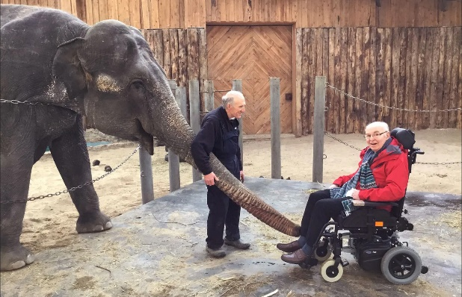

[Skanda Vale Hospice](https://www.skandavalehospice.org/)

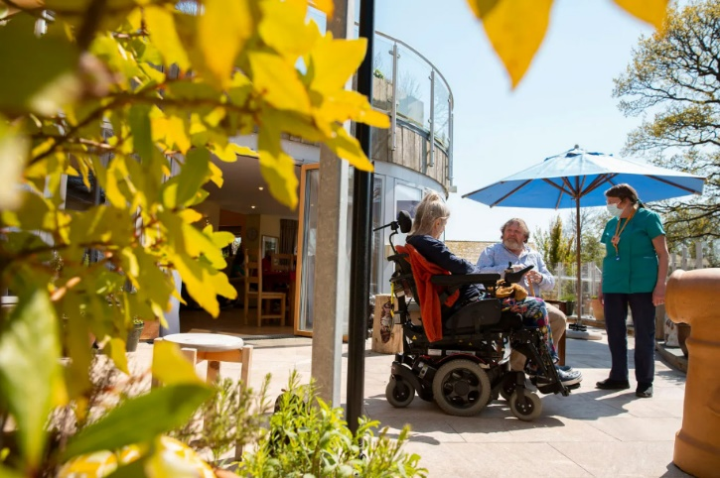

[Skanda Vale Hospice](https://www.skandavalehospice.org/)

In the hospice near Llandysul, there is an emphasis on a person's mental, emotional and spiritual elements - without forgetting about the physical elements. There is a great emphasis on tailoring the care according to the individual's wishes and needs. At Skanda Vale, individuals with the skills and the time come together to provide free care to the patient and a break for the family. To help with fund-raising, there is a shop in the town of Newcastle Emlyn.

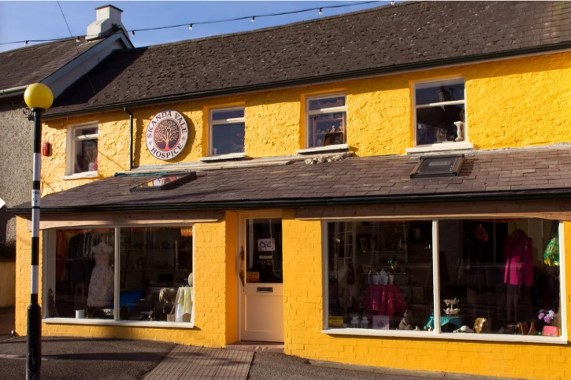

[Skanda Vale Hospice](https://www.skandavalehospice.org/)

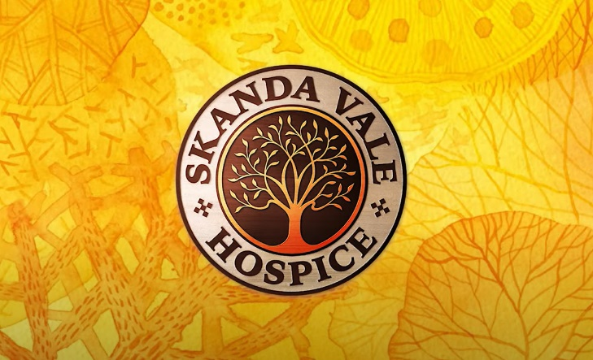

[Skanda Vale Hospice](https://www.skandavalehospice.org/)

At Skanda Vale, there is a special emphasis on many values:

* Showing compassion through kindness, generosity and commitment
* Providing a prominent place for emotional, mental and spiritual needs
* Accepting everyone as an individual in a non-judgemental way
* Respecting everyone regardless of their belief, culture or background
* Fully committing to the well-being of those who receive care
* Being accountable while ensuring the highest standards in every aspect of the work.

This is a comment by one of the centre’s leaders:



*'People are overwhelmed by the love that somehow just flows so easily here. Patients have said; 'There’s something here, I don’t know what it is, but there’s something... you can feel it!'*

The following video gives us an idea of the feeling that exists there:

<https://youtu.be/SZUC6tkQ8a4>