**Religion, Values and Ethics E-magazine: September 2024**

**Title: Black History Month**

| **Titles** | **What is Black History Month?** | **What does it mean to be Welsh?** | **Creating a Rainbow World** |
| --- | --- | --- | --- |
| **Logic** | **DISCLAIMER:** The Teachers' Notes have been updated so that the resource can be used through Curriculum for Wales. However, the content of the articles has been archived and the information has not been updated. The articles are kept on the website as the content is still relevant to Curriculum for Wales: Religion, Values and Ethics.  **The four purposes of 'Curriculum for Wales - A curriculum for life'**  **By learning about Black History Month in their Religion, Values and Ethics education lessons, there will be opportunities for learners to develop [as/into]:**  • Ambitious, capable learners who can explain the ideas and concepts they are learning about;  • Healthy, confident individuals who have secure values and are establishing their spiritual and ethical beliefs;  • Enterprising, creative contributors who give of their energy and skills so that other people will benefit;  • Ethical, informed citizens who engage with contemporary issues based upon their knowledge and values.  **RVE in The Curriculum for Wales**  By reading and using the articles in their Religion, Values and Ethics lessons, learners will have opportunities to:   * Engage with and explore ultimate and philosophical questions * Undertake enquiries and engage with sources of wisdom and philosophies * Develop and express their own informed viewpoints * Use their knowledge and understanding of religious and non-religious worldviews to think critically about their own values * Explore the ways in which religion and non-religious philosophical convictions have influenced human experience throughout history * Evaluate and use evidence from a range of religious and non-religious sources to engage with ethical and moral issues * Explore the beliefs and practices of the people in their community, Wales and the wider world and respond sensitively to them * Develop secure values and establish their own ethical beliefs and spirituality * Discuss and reflect on their own perspectives and those of others   **The RVE lens**  By reading and using the articles in their Religion, Values and Ethics lessons, learners willhave opportunities to explore a range of RVE concepts through **the sub lenses below:**  • Search for meaning and purpose;  • The natural world and living things;  • Identity and belonging;  • Authority and influence;  • Relationships and responsibility;  • Values and ethics;  • The journey of life;  *Please note that RVE is locally determined through an agreed syllabus. Each local authority has its own agreed syllabus for RVE that schools must have regard to. All agreed syllabi have had regard to the Curriculum for Wales framework and RVE guidance referenced above and below.  **Useful Links:**  **The RVE Guidance -** [**https://hwb.gov.wales/curriculum-for-wales/humanities/designing-your-curriculum/#religion,-values-and-ethics-guidance**](https://hwb.gov.wales/curriculum-for-wales/humanities/designing-your-curriculum/#religion,-values-and-ethics-guidance) **Hwb Humanities Guidance -** [**https://hwb.gov.wales/curriculum-for-wales/humanities**](https://hwb.gov.wales/curriculum-for-wales/humanities)  **Statements of What Matters -** [**https://hwb.gov.wales/curriculum-for-wales/humanities/statements-of-what-matters/**](https://hwb.gov.wales/curriculum-for-wales/humanities/statements-of-what-matters/) **Cross-cutting Themes -** [**https://hwb.gov.wales/curriculum-for-wales/humanities/designing-your-curriculum/#cross-cutting-themes**](https://hwb.gov.wales/curriculum-for-wales/humanities/designing-your-curriculum/#cross-cutting-themes) | | |
| **Key words** | . | Culture - the ideas, customs, and social behaviour of a particular people or society.  Identity - who a person is, or the qualities of a person or group that make them different from others.  Tradition - customs or beliefs from generation to generation, or the fact of being passed on in this way.  Unique - being the only one of its kind; unlike anything else.  Welsh Not - a wooden token given to children caught speaking Welsh in nineteenth-century schools. The child wearing it at the end of the day would be beaten.  Eisteddfod - Welsh Language National Festival.  Pride - to be proud.  Heritage - relating to things of special architectural, historical, or natural value that are preserved for the nation.  Mixed Heritage - relating to things of special architectural, historical, or natural value that are preserved for differing nations.  Stereotype - a widely held but fixed and oversimplified image or idea of a particular type of person or thing.  Racism - the belief that different races possess distinct characteristics, abilities, or qualities, especially so as to distinguish them as inferior or superior to one another.  Globalised/Globalisation – a term used to describe how trade and technology have made the world into a more connected and interdependent place.  Contemporary - belonging to or occurring in the present. | The 'ideal world' - a perfect world.  Prejudice – judging people without having any knowledge or experience of them.  Discrimination – treating people differently, usually unfairly, for example based on the colour of their skin.  Stereotyping – applying an individual's characteristics to a whole group.  Immigrants – people moving to another country for various reasons.  Asylum seekers – people who have to flee from their country to seek safety in another country.  Mosques – places of worship in the Islam religion.  Children’s Commissioner for Wales – Rocio Cifuentes is the Children’s Commissioner for Wales; she has been in this role since April 2022. The purpose of her job is to tell others about the importance of children's rights, and to look at how decisions made by public bodies in Wales, including the Welsh Government, affect children's rights.  Racism – treating people differently because of their race.  Nazi – the name given to Hitler's followers during the Second World War.  Muslim – relating to the religion of Islam.  ⁠Hijab – the head-dress worn by some Muslim women.  The 'N' word – the word 'nigger' which is a word of racist hatred.  The Oneness of Humanity – the belief in Sikhism that everyone is equal because they were created by God.  Tolerance – being willing to tolerate or accept different ideas and traditions.  Langar – a meal shared by everyone who visits a Sikh gurdwara.  Hindu Dharma – Hindu teaching.  Brahman – the supreme god in Hinduism who is part of every living thing.  Ahimsa – the principle of not causing harm to any living being. |
| Search words |  | Culture  Identity  Tradition  Unique  Welsh Not  Eisteddfod  Pride  Heritage  Mixed Heritage  Stereotype  Racism  Globalised/Globalisation  Contemporary | Coca-Cola  Prejudice  Discrimination  Southport  Immigrants  Asylum seekers  Mosques  Children’s Commissioner for Wales  Racism  Terrorists  Nazi  Muslim  Hijab  Bomb  Indian  The 'N' word  Social media  TikTok  Christianity  Hinduism  Sikhism  The Oneness of Humanity  Langar  Hindu Dharma  Brahman  Ahimsa  Education  Tolerance  Rainbow |
| Extended tasks |  | | |
| Classroom tasks | 1. Your school wants to organize events for the celebration of Black History Month. In groups draw a list of suggestions for activities during the month. 2. Research the history of some celebrities who could be celebrated during Black History Month. 3. Visit the following site to see how John Ystumllyn's rose is a symbol of inclusion - <https://www.bbc.co.uk/news/uk-wales-58983377>   Make a poster with the rose in the centre and write out points about the message of the rose according to Zehra Zaidi who grew up in Carmarthenshire.   1. The old Tiger Bay in Cardiff disappeared making way for the development of the modern bay area. What kind of multi-ethnic community could be found there in the 19th century and into the 20th century? 2. Draw a table of Betty Campbell's accomplishments, highlighting the difficulties she had to face. 3. The treatment of a large number of the Windrush Generation has been described as a scandal. In what way were many treated badly? Make bullet points to note your results. | Find tasks at the bottom of the page. | 1. Search for one story that is in the news about prejudice and discrimination and give a presentation to the rest of the class explaining the situation and what is being done to try to solve the problem. 2. Research in more detail the teachings of any of the world's major religions about prejudice and discrimination. 3. Produce an effective poster to promote the 'oneness of humanity.' 4. Try to put yourself in the shoes of someone who is a victim of prejudice and discrimination and create a blog about your feelings and what you would like to see people do to support you. 5. Try to come up with Welsh lyrics to the song – 'I'd like to teach the world to sing' 6. Class discussion – 'It is impossible to remove prejudice and discrimination.' |
| **Further resources** | [BBC - Mis Hanes Pobl Dduon](https://www.bbc.co.uk/programmes/p0ggwpj0)  [Windrush Cymru: dathlu bywydau a siwrneiau cenhedlaeth (senedd.cymru)](https://senedd.cymru/ymweld-a-ni/arddangosfeydd/arddangosfeydd-blaenorol/windrush-cymru-dathlu-bywydau-a-siwrneiau-cenhedlaeth/) |  | [Coca Cola Commercial - I'd Like to Teach the World to Sing (In Perfect Harmony) - 1971 (youtube.com)](https://www.youtube.com/watch?v=ib-Qiyklq-Q) |

**On the white, note unique things that make up YOUR Welsh identity.**

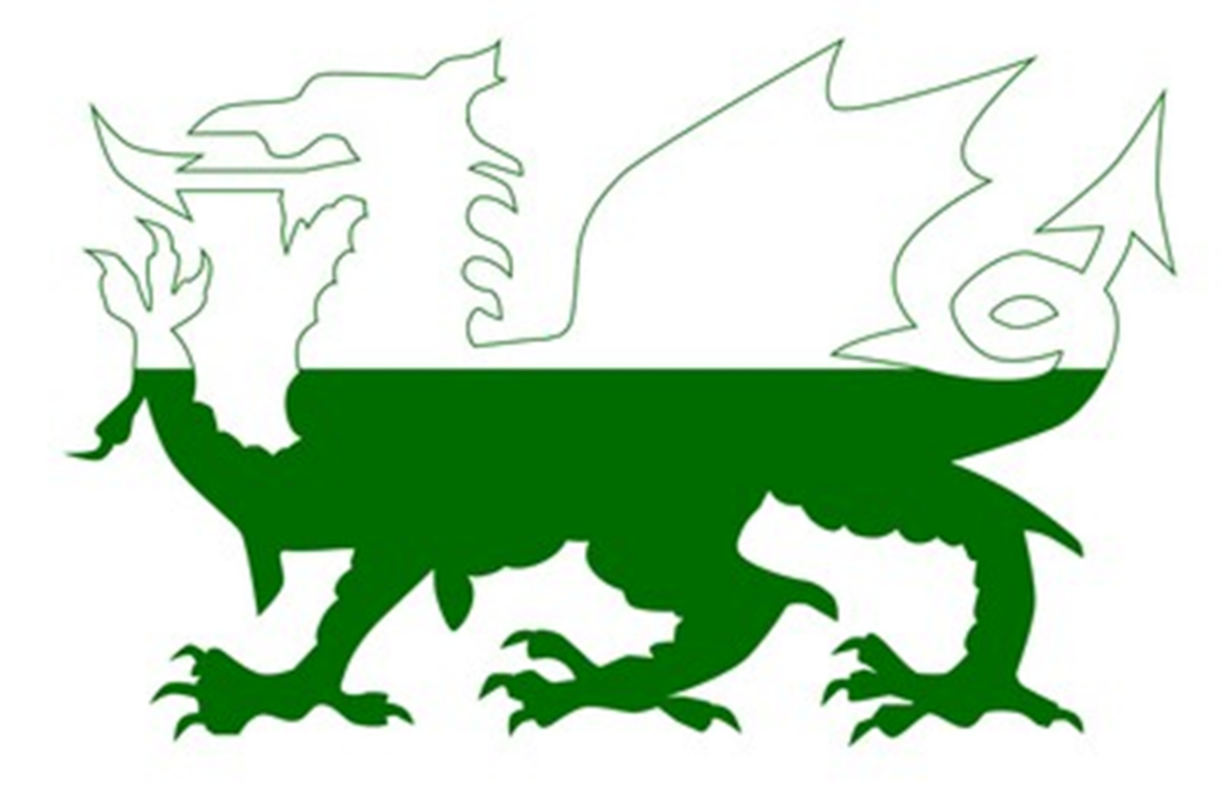

**On the green, note unique things that may make up someone else’s Welsh identity, differently to yourself.**

**Watch the video to answer the following questions:**

Link to view video - <https://www.bbc.co.uk/programmes/articles/1HCpKqv21VRFr3jL7XM9qgQ/why-are-people-surprised-that-i-speak-welsh>

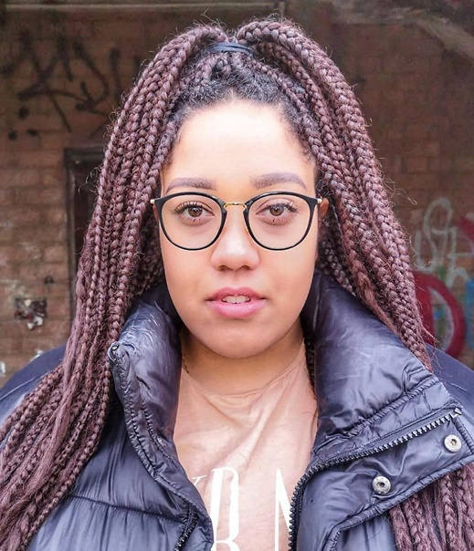

1. How do people react to Jalisa when she speaks Welsh?
2. What does Jalisa believe that makes people surprised that she speaks Welsh?
3. What happened to Jalisa and her mother in a shoe shop?
4. What does Jalisa think is the issue with people not believing she’s Welsh? Racism, or Stereotyping?
5. How has speaking Welsh been an advantage to Jalisa? Can you name 3?
6. Why does Jalisa feel confused as a mixed woman?