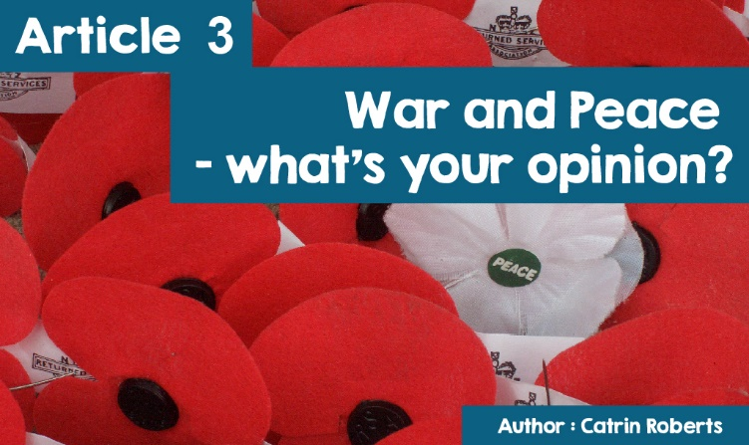

|  |  |  |
| --- | --- | --- |
| **What’s your opinion on the Welsh rock scene, I wonder?** | **Or** | **Colouring hair purple?** |



If you like Welsh rock music, you possibly go to gigs or download songs. If not, you'll be ignoring it all. And if you like the idea of purple hair, you may have already ventured having the color. But if not, you will have kept to your natural hair colour.

That is - if you have an opinion about something, your views will influence what you do in life.

**What about war and peace, then?**



Here is a snapshot of the views of some people in Wales today. In some cases, their religious beliefs have influenced their attitude and actions and work.

**Shôn Hackney** from Llwyngwril has been in the Army for over 20 years, and finds working as a member of the armed forces different and exciting. Although terrifying at times (he has been on exercises and campaigns around the world including Iraq and Afghanistan), he thinks his work is interesting and worthwhile. He has never felt a conflict between his work and religion. "Sometimes religion can be comforting, and ultimately having something to believe in is valuable, whatever your faith or belief".

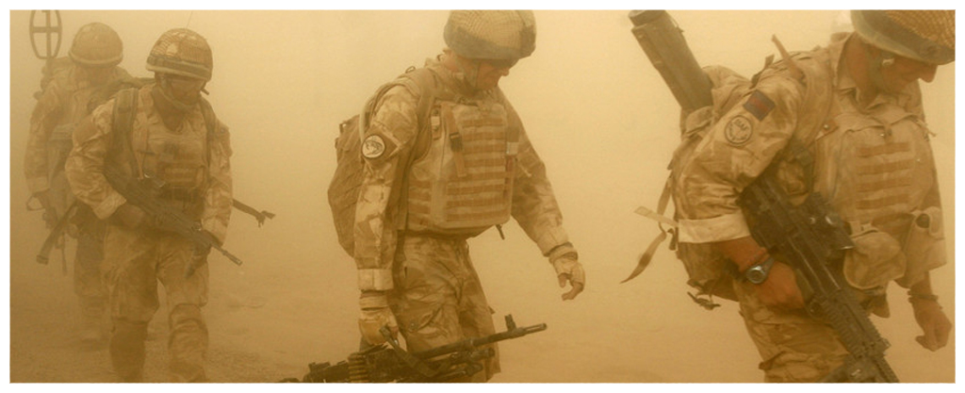

**Reverend Aled Huw Thomas** chose to serve as a Chaplain in the Army for 24 years ([www.army.mod.uk/chaplains/chaplains.aspx](http://www.army.mod.uk/chaplains/chaplains.aspx)). He was a Chaplain in Germany, Bosnia, Northern Ireland, Oman, Kuwait, Iraq and Afghanistan. The Chaplain fulfills the role of minister or vicar to soldiers and their families. They share the same dangers as soldiers in a war situation. A Chaplain does not carry weapons, but wears a uniform and has to pass fitness tests. He supports the soldiers in his charge, emotionally and spiritually, and helps with personal problems and needs. Aled Thomas states "The army is a very young community and it is a chaplain’s privilage to work, almost without exception, with young people". He also serves the 'enemy', for example, in protecting the rights of prisoners of war, and ensuring that they are treated fairly.

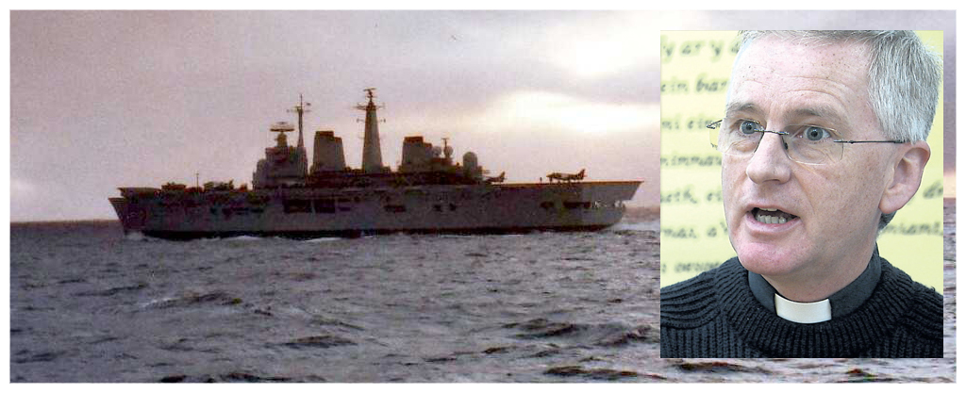

**Reverend Marcus Wyn Robinson** worked as a Chaplain with the Navy - during the Falklands troubles, offering humanitarian assistance in Somalia and work in the Antarctic among other things. He believes that compassion must be shown - "seeing a fellow man suffering from the power of oppression, I feel we have a duty to show compassion by protecting the weak who cannot defend themselves. I believe that God fully understands our complexity - our practical choices are often between 'the lesser of the two evils' and not 'the bad and the good'. ”

(<http://www.royalnavy.mod.uk/careers/roles-and-specialisations/branches/chaplaincy>)

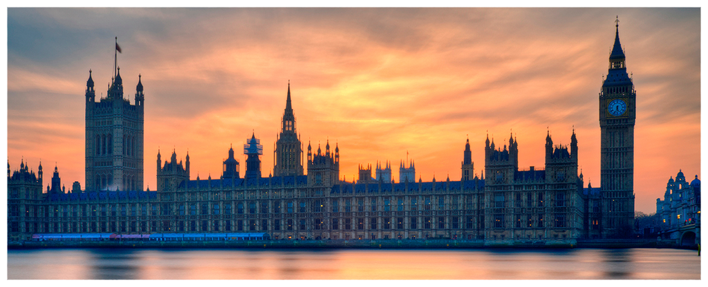

MPs have to make difficult decisions about war and peace, the situation is often not 'black and white' and it is a daunting responsibility to send young soldiers to the battlefield. The Westminster Parliament usually holds a debate before going on to conduct a military campaign against another country. **Mr Jonathan Edwards** (MP for Carmarthen East and Dinefwr) believes that the armed forces have the role of defence, not of attack.

In 2011, Mr Edwards voted in favor of military action in Libya because he believed (at the time) that there was a need to protect the Libyan people who were about to be killed by forces supporting the leader General Gaddaffi. But he has since regretted doing so, and voted against more recent military attacks in Syria. He believes that everything has to be done to avoid war because the consequences of war are so terrible.



The opinion of **Sian Cwper**, a Buddhist from Llanfrothen, Penrhyndeudraeth is so strongly opposed to war that she refuses to pay her taxes in full because she does not want to pay for bombs and airplanes. She said, "One thing Buddha teaches is not to kill any living creature, because one's people, like me, want to live and be happy. I have taken an oath before the Dalai Lama not to kill. To me, paying a government tax to kill people is equivalent to killing myself. 6 other people and myself have brought a judicial review against the government claiming that, by taxing us in this way, it violates our human rights to freedom of religion and conscience ”.

The case was taken to the European Court of Human Rights, in Strasbourg, but the court has refused to hear the case. "I've been withholding 12% of my income tax for many years because I want to pay for roads, education, health etc, but not to kill my fellow man."<http://www.peacetaxseven.com>

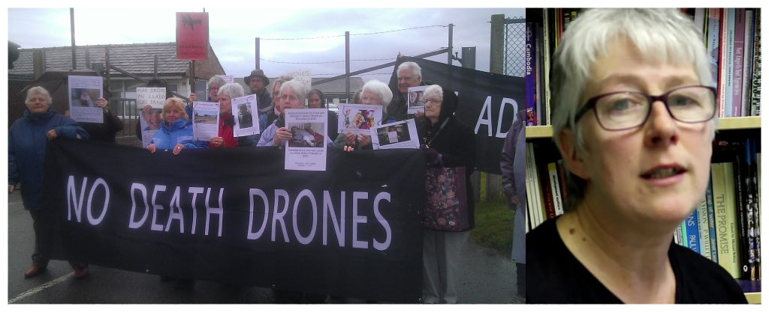

**Anna Jane Evans** and 3 other women who are members of the Peace movement Society of the Reconciliation (www.cymycommunity.org.uk) did something to show their opposition to war and killing. The Society of Reconciliation was founded in 1914 by conscientious objectors to war, based on their Christian belief. Today it has developed into a multi-faith movement of pacifists with a spiritual mission to prevent conflict and create justice based on their belief in the power of God's love. The members try to live a non-violent life. They staged a protest at Llanbedr airport near Harlech against the use of non-pilot military aircraft. They broke in to the airport to paint the words 'Dim Adar Angau / No Death Drones' on the jetty, and also put pictures of children injured in Middle East attacks on the airport fence to show that the development of robotic warfare creates terror and killing among ordinary people in countries such as Pakistan and Afghanistan. During the court case (they were charged with criminal damage) they said they acted because of their Christian principles.

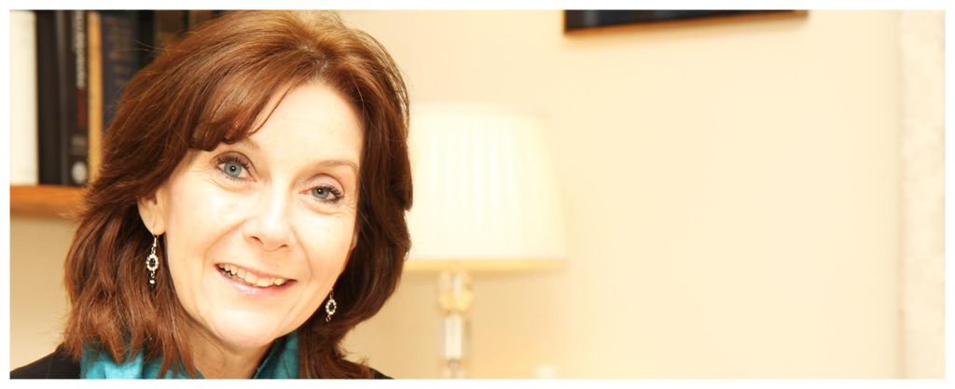

A chaired bard, Mererid Hopwood, declared her opinion and her desire to see peace in the world, not war, when she was part of the Carmarthen White Book scheme.

The Black Book of Carmarthen is a treasure held at the National Library in Aberystwyth - the oldest manuscript in Welsh dating from the 13th century and containing poetry, prayers, Bible verses and other literary excerpts.

Mererid and her friends decided to create a beautiful new book - A White Book - with space on its pages for people to record their signature by swearing an oath *"I, by signing my name in the White Book, commit myself to working for peace in the world”.* When it was launched there was some bustle in Carmarthen as young people queued to sign it.

On the cover of the White Book are these lines of poetry by Bard Tudur Dylan Jones, extolling thr virtues of the White Book:

Rhag rhyfel, rhag creu gelyn, yn annwyl

Daw’r enwau’n ddiderfyn,

Yn ddi-oed fe ddaw wedyn

Yfory gwell drwy’r Llyfr Gwyn.

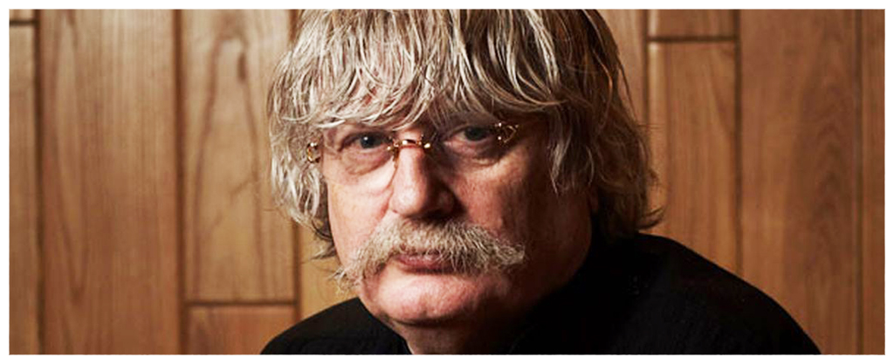

The desire for a 'better tomorrow' prompted the famous Welsh musician, **Karl Jenkins,** to compose two works on the theme of War and Peace.

The first piece *The Armed Man (Mass for Peace)* was commissioned by the Royal Armory Museum. The composer presents the work as a tribute to the victims of the fighting and violence in Kosovo. Following the pattern of Catholic mass (with additions such as an Islamic call to prayer, and excerpts from the Mahabharata), the work depicts the horrors of war but ends as the composer expresses his hope for peace.

The name of the second piece of work - *The Peacemakers* - sets out clearly what Karl Jenkins hopes for. In it, he uses the words of people like Ghandi, Martin Luther King, the Dalai Lama, Nelson Mandela, Ann Frank, Mother Teresa, Terry Waite, and quotations from the Bible and the Qur'an. Here the composer says, "*The Armed Man* ends with a plea for peace, and *The Peacemakers* continues with that plea - it's all a plea for peace, really."

(Listen to the podcast for a discussion between Anna Jane Evans and the

Reverend Aled Huw Thomas following terrorist attacks in 2015.)

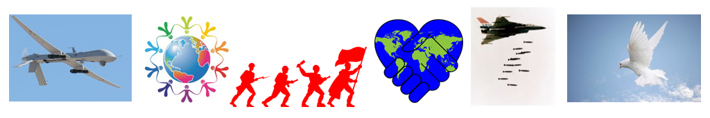

**War**

**Peace**

Here you have read about some people's opinions, and what they have done because of what they believe.

**What is your opinion?**

