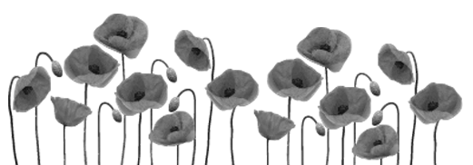

**Key Words**

**Ahimsa** - the principle of not harming any living thing.

**Archdruid** - the head of the Gorsedd of the Bards is the Archdruid, who is elected for a term of three years and is responsible for conducting the Gorsedd ceremonies during Eisteddfod week.

**Armed forces** - a group of people carrying weapons.

**Bard** - poet who has won the chair or crown at the National Eisteddfod.

**Birkenhead** - where the National Eisteddfod was held in 1918.

**Bonhoeffer** - a German theologian who opposed Hitler.

**Calvary** - where Jesus Christ was crucified.

**Chaplain**- clergyman or minister within the Christian or other faith working with the armed forces.

**Colonel Von Stauffenberg**- a senior officer in the German army who led a plot to assassinate Hitler.

**Conchy** - a derogatory nickname, used for conscientious objectors.

**Conflict**- disagreement.

**Conscience** - the inner thing that makes us recognise good / evil deeds.

**Criminal damage**- breaking / doing something against the law.

**Cynan** - an extremely important poet and character in the eisteddfodic history of Wales.

**Ellis Humphrey Evans** - Christian baptismal name OF Hedd Wyn.

**Fellow man**- member of the human race.

**Flossenburg** - one of Hitler's concentration camps where Bonhoeffer was executed. War - a situation of armed conflict between two societies or countries.

**Function** - role of person, job; a particular area or area of activity.

**Gandhi**- the leader of the movement which ensured independence for India.

**Human rights** - rights that should be accessible to all - human rights.

**Jihad** - the greater jihad is a personal struggle to live well. The lesser jihad is to fight in the name of Islam.

**Just War** - a war to protect the innocent or oppressed and to secure justice and peace.

**Karma** - all kinds of actions that lead to results.

**Kosovo** - the collapse of Yugoslavia as a country in 1990 led to fierce fighting between the Albanians and the Serbian people, and NATO forces had to intervene. The fighting ended in 1999.

**Mahabharata** - a long Hindu poem.

**Manuscript** - a book, a handwritten document (sometimes an old document).

**Martin Luther King**- leader of the American civil rights movement.

**Minister** - a person who works for the Christian church.

**Non-violent methods**- highlighting unfairness without destroying property, threatening, or hurting people.

**Pacifism** - the belief that any form of violence or war is completely unacceptable.

**Pacifist / Pacemaker**- someone who completely opposes the use of violence.

**Peace**- the ability to live on good terms with others and avoid conflict.

**Pilckem Ridge** - a place near Ypres in Belgium where Hedd Wyn was killed.

**Prevent** - stop / hinder

**Principles** - judgment, moral conviction, which governs a person's behaviour and actions.

**Regret** - to be sorry for an action.

**Swearing an oath** - promising to do something.

**Terrorism** - using unacceptable violence against others, often innocent members of society.

**To offend** - violate

**Uniform** - official uniform

**Vicar** - a person who works for the Christian church.

**Violence** - behaviour involving the use of physical force with intent to hurt or kill.