

**AN IMPORTANT QUESTION**

The question of who created the world is as old as the world itself and is still being asked today. Several answers have been proposed, some very old, mostly religious, and more recently scientific, answers. And, of course, the answer to this question affects our answers to other important questions, such as what the purpose of life is, what are our relationships with other creatures who share the world with us and what is our attitude towards the environment.

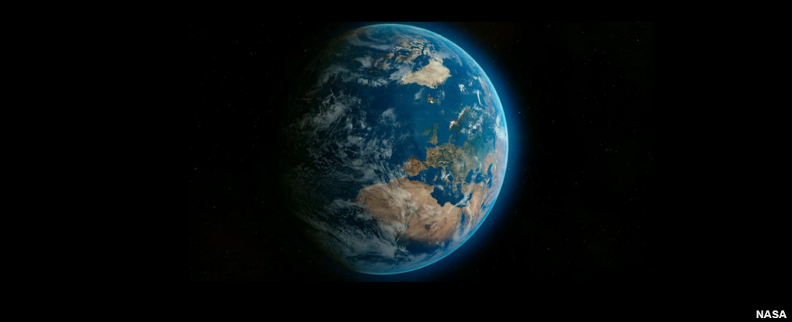

All the major world religions except Buddhism have a report or reports about the creation of the world. Some believers, known as fundamentalists, read these reports as being true, that every detail is true. Others, on the other hand, read the reports differently and see them as stories that try to explain the purpose and reason behind the creation, rather than give a practical description of how it happened. Yet, they all agree that the world was created by God and not by accident.

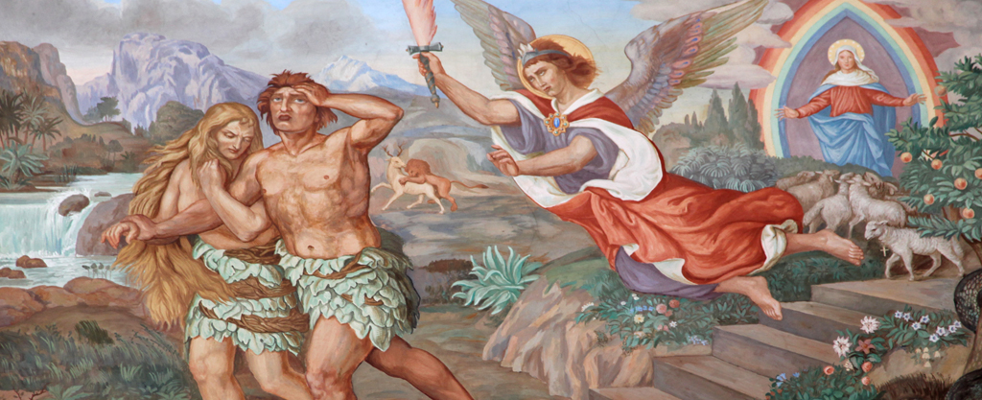

Christianity and Judaism share the same stories of creation as they, of course, share the Old Testament. Not everyone realises that there are two reports about creation in Genesis and that one is much older than the other. Genesis 2 contains the story of Adam and Eve, the Hebrew words for spouses and is one of the oldest pieces in the Bible. In this report, God creates man before anything else. He creates a model of it out of the dust of the land and then breathes into it to give it life. This shows how important human beings are, as they have a part of God in them.

Then God plants a garden in Eden and places man in it. The garden contained everything a man needed and was entitled to eat anything other than the fruit of the two trees in the centre of the garden - the tree of life and the tree of good and evil. God realised that man was lonely and, so, he created all the other creatures with him but none of them was suitable for him. So, God put a man in a deep sleep and took out one of his ribs and made him a wife - to be by his side looking after the garden.

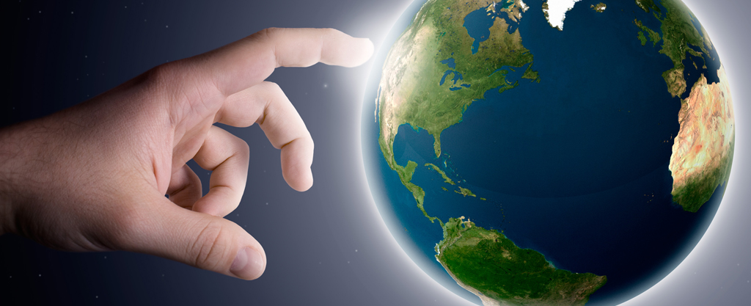

The other story is of course the creation of the world in seven days, a report that is more recent and more familiar. God creates different elements of the world on each day. In this report, husband and wife are finally created together on the sixth day. They are created differently from the other animals because they are created 'in the image of God'. This, again, shows how important human beings are. On the seventh day God rests.

Christians and Jews would agree that creation stories in Genesis teach extremely important things - that God created everything for a purpose, that the beginning of the world and life was not an accident and that humans are different from all other creatures and have responsibility for the world.

According to Sikhism, God is the creator of everything. He existed before the creation of the world. Before creation there was only deep darkness everywhere but, through the love of God, the universe came into being. The Sikh believes that God is present in everything in his creation, which is one reason for Sikhism's high regard for the environment.

Buddhists have a quite different attitude. They do not believe that it is possible to give details of how the universe came into being. It is ever-changing and constantly evolving and no being creates. Focusing on how one lives in this life is far more beneficial than discussing questions such as when the universe began.

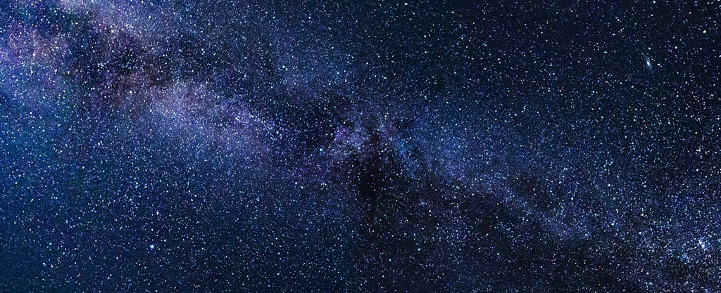

Science has a different answer to the question. There are two main theories - the big bang theory that tries to explain how the universe started and the theory of evolution that tries to explain how life on earth has evolved. According to the big bang theory, there was a massive explosion in space some 15,000 million years ago and as the pieces began to cool, and the earth was one of them, they accidentally found the right conditions for life.

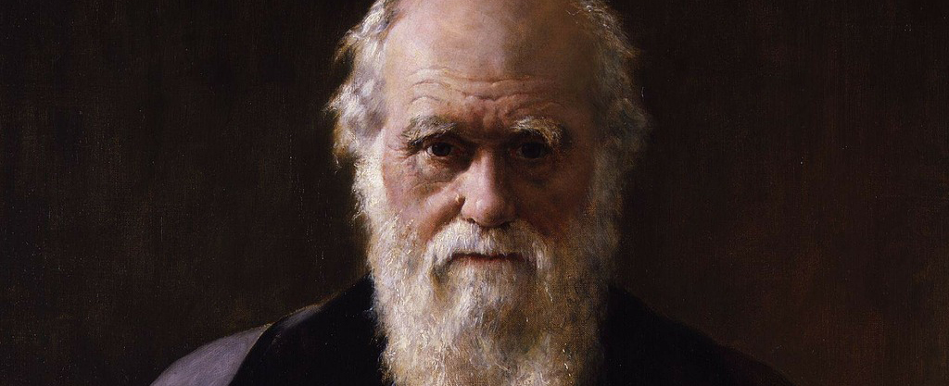

Charles Darwin published his theory of evolution in the nineteenth century. When life on earth began, it was very simple, a single cell but, from that, it has evolved into the complex and diverse creatures that live on earth today. Scientists believe that life is still evolving.

So, we see that there are very different answers to the question of who created the world and that there are big differences between the religious and scientific answers. But is it possible to accept both? For fundamentalists that is impossible. God created the world exactly as described in the holy books, no matter what science says. Yet there are many scientists who are religious believers, and many non-Christian Christians believe that God was responsible for the big bang and that he was controlling evolution and the development of life. Hinduism and Sikhism have no trouble accepting the scientific theories as they learn that the world has been created to grow and develop or evolve.