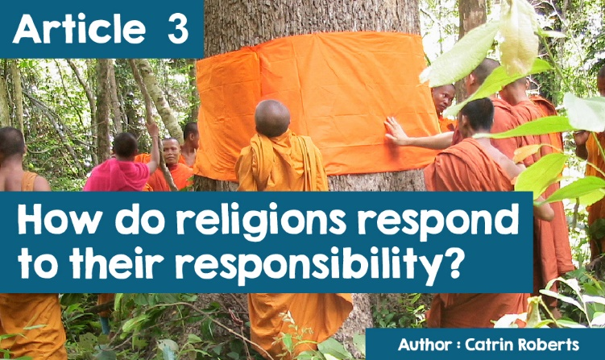

**Faith communities as eco-goalkeepers?**



I remember playing a game of football many years ago at primary school. After choosing teams, nobody wanted to be in goal! So, what the teacher did was to arrange for everyone in turn to defend the goal and keep the ball from crossing the line into the net.

Today we do not need to defend a goal, but to protect the future of the earth, because we face the consequences of abusing our planet and misusing its resources. We must be greener; rare animals must be protected; resources must be recycled; emissions leading to global warming must be reduced… and more. It is easy to say this, but I wonder what the different faith communities are doing to 'defend the goal'!

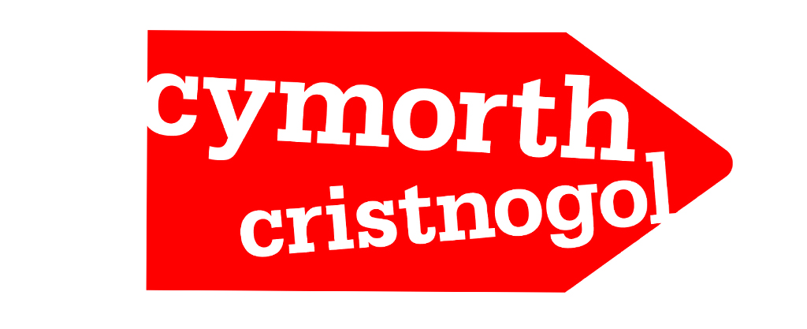

Christian Aid aims to end poverty in the world. To do this we have to deal with climate change - because the world's poorest people suffer as a result. They live in areas prone to drought, storms, and floods, and have no means of protecting themselves. Many poor communities rely on the weather because they earn their living from farming so, when the climate changes, they will be the first to suffer.

You can see how climate change is affecting the lives of Champra and Fatimata within the section **Listen and Watch**.

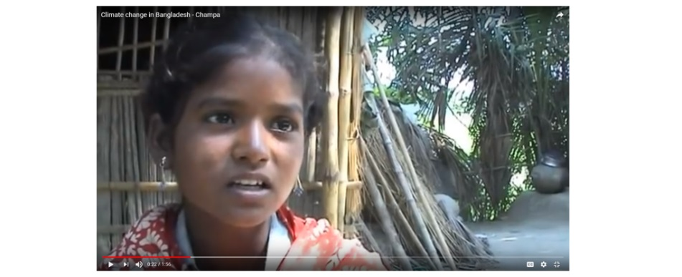

Or ([Hinsawdd Hurt.pdf](https://www.christianaid.org.uk/sites/default/files/2017-08/crazy-climate-case-studies-welsh.pdf))

**Another part of Christian Aid's work is campaigning**

One of the biggest contributors to climate change is the extraction and burning of fossil fuels. Burning gas and coal produces most of the energy we use. Relying on such fossil fuels is what has raised the earth's core temperature.

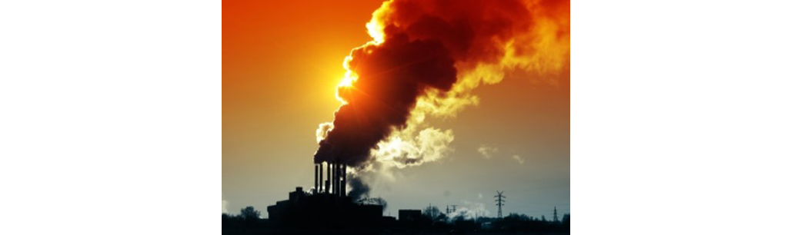

Christian Aid wants to put pressure on the UK Government and global companies to reduce fossil fuel consumption and move to becoming more reliant on sustainable energy.



And they are asking their supporters to be part of the BIG SHIFT campaign.

**And do what?**  
  
Write to our members of parliament asking them to put pressure on the British Government

a) to make a clear commitment to step away completely from coal burning in the **UK** - by 2023.

b) to work with the Business Department to ensure that UK **Export Finance** no longer supports any form of coal extraction abroad

c) and ensure that any funding saved by doing this is reinvested to help create new green jobs and a low carbon economy globally.

Christian Aid also wants us to go to our local banks and issue a letter asking these banks to stop investing money in the fossil energy industry.

To read more about the campaign click on: [www.christianaid.org.uk](http://www.christianaid.ie/cymru/our-campaigns/campaign-for-christian-aid-wales.aspx?Page=2)

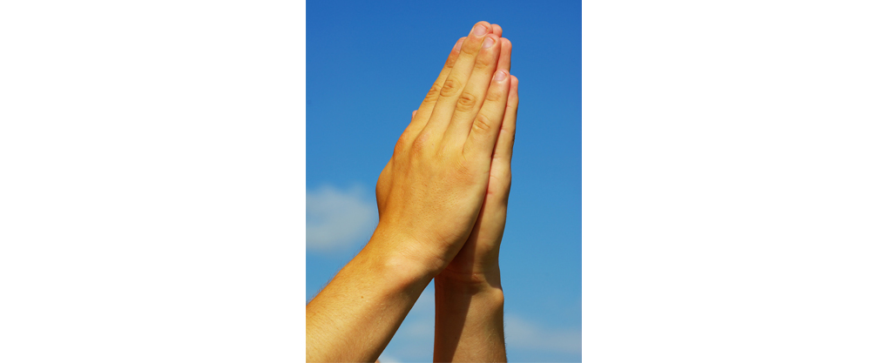

**Do we do something for the environment in prayer?**

Christians believe so, and the Pray and Fast for the Climate website[www.prayandfastfortheclimate.org.uk](http://www.prayandfastfortheclimate.org.uk/) offers resources to help us pray for the world and the environment



**Have you heard of the term jihad?**

The word means an effort - a Muslim's effort to live according to his faith, to strengthen the Muslim community, and to fight for Islam. Due to terrorism in today's world, the term **jihad** is associated with killing, but a group of young Birmingham Muslims have set out to proclaim **jihad** against litter and waste. They want to stand in goal and play their part in looking after the land of their community.

Tired of messy, litter-free streets, they decided to clear and recycle from mosque to mosque, starting with the oldest mosque in Birmingham, the *Noor ul Uloom*. You can view a very lively presentation of this campaign - *Clean Medina* - by clicking on the link[Clean Medina - You Tube.com](https://www.youtube.com/watch?v=VZdNqJ9WGFg)   
  
**And what are people of the Jewish faith doing with regard to the environment? Here are some examples**



The *Coalition on the Environment and Jewish Life* has challenged Jews to use the eight **Hanukkah** festival days to act individually, as communities and politically, to protect the earth in the face of climate change. They are a group committed to stewardship and protection of the Earth through Jewish outreach, activism, and teachings. They ask everyone, having lit up the menorah every night, to consider what they could do. Click on this link to see what is being suggested. <http://www.coejl.org/resources/hanukkah-8-days-of-action/>



Some Jews who wanted to protest about the precarious position of this famous lake, swam in the **Dead Sea**. Swimmers from many parts of the world **dived** into the salty water and tried to swim across the Sea (a 7-hour journey). This is the lowest point in the world (423 meters below sea level). The size of the lake has reduced over recent decades due to the diversion of the water of the Jordan River, which feeds the lake, to irrigate the land, and due to the evaporation ponds used to collect valuable minerals from the water. We must protect the Sea - that is what the protesters' say.  
  
**Do the people of the Hindu faith community take turns in protecting the environment?**  
  
Many Hindu groups want to minimise the environmental impact of their activities. For example, tens of thousands of pilgrims visit the temple of Sri Venkateswara in Tirumala, India daily and are fed in a communal kitchen.

Prior to 2008, the food was prepared using diesel energy, but now solar energy is used. Tirumala also wants to reduce plastic and rubbish pollution by using used bags, paper or jute for sharing prasad, and reusable or paper cups for drinks.

Follow the link for more information:

<http://www.bbc.co.uk/news/business-16746656>  
  
**And what about one example from the Buddhist faith - an unusual one!**

Some communities have started to ordain trees for protection! Buddhist **monks** and villagers wrap the **monks**' orange robes around the tree to sanctify the forest and protect it when threatened (for example when a forest was threatened in Pongpet in Thailand in 1991)

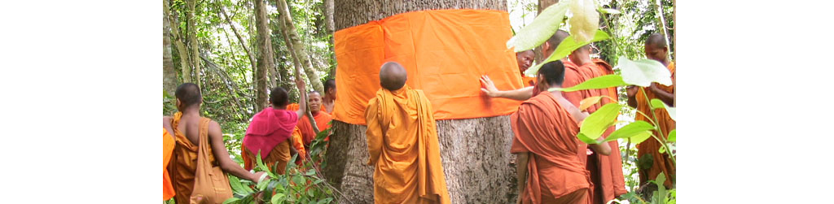

**Do you remember that football match?**

One person took the turn in goal, but he was not the only person trying to stop the ball from reaching the net. Every member of the team did just that. Fortunately, different faith communities are working together to protect the environment. This happens through the work of **ARC**, an organisation that helps major world religions to develop environmental programmes based on their sacred teachings, beliefs, and writings. Actions are more powerful than words, so ARC helps faith communities turn their beliefs about the environment into actions, for example

• By helping the Hindus of northern India to protect the tiger and their forests.

• By helping Dao's faith communities in China to persuade people that using animal body parts for medical purposes is unacceptable

• By working with Indonesian Muslim leaders to educate people about the crisis facing the Sumatran tiger



• By helping Christian, Muslim and Hindu faith communities in Tanzania, Cameroon and Kenya to make practical plans to prevent the stealing / poaching of wild animals.  
  
[http://www.arcworld.org](http://www.arcworld.org/projects_overview.asp)   
  
**That's what some of the world's religions do.**

**Do you want to be an eco-goalkeeper and part of the team?**