**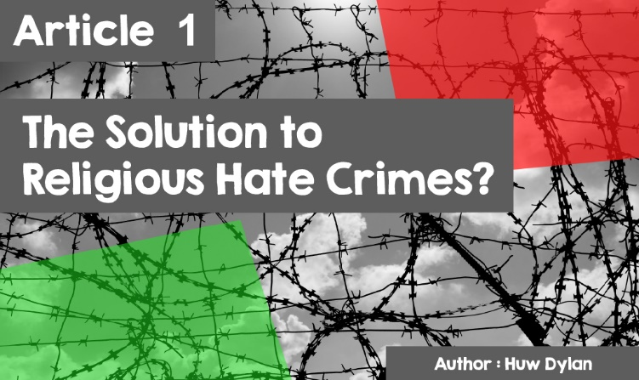**

|  |
| --- |
| **THE SOLUTION TO RELIGIOUS HATE CRIME?**  There is tension in many religions between offering criminals’ forgiveness or punishment. Christianity is a religion of forgiveness that teaches that since God forgives people, believers should act in a similar way and forgive others. Yet, some Christians would emphasise the need for justice and that this means punishment. They would say that punishment and forgiveness can be mutually exclusive.  Islam also stresses the importance of forgiveness and reconciliation but that there is a need to protect society. Punishment is, therefore, seen as an important part of justice. Punishment is necessary to learn the difference between right and wrong.  For Buddhism, having a system of punishment prevents more violence. Yet, there is no room for revenge within punishment as this contradicts the teachings of Metta (loving kindness) and Karuna (compassion).  One of the crimes that is becoming more common in our society is what is called religious hate crime. What is that? – well, a crime that is committed because of hatred or prejudice based on religion. Someone can be the victim of such a crime - someone can target you because you belong to a particular religious group or because of your religious beliefs or those of someone in your family. A religious group is a group of people who share the same religious beliefs as Muslims, Hindus, and Christians.  There was a 35% increase in religious hate crime cases (4,400 to 5,949) reported by the Police between 2015/16 to 2016/17. Organisations such as [Ethnic Youth Support Team Cymru](http://eyst.org.uk/publications/) offers training in understanding Islam and dealing with Islamophobia. |
| R:\2015-16 E-gylchgrawn Addysg Grefyddol\HTML\cylchgrawn_5\images\article1_pic1.jpg |
| These crimes can occur in a variety of ways - verbal and physical abuse; bullying; threatening behaviour; online abuse or property damage. It can be one specific event or a regular series of events. And the offender can be anybody - someone you do not know, a neighbour, a teacher or even someone you considered a friend.  POLICE AND PARTNERS IN WALES JOIN FORCES FOR HATE CRIME AWARENESS WEEK -  True Vision  In 2006 the Racial and Religious Hatred Act was passed by the United Kingdom Parliament, which made it an offence to incite hatred against a person on the grounds of their religion. Yet, one thing is to pass a law, another is to try and implement it and get rid of such crimes. Although it is difficult to gauge the effectiveness of the law in general, its success is limited as there are still constant examples of hatred towards various religious groups. |
| R:\2015-16 E-gylchgrawn Addysg Grefyddol\HTML\cylchgrawn_5\images\article1_pic2.jpg |
| Therefore, religious groups have taken the lead and tried to act in diverse ways to try to bring different communities closer together in the hope that a better understanding of each other's beliefs and practices will lead to less prejudice and hatred. They encourage goodwill towards people of different faith communities, which means respecting the freedom of people within the law to express their beliefs; respect the conviction of others regarding food and dress; work to avoid misunderstandings turning into conflicts and always avoid violence. When discussing faith issues, one must do this honestly and realise that listening as well as speaking are necessary for a sensible dialogue. Leaders of the different religions believe that the different religions have more similarities than differences in common, especially in terms of values ​​such as love, compassion, respect, and fairness.  The ADL - Anti-Defamation League - produced an 80-second video in 2013. The theme was that if people stood together against religious and racial hatred, history could be changed, and a world created without conflict. Musical background to the video was John Lennon's 'Imagine' song. John Lennon was an ardent supporter of **peace** but was murdered by Mark Chapman who disagreed with his religious ideas. Check out the video on You Tube. |
| A picture containing graphical user interfaceDescription automatically generated  ([Imagine a World Without Hate - YouTube](https://www.youtube.com/watch?v=3KyvlMJefR4)) |
| Leaders of the different religions do not deceive themselves that living side by side is easy. Religion contains deep emotions that can be destructive at times and so to prevent that happening, faith must be strong enough to promote reconciliation and understanding. There is a famous story about a man talking to his grandson and telling him - 'There's a big fight going on inside me - a battle between two wolves. One is evil, and represents hatred, greed, and intolerance. The other is good and represents joy, **peace**, love, humility, kindness, generosity, and compassion. This fight is happening inside you, too, and inside every person.” The grandson then asked, “which wolf is going to win?” The old man replied, 'The one you feed.'  Religious communities have done much in practice to seek a better understanding between them and, thus, reduce the possibility of hate crime occurring. Some faith communities have run a one-day project, such as litter picking in the local park and inviting other communities to join them. Young people from different faith communities working together to clear a local cemetery. Faith communities in Grangetown, Cardiff came together to produce a book <http://188.65.112.140/~daftscou/steve/OurFaith.pdf> to promote tolerance and understanding. Some faith communities organise joint meetings to discuss different religious and social issues. Many religious buildings within the various religions have held open days to promote understanding of their beliefs and practices. |
| R:\2015-16 E-gylchgrawn Addysg Grefyddol\HTML\cylchgrawn_5\images\article1_pic4.jpg |
|  |
| One such flagship project in Wales is the Peace Mala. It is an educational project to promote peace initiated by Pam Evans, former Head of Religious Education at Ysgol Gyfun Coedcae in Llanelli. It was established in 2001 in response to the racial and religious bullying emanating from Islamophobia following the 9/11 attacks. Using a symbolic double rainbow bracelet focusing on the 'Golden Rule' found in different religions – ‘do to others what you would have them do to you’, the project encourages inter-religious dialogue to ensure global citizenship and peace. It encourages friendship and respect between people of all cultures, lifestyles, and religions. It is a vision for the future. Wearing the 'Peace Mala' is a promise to create a better world. |
| R:\2015-16 E-gylchgrawn Addysg Grefyddol\HTML\cylchgrawn_5\images\article1_pic5.jpg |
| The Religious Education Council for England and Wales has set up Young Ambassador groups to try to improve public understanding of Religious Education. Young people of different faiths come together to promote a subject that they believe is important to build positive community relations and inter-religious understanding. The council celebrates diversity and believes that Religious Education provides people with information that enables them to challenge prejudice and stereotyping. |

