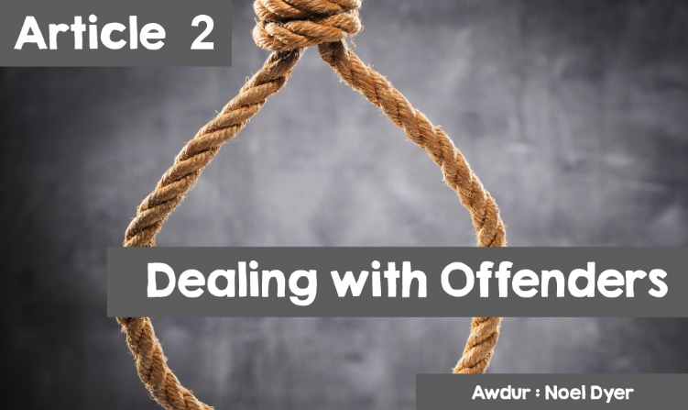

**DEALING WITH OFFENDERS – PAST AND PRESENT**

A **crime** is an act, which is wrong and that can be punished by law. Approaches to dealing with offenders have varied from one age to the next and to this day there is no full agreement on how to deal with offenders. Usually, a **punishment** is given. The starting point in the western world was traditionally the words of the Old Testament- **'An eye for an eye, a tooth for a tooth.'** Simply, if someone hurt you, you had the right to hurt them back. If someone took your property, you were entitled to take something of equal value. You were therefore entitled to revenge, pay back, and make up for your loss. At times, it was felt necessary to imprison people to protect others from a dangerous offender. It was felt that there was a need to ensure that people realised their wrongdoings, in the hope that they would change for the better. To some extent, there has been a change in attitude and more help to rehabilitate and **reform** the offender.

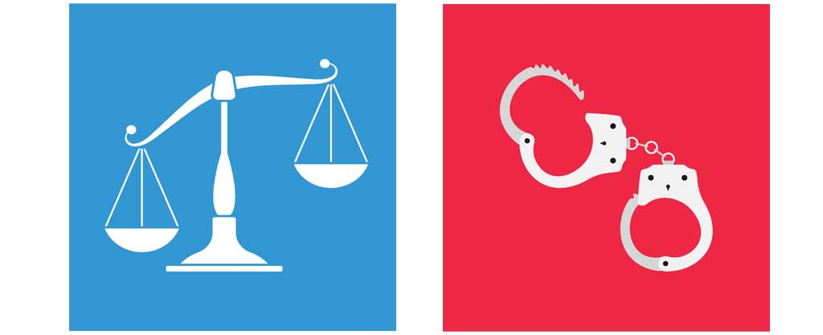

**THE ATTITUDE OF CHRISTIANS**

Christians would turn to the New Testament for guidance. It teaches that people will receive God's **forgiveness**. Therefore, believers should act in a similar way and forgive others - this is the ideal anyway. When looking at criminals today, many comment on Jesus' words, such as - '**' Love your neighbour as yourself '' There is no commandment greater than this'** '(Mark 12: 31), arguing that showing love for others is the first duty of the Christian. One of Jesus 'most famous parables is' **Judging the nations**', where Jesus places himself in the position of others -' **For I was hungry, and you gave me food ............ I was in prison, and you came to me'** (Matthew 25: 35-36). At the end of the parable, Jesus praises those who have helped, promising those people a reward.



As a result, some Christians have been inspired to offer a support service for ex-prisoners. They have also offered support to prisoners and their families. This has included arranging a bus for visits to the prison. One example of this is **Noddfa Presbyterian Church in Caernarfon**. There is a sense within the church that serving the community in every way is an essential part of the work of the church. They have a project called **BARA Arfon** which supports ex-prisoners and their families. What worries people is the way so many of them re-offend. Many are homeless after leaving prison. Many can return to their families but cannot find work. It is difficult for many to get back to a life free from crime and problems, therefore, practical help must be given.

Christians, on the other hand, also argue that punishment and forgiveness can go hand in hand. The innocent must be protected from criminals. Changing the attitude of offenders is important and getting them to realise that their behaviour is not acceptable. Justice must be ensured and that includes punishment.

**THE ATTITUDE OF ISLAM**

"If anyone kills someone - unless he is murdered for murder or spreading wickedness through the land - it will be as if he is killing all men, while if he saves a life, it would be as if he were saving the life of every man.”

In Islam, forgiveness and reconciliation are important but society must be protected from criminals. Punishment is acceptable as an element of justice - preventing further crime and leading them on the right track. Muslims believe that people who offend go against the **Qur'an** and deserve the punishment of the law and the punishment of Allah on Judgment Day. Islam implements **Sharia law** in a just and public way. According to the Qur'an **'Stand firmly for justice, as witnesses to Allah, even if against yourselves, or your parents, or your relatives. Whether one is rich or poor** '(Qur'an 4: 135)

Fairness must be seen to be implemented in a just way, with an opportunity for recovery. Many Muslims are concerned about the welfare of prisoners, campaigning for prison improvements, visiting prisoners and securing opportunities for them on leaving prison. The Qur'an, nevertheless, carries harsh punishments in the eyes of Western countries. One example is cutting off a hand for serious theft, a punishment that would not be allowed in Wales.

**THE DEATH PENALTY**

Only the state has the right to do this following a fair trial. The **death penalty** still exists in **over 50 countries** (though not all countries implement it). There have been no executions **in Britain since 1964** and it has now been abolished, although it remains a subject of debate.

**Over 2,000 people were executed in 2015: over 1,000 in China**. Second was **Iran (360);** then **Saudi Arabia (82+); US (43**, half of them in Texas), and **Iraq (68**). **Belarus** is the only country in Europe that still executes.

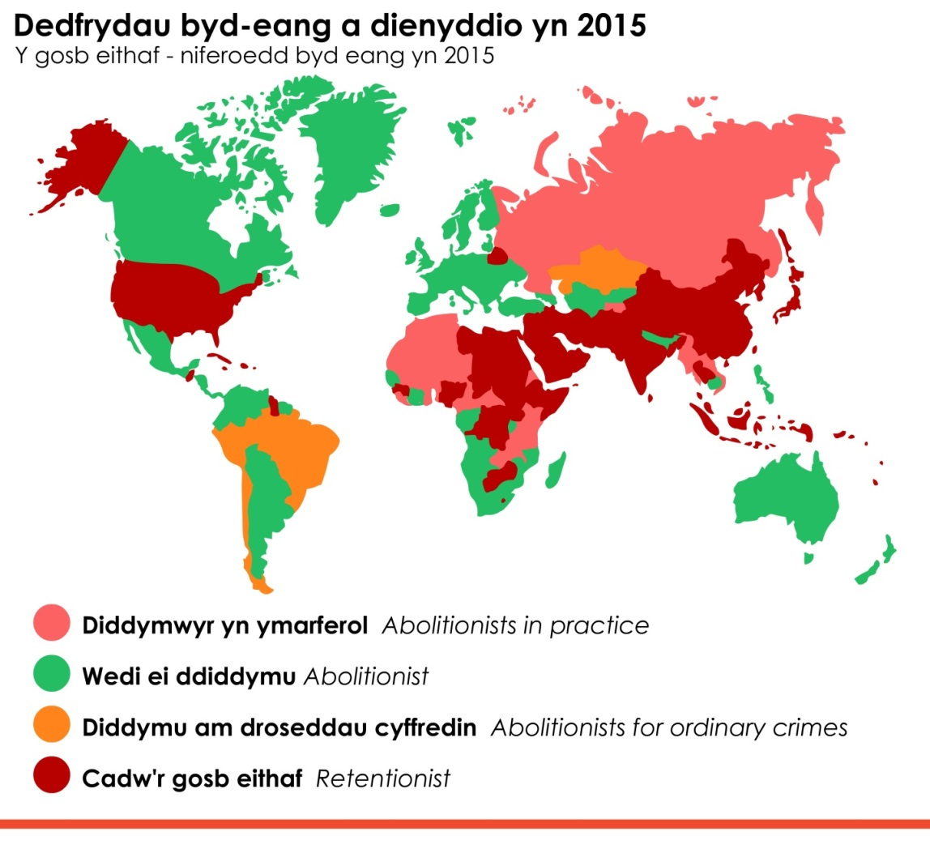

Global sentences and executions in 2015

The death penalty – global numbers in 2015

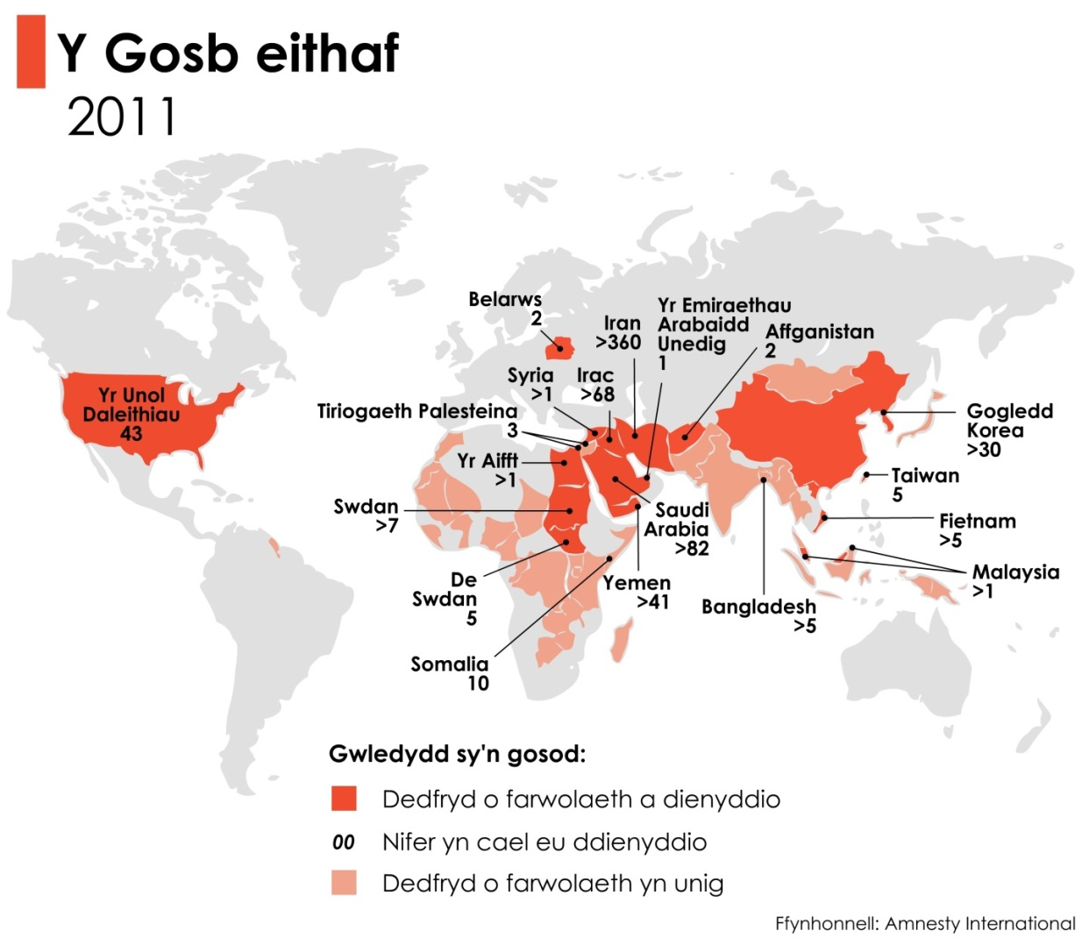

**The Death penalty**

The United States

Palestinian Territory

Belarus

The United Arabian Emirates

Afghanistan

North Korea

Vietnam

South Sudan

Sudan

Egypt

**Countries which impose:**

Death Sentence and execution

Numbers executed

Death sentence only

Source: Amnesty International

**ARGUMENTS FOR THE DEATH PENALTY**

It prevents murder and protects society from terrorists and serial murderers. It reflects some of the Old Testament statements and saves the country a lot of money! It closes the case for the family and helps them move forward.

**ARGUEMENTS AGAINST**

Unfortunately, innocent people have been wrongly punished and the situation cannot be put right. All life is holy and killing in the name of the country is not acceptable. The danger of life imprisonment should be enough to deter a murderer. Occasionally, a terrorist is seen as a martyr of execution.

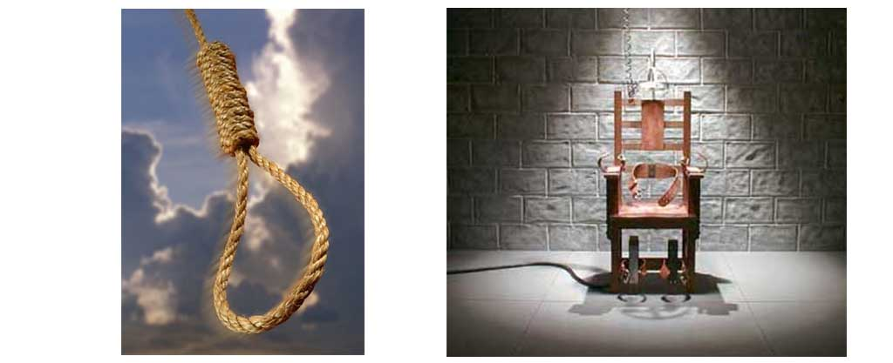

**CHRISTIONS AND THE DEATH PENALTY**

Some Christians would turn to the **Old Testament** pointing out the words of Moses' law on the right to revenge – ‘**But if there is serious injury, you are to take life for life, eye for eye, tooth for tooth.’** (Exodus 21:23-24)

Some Christians would agree with several of the above arguments for the death penalty.

On the other hand, most Christians today would disagree with the death penalty. The emphasis of Jesus' message is on avoiding violence and showing forgiveness and love. The words of the **New Testament** change the emphasis as Jesus says,’ **'An eye for an eye, a tooth for a tooth', ‘But I tell you not to resist an evil person. If someone slaps you on your right cheek, turn to him the other also.’**

**AS A CHRISTIAN:**

* Jesus taught about love and forgiveness.
* Jesus came to save people and change them for the better.
* All life is holy and owned by God.
* The sixth commandment is clear - **'Do not kill'.**
* The death penalty belongs to a more primitive era.
* **The Society of Friends (Quakers)** has been campaigning against the death penalty since 1818. This is also part of the **Amnesty International** campaign.

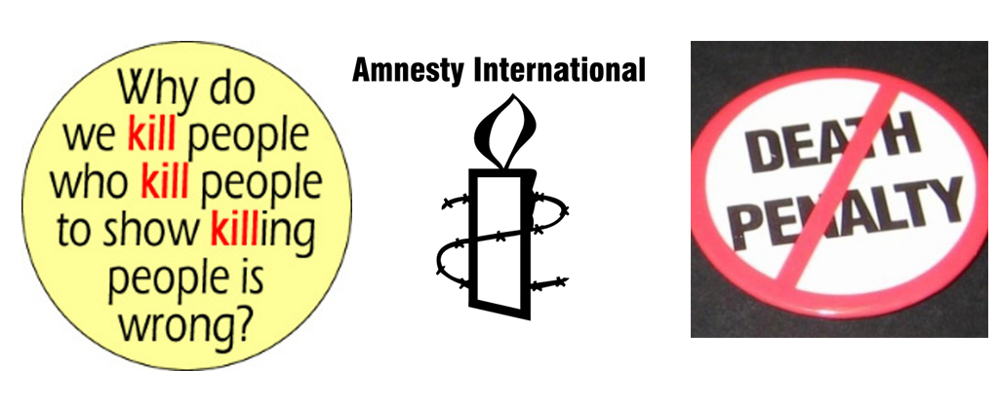

**ISLAM AND THE DEATH PENALTY**

The Islamic legal system is called **Sharia Law**. It is founded on justice in a way that ensures that all people are treated fairly. Islam sees the death penalty as justifiable for some serious crimes. Sharia law allows the death penalty for:

* **Deliberate murder.** The victim's family has the right to say if they want the murderer executed.
* **Threatening to undermine authority.** This is a broad area that can be interpreted in many ways, e.g. betrayal and terrorism, deliberate action against Islam.

As a result, all Muslim countries allow the death penalty but not all those countries implement it. Yet, some Muslims still believe that forgiveness is better as forgiveness (along with peace) is one of the main themes of the Qur'an.

