

**CRIME AND PUNISHMENT**

**- THE EXPERIENCE OF A PRISONER, A SOLICITOR WHO IS NOW AN ARCHBISHOP, AND A FORMER POLICEMAN TURNED MINISTER**

*Catrin Roberts spoke to the three, starting with the* ***Reverend******Nan Powell-Davies***



**CR**: *Nan, you worked as a Prison Chaplain for some years as part of your ministry.*

**NPD:** Yes, for eight years in the men's and category B offenders’ prison at Altcourse, Liverpool. This is the prison to which criminals from North Wales are being sent, and I had a special responsibility for Welsh speakers. A new prison has recently opened in Wrexham to serve North Wales, but most North Wales offenders are still going to Altcourse. The crimes varied greatly – some were in for stealing and spent only a few days in custody, others had committed horrific crimes such as murder and violence.

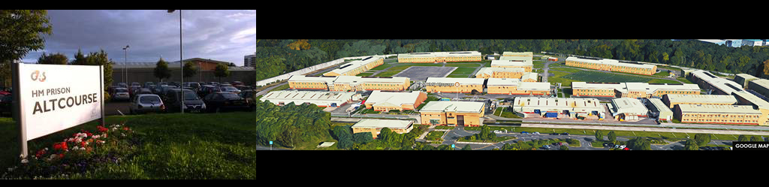

**CR**: *What was your work pattern like?*

**NPD:** Arrived by 7.30 am (when cells are unlocked); went through the Security system (no mobile phones, chewing gum, anything metal were allowed); collected keys to open doors / gates to get around; compiled a list of any newly- arrived offenders to see them; also visited any offenders in hospital or those who had been segregated.

Then in the afternoon, I saw any prisoner who had requested a visit. Many face problems and need to talk. These meetings can be very emotional, and I often had the opportunity to read the Bible and pray with the men in their cells. Sometimes they would come to the chapel to light a candle after hearing of the death of a family member. I also went to see the families when something happened to the offender in prison, for example, suicide.



**CR:** *So, faith could play a role in the lives of the criminals.*

**NPD:** When arriving in prison, every offender is asked the question, "Do you have faith?" and if so, what religion. The most common answer was - no faith, but the chaplains are there to help everyone, faith or not! That is what the sacred writings of the various religions teach - the need to help others. There was a part-time Muslim chaplain there, and sessional chaplains would come on behalf of the Jehovah's Witnesses, Buddhists, Sikhs, Pagans, Hindus, and Jews.

I used to lead Bible studies at night, especially with the vulnerable, who were kept separate from everyone else for different reasons.



**CR:** *Did you see that the work of Chaplains helped prisoners?*

**NPD:** The company of a chaplain certainly helped as they faced crisis and depression, and the experience of losing their liberty. I saw many men coming to believe in Jesus Christ. One of them, Tony Riley, used to sell drugs on a large scale, and was a member of a gang in Liverpool. He used to say that his mother was so worried about him that she started losing her hair! But Tony changed - he left prison last time around 7 years ago, and is now a drug counsellor at Anfield, and a very active member of a local Church. So, people can change! Witnessing the experience, Tony says, “When I came in and out of prison, I used to say, 'I came in with nothing, and I went out with nothing.' Last time, I could say, 'I came out with nothing, but I'm going out with Jesus in my heart!'



**CR:** *Does imprisonment make people realise they need to change?*

**NPD:** Many criminals claim to be innocent or downplay their crime. As a Chaplain I helped with a course called SORI - a course to help people see that they needed to be truly remorseful for what they did, and to think about how they were going to remedy the harm caused. We were inviting members of the public in to accept these people's apologies. The statistics showed that offenders who had taken the SORI course were much less likely to reoffend.

**THE MOST REVERAND JOHN DAVIES, ARCHBISHOP OF WALES**

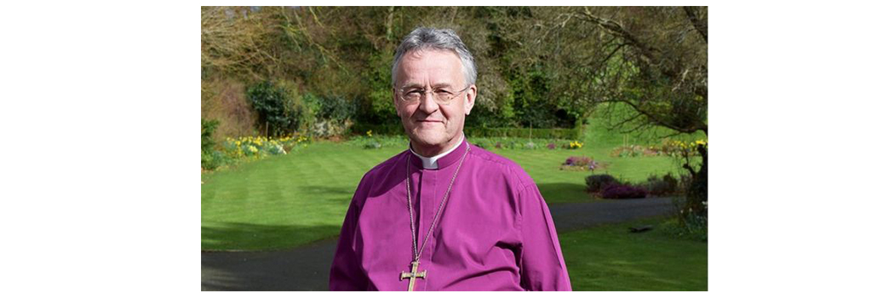

**CR:** *What is your experience of crime and punishment?*

**JD**: I had no idea what to study at university, but I opted for Law. Of all the subjects I studied during the course, criminology and criminal law were the most appealing, and I was a legal worker before becoming a priest. In retrospect, my 'faith' background may have led me to an interest in justice, forgiveness, the possibility of rehabilitation.

The Bible describes the ministry of Jesus Christ as restoring people, seeing people's potential and value, repairing people's relationships with one another. Think about the history of Zacchaeus and Matthew - tax collectors who cheated, stole, and made people suffer, but Jesus led these men to see that they needed to change, and to follow a new path. I'm not talking about being 'soft', but about justice and giving people a new opportunity.

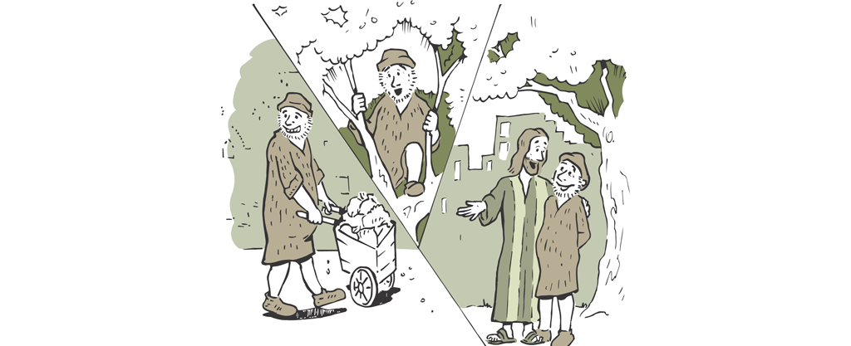

**CR:** *Does incarceration help people change?*

**JD**: I'm not sure if prison helps. So many re-offend. The prisons are overcrowded - about 800 prisoners in Swansea prison for example, but the prison was built to hold only about 250. There is not enough time or money to educate, counsel, train offenders to give them a chance to change. And a high percentage suffer from mental illnesses. In our prisons today, we have people who need help, and, for whatever reason, they don't get that help.

**IAN SIMS,** MINISTER



**CR:** *Can you describe your experience of crime and punishment?*

**IS**: Prior to being ordained as a minister, I served with the Police for 30 years.

***CR****: What kind of work did you do with the Police?*

**IS**: I was in uniform, then in the Criminal Investigation Department, the Drugs Department, and the Central Detective Department. I started with dealing with petty crime - traffic issues, but then faced worse crime - murder and the drug market.

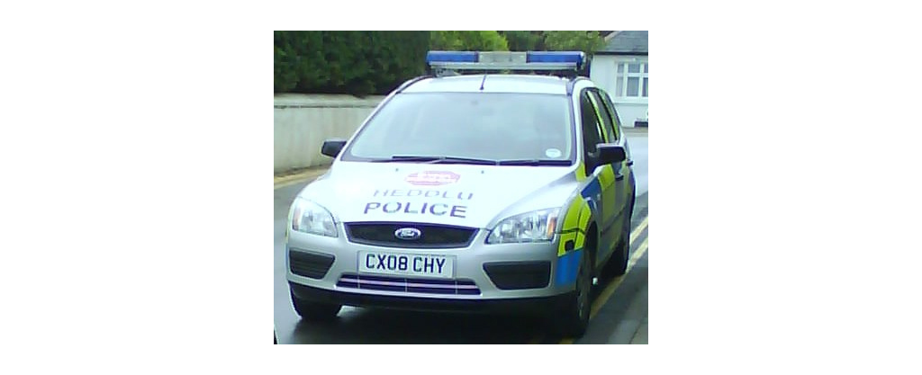

**CR:** *In your experience, do punishment and prison work?*

**IS**: I have seen one or two that have changed the course of their lives after being punished by law, but a very low percentage. As a youngster, I was friends with a boy who committed armed robbery - he was apprehended and sentenced to a term in a young offenders’ institution. He didn't commit a crime again. But some see prison as an improvement. One offender told me. “I’m better off in here. I get three squares a day, and somewhere to sleep.”

**CR**: *Did your faith, or Bible teaching, influence your work with the Police?*

**IS**: The Bible teaches us to be fair and honest. I always tried to be fair to criminals and kept to my word. I never promised anything that I wasn't going to stick to.

**So, there we are - three recounting their experience of putting their faith into practice in the context of law, crime and punishment.**