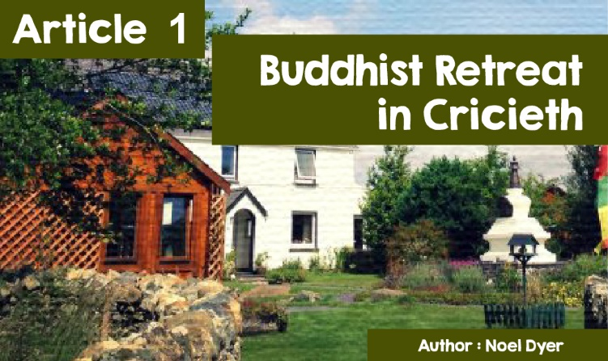

|  |
| --- |
| **Buddhist Centre near Criccieth** |

|  |
| --- |
| If you were looking for refuge - perhaps a place to go for peace and quiet or time to think - where would you choose? One of the following, perhaps?  · A quiet area at the bottom of the garden, in the shade of the trees.  • A lovely riverside walk, relaxing at the sound of water.  • To the top of some hill or mountain to appreciate the views.  • Visit some site that is important to you or your family.  For some years in North Wales, there is a choice that’s a little unexpected. A centre called ‘The Hermitage of the Awakened Heart.’ It is located in the area of Ynys near Criccieth, about 10 miles from Porthmadog. According to the website [*https://buddhisthermitage.wales*](https://buddhisthermitage.wales)  the Refuge, from where you can see the mountains of Snowdonia, is the centre of the activities of the Awakened Heart’s Sangha and is home to Lama Shenpen Hookman, where she spends most of her time, retreating or working with her students, following a home study course on meditation and Buddhism '. |

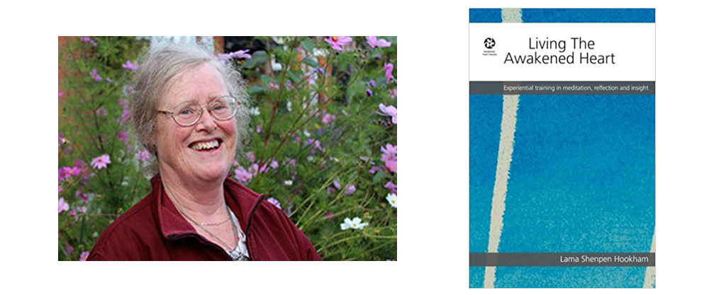

**Why come to the Criccieth area?**

The Awakened Heart Refuge was established in Sunnyland Island in 2003. Lama Shenpen Hookham (Lama means Buddhist teacher) has been interested in the religion of Buddhism since she was in her 20s and pursued numerous Buddhist teachers in India and Tibet. She is now an expert in the field and has published many books. She says she was led by a Tibetan Lama to choose a place west of London and, in time, under further guidance, north Wales and then the Criccieth area.

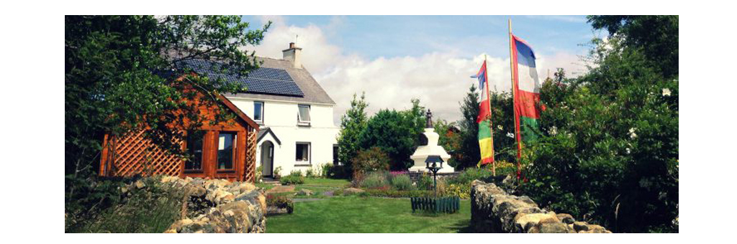

As you can see from the picture, Ynys Graianog is a lovely house and place. Lama Shenpen sees advantages to a quiet rural setting, saying; 'You can meditate while walking, there are so many wonderful locations in this area in which to do so '. Within the Sangha there are study rooms and practical and spiritual provision for the people who come there. By now, there is an impressive Stupa outside. This is a statue containing the remains of some notable Buddhist teachers from the past. One of these is usually found in a Buddhist centre (this is, probably, the first in Wales) and is a focal point for reflection.

You can learn more about Stupa Ynys Graianog by visiting the website: [*https://buddhisthermitage.wales/the-stupa/*](https://buddhisthermitage.wales/the-stupa/)   
  
There is also a striking image of the Tara Wen Buddha, a female Buddha. Lama Shenpen Hookham chose a statue of this Buddha following the guidance of her own Lama, Khenpo Tsultrim Gyamtso Rinpoche. The statue itself came from Nepal. She said, **'Having images is important as a focus for sacred space'.**

A spokesperson for the Refuge says links with the local community are growing. A resident of the centre works on behalf of 'Ymwybyddiaeth Gwynedd Mindfulness', offering courses and public discussion sessions on issues of mental wellbeing, dealing with stress and so on. Locals are welcome to visit and join in meditation and training days.

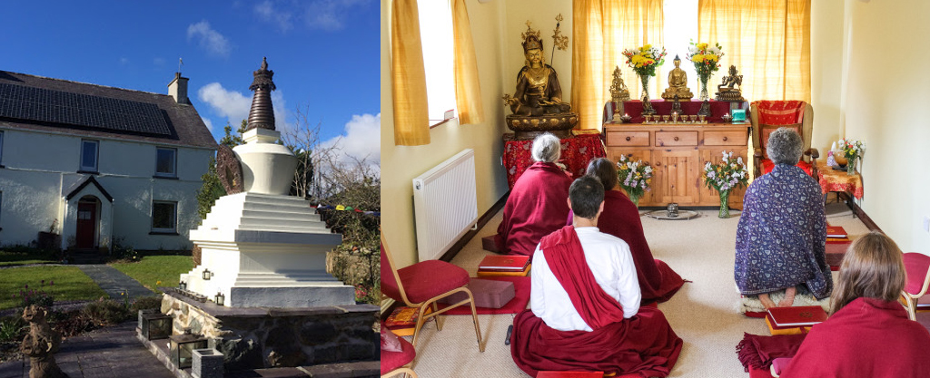

**What happens at the Awakened Heart Refuge?**

The main function of the Sangha (Community) is to guide students. It is possible to do so remotely, especially over the internet. Lama Shenpen has a lot of material on YouTube. She has also written many books as guidance. On the other hand, the main emphasis is on personal leadership. People come to stay and spend time receiving individual and group guidance. It is possible for people to come there as individuals or as a group. Up to 25 people can attend the courses available. There is no set cost, but everyone is free to contribute financially to sustain the work.

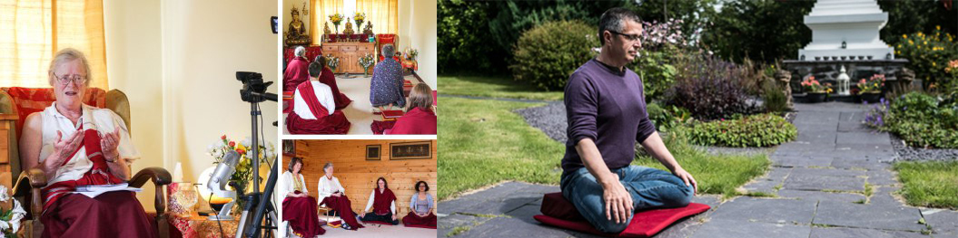

The training offered in the Sangha is detailed and includes training in Buddhist meditation and insight, including the following:

* Discovering the truth about the Buddhist religion through experience and inquiry;
* Connecting to the truths of Buddhism, for the experienced and less experienced;
* Gaining an understanding of the characteristics of Tibetan Buddhism in particular.
* Receiving guidance from teachers and mentors.
* Becoming part of a spiritual community sharing experiences and discussion.  
    
  All who wish to explore the features of Buddhism are welcome to join in the activities, rituals, and celebrations. For some the religion is completely new while others are more experienced. Course content is customised as needed. Meditation is clearly an important part of the courses. Reflection is seen as a way for the individual to better understand themselves. It is about dealing with life's difficulties such as doubts, stress and confusion and aiming for hope and positive feelings. According to Lama Shenpen 'The aim is to provide everyone - young or old, Buddhist or non-Buddhist - with an accurate and direct way of connecting with their awakened heart'. By doing this, it is hoped that people will be enabled to live full and fulfilled lives in a way that benefits everyone around them.

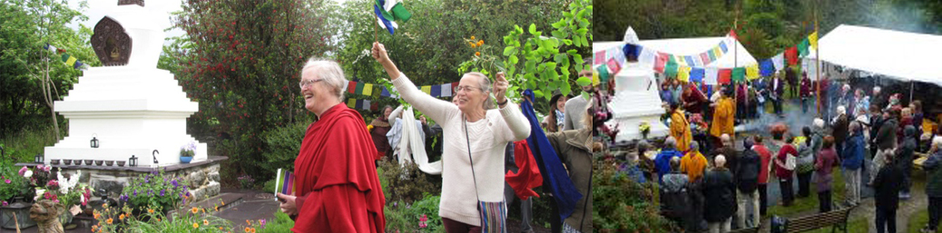

**Response to the Awakened Heart Refuge.** The reaction of people following a visit to the centre near Criccieth is very positive. Here are a few comments:

*'The Refuge is a wonderful place to visit .... I am always welcomed there, and it is a great opportunity for reflection and study, under the guidance of Lama Shenpen.*

*'A very special sacred space for the retreat and message of Buddhism.'*

*'I started coming to the Refuge in 2013 and loved the place from the start. If you are interested in Tibetan Buddhism or Buddhist meditation, which includes consideration of the needs of the people of the West, this is the place.*

*'It has been a blessing to find a Lama who understands the Western mind and who is also steeped in the tradition of Tibetan Buddhism.'*

*'Lama Shenpen's teaching is great, whether you are new to Buddhism or experienced. The community (Sangha) is helpful and friendly.'*