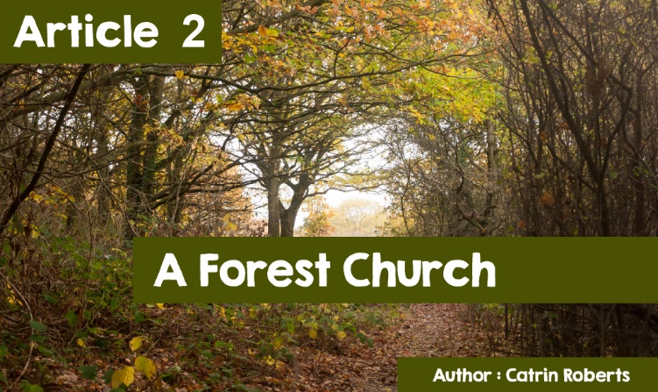

|  |
| --- |
| **A Forest Church?** |

|  |
| --- |
| What picture comes to mind when you hear of a 'special place of worship', or a 'place to get nearer to God'? |

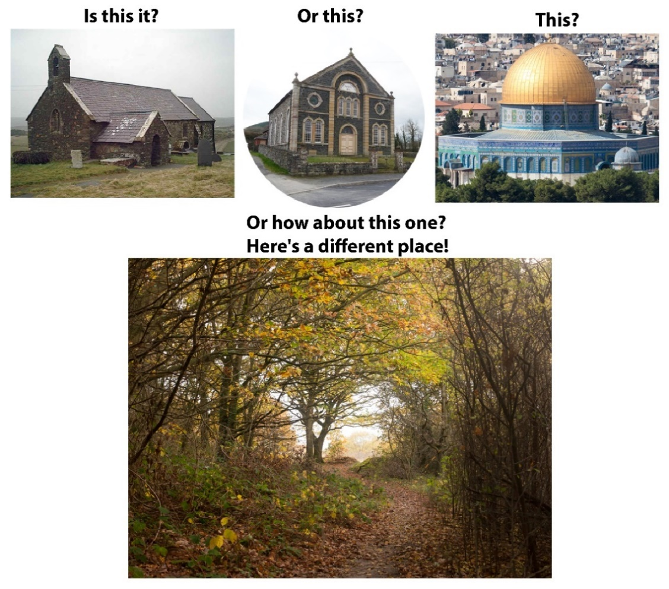

Does this picture show a special place to worship?

|  |
| --- |
| **A Forest Church?** |
| A recent development in Wales is what is known as the Forest Church, where people are looking for an opportunity to connect with God, not when sitting in a particular building and following an order of worship, but while sitting or walking in the middle of nature.  A Recent development?  Yes, but it's not brand new either! If you go to the book of Psalms in the Bible, it is clear that looking at creation made the Psalmist think of God, and praise him  ***O LORD, our Lord,  how excellent is thy name in all the earth!*** (Psalm 8, verse 1)  ***When I consider your heavens, the work of your fingers, the moon and the stars, which you have set in place,***  (Psalm 8, verse 3) |



And in the New Testament, Paul says in his letter to the Christians of Rome, **for since the creation of the world His invisible attributes, His eternal power and divine nature, have been clearly seen, being understood through what has been made.** (Chapter 1 verse 20)

As we follow the story of Jesus, we see him going to the top of a mountain for peace to think and pray to God.

In Buddhism, we learn that Buddha had a vision while sitting under the Bodhi tree,

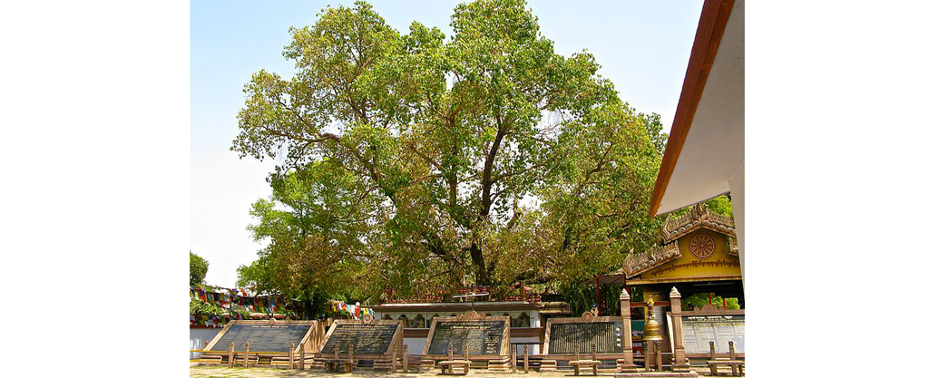

|  |
| --- |
| and Hindus make pilgrimages to various holy rivers and mountains.  The Forest Church is not about moving what used to happen in a place of worship, and doing it outdoors, but giving people the opportunity for a completely new experience of trying to experience God. It is possible to learn, listen, pray, meditate, worship, and have an association with people in the midst of trees, beside a river, or sometimes at the seaside. |

|  |
| --- |
| **WOW!** |

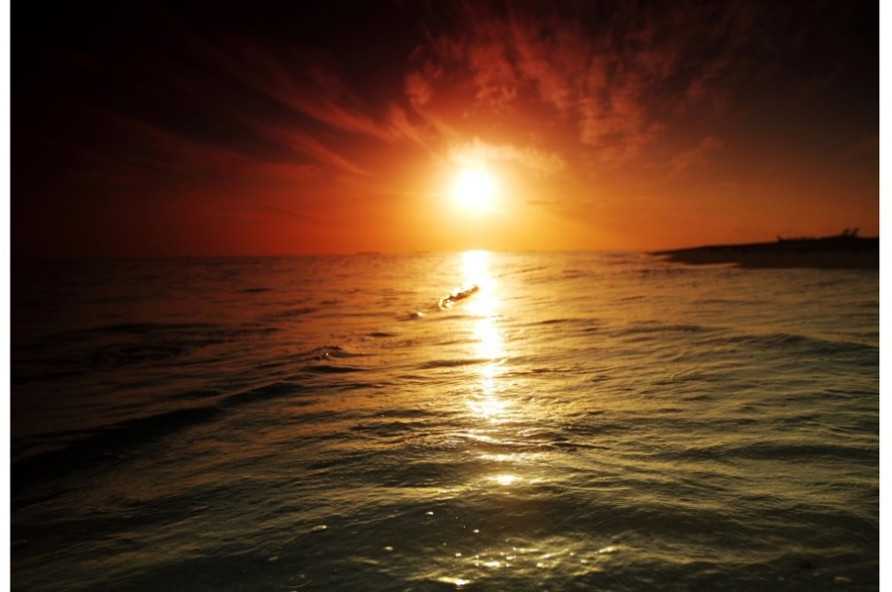

Years ago, I remember reading the story of a teenage boy who attended the chapel service on a Sunday morning, and then the chapel Youth Club in the evening. The morning was a bit boring, but he enjoyed the club. One night, members of the Youth Club went to watch the sun set beside a nearby lake. Seeing the golden colours of the sun setting with the other club members, the young man said, "Wow! God's world is fantastic.” And one of his friends said to him, "I’m sure God loves to hear you say, 'Wow! Like that' The boy had felt something new about God when he saw one of the wonders of nature.

Many people believe that they have spiritual experiences and feel that God is speaking to them through nature.

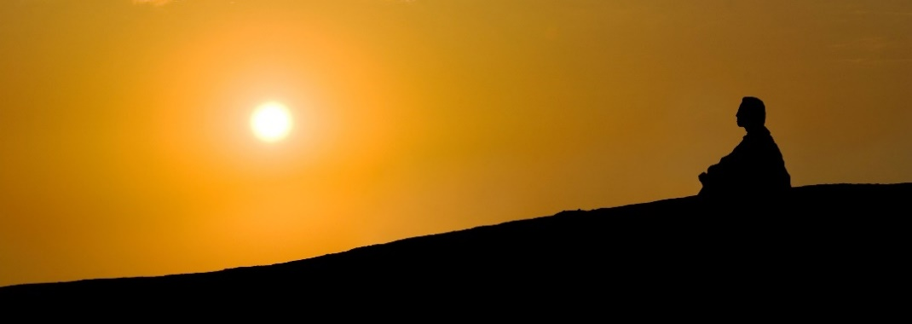

**A Forest Church** **in Wales**

There is a Forest Church meeting in mid-Wales, and one of the leaders is a man by the name of Bruce Stanley. He has written a book entitled *Forest Church: A Field Guide to Nature Connection for Groups and Individuals.* By visiting the group's website here: *www.mysticchrist.co.uk/forest_church**,* you will find that they meet on the third Sunday of the month within a fairly wide area, from Barmouth down to Builth Wells.  
  
The activity differs from month to month. Sometimes they go for a walk, giving people the opportunity to pause to reflect, or to appreciate nature by touching or listening to the silence, or the sounds of nature.

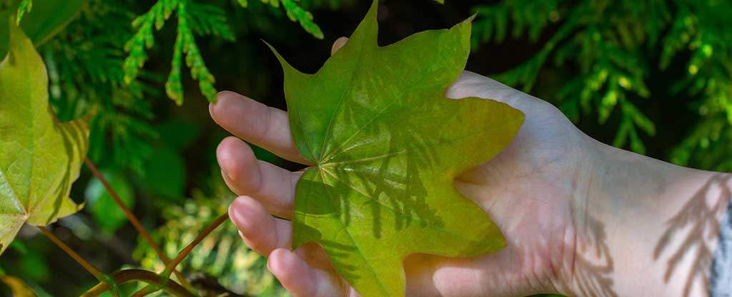

Other times they will undertake an activity - planting trees or running a workshop on some aspect of conservation or natural remedies.

But every three months, Mid Wales Forest Church holds a ritual - a kind of service - that is linked to the different seasons of the year, the days of solstices - the summer days and the winter days - and equinoxes, or even the old Celtic festivals like May (Beltane), or Halloween (Samhain). Some would call these rituals pagan, but the Forest Church is trying to bring together the old Christian celebrations and traditions. Others question whether the Forest Church is really a Christian church because there is usually no scriptural teaching involved in the activity. However, the Reverend Andrew John, Bishop of Bangor, believes that nature has the power to speak powerfully about God. ***"I have been fortunate enough to attend ... [The] Forest Church in Mid Wales where we have found meaning in some of the simplest things we experience on a daily basis and rarely take time to think about them. Sharing the experience with others was both enriching and refreshing. ”***  
  
Some people will read from the Bible, or other holy writings in the outdoors, staying silent to let the reading speak to them both in their minds and hearts.

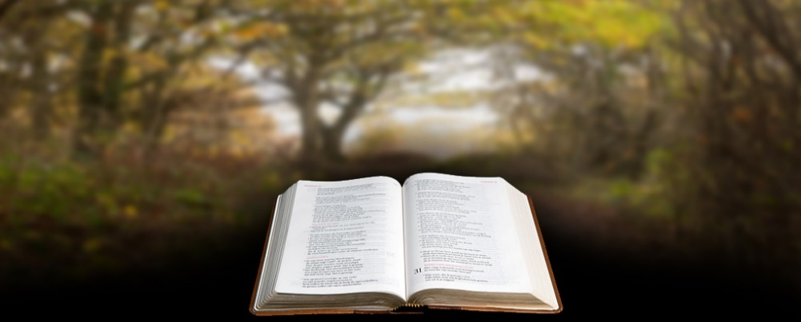

Others will go on a prayer trip.

In ancient times, monks walked the country sharing the Christian message with others, reciting psalms, praying. Forest Church attendees also enjoy the same experience and feel that the influence of nature on their emotions and spirit is very beneficial as they walk. As Bruce Stanley says  
  
***"For many, it is easier to follow a spiritual journey when walking along a beach, through a forest, or climbing a mountain. Mid Wales Forest Church is a new, experimental type of group open to anyone who wants to explore that journey. Many people can describe truly special moments they have experienced through nature, moments when they feel a connection with something greater than themselves, and a Forest Church is a way of exploring that connection with others, and a new way of being a Church.”***