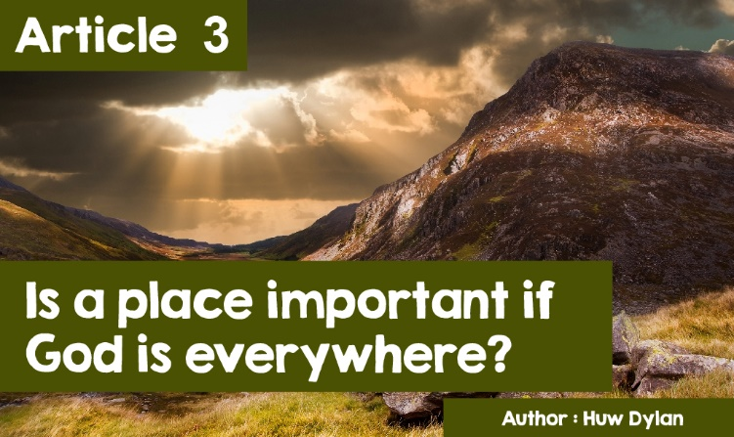

|  |
| --- |
| **‘THIS IS WHERE I BELONG’** |

|  |
| --- |
| If someone were to ask you where the most special place in your life is, what would your answer be? No doubt most would say without a doubt - 'my home'. But apart from your home, where else? The place where you were born? Grandparent's house? Somewhere where you had a special holiday? And once you've decided on a place there's another question that must be answered - why are these places special to you? Many people believe that they have a special relationship with some places and that those places are a part of them, having influenced their character even though they may have moved away to live years ago. T.H. Parry Williams, who was brought up in the Schoolhouse in Rhyd-Ddu, speaks of that area’s influence on him and many of his poems show how special his native area was to him. This is his poem, Cynefin, which refers to the special appeal and the pull of his birthplace even though he moved to live from there to Aberystwyth. |
|  |
| **CYNEFIN (HOME)**  Ni byddaf yn siwr pwy ydwyf yn iawn Mewn iseldiroedd bras a di-fawn  Mae cochni fy ngwaed ers canrifoedd hir Yn gwybod fod rhagor rhwng tir a thir.  Ond gwn pwy wyf, os caf innau fryn A mawndir a phabwyr a chraig a llyn. |  |  |

|  |
| --- |
| More recently Meirion Macintyre Huws wrote a poem about his special relationship with the town of Caernarfon under the title 'This is Where I Belong' and Geraint Lovgreen composed music for it. Each verse ends with the words -  ‘Dwin geiban ond dwi’n gwybod   Mai yma wyf finna’ i fod.’  (I’m drunk but I know  that this is where I belong)  Many religious people of all religions can say the same about many places that are special in their religions. If we were to ask different religions about why these places are special, then we would get a variety of answers. One answer for some believers is that these places are important because visiting them is an expected, if not obligatory, part of their religions, in order to perform special rites in those places. |

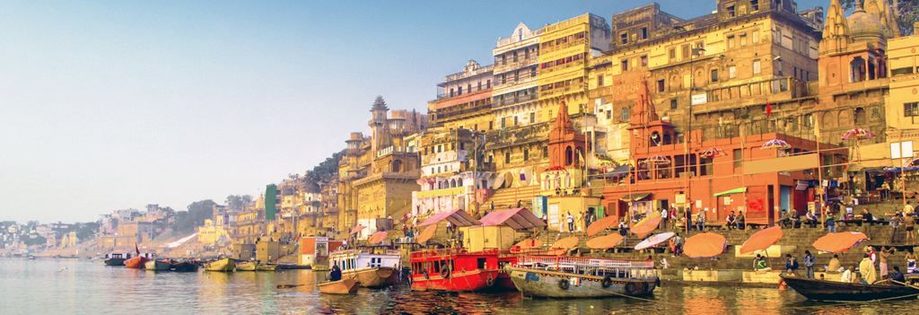

One of the main places of **pilgrimage** for the Hindu is Varanasi in India since the river Ganges runs through it. In addition, it is known as the home of the god Shiva. There are several temples beside the river with steps (ghats) leading down to the river for pilgrims to reach the water to wash and perform puja. Varanasi is specifically associated with death rituals; many go to the riverside to die near, or in, the river. In addition, they would be cremated by the river and the ashes scattered in the river; some families would bring the ashes to the river to be scattered there. This facilitates the journey of the soul (atman) towards unification with Brahman (Moksha).

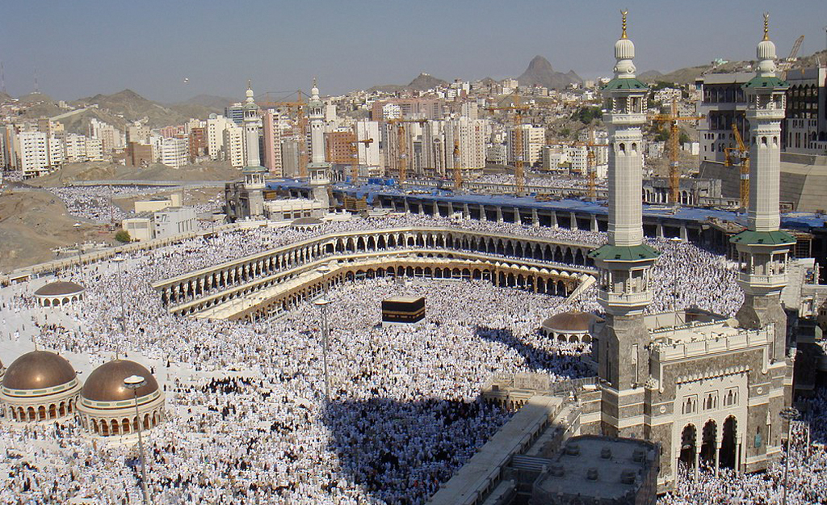

Makkah in Islam is a very special place for the Muslim. One of the five pillars of Islam - the Hajj states that every Muslim is expected to try to visit the place once in a lifetime. This is also, of course, the direction that the Muslim must face when praying. The Hajj contains a number of important rites associated with significant events in the history and development of the religion of Islam.

Another reason why religious people visit particular places is that they are associated with significant events in the life of the founder or history of the religion. Many Christians visit significant places in Christ's life such as his birthplace in Bethlehem or walk the Via Dolorosa in Jerusalem. In the Catholic tradition visiting special places is very important, especially the places where the Virgin Mary appeared as Lourdes in France, Knock in Ireland, or Fatima in Portugal.

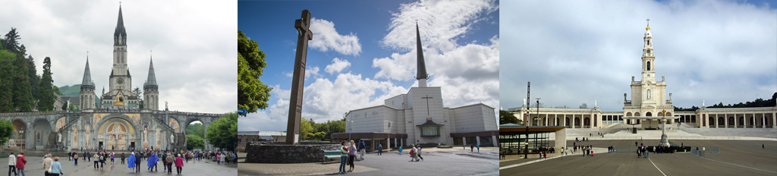

Of course, all religions have their buildings of worship and for religious people they are special places whether it is a Muslim Mosque, a Jewish Synagogue or a Christian Chapel or Church.

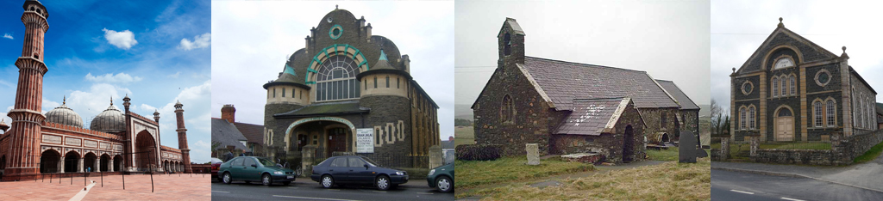

|  |
| --- |
| Many would ask why visiting special places is important and what is the value of such visits, both personally and religiously. With regard to particular religious buildings, many would note that the presence of God is felt there and that there is a special atmosphere that promotes worship. There may be features in the buildings that help believers focus on the most important beliefs within theirreligion. Others will recognise the benefits of being part of a society with their fellow believers. Those who visit special places would refer to spiritual experiences that affirm and strengthen their faith; others refer to the experience of gaining a better knowledge and understanding of the founder by walking in his footsteps. For others, visiting a special place can be a blessing, spiritual or physical, such as healing at Lourdes or St Winfried’s Well. Here is one Christian's description of what it meant to visit Israel - "Walking the streets where Jesus walked and visiting the places where the most important events in his life were, are great. One of the greatest spiritual experiences I have had was a communion service in the Garden of Gethsemane. I've never felt anything like it - it was so special. No communion will ever be the same again. Thinking of everything Jesus did and said made us feel as if he were here with us.”  Yet some question the value of special places, especially whether special buildings are needed for worship. One reason for this is the belief that is common to most religions in the world that God is present everywhere and, therefore, his presence can be felt and worshipped anywhere. The first followers of religions did not have special buildings. The word 'church' originally means a community of people rather than the building. Many see this question as particularly relevant to the situation of Christianity in Wales, where the congregations of chapels and churches are getting smaller. This means that the costs of maintaining large religious buildings are high and a problem that is getting worse from year to year. But, often in towns and villages, there is more than one chapel or church, and many believe that the solution to the problem is to unite in one and close the rest. But easier said than done! The buildings are special to some and attempts to bring everyone together have failed in many areas. Does this mean that the building is, therefore, more important than what goes on inside it? |

|  |
| --- |
|  |