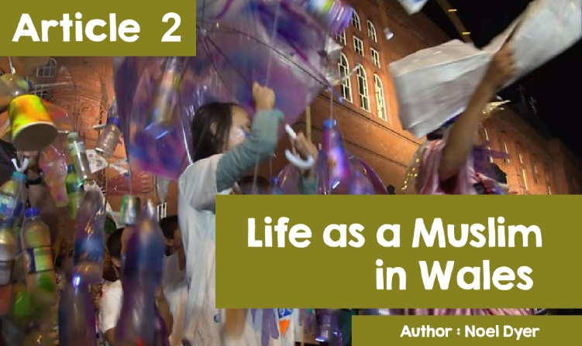

|  |
| --- |
| **Life as a Muslim in Wales.** |

|  |
| --- |
| Allah, Muhammad, **Mosque, Imam**, Quran, Salat, Ramadan, Sunni and Shi'a - these are terms that have become familiar to most of us by now. When did these words first come to be heard in Wales? Well, a bit further back than most of us would think. The first record of connections between Wales and the Muslim world goes back as far as the 12th century. Islam is the second largest religion in Wales after Christianity with 46,000 followers recorded in the 2011 census.  For those who attended the National Eisteddfod in Cardiff Bay, it is interesting to note that there has been a community of Muslims from Somalia and Yemen in the dockland area of ​​Cardiff for two hundred years. During the Eisteddfod week, a Marine carnival was organised to draw the various communities of the Bay into the hustle and bustle of the Eisteddfod. The first purpose-built mosque in Cardiff was built in 1947. Today there are about 40 mosques in Wales. Many are in Cardiff but also in Aberystwyth, Bangor, Carmarthen, Haverfordwest, Lampeter, Newport, Swansea and Wrexham, mainly important university, or hospital towns. |

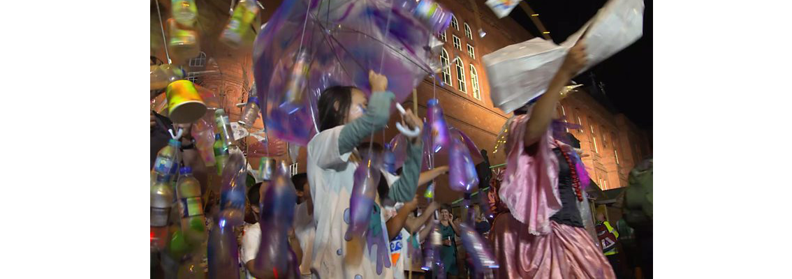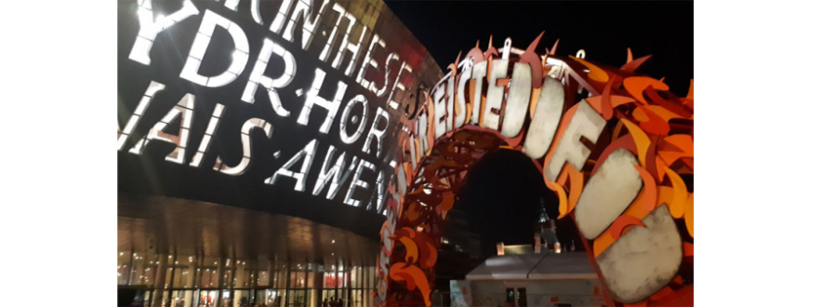

Cardiff is now home to about twelve mosques ranging from the South Wales Islamic Centre in Butetown to a converted house in the Cathays area. It is home to one of the most vibrant student Islamic Associations in Britain. In addition, there is a group of scouts and several Islamic charities. Swansea **Mosque**s have been housed in chapels and churches for decades. In North Wales, the Muslim community in Wrexham has purchased a building that will house the first mosque in the city.

The Muslim community in Wales is trying to increase its contact with the wider community. It is hoped that this will create a more Welsh identity for the Muslims of Wales. The aim is to create a local civic contribution alongside global citizenship.

**Here are some of the current mosques in Wales:**

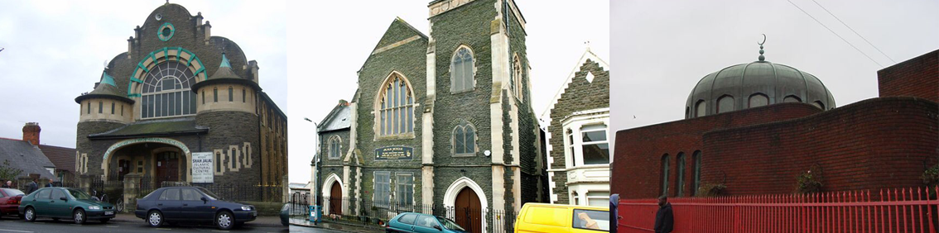

There has been a long-standing Muslim presence in Bangor. Bangor Islamic Centre was founded back in the late 80s by students who came to Bangor University. Also, some business people had moved to Bangor in the early 70s. Many also worked at the new Ysbyty Gwynedd. Their place of worship is off Bangor's High Street in a converted building that can hold nearly 400 worshippers. According to one visitor, ***'I love this place. If you are looking for a place to pray, here it is. It's a good place to relax and I would recommend it to anyone '.***

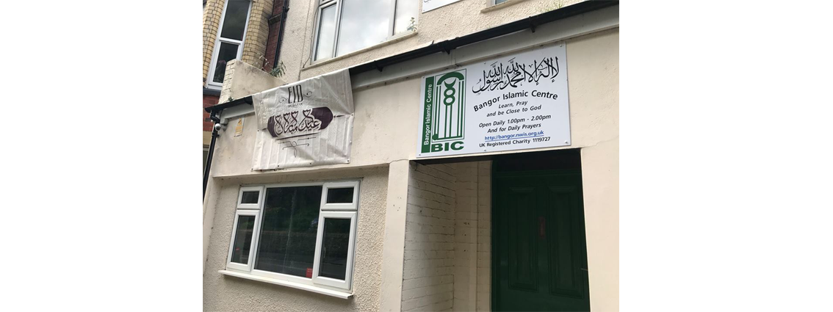

The mosque in Bangor is clearly a prosperous one as the Muslim community there is currently expanding the building. This is a building that will double the number of people who can attend for worship during the week and especially on Fridays.

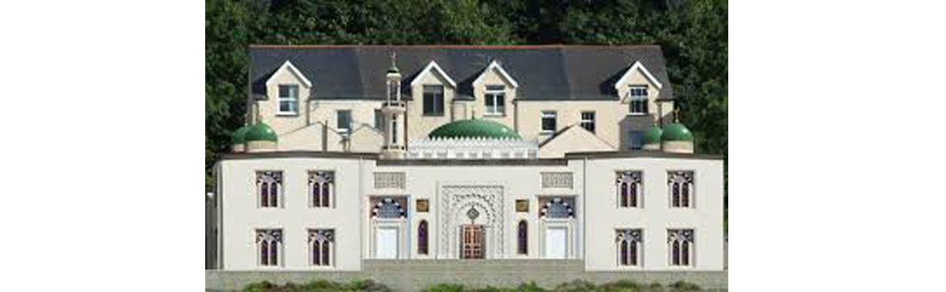

The Mosque in Bangor has a lively Facebook page with over a thousand followers. It includes comments both in Welsh and English, which shows an effort to connect and engage with the wider local community. There is an emphasis on inviting people and open days are held regularly.

Here is an example of those invitations; ***'This Friday we will be celebrating Eid. We will be inviting our non-Muslim neighbours and members of the local community. We will share tea and refreshments with them, giving them an opportunity to learn about Islam and Muslims, and for us to learn more about our neighbourhood and community from them, too. The event is open to everyone from all religious backgrounds. Come along with your friends and family and join in our Eid celebration.***

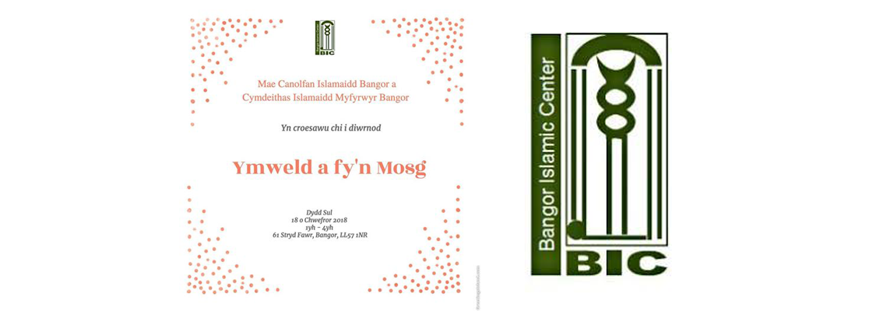

Members of the Bangor Mosque perform a variety of duties. The **Imam** leads the prayers and services and delivers the sermon. There are several involved in charitable work, e.g., on YouTube, there is a video of volunteers at Bangor **Mosque** handing out food they have collected to the homeless and needy in the city. [*https://www.youtube.com/watch?v=wm5R4rZWSw4*](https://www.youtube.com/watch?v=wm5R4rZWSw4) This is one way in which their beliefs influence their lifestyle.

Collective worship, celebrating festivals, such as the **Eid** as reward for fasting, and keeping to the path acceptable to Muslims is another essential way of keeping their faith here in Wales. Preserving their culture is a different matter because Bangor Muslims come from different cultures around the world - what they have in common is their religion.

As already noted, their Facebook page shows an effort to communicate and engage with the Welsh community around them and to participate in various inter-faith activities; [*https://www.facebook.com/bangoric/-*](https://www.facebook.com/bangoric/- )***'We have chosen North Wales as our home. While working in the fields of Education, Medicine, Learning and Business and others, to the best of our ability; we serve at every opportunity'.***

Many schools have visited the **Mosque** in Bangor and there are regular invitations for local people to visit, e.g., during open days and special celebrations. According to one member, ***'Transitioning between people is one of the most honourable endeavours of people... If our religion does not lead to that, then we have completely lost the purpose of religion'.***

