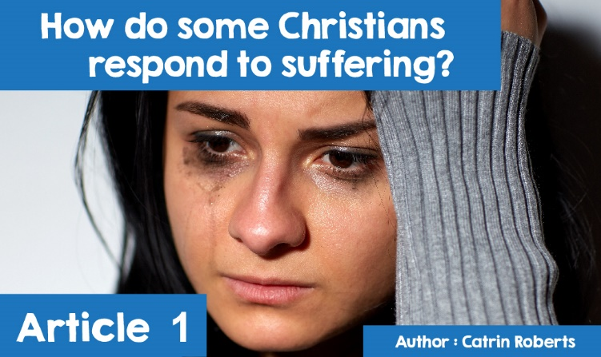

**How do some Christians respond to suffering?**

What do you think of when you hear the word ‘suffering’?



Earache?



War?



Famine?



Bullying?

Everyone faces some suffering throughout their life, no matter what that suffering is.

**There are numerous references to suffering in the Bible:**



* The God-created world was pain-free at first, but when people started refusing to listen to God ([Genesis 3](http://www.beibl.net/beibl-chwilio?pennod=3&book=BNET%3AGen&viewid=BNET%3AGen.3&newwindow=BOOKREADER&math=)), suffering came in the form of pain, death, conflict
* When the end of the world comes in its present form, God will eradicate all suffering ([Revelations 21.4](http://www.beibl.net/beibl-chwilio?pennod=21&book=BNET%3ARev&viewid=BNET%3ARev.21&newwindow=BOOKREADER&math=))
* Jesus Christ came into the world to save people from evil (sin), suffering and death, and did this by suffering himself on the cross (John 3.17)
* God helps people in their suffering ([Salm 23](http://www.beibl.net/beibl-chwilio?pennod=23&book=BNET%3APsa&viewid=BNET%3APsa.23&newwindow=BOOKREADER&math=), [Salm 18.1-6](http://www.beibl.net/beibl-chwilio?pennod=18&book=BNET%3APsa&viewid=BNET%3APsa.18&newwindow=BOOKREADER&math=))
* The book of [Job](http://www.beibl.net/beibl-chwilio?viewid=BNET%3AJob.1&newwindow=BOOKREADER) tells the story of a good man who suffered terrible loss of his family and wealth, yet did not turn his back on God
* God sometimes lets people suffer so they can learn to trust him, and turn to him for help ([Judges 3.7-9](http://www.beibl.net/beibl-chwilio?pennod=3&book=BNET%3AJdg&viewid=BNET%3AJdg.3&newwindow=BOOKREADER&math=))
* If Christians share the good news of Jesus, and do his work, they may well face suffering ([John 16.33](http://www.beibl.net/beibl-chwilio?viewid=BNET%3AJohn.1&newwindow=BOOKREADER))

One who has suffered greatly during his life is actor Wynford Ellis Owen, aka Sir Wynff ap Concord, producer and screenwriter of programmes and plays.



**©** *Copyright BBC Cymru Fyw*

**What caused Wynford the suffering?**

**Alcohol**



Wynford almost lost everything because he was an alcoholic. His **autobiography,** *Raslas Bach a Mawr,* describes the suffering, and how he changed his life with God's help.



Although he had a good home, Wynford was not happy as a child. The son of a minister, he was expected to behave like a minister's son! No misbehaving, no swearing, school success etc and the sentence "A minister's son is not supposed to be…." ‘like a stuck record. He began to feel as if a dragon inside him was saying "You're useless, something's wrong with you", causing him to feel shame and guilt. He also suffered from **dyslexia** and was being bullied.

Wynford wanted to escape these bad feelings, and to keep the 'dragon' quiet. He started stealing his mother's **tranquillizers** (she was addicted to them) and, having swallowed them, all problems would disappear. He could deny that anything was wrong, even though he stole, lied, and smoked at the age of 7!

He was good at doing one thing only at school - acting and public speaking. Therefore, he decided to go to Cardiff College of Music and Drama. He had no intention of drinking when he arrived at college - his father had warned him not to - but soon he was drinking heavily and getting drunk. When drunk, he felt better about himself, people liked him, he was popular with women, but by morning the old worry would be back, and the only way to re- create the good feelings was – to drink again. He believed that alcohol **solved** his problems, but he was facing great suffering.

Over the years, during college and having started work,

Wynford suffered –

* Physical pains: in his stomach, liver. He would vomit and trip and injure himself. He nearly killed himself while sleeping with a gas fire on and inhaled carbon dioxide. He began to stammer and was unable to pronounce words. He tried to kill himself several times.
* In his work: he achieved great success as an actor on stage, in pantomimes, as a producer in theatres, both in Wales and England, at the National Eisteddfod and with the BBC and S4C. His humorous characters, Sir Wynff ap Concord and Plwmsan are still popular today.

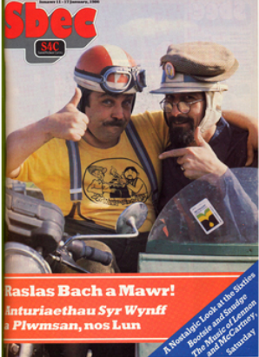

But as the drinking got worse, work started to slow down, and eventually stopped

* Financial debt
* Colleagues and friends whispering and laughing at him.
* Problems in his marriage and family life. It was not just Wynford who suffered, but his wife and two daughters as well. He stole the girls’ opportunity to grow up in a safe environment, and to have a responsible father looking after them. Their father loved alcohol more than them.



But Wynford still denied that anything was wrong.

Finally, with his life hell, he decided to seek treatment at an alcohol treatment centre near Aberystwyth. He was rejected at the centre’s door because he was drunk. Shock! After two more days of drinking, he found himself outside an Off Licence and, suddenly, he saw the truth about himself. The denying disappeared and he realised that he could blame no-one but himself. He heard a voice saying, "It's all over! Everything is going to be fine from now on.” Everything changed from that moment.

Wynford had turned his back on God years earlier because God had not answered his prayer for his mother to stop taking tranquillizers. But now he understood that he needed the power of that God. The next morning, at his accommodation in Aberystwyth, he appeared to have had a stroke, unable to move. In a weak voice, he shouted, "HELP". The housewife came to him, but Wynford was now asking for God's help. "Help me, Oh heavenly Father". HELP was the simplest and perfect prayer. He said, "At that moment, I surrendered completely to the lowest depths of my soul, that I was an alcoholic. God did an 'inside job' on me and filled in what was missing in my life, what I had been trying to fill while drinking. I felt his love and compassion.”

Wynford spent a long time in a psychiatric ward being weaned off the alcohol and tablets. His health started to improve. Over time, his relationship with his wife and children also improved. He went to an Alcohol Treatment Centre because he needed the tools to live without alcohol one day at a time. Very suddenly, he had had the strength to choose not to listen to the dragon. Wynford said, "The alcoholic has to find another power, stronger than the alcohol. It can't just rely on its own resources, it's not enough. And the key is acceptance.

Accepting that he is an alcoholic.

Accepting himself as he is - the bad and the good.

Accepting other people and his relationship with them.

Accepting God's help.

Acceptance is the catalyst that makes change possible. But this acceptance has to happen on a daily basis.”

Wynford believes that, had he not suffered as he did, he would not have reached that place in Aberystwyth. He is now helping other people through the *Living Room* in Cardiff, where people addicted to alcohol, drugs, sex, food, gambling etc get help. "I tell people about my experiences while I was drinking, in the hope that maybe one person will identify with me, and, thus, save having to endure the hell that was so much of my existence until 1992. People who misuse are looking for something, looking for something to fill a spiritual void in their lives."

