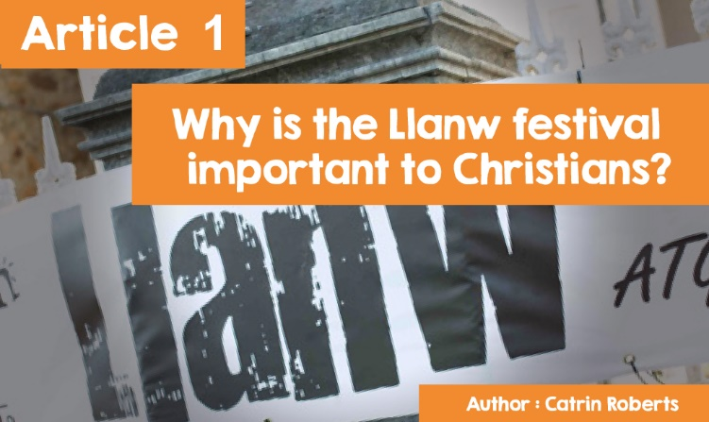

**CELEBRATING THE RESURRECTION**

**THE LLANW FESTIVAL**



|  |
| --- |
| What makes you celebrate?  A birthday?  Finishing exams? Passing an exam?  With whom will you be celebrating?  A special friend? Your family? A crowd of friends?  And how will you celebrate?  A party? A special meal? Going out somewhere special?  **Christians Celebrating**  Celebration is an important part of the Christian family's life e.g. celebrating Christmas, celebrating Thanksgiving, and especially Easter, when Christians remember the crucifixion and resurrection of Jesus Christ ([LINK : Mark 15 and 16](http://www.beibl.net/beibl-chwilio?pennod=15&book=BNET%3AMark&viewid=BNET%3AMark.15&newwindow=BOOKREADER&math=)). Celebrations vary widely throughout the world - ceremonies, marches, enactingEaster street events …… and more. |
| **The Crucifixion and Resurrection** |

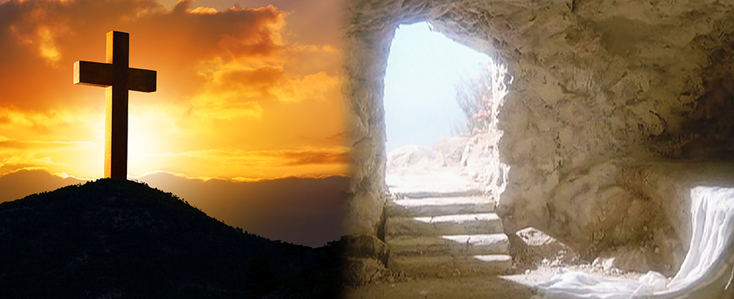

Remembering the Crucifixion can make Christians feel sad, but the Resurrection is a cause for celebration and rejoicing.

Why?

The Resurrection is vital to the Christian faith because it shows Christians that they can trust everything Jesus said while he was on earth.

For example, Jesus said that his death on the cross meant that God was willing to forgive the sins of believers. According to Christians, in order to receive the forgiveness, you must repent, change your lifestyle, and let Jesus have a place in your life.

Jesus also said that he would come back to life on the third day after the crucifixion - which is amazing - and impossible, according to some! But the Gospels present witnesses who say that this is exactly what happened. So, if Jesus was telling the truth about coming back to life, the Christian thinks he is telling the truth about other things too.

Christians today are not worshipping a dead person, but a living person whom they can talk to in prayer and know that he is with them every day.

The Resurrection is proof that Jesus, the son of God, has conquered death and is a sign that there is life after death for those who believe in Jesus.

In his letter to the church of Corinth ([LINK: 1 Corinthians 15](http://www.beibl.net/beibl-chwilio?pennod=15&book=BNET%3A1Cor&viewid=BNET%3A1Cor.15&newwindow=BOOKREADER&math=) (NIV)) the Apostle Paul writes about the Resurrection and says, "And if Christ has not been raised, your faith is futile; you are still in your sins.”

That is, what is the point of following Jesus if he is in a tomb?



**Celebrating Easter in Wales**

Apart from chocolate Easter eggs, what picture comes to mind when you hear the words Christians; celebrate; Resurrection; Wales? ........... a chapel of old people listening to a sermon?

So what about these pictures!



Since 2008, an exciting Christian Festival has been held in Wales during the week following Easter, where people of all ages come together to celebrate the Resurrection. And the name of the festival? .........



**What is LLANW?**

It is a Welsh language festival (but there is a translation service there) for people who believe in Jesus Christ, and also for people who want to learn more about Jesus and the Christian faith. It is organised by a group of people of different denominations. It is hoped that Christians will be inspired to go home at the end of the week with a renewed desire to be part of their local church / chapel and to share the Christian faith in word and deed.

Congregations of chapels and churches are diminishing, therefore Christians, old and young, enjoy the opportunity to attend a large festival and to worship in a vibrant congregation. LLANW offers activities for everyone. There are opportunities to attend family services and sessions for children and young people. Seminars, Bible study workshops and talks by guest speakers. And of course there are plenty of opportunities to socialise and have fun. You could stay for the whole festival or visit for the day. Details of the week will be available on the website [llanw.org](http://llanw.org/) or on the [Llanw](https://www.facebook.com/llanw) Facebook page

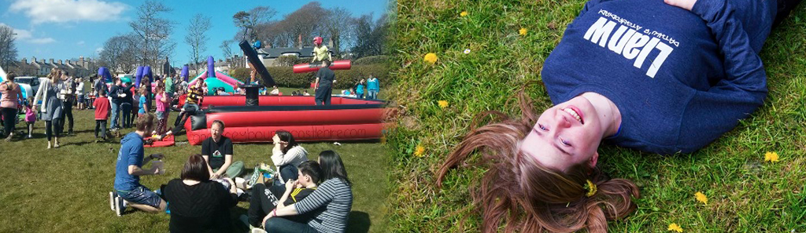

*© Llanw*

When LLANW was first held at the Llangrannog camp in 2008, there were only 60 people. There are now around 400 attendees. The festival is held in places where there are facilities for people to stay - holiday camps, caravan parks or chalets and attendees have access to the facilities (swimming pool, gym, cafes, beach…) as well as to enjoy the festival itself. LLANW has visited Llangrannog, New Quay, Tenby, Criccieth, Kidwelly and, in 2019, it will return to Tenby.

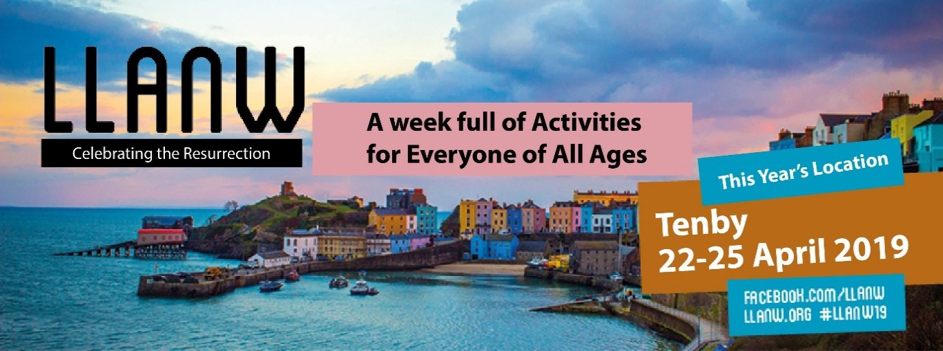

*© Llanw*

**The experience of two young people - and a not-so-young person!**

Ryan, aged 13, has been going to LLANW for four years, and is enjoying the experience. Here's what he has to say,

*LLANW helps young children and older people understand the Bible, who was and who is Jesus. Worshipping there is more fun than in our chapel, and what is said to us about God and Jesus and the Bible is easier to understand. I have fun with friends there and meet young people from all over Wales. And I have come to understand the Resurrection of Jesus better by going to LLANW.*

Seren, his sister, also praises LLANW.

*Llanw is really good. There is a lot of opportunity there to talk to God and get closer to him. I get to pray there, and people also pray for me. I like the band that leads the singing and the praise. There are plenty of other activities too, where I can be with friends and have fun.*

People with white hair also enjoy Llanw! - click on  
([LINK: Pam fod Llanw yn Ŵyl sy'n cyflwyno Gobaith - Dr Rhiannon Lloyd / YouTube](https://www.youtube.com/watch?v=2dbmRYjRSS8) (Welsh)) to hear Dr Rhiannon Lloyd speak.

**A final question - Why the name LLANW (Tide)?**

The phrase 'ebb and tide' is used to describe something that experiences success for a time but then things do not go so well. So it is with the Christian Church. It's been a time of decline in recent years, chapels closing; people abandoning worship, but LLANW organisers believe that God is doing new work in Wales, and that the Holy Spirit fills (in some parts of Wales, ‘llanw’ means ‘to fill’) Christians with life and new energy.