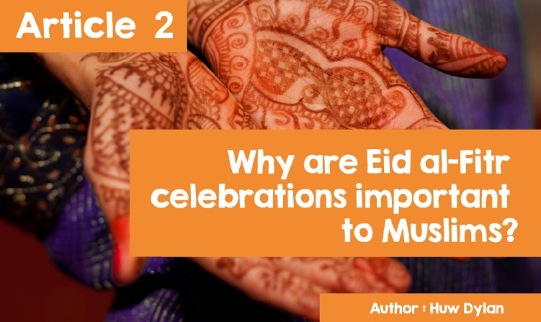

**Celebrating Eid al-Fitr.**

In early June this year, Muslims around the world will be celebrating Eid al-Fitr, a festival that marks the end of Ramadan. During the month of Ramadan, Muslims fast from dawn to dusk to honour the month in which the Qu'ran was revealed to Muhammad. Eid al-Fitr celebrates the end of the month and the end of the fast.

Fasting is not just about food - it also includes abstaining from taking medicines, drinking any fluid (including water), smoking and having sex. The month of Ramadan is full of celebration and joy as Muslims dedicate themselves to reading the Qu'ran and Duas and spending a lot of time doing Dhikr.

Muslims fast for the whole month as it teaches them about the true meaning of perseverance and tolerance and fosters greater sympathy for the poor and needy. At the end of the month, Muslims will be rewarded with the Eid al-Fitr festival. It is important to note that fasting on Eid day is completely banned.

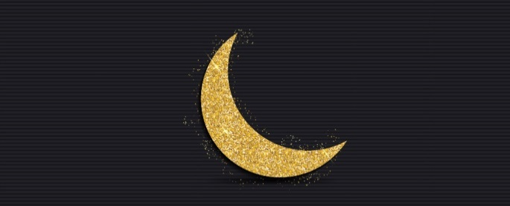

'Eid al-Fitr' literally means 'Break the Fast Festival'. Eid al-Fitr does not start until the new moon appears in the sky and, so, it can mean that the festival starts at different times and even on different days, depending on where in the world someone is. To try and avoid this and get everyone started at the same time, some Muslims celebrate Eid when the new moon appears above Makkah and not its own location. The festival traditionally lasts for three days but often the parties and activities can go on for longer.

The way Eid is celebrated can vary from country to country as the traditions of that country can influence the festival. Before leaving for the first prayers of the day, Muslims wash their bodies in a ritual called "ghusl." They then wear new or best clothes and decorate their hands with intricate henna patterns.

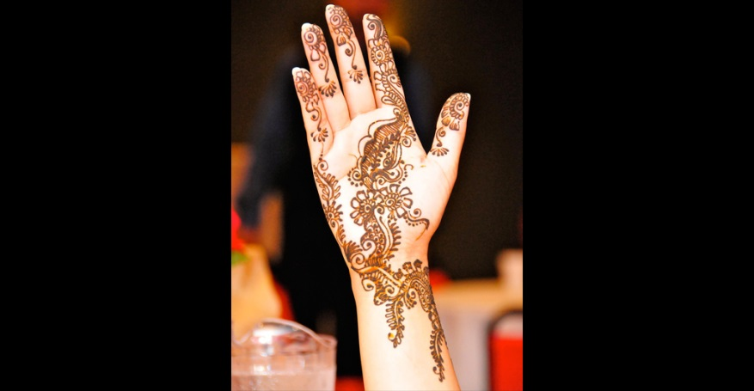

*© Jyothis / Wikipedia*

Some wear traditional clothing while others choose to wear contemporary clothing. Muslims around the world celebrate Eid al-Fitr by starting the day with the Eid prayer. After the Eid prayers people greet each other with the traditional Eid greeting 'Eid Mubarak' which means 'May you have a blessed Eid.' They also formally embrace three times. Then, some visit the graves of their loved ones to pray and clean the cemetery. Then a sweet meal is prepared in Muslim homes and eaten in happiness.

The day is spent with family and friends eating and sharing 'Eidi' which are gifts, usually silver, given to children on Eid. The festival focuses on the theme of unity and happiness and is, therefore, an event of great happiness as Muslims celebrate and give thanks for the blessings that Allah has given them.

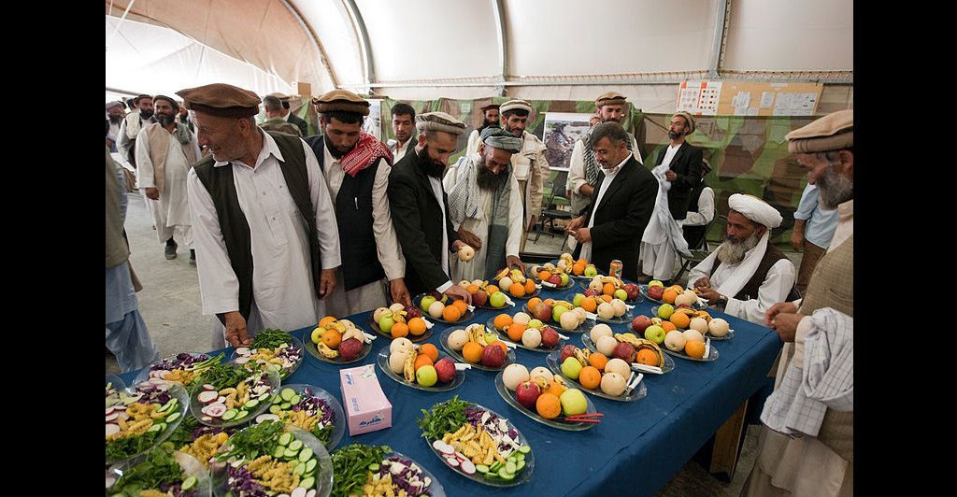

*© U.S. Air Force / Wikipedia*

**Celebrating Eid al-Fitr.**

When Carwyn Jones was the First Minister of Wales, he noted that Wales had traditionally welcomed different traditions and communities to live together peacefully. He wished all the Muslims of Wales 'Eid Mubarak'.

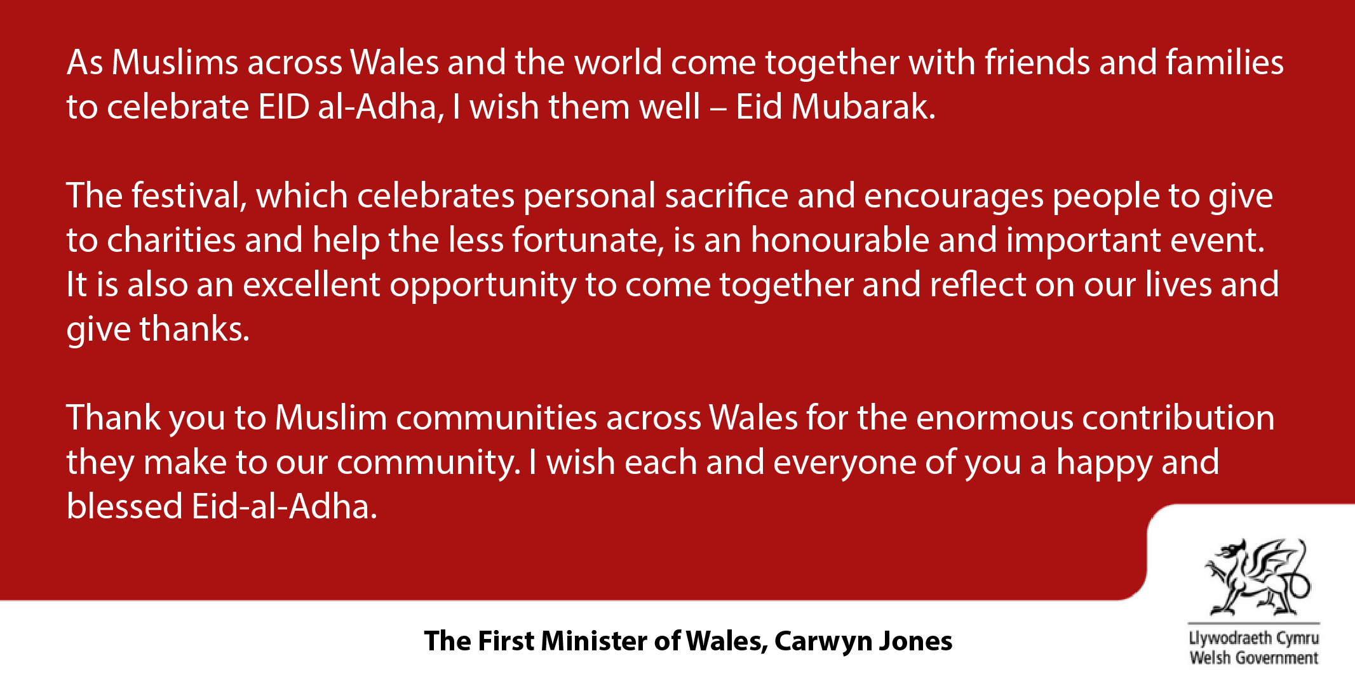

[**Link: The First Minister’s Eid message** / CCC Cymru fyw 19 Awst 2012](https://www.bbc.co.uk/cymrufyw/19308634)) (Welsh)

As Muslims across Wales and the world come together with friends and families to celebrate EID al-Adha, I wish them well – Eid Mubarak.

The festival, which celebrates personal sacrifice and encourages people to give to charities and help the less fortunate, is an honourable and important event. It is also an excellent opportunity to come together and reflect on our lives and give thanks.

Thank you to Muslim communities across Wales for the enormous contribution they make to our community. I wish each and everyone of you a happy and blessed Eid-al-Adha.

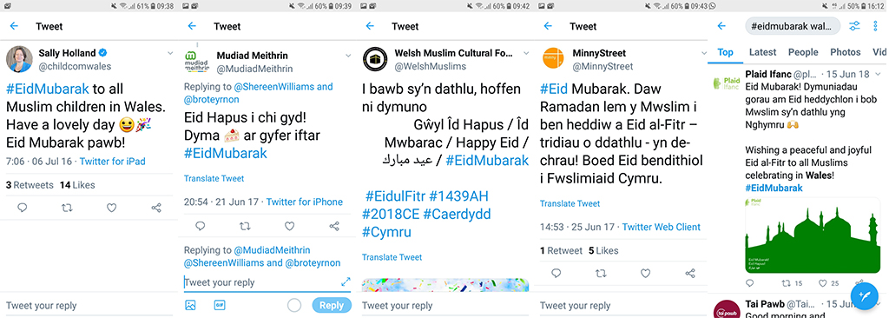

*(A happy Eid to you all! Here is a cake for iftar)*

*(The Muslim’s strict Ramadan ends today and Eid al-Fitr (three days of celebration) begins. May the Muslims of Wales have a blessed Eid.)*

Eid is celebrated in Muslim communities across Wales. In 2017, the Muslim staff at Morriston Hospital decided to hold an Eid event that was open to all including the youth on the children's ward. The hospital's first Eid celebration was held in the Chapel and Multi-Faith Centre and over 120 people attended. And to make sure the children did not suffer any injustice, the hospital's chaplain Muslim Shakirah Mannan toured the children's wards, sharing 'Eidi'.

The event was organised by Shakirah and the Muslim staff of the hospital, and all included free food and drink. Shakirah explained the reason for holding such an event - “*Eid al-Fitr marks the end of Ramadan for Muslims. So, what we were trying to do was celebrate together and, at the same time, teach people about Islam. We felt that an Islamic event in hospital would help people appreciate the beauty of Islam especially given that many people have a negative view of the religion.”*

The event was open to staff and the public, and people had the opportunity to ask questions about Islam and Muslims. Leaflets about Islam and free copies of the Quran in English were also available.

Shakira was born and raised in Swansea and is the first Muslim chaplain to a Health Board in Wales and the first female Muslim chaplain in South Wales. *"This was the first event I organised as the hospital's Muslim Chaplain, and it went very well. I will certainly arrange such an event for every Eid celebration.”*