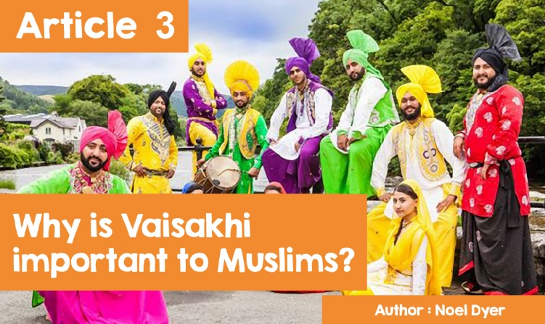

**The Vaisakhi Festival**

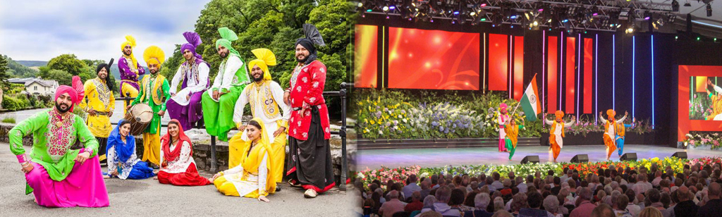

Have you seen these pictures before? They are pictures of Bhangra dancers at the Llangollen Eisteddfod. These dancers have their roots in the Punjab region of India. The turban, which is a smarter turban than usual, shows that they are Sikhs. The Punjab region is the original home of Sikhs but many of them have travelled all over the world. The crew who regularly perform at the Llangollen International Eisteddfod come from the Birmingham and Wolverhampton area over the border in England and their colorful and spectacular dancing has won them many awards.

The religion of Sikhism goes back to the sixteenth and nineteenth centuries in the Punjab area which is now part of India. It was founded by Guru Nanak around 1500 AD. There are about 20 million Sikhs in the world with most of them in the Punjab in India. There are over 330,000 living in the UK and, of those, 3,000 in Wales. The Sikhs have been based in Cardiff since 1956 and the first dedicated Gurdwara opened in 1988.

One of the major religious festivals of Sikhism is Vaisakhi (or Baisakhi), which is usually celebrated on 14th April. This is the festival that celebrates the new year of the Sikhs and the inception of the Khalsa, the Sikh community. In 1699 AD Sikhs from all over came to celebrate the harvest at a time when they were being persecuted for their faith. The tenth Guru, Gobind Singh, realised the need for followers who were fully committed to the faith and who were prepared to fight and die for it. From the door of his tent, he challenged the crowd by holding his sword in the air and calling on those who were willing to die for the faith to come forward. One came forward and disappeared into the tent. Guru Gobind Singh came out with his sword covered in blood. More came forward until five disappeared into the tent - but all five came out of the tent alive and well, wearing the turban and the 5Ks.

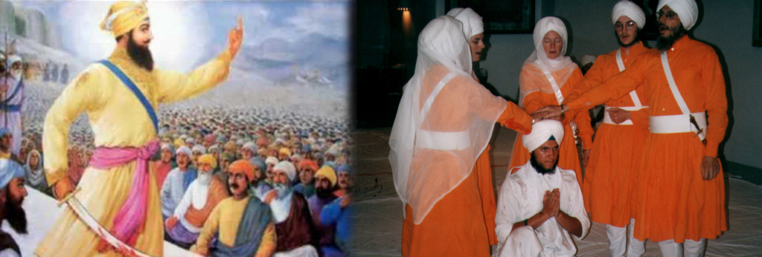

These five were greatly honoured as the Panj Pyare (The Five Beloved Ones). These five were the first members of the Khalsa. Since then, Sikhs who want to commit fully to the faith have been accepted as members of the Khalsa. They often choose the time of the Vaisakhi Festival for the Amrit Sanskar, which is the acceptance ceremony of new members.

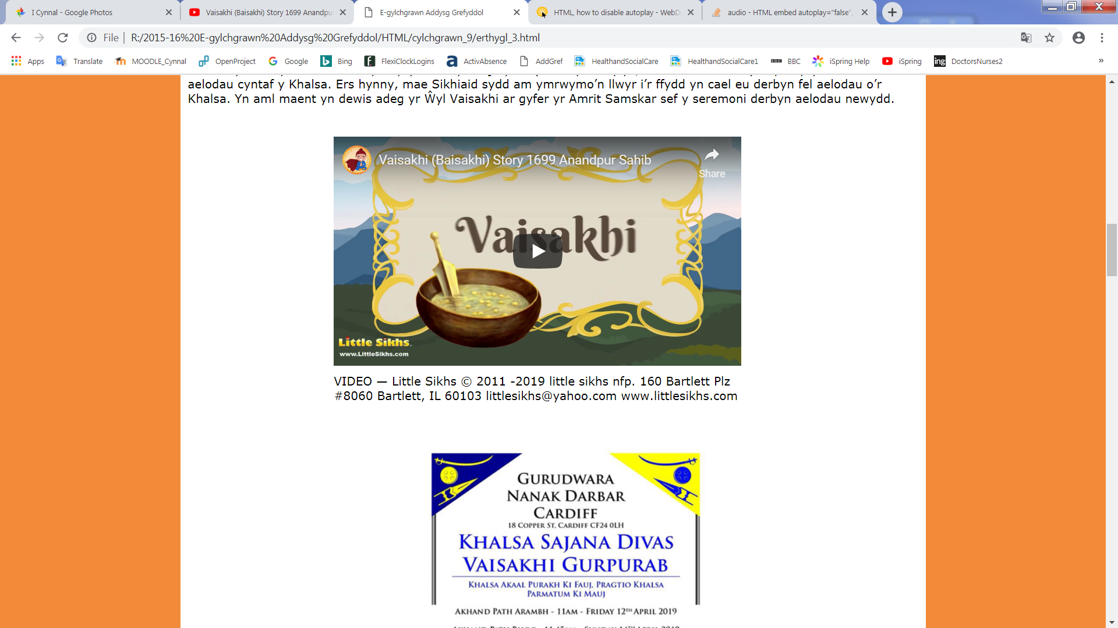

<https://www.youtube.com/watch?time_continue=108&v=0AE01rU2jdQ>

VIDEO — Little Sikhs © 2011 -2019 little sikhs nfp. 160 Bartlett Plz #8060 Bartlett, IL 60103 littlesikhs@yahoo.com www.littlesikhs.com

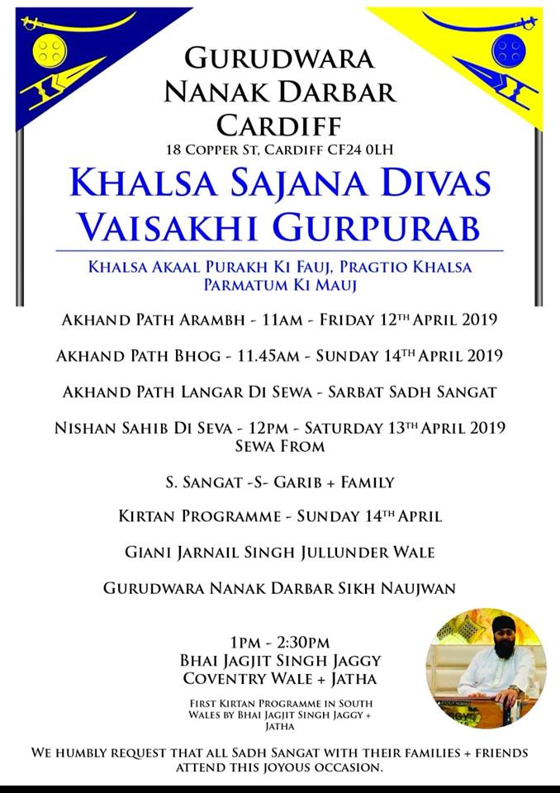

Cardiff's gurdwara Nanak Darbar, like other gurdwaras around the world, organises activities to celebrate Vaisakhi annually, and everyone is welcome to join in the celebrations.

Bethan and Mary were two visitors on Saturday 14th April, 2019. What really impressed Mary was the Nishan Sahib de Sewa ceremony outside the gurdwara. *"It was a colourful and lively scene while, at the same time, a devotional occasion. To the accompaniment of the nagara (drums) and the chimta (a row of small cymbals) everyone worked together to take down the old flag (the Nishan Sahib), clean the pole and plinth with water and yoghurt and set a flag up for the new year. Everyone was barefoot to show respect for the Nishan Sahib despite the cold. I heard the granthi leading the prayers and the worshippers chanting in response, 'Waho, waho Gobind Singh Ji, apeh Gur chela' (Wonderous, wonderous, Gobind Singh. He is the Guru and the disciple). The leaders had hidden silver and flower petals in the new banner and when rebuilding the pole, these fell to the ground, and the children had a lot of fun looking for the money on the pavement.”*

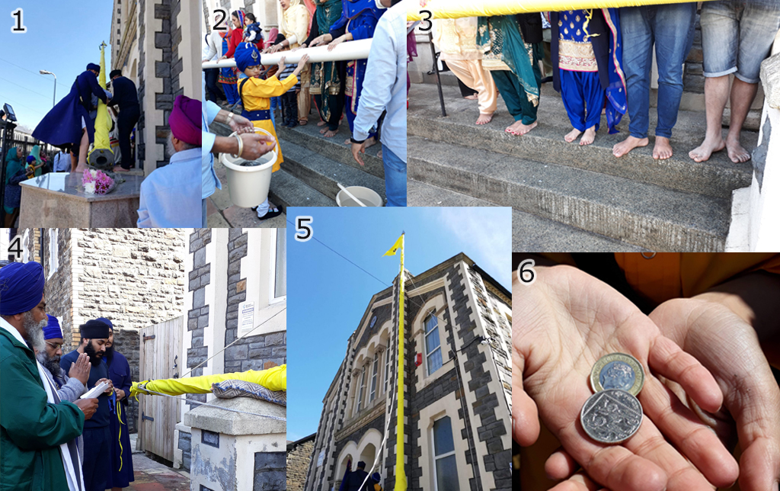

Everyone was glad to delve into the warmth of the gurdwara to listen to the members take turns reading the Guru Granth Sahib. They had started at lunchtime on Friday, and undertook two-hour continuous shifts for about 48 hours to read the holy book from cover to cover. This reading is called the *'Akhand Path'*. People were seen presenting gifts of food, flowers, and money in front of the holy book to be blessed. The food is then distributed to the worshippers, so that they, too, can receive the blessing. One of Bethan's fondest memories was the Sikh hospitality. “*I first got karah parshad which is a handful of sweet and savory things. We were then invited to the langar for a meal. The chapattis and the vegetarian curry were very tasty Everyone got together to prepare and serve the food and it was nice to chat around the table with everyone.”*

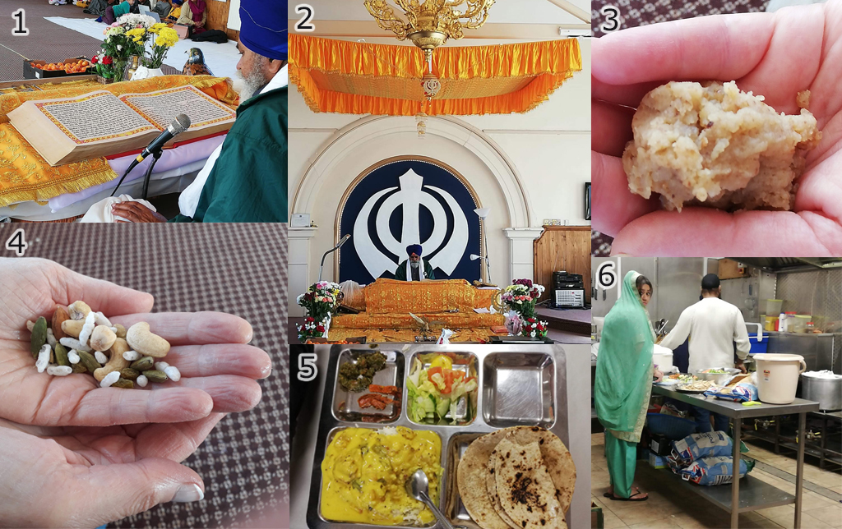

Bethan and Mary had the opportunity to speak to a number of Sikhs during the afternoon. Taran Singh, a member of the Khalsa and wearing the 5 Ks with pride, was very enthusiastic about telling the story of Guru Gobind Singh and the founding of the Khalsa. He and his family were active in the gurdwara; some taught the children to sing kirtan (hymns), some distributed food to the homeless in Queen Street, Cardiff, and others played traditional instruments in the band.

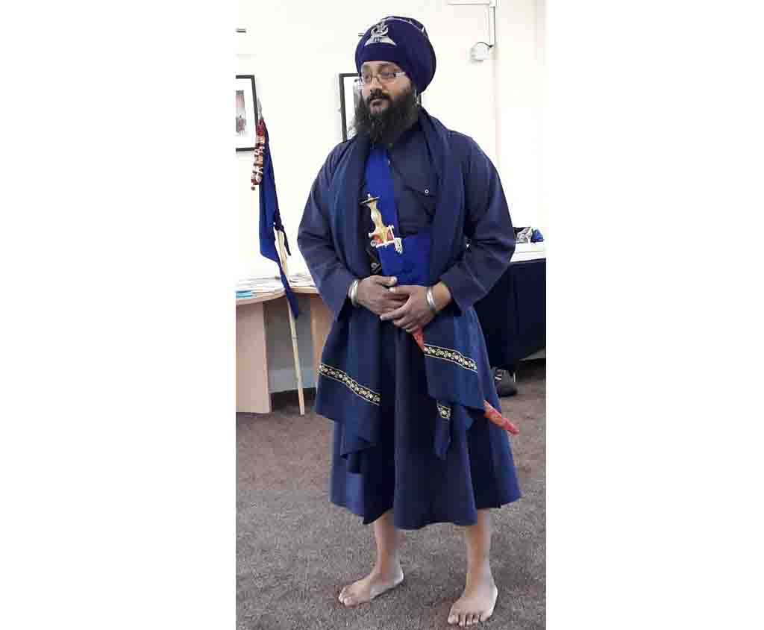

Taran explained to both visitors that Vaisakhi celebrations would continue the next day. The gurdwara would be packed with members of the community coming to listen to the 'Akhand Path Bhog', which is the reading of the last part of the Guru Granth Sahib. This would be followed by the Kirtan programme, the singing of sacred hymns to the accompaniment of musical instruments. Famous Sikh musicians as well as members of the local gurdwara would be involved and everyone was very excited about this. And to end the Vaisakhi celebrations for 2019, everyone would come together to share a langar.

Bethan and Mary were disappointed that they couldn't attend the following day's celebrations. However, they got a glimpse of what was to come when they listened to the gurdwara band rehearsing - what talented musicians!

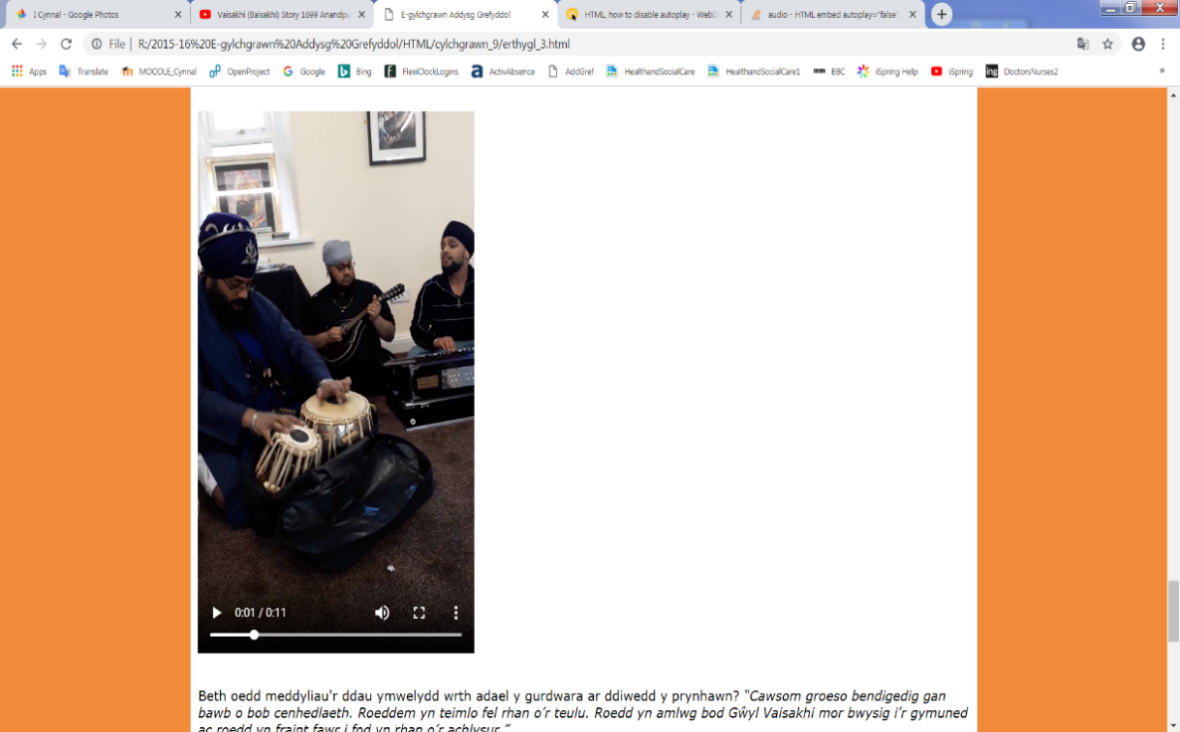

What were the thoughts of the two visitors when leaving the gurdwara in the late afternoon? “*We had a wonderful welcome from all generations. We felt like part of the family. The Vaisakhi Festival was clearly so important to the community and it was a great privilege to be part of the event.”*

