**Teachers’ Guide**

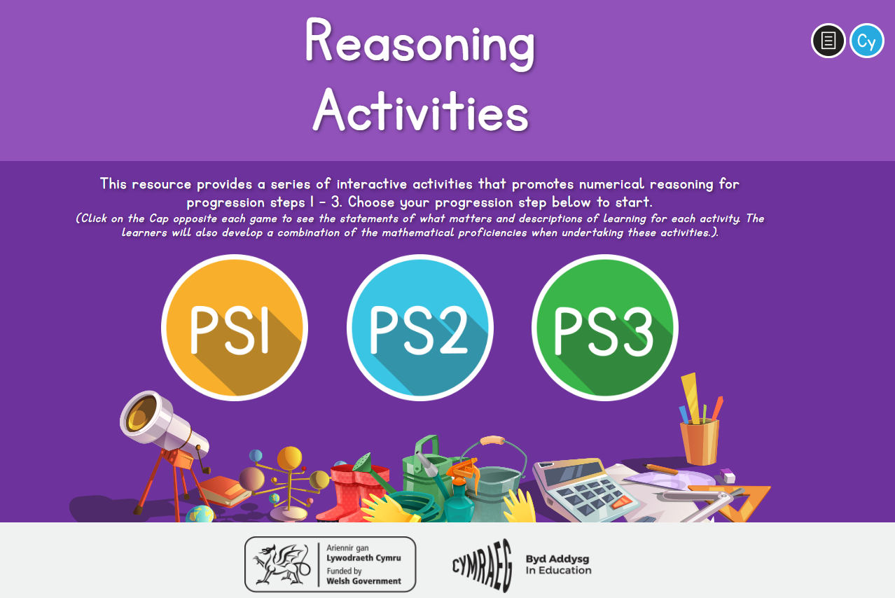

Click here to view progression step 3 activities.

Click here to view progression step 1 activities.

Click here to view progression step 2 activities.

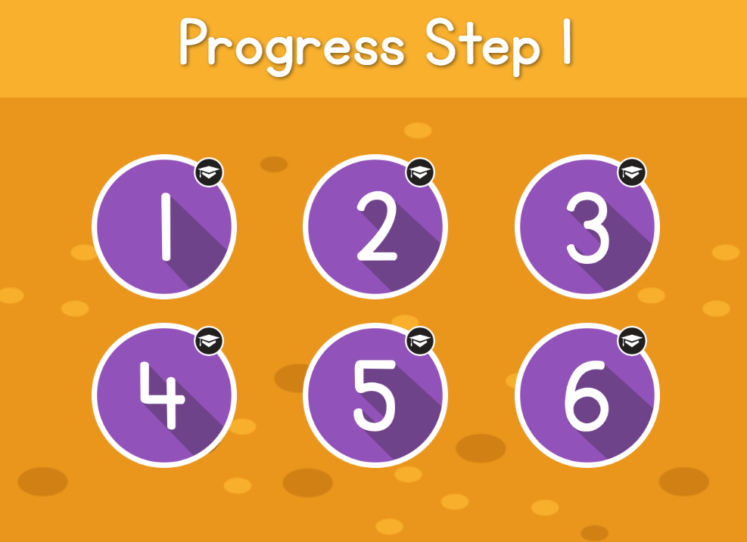

Once you have chosen a progression step, you can choose one of six activities. Click on the icons, or the "cap" icon to view the statements of what matters and the descriptions of learning which are specific to the activities. Developing the mathematical proficiencies, which are inter-related and inter-dependent are key to ensure progress and depth of understanding within Mathematics and Numeracy. The Curriculum for Wales guidance on the mathematical proficiencies is included at the beginning of each activity.

Once you have selected an activity, use the navigation bar at the bottom of the screen to navigate your way through the questions.

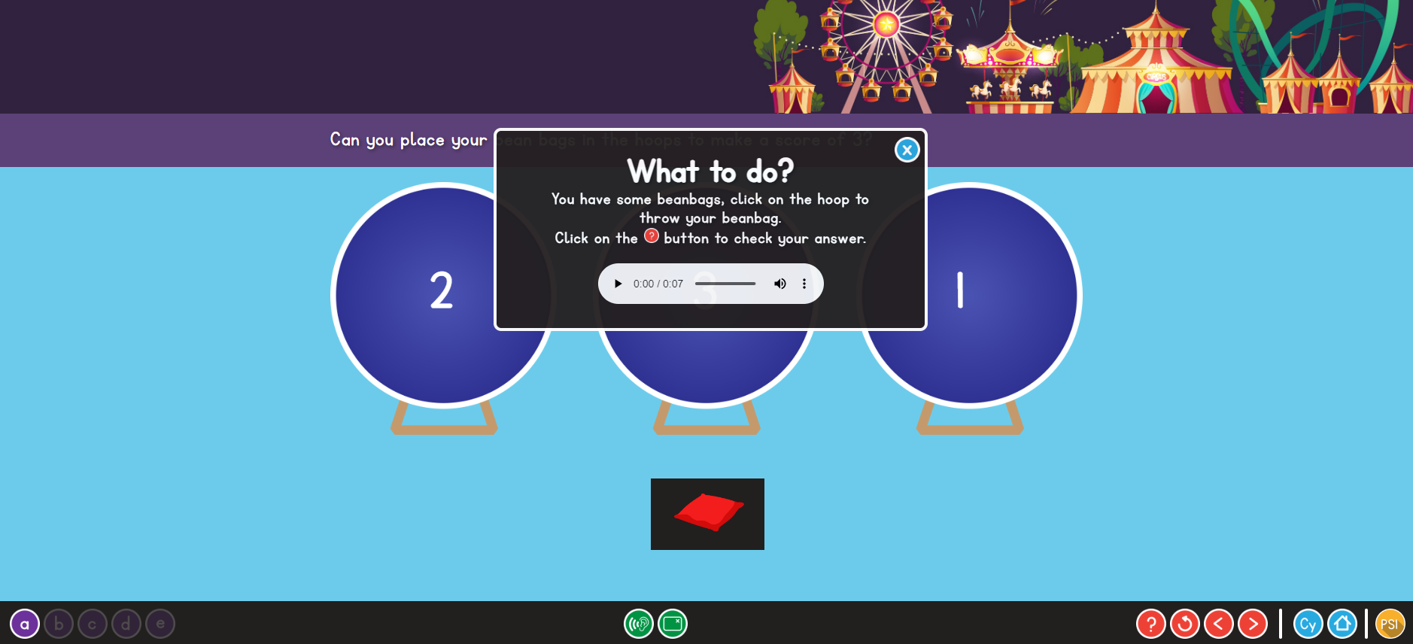

Progression step activities

Instructions

Home page

Click this button to listen to an audio reading the questions. After clicking on the ear icon the text will be coloured black. You’ll need to click on the text to hear the audio reading the text.

Check your answers



Click here for a different version of the activity. There are five different versions. The question will remain the same but the figures will vary.

Choose language

Restart

Previous / next step

It is suggested that you use the online activities to practice specific skills which are currently or have previously been taught. It would be beneficial if these activities are enhanced with practical, active learning experiences.

This resource also provides opportunities to enrich home learning experiences.

The activities provide many opportunities for problem solving and skill development within practical, real-life contexts. You can adapt and develop them within provision areas, both inside and outside, by providing a variety of resources and equipment for the pupils to make their own choices, and to develop their creative and critical thinking skills when solving problems.

As adults you could facilitate and support the learning as they complete the activities online or through practical real life, problem solving experiences. This can be done by asking open-ended questions to develop pupils’ understanding of mathematical concepts and proficiencies.

There are many possibilities and answers to some of the questions within the activities, which you can encourage the pupils to further explore.